**Question 1**

For the binary tree shown in the figure , the in-order traversal sequence will be  
  
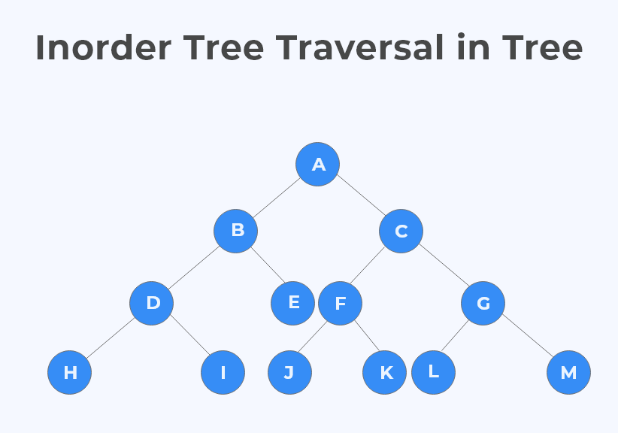

1. HDIJBKEALFMCNGOA
2. HDIBJEKALFMCNGOA
3. HIDJBKEALFNCMGOA
4. HIDJBEKLAMFCNOGA

Ans:

When we want to traverse the tree in inorder  traverser, so we follows this sequence. That is Left Root Right.  
  
**Question 2**

Assuming that the tree's height starts from 0. Then number of nodes in a tree of height h will be?

1. 2h
2. (2h-1)
3. (2h + 1- 1)
4. (2h -1-1)

**Ans:**  
(2h+1 – 1)nodes  (if h starts from 0)

(2h – 1)nodes  (if h starts from 1)

**Question 3**

The data structure used by level order traversal binary tree:

1. Linked List
2. Queue
3. Array
4. Stacks

**Ans:**

Queue works on the first in first out manner. So when we traverse the tree so we can put the node in the queue  
  
**Note -** Linked List can also be used to implement level order traversal, however, doing level order traversal using stack is more efficient

**Question 4**

For the binary tree shown in the figure , the pre-order traversal sequence is  
  
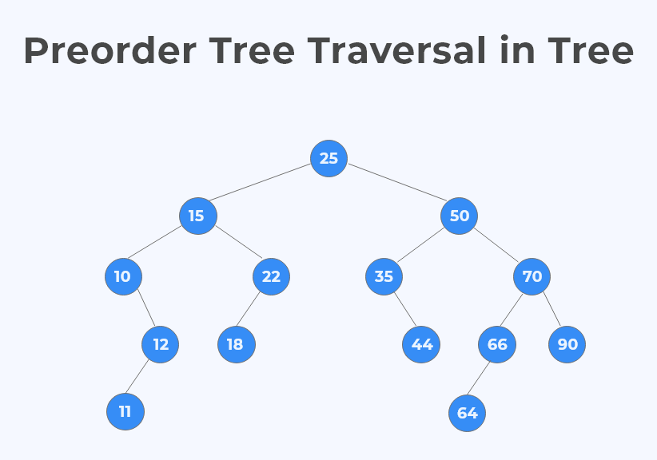

1. 10 11 12 15 18 22 25 35 44 50 64 66 70 90
2. 25 15 10 12 11 22 18 35 50 44 66 70 64 90
3. 25 15 10 12 11 22 18 50 35 44 70 66 64 90
4. 11 12 10 18 15 22 44 35 64 66 90 70 50 25

**Question 5**

A binary tree where all the node have either two children or zero is known as

1. Full binary tree
2. Complete binary tree
3. Binary search tree
4. AVL binary tree

A full binary tree is a binary tree in which every node in the tree has exactly zero or two children.  
  
  
**Question 6**

If the preorder and inorder traversal of the binary tree is ABDEFCGHJLK and DBFEAGCLJHK respectively so what is the postorder traversal.?

1. DFEBGLJKHCA
2. DFEBLJGKHCA
3. DFEBLKHGJCA
4. DFEBLGKJHCA

Explanation

1. We know that in PreOrder of tree the first node is always the root node of the tree right ?

1. We can then search 'A' in the inorder sequence of the tree

1. All elements on left side of 'A' in inorder are left subtree and on right are right subtree

1. Keep on doing the same recursively to obtain the visual representation of tree

1. Finally find postorder of this tree

Below image explains the following clearly:  
  
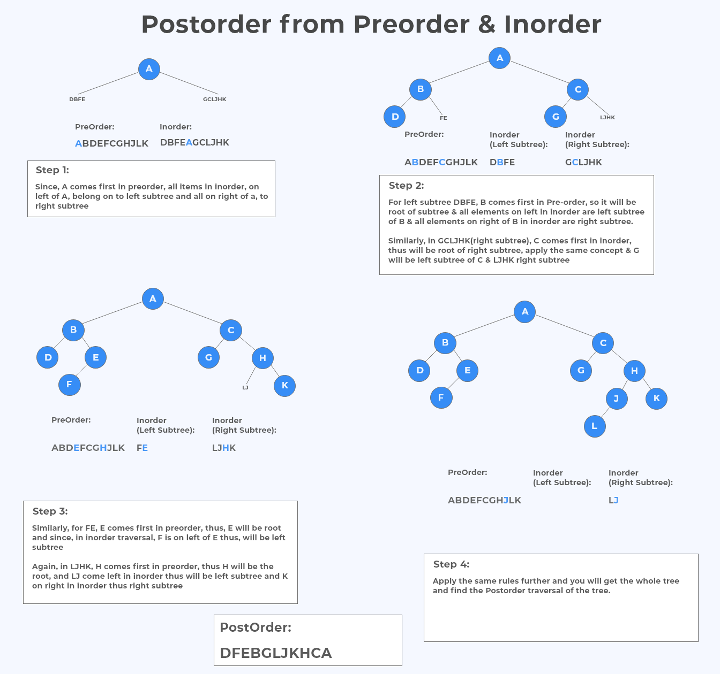

**NOTE**:

If an MCQ Question comes in the exam, it will generally say - Assume Height starts from (0 or 1), if not then learn both below formulas safe side mark whichever is present.  
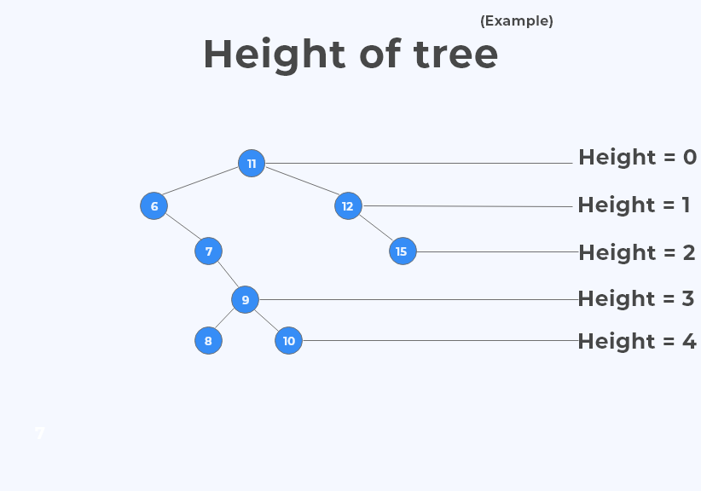  
So the height of the tree is 4.

**Question 9**

What is the maximum number of nodes in full binary tree which have a depth 3 ?

4

10

15

12

* The number of edges that lie in between the path from a node to the root in a tree is defined as the depth of the tree.

* In the image given here, we can see the depth of each node. For instance the depth of the root node is zero.

At one level the total number of node is 2^n, where n=level.

* At zero level=2^0=1

* At first level=2^1=2

* At second level=2^2=4

* At third level=2^3=8

* So total number node is=1+2+4+8=15.

Or you can use the direct formula : (2d+1- 1) = (23+1- 1) = (24- 1) = 15