Explainable AI Techniques for Student Academic Performance Analytics: A Comparative Study
Naru Mokshita, Ramayanam Vaishnavi, Thota Usha Sri Sai
Department of Computer Science and Engineering, Koneru Lakshmaiah Education Foundation, Bowrampet, Hyderabad – 500043, Telangana India.
mokshita.naru@gmail.com, rvsv.col@gmail.com, ushasrisai.thota@gmail.com
ABSTRACT
This study presents an explainable artificial intelligence framework for early student-failure prediction using the UCI Student Performance Mathematics and Portuguese datasets. The implemented experiment compares five standalone machine-learning baselines with seven hybrid configurations, including ML+DL, DL+DL, DL+optimization, and ML+optimization. All models use the same leakage-controlled preprocessing, stratified hold-out test set, and probability thresholds selected from five-fold out-of-fold training predictions. The selected LR+RF+HGB soft-voting hybrid achieved 0.7808 accuracy, 0.5088 recall, 0.5043 F1-score, 0.6830 balanced accuracy, 0.7186 ROC-AUC, and 0.4619 PR-AUC. A dual deep-neural-network ensemble achieved the highest ROC-AUC of 0.7462, demonstrating that the best ranking model was not the best operating-point model. SHAP explanations and an interactive Streamlit dashboard connect the selected model’s predictions with student-level risk factors.
Keywords: academic performance analytics; educational data mining; machine learning; explainable AI; SHAP; LIME; student risk prediction; early-warning system; comparative analysis; student failure classification

1. INTRODUCTION
1.1 Background
Educational data mining and learning analytics increasingly use student information to support evidence-based academic decision-making. Variables such as academic history, attendance, study behavior, family support, health status, and access to educational resources can provide signals associated with later academic outcomes. Research on student success, at-risk identification, and educational XAI shows that machine learning is increasingly being paired with interpretability so that predictions can be examined by educators rather than treated as opaque scores [1]–[6], [8], [18], [23], [24].
However, prediction alone is insufficient when a model is intended to support intervention. Prior reviews identify the post-hoc treatment of interpretability and limited standardization of explainability evaluation as continuing challenges [1], [2], [6], [36]. The project therefore places EDA, comparative modeling, and explainability within one analytical workflow. In particular, it compares five classifiers using multiple predictive metrics and then uses SHAP to connect the selected model's risk estimates to global and student-level feature contributions [14]. The current paper reports the implemented UCI-based experiment and clearly distinguishes completed components from the broader SHAP/LIME and multi-dataset roadmap.
1.2 Problem Statement
The problem addressed is the development of a reproducible student academic-performance analytics framework that can examine educational datasets, prepare and explore their attributes systematically, compare multiple machine-learning classifiers, and explain individual predictions. A key requirement is to avoid target leakage when defining academic-risk outcomes and to make model outputs understandable to educators [13], [15]. The current implementation operationalizes this problem on the UCI Student Performance dataset using binary final-grade failure prediction, while the project roadmap extends the framework to xAPI and OULAD and to both SHAP and LIME explanations.
Core research problem: How can machine learning identify students at risk of academic failure while providing transparent explanations of the factors contributing to each prediction?

1.3 Research Gap
The literature survey identifies several gaps relevant to this study: interpretability is often treated as a post-hoc component; quantified and standardized explainability evaluation is limited; comparative evaluation of multiple classifiers under a common pipeline remains insufficient; and performance is difficult to compare directly across studies because datasets and evaluation designs differ [1], [2], [6], [36]. The proposed framework responds by combining systematic EDA, five-model comparison, multi-metric evaluation, and XAI within one workflow. The current experimental evidence remains limited to the UCI dataset and implemented SHAP explanations; cross-dataset benchmarking, LIME comparison, formal fairness analysis, explanation-stability testing, and statistical testing are not presented as completed results.

1.4 Research Objectives
- Design and implement an end-to-end data analytics and machine-learning pipeline for student academic-performance and risk prediction.
- Compare standalone baselines and multiple hybrid categories under one evaluation protocol: ML+DL, DL+DL, DL+optimization, ML+optimization, heterogeneous soft voting, and stacking.
- Identify influential academic, behavioral, demographic, social, and support-related factors using SHAP, distinguishing global importance from student-level local attribution, with LIME included in the broader roadmap for complementary local explanations.
- Evaluate models using Accuracy, Precision, Recall, Specificity, F1-Score, Balanced Accuracy, MCC, ROC-AUC, and PR-AUC, with decision thresholds selected only from out-of-fold training predictions.
- Deliver an interactive dashboard combining EDA outputs, student-level prediction, model comparison, visualizations, and interpretable explanations.

1.5 Research Questions
- RQ1: What patterns and relationships in academic, demographic, behavioral, social, and support-related attributes are revealed through systematic EDA?
- RQ2: How do standalone machine-learning models and the four required hybrid categories—ML+DL, DL+DL, DL+optimization, and ML+optimization—compare under a common leakage-controlled evaluation pipeline?
- RQ3: Which features most strongly influence predicted academic risk according to SHAP, and how can local explanations support interpretation of individual predictions?
- RQ4: How can an interactive dashboard integrate exploratory analytics, model comparison, risk prediction, and explainability for academic decision support?
1.6 Contributions
- A structured educational data-analytics workflow covering preprocessing, EDA, feature preparation, model comparison, and visualization.
- A reproducible comparison of five standalone classifiers and seven hybrid configurations, including one implemented candidate from each required hybrid category.
- Global and local SHAP explanations for the implemented UCI model, linking aggregate feature influence to the reasons behind an individual risk prediction, with LIME retained for future explainer comparison.
- An interactive dashboard integrating student-level prediction, model performance, and explainability for educator-oriented decision support.
1.7 Organization of the Paper
Section 2 reviews related work and the research gaps identified in the supplied literature survey. Section 3 describes the proposed methodology, benchmark datasets, EDA workflow, preprocessing, models, explainability techniques, and mathematical formulation. Section 4 presents the experimental setup and evaluation metrics. Section 5 reports the currently implemented UCI results and SHAP-based explanations. Section 6 discusses the findings and their implications. Section 7 presents limitations and scope gaps. Section 8 concludes the study and outlines future work, including cross-dataset evaluation and LIME comparison.
2. RELATED WORK
2.1 Existing Works
Existing research in student academic analytics can be organized into five connected streams: (i) interpretability and educational-XAI reviews, (ii) student-success and at-risk prediction, (iii) advanced educational analytics and intervention, (iv) benchmark datasets, and (v) machine-learning and imbalance-learning foundations. The studies below are summarized to make the comparison explicit and to show how the present work combines predictive benchmarking with model-level and student-level explanation.
2.1.1 Interpretability, XAI, and review studies
[1] Carvalho, Mattos, and Aguiar map interpretability research in educational data mining and highlight the recurring treatment of interpretability as a post-hoc component. This motivates integrating explanation into the analytical workflow rather than presenting prediction alone.
[2] The 2025 IEEE Access systematic review surveys explainable learning analytics and educational data mining, identifying growing use of SHAP and a lack of standardized quantitative evaluation of explanations. This directly supports the comparative-XAI emphasis of the present study.
[6] Alamri and Alharbi systematically review explainable student-performance prediction models and establish the need to consider interpretability alongside predictive performance.
[8] Khosravi et al. survey XAI in education and emphasize that explanation needs depend on educational stakeholders and context. Their work supports presenting understandable factor-level contributions rather than only risk probabilities.
[12] Talmoudi and Choukir discuss the transition from predictive analytics toward explainable AI in higher education, reinforcing the movement from prediction-only systems toward interpretable decision support.
[14] Lundberg and Lee introduce SHAP as a unified additive framework for interpreting model predictions. This is the theoretical basis for the SHAP analysis used in the present implementation.
[36] Gunasekara and Saarela provide a recent systematic review of explainable learning analytics and educational data mining, further establishing XAI as an emerging component of educational prediction systems while identifying methodological gaps.
2.1.2 Student-performance, success, and at-risk prediction
[3] The 2026 study on psychological and engagement data evaluates transparent machine-learning approaches for student-success prediction and identifies factors such as digital self-efficacy, perceived feedback usefulness, and discussion engagement as influential predictors.
[4] Almazroei presents a multi-dataset ensemble framework using SHAP and LIME for early student-success prediction. Its multi-dataset design demonstrates the value of combining predictive performance with global and local explanations.
[5] The 2026 Frontiers in Education study develops an interpretable student-success framework using CatBoost and XAI, illustrating the usefulness of nonlinear ensemble models together with global and individual-level interpretation.
[9] Paul et al. examine explainable dropout prediction and show the relevance of interpretable risk models for identifying students requiring attention, supporting the inclusion of simpler baselines alongside ensemble learners.
[10] The lifestyle-factor study investigates interpretable machine learning for academic-performance prediction, broadening the predictor space beyond purely academic records and motivating analysis of behavioral and contextual attributes.
[13] Cortez and Silva provide the foundational study associated with the UCI Student Performance dataset used in the current experiment. Their work establishes the dataset's role in student-performance prediction.
[18] Johora et al. study an explainable AI approach for undergraduate academic-performance prediction, making it closely aligned with the present combination of classification and explanation.
[19] Hoque, Brusilovsky, and Akram analyze an explainable student-performance prediction model in an introductory programming context, demonstrating the relevance of explanations at the course or student level.
[20] Pereira et al. investigate explanations of individual and collective programming-student behavior from a black-box predictive model, supporting the distinction between individual explanations and aggregate model interpretation.
[21] Adnan et al. focus on earliest possible global and local interpretation of student performance in virtual learning environments, directly supporting the present use of global feature importance and local student-level explanations.
[22] Chen et al. investigate week-wise early prediction in a virtual learning environment using deep explainable AI, highlighting the importance of obtaining useful signals before final academic outcomes are observed.
[23] Alwarthan, Aslam, and Khan develop an explainable model for identifying at-risk students in higher education. This is particularly close to the present early-warning objective.
[24] Nagy and Molontay study interpretable dropout prediction and XAI-based personalized intervention, connecting risk prediction with the practical requirement that explanations should support subsequent educational action.
[27] Alyahyan and Düştegör review academic-success prediction in higher education and discuss literature-level best practices for early identification and predictive modeling.
[28] Aslam et al. investigate improved early academic-performance prediction using deep learning, representing a more complex modeling direction than the conventional classifiers used in the current comparative experiment.
[29] Alsubhi et al. examine feature-prediction models for student performance, reinforcing the importance of feature selection and the identification of informative predictors.
[30] Pallathadka et al. compare multiple machine-learning algorithms for student-performance classification, providing methodological support for a multi-model benchmark rather than relying on one classifier.
[31] Ha et al. conduct an empirical study of student academic-performance prediction using machine-learning techniques, adding evidence that algorithm choice can vary across educational datasets.
[32] Zulfiker et al. predict student performance in private universities using machine-learning approaches, illustrating the influence of institutional context on predictive modeling.
[33] Hossen et al. propose a web-based four-tier architecture using a reduced-feature neural-network approach for student-performance prediction, connecting prediction with deployable system architecture.
[34] Janan and Ghosh investigate student-performance prediction using support vector machines, representing another supervised-learning baseline outside the five-model set adopted here.
2.1.3 Advanced approaches, feature selection, and intervention
[7] The clustering and explainable-AI study extends beyond straightforward supervised classification by using clustering to track student progress and then connecting the discovered patterns with explanation.
[11] Bin Azmi et al. propose a hybrid feature-selection framework aimed at improving both predictive accuracy and interpretability, reinforcing the role of feature selection in a transparent modeling pipeline.
[25] Livieris et al. present an advanced explainable and interpretable machine-learning framework for educational data mining, supporting the integration of prediction and interpretation rather than treating them as isolated stages.
[26] Swamy et al. evaluate black-box explainers for student-success prediction in MOOCs, highlighting that the quality of an explanation method itself should be examined rather than assuming that every explainer is equally informative.
[35] Afzaal et al. connect explainable-AI-based recommendations with student self-regulation, providing a bridge between explaining a risk prediction and using the explanation to guide supportive educational feedback.
2.1.4 Benchmark datasets and data resources
[15] The UCI Machine Learning Repository entry for Student Performance is the primary dataset resource used in the current numerical experiment.
[16] The xAPI Educational Dataset is included in the project roadmap as a behavioral learning-data benchmark and provides a complementary context to the UCI academic/social attributes.
[17] The Open University Learning Analytics Dataset (OULAD) is included in the roadmap as a higher-education learning-analytics benchmark, enabling future cross-context robustness analysis.
2.1.5 Algorithmic and imbalance-learning foundations
[37] Breiman's Random Forest work provides the foundational basis for the Random Forest classifier used in the comparative benchmark.
[38] Chen and Guestrin introduce XGBoost, providing the methodological foundation for the gradient-boosted model used as a nonlinear benchmark.
[39] Prokhorenkova et al. introduce CatBoost, the categorical-feature-oriented boosting method included in the present comparison.
[40] Chawla et al. introduce SMOTE for synthetic minority oversampling. It provides the methodological basis for future imbalance-handling experiments; the current reported UCI results do not claim completed SMOTE correction.
2.2 Comparative and Explainability Synthesis
Across the literature, three comparison dimensions are especially relevant to the present project. First, predictive comparisons show that no classifier should be assumed to dominate across datasets or metrics: linear models can remain competitive, decision trees can provide strong threshold-level recall, and ensemble methods can provide stronger probability discrimination. Second, educational-XAI studies distinguish global questions—Which factors generally influence predictions?—from local questions—Why did the model assign this risk to this student? [8], [14], [20]–[26]. Third, the literature increasingly connects explanations with intervention, but quantitative and standardized comparison of explanation quality remains limited [1], [2], [26], [35]. The present study therefore treats model comparison and explainability as complementary rather than independent tasks.
Study / Ref. | Prediction focus | Explainability focus | Relevance to present study
Reviews [1], [2], [6], [36] | Synthesize educational XAI/EDM evidence | Identify gaps in interpretability evaluation | Motivates a unified comparative-XAI pipeline
Khosravi et al. [8] | Educational prediction and analytics | Stakeholder/context-aware XAI | Supports readable educator-facing explanations
Almazroei [4] | Early success prediction across datasets | SHAP + LIME | Motivates ensemble and multi-explainer comparison
Frontiers study [5] | Student-success classification | Global + local XAI | Supports CatBoost plus explanation
Alwarthan et al. [23] | At-risk higher-education identification | Explainable risk prediction | Closest conceptual match to early-warning objective
Nagy & Molontay [24] | Dropout prediction | XAI for intervention | Connects prediction with actionable support
Adnan et al. [21] | Early student-performance prediction | Global + local interpretation | Supports two-level SHAP analysis
Johora et al. [18] | Undergraduate performance | Explainable AI | Closely aligned with academic-performance/XAI combination
Cortez & Silva [13], UCI [15] | Student-performance prediction | Dataset foundation | Primary empirical benchmark
Present study | Five-model binary failure comparison | Global/local SHAP in dashboard; LIME planned | Combines common-pipeline comparison, risk detection, and explanation
2.3 Critical Comparison
The central distinction of the present study is not simply the number of algorithms tested, but the use of a common data-preparation and evaluation pipeline so that model behavior can be compared on the same UCI task. The comparison uses Accuracy, Precision, Recall, F1-Score, and ROC-AUC because an early-warning system can produce misleading conclusions if accuracy alone is used. Recall is especially important because false negatives correspond to at-risk students who may not be flagged. Precision describes the burden of follow-up generated by the system, F1 balances precision and recall, and ROC-AUC evaluates probability-ranking behavior across thresholds.
Explainability adds a second comparison layer. Logistic Regression offers a naturally interpretable linear reference, Decision Tree exposes rule-like splits, while Random Forest, XGBoost, and CatBoost represent increasingly complex nonlinear ensemble behavior [37]–[39]. SHAP provides a common attribution language for the deployed model, allowing global feature patterns to be compared with a specific student's local explanation [14]. The current manuscript reports SHAP for the implemented dashboard model; it does not claim a completed SHAP-versus-LIME or cross-model explanation benchmark.
2.4 Research Gap and Positioning
The literature demonstrates strong progress in student-success prediction and educational XAI, but several gaps remain. First, many studies emphasize predictive performance without placing model comparison and explanation in one reproducible workflow. Second, explainability is frequently reported qualitatively, while systematic evaluation of explanation stability, consistency, and usefulness remains limited [1], [2], [26], [36]. Third, reported performance is difficult to compare across studies because datasets, target definitions, feature sets, class distributions, and validation procedures differ. Fourth, the practical link between a predicted risk and a human-readable reason is not always integrated into an operational dashboard.
The present project addresses these gaps by comparing standalone and hybrid models under a common UCI failure-prediction task, reporting threshold-dependent and ranking metrics, and embedding global and local SHAP explanations in an interactive dashboard. Four hybrid categories are implemented explicitly: Random Forest plus a deep neural network, dual deep-neural-network voting, a grid-optimized deep neural network, and a grid-optimized Random Forest.
3. PROPOSED METHODOLOGY
3.1 Overall Framework
The proposed workflow follows the project roadmap: benchmark dataset collection, data cleaning and quality assessment, systematic EDA, feature engineering and selection, preprocessing, class-imbalance assessment, train-test splitting, comparative model training, performance evaluation, SHAP/LIME explanation, visualization, and dashboard presentation. The three intended benchmark sources are UCI Student Performance, xAPI Educational, and OULAD. For the current reported experiment, the UCI dataset is the implemented source and the binary target is final-grade failure. Preprocessing is performed within the modeling pipeline where applicable so that learned transformations use training data only.

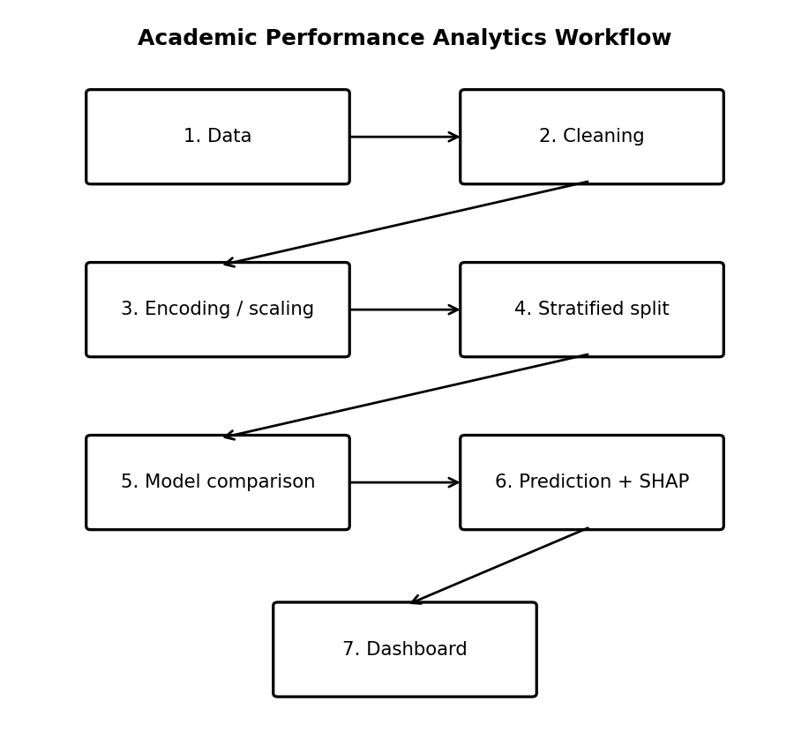
Fig. 1. End-to-end Academic Performance Analytics pipeline emphasizing comparative modeling and the transition from prediction to explanation and dashboard presentation.
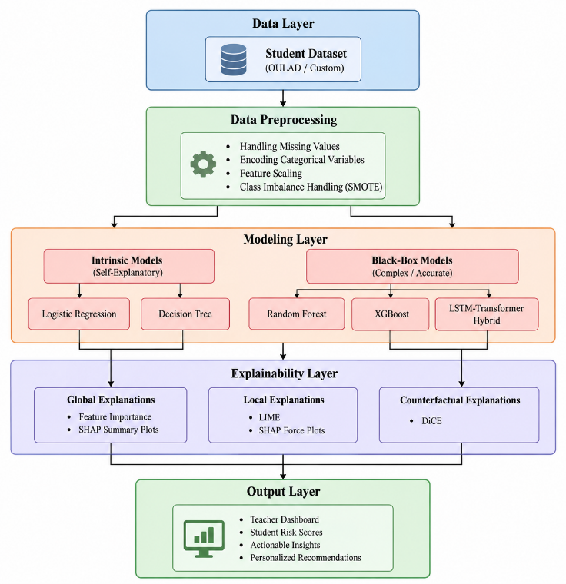
Fig. 2. End-to-end Academic Performance Analytics System architecture.
3.2 Dataset(s)
The project roadmap specifies three benchmark datasets with complementary contexts: the UCI Student Performance dataset (secondary-school academic, demographic, and social attributes), the xAPI Educational Dataset (learning-management behavioral data), and the Open University Learning Analytics Dataset (OULAD) for large-scale higher-education learning analytics. The current reported experiment uses UCI Student Performance (dataset ID 320), containing Mathematics and Portuguese course records and grades G1, G2, and G3. For the implemented early-warning classification task, the target is fail = 1 when G3 < 10 and fail = 0 otherwise. G3 is excluded from predictors to avoid target leakage. The xAPI and OULAD datasets are part of the broader project roadmap and are not used to generate the numerical results reported in Section 5. The UCI dataset is grounded in the work of Cortez and Silva [13] and the repository record [15], while xAPI and OULAD are the additional roadmap resources [16], [17].
- Primary source: UCI Student Performance dataset (ID 320).
- Target: final-grade failure, defined by G3 < 10 on a 0–20 scale.
- Predictors: selected academic, behavioral, demographic, health, support, and access-related features; the roadmap further calls for feature engineering and feature selection so that the final feature set can be selected systematically.

3.3 Data Preprocessing
- Remove duplicate records.
- Handle missing values and correct invalid values where applicable.
- Encode categorical variables using one-hot encoding inside the preprocessing pipeline.
- Standardize numerical variables using StandardScaler.
- Exclude G3 from predictor variables to prevent target leakage.
Assess class distribution before modeling and apply an appropriate imbalance strategy when supported by the experimental design; the current reported UCI results do not document a completed imbalance correction. If oversampling is used in a future experiment, SMOTE provides the methodological basis [40].
- Fit preprocessing transformations on the training data only.
3.4 Exploratory Analysis
The project roadmap defines a 12-stage EDA workflow: dataset overview; data-quality assessment; descriptive statistics; missing-value analysis; duplicate-record detection; outlier detection; univariate analysis; bivariate analysis; multivariate analysis; correlation analysis; feature engineering; and feature selection. Recommended visual outputs include summary tables, quality reports, missing-value heatmaps, boxplots, histograms/KDE plots, scatter or pair plots, correlation heatmaps, feature-importance plots, ROC curves, confusion matrices, learning curves, and dashboard views. The current paper documents the UCI-based dashboard and selected features, while the complete EDA sequence is part of the broader project roadmap; no numerical EDA findings are invented where they are not present in the supplied implementation results.
3.5 Proposed Model(s) and Baselines
- Standalone baselines comprise Logistic Regression, Decision Tree, Random Forest, Histogram Gradient Boosting, and CatBoost. Three heterogeneous ensembles provide additional references: LR+RF+HGB voting, LR+RF+HGB stacking, and RF+HGB+CatBoost voting.
- ML+DL uses probability-level soft voting between a class-balanced Random Forest and a multilayer feed-forward neural network with three hidden layers.
- DL+DL combines two multilayer neural networks with different hidden-layer widths, activation functions, and random seeds through soft voting.
- DL+optimization wraps a multilayer neural network in three-fold grid search over hidden-layer structure, activation, and L2 regularization. The search uses only training folds and optimizes F1-score.
- ML+optimization wraps a class-balanced Random Forest in three-fold grid search over maximum depth, minimum leaf size, and feature sampling. The search uses only training folds and optimizes F1-score.

3.6 Explainability Techniques
The project roadmap specifies SHAP and LIME. SHAP provides additive feature attributions that can be aggregated for global importance and inspected for individual predictions [14]. LIME provides local surrogate-model explanations around an individual instance and is represented in the reviewed explainer literature [2], [26]. SHAP is implemented and reported in the current UCI dashboard; LIME is retained as a planned complementary technique and is not assigned numerical results here.
3.7 Algorithmic / Mathematical Formulation
The binary target is defined as:
y = 1, if G3 < 10; y = 0, otherwise. (1)
For a classifier producing a failure probability p(x), the binary decision at threshold τ can be written as:
ŷ = 1, if p(x) ≥ τ; ŷ = 0, otherwise. (2)
SHAP expresses a prediction as a base value plus feature contributions. For an input x, the explanation can be represented as:
f(x) = φ₀ + Σᵢ φᵢ, (3)
where φ₀ is the expected model output and φᵢ is the contribution assigned to feature i. In the dashboard, positive contributions increase predicted failure risk and negative contributions decrease it.

4. EXPERIMENTAL SETUP
4.1 Hardware and Software
The system is implemented in Python using pandas, NumPy, scikit-learn, CatBoost, SHAP, Matplotlib, and Streamlit. The deep models are multilayer feed-forward neural networks implemented with scikit-learn MLPClassifier so that every hybrid remains compatible with the same preprocessing, probability, and persistence pipeline.
4.2 Dataset Split / Design
The executed experiment uses a 75:25 stratified train-test split with random state 42. After exact duplicate removal, 1,038 records remain: 778 training records and 260 held-out test records. Preprocessing is fitted only within training folds. Five-fold out-of-fold predictions on the training split select each model’s decision threshold by maximizing 0.60×F1 + 0.40×balanced accuracy. The held-out labels are used once for final reporting.

4.3 Hyperparameter Configuration
The DL+optimization search evaluates two neural-network architectures, ReLU and tanh activation, and two L2 regularization values using three-fold training-only grid search. The ML+optimization search evaluates two depth settings, two minimum-leaf settings, and two feature-sampling settings. Other models use fixed documented configurations and random state 42.
4.4 Validation Strategy
The validation design separates model and threshold choices from final evaluation. Hyperparameter searches and five-fold out-of-fold threshold selection operate only on the training split; all reported metrics use the untouched 260-record test split. This design reduces leakage, although repeated nested cross-validation remains desirable for confidence intervals and statistical comparison.

4.5 Evaluation Metrics
- Accuracy — proportion of all predictions that are correct.
- Precision — proportion of predicted failures that are actual failures.
- Recall — proportion of actual failures that are detected by the model.
- F1-Score — harmonic mean of precision and recall.
- ROC-AUC — probability-ranking measure of how well the model separates failure from non-failure across thresholds.
Specificity — proportion of non-failure cases correctly identified by the model.
Balanced Accuracy — average of recall for the failure class and specificity for the non-failure class.
MCC — Matthews correlation coefficient, summarizing binary classification quality using all four confusion-matrix categories.
PR-AUC — area under the precision–recall curve, useful for assessing positive/failure-class discrimination.
4.6 Visualization and Dashboard
The planned visualization layer includes heatmaps, boxplots, feature-importance plots, ROC curves, confusion matrices, learning curves, SHAP force/summary views, metric-comparison charts, and an interactive dashboard. The current implementation demonstrates dashboard views, model-metric comparisons, a confusion matrix, ROC curves, feature-importance views, and SHAP-based explanations; the manuscript does not claim that every roadmap visualization has been experimentally generated.
4.7 Statistical Testing
No formal statistical significance test is reported for the current experiment. This is identified as a limitation, and repeated cross-validation with appropriate statistical comparison is proposed for future evaluation.
5. RESULTS
The following results were generated by executing the revised training pipeline on the local UCI Mathematics and Portuguese files. The table and figures report the same held-out test split for all standalone and hybrid candidates.
5.1 Overall Performance
Logistic Regression produced the strongest F1-score (0.5424) and recall (0.5614) among all candidates. Among the requested hybrid categories, dual-DNN voting produced the highest ROC-AUC (0.7462) and PR-AUC (0.4924), but its thresholded recall was only 0.3333. The selected LR+RF+HGB voting hybrid provided the strongest recall/F1-weighted selection score among the hybrid candidates, with 0.5088 recall, 0.5043 F1-score, and 0.6830 balanced accuracy.

5.2 Model / Method Comparison

Table 2. Standalone models and implemented hybrid categories included in the held-out comparison.
Model and category | Held-out test metrics
Hybrid E (DL+DL): Dual-DNN Voting [DL+DL] | R=0.333; F1=0.404; AUC=0.746; PR=0.492
Logistic Regression | R=0.561; F1=0.542; AUC=0.728; PR=0.483
Hybrid C: LR+RF+HGB Stacking | R=0.456; F1=0.495; AUC=0.728; PR=0.471
Hybrid D (ML+DL): RF+DNN Voting [ML+DL] | R=0.298; F1=0.382; AUC=0.725; PR=0.456
Hybrid G (ML+Optimization): Grid-Tuned RF [ML+Optimization] | R=0.509; F1=0.487; AUC=0.722; PR=0.445
Hybrid A: LR+RF+HGB Voting | R=0.509; F1=0.504; AUC=0.719; PR=0.462
Random Forest | R=0.404; F1=0.434; AUC=0.711; PR=0.427
Hybrid B: RF+HGB+CatBoost Voting | R=0.404; F1=0.451; AUC=0.708; PR=0.435
Histogram Gradient Boosting | R=0.491; F1=0.509; AUC=0.705; PR=0.455
Hybrid F (DL+Optimization): Grid-Tuned DNN [DL+Optimization] | R=0.509; F1=0.483; AUC=0.698; PR=0.467
Decision Tree | R=0.509; F1=0.509; AUC=0.697; PR=0.424
CatBoost | R=0.439; F1=0.463; AUC=0.695; PR=0.410

5.3 Hybrid Model Comparison
The four required hybrid categories were evaluated alongside three heterogeneous reference ensembles. The DL+DL candidate achieved the highest ranking metrics, while ML+optimization and DL+optimization improved failure recall to 0.5088. The overall and hybrid-only figures below make these trade-offs visible.
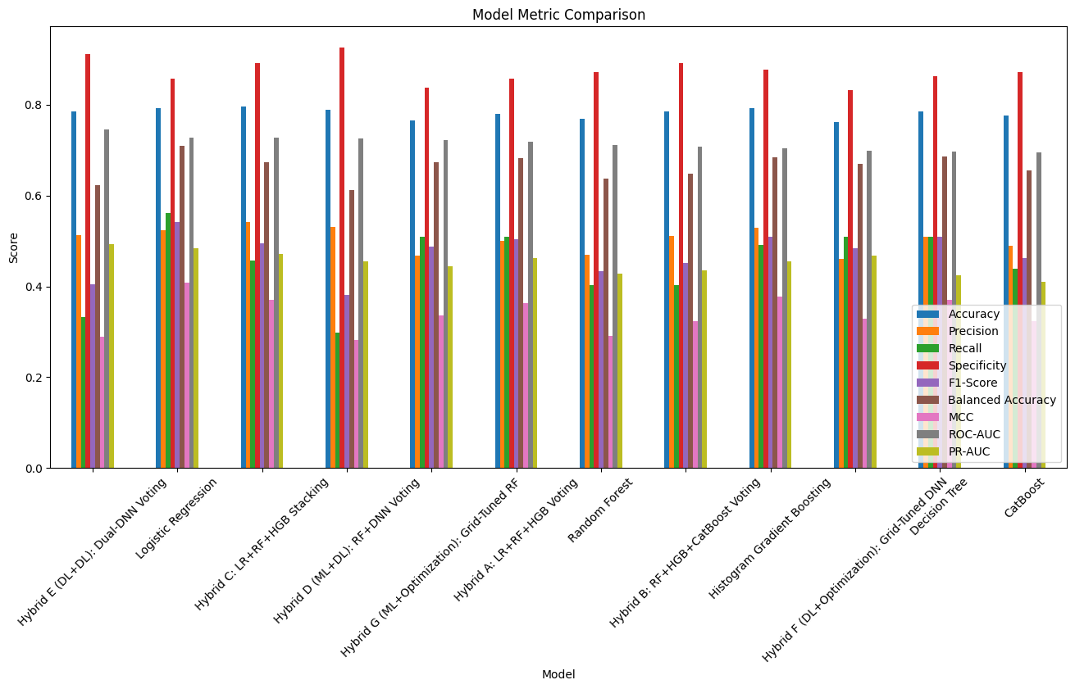
Fig. 3. Overall comparison of standalone and hybrid models across all reported metrics.
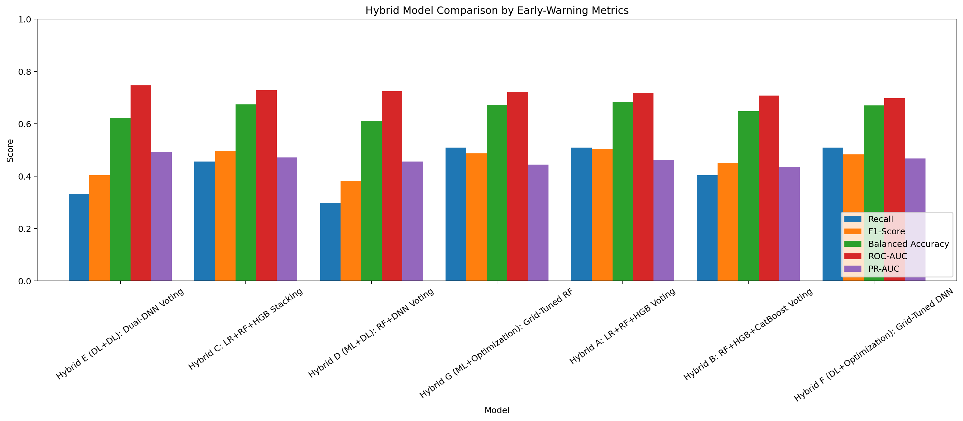
Fig. 4. Hybrid-only comparison emphasizing recall, F1-score, balanced accuracy, ROC-AUC, and PR-AUC.
Selection rationale. LR+RF+HGB soft voting was selected because it achieved the highest weighted deployment score among hybrid candidates when F1-score, failure recall, balanced accuracy, PR-AUC, and MCC were considered together. Its 0.5088 recall and 0.5043 F1-score provide a better early-warning operating balance than the higher-AUC dual-DNN ensemble, whose recall was 0.3333. The selection does not imply universal superiority: Logistic Regression achieved the best overall F1-score and recall, while dual-DNN voting achieved the best ROC-AUC and PR-AUC.

5.4 Student Level Risk Prediction
In the illustrated dashboard case, the selected student profile receives an estimated failure probability of 68.0% and is labeled HIGH RISK. This output is presented as an estimated academic-risk score and is explicitly not treated as a guaranteed outcome.
5.5 Feature and Factor Importance
The local SHAP explanation identifies the strongest displayed upward contributions as Intends Higher Education (+0.263), Previous Class Failures (+0.157), Weekly Study Time (+0.069), School Absences (+0.027), and Family Educational Support (+0.018). Going Out with Friends contributes negatively (−0.037), reducing the predicted risk relative to the model baseline. The global SHAP chart similarly places Intends Higher Education, Previous Class Failures, and Weekly Study Time among the largest displayed influences. This creates two complementary explanation levels: the global view indicates which variables matter across the model's predictions, while the local view shows which variables pushed this particular student's prediction upward or downward. These attributions describe model behavior and should not be interpreted as causal effects.
The comparative contribution of the project is therefore two-layered. At the predictive level, the five classifiers are evaluated on the same target and metrics. At the explanatory level, the selected model is examined through SHAP to determine whether the numerical risk output can be decomposed into understandable feature contributions [14]. The models also differ in their native interpretability: Logistic Regression offers a linear reference, Decision Tree provides rule-like structure, and Random Forest, XGBoost, and CatBoost provide increasingly complex ensemble behavior that benefits from post-hoc attribution [37]–[39].
Importantly, the current evidence should not be interpreted as a completed cross-model explanation benchmark. Only the implemented dashboard explanation is reported numerically. A stronger future comparison would compute SHAP explanations for all candidate models and assess agreement in global feature rankings, stability of local explanations, and sensitivity to changes in the input profile. A parallel SHAP-versus-LIME evaluation could then examine whether different explainers provide consistent and useful reasons for the same student-level prediction [2], [26].
5.6 Comparative Explainability Analysis
Selected dashboard views are shown below.
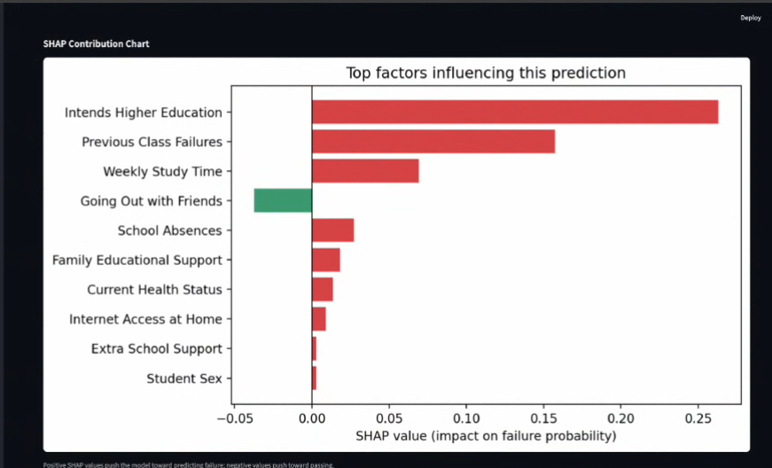
Fig. 5. Dashboard view showing the implemented model-performance and SHAP-based academic-risk interface.
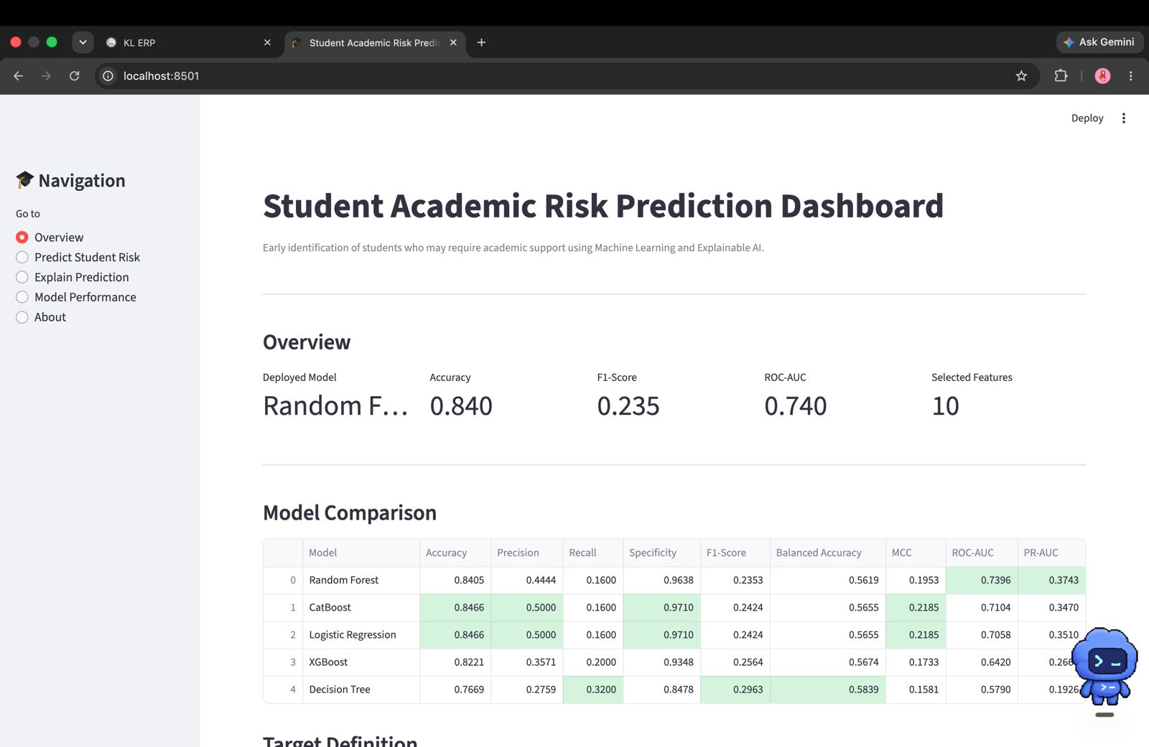
Fig. 6. Implemented dashboard overview showing the deployed model, headline metrics, and model-comparison table.
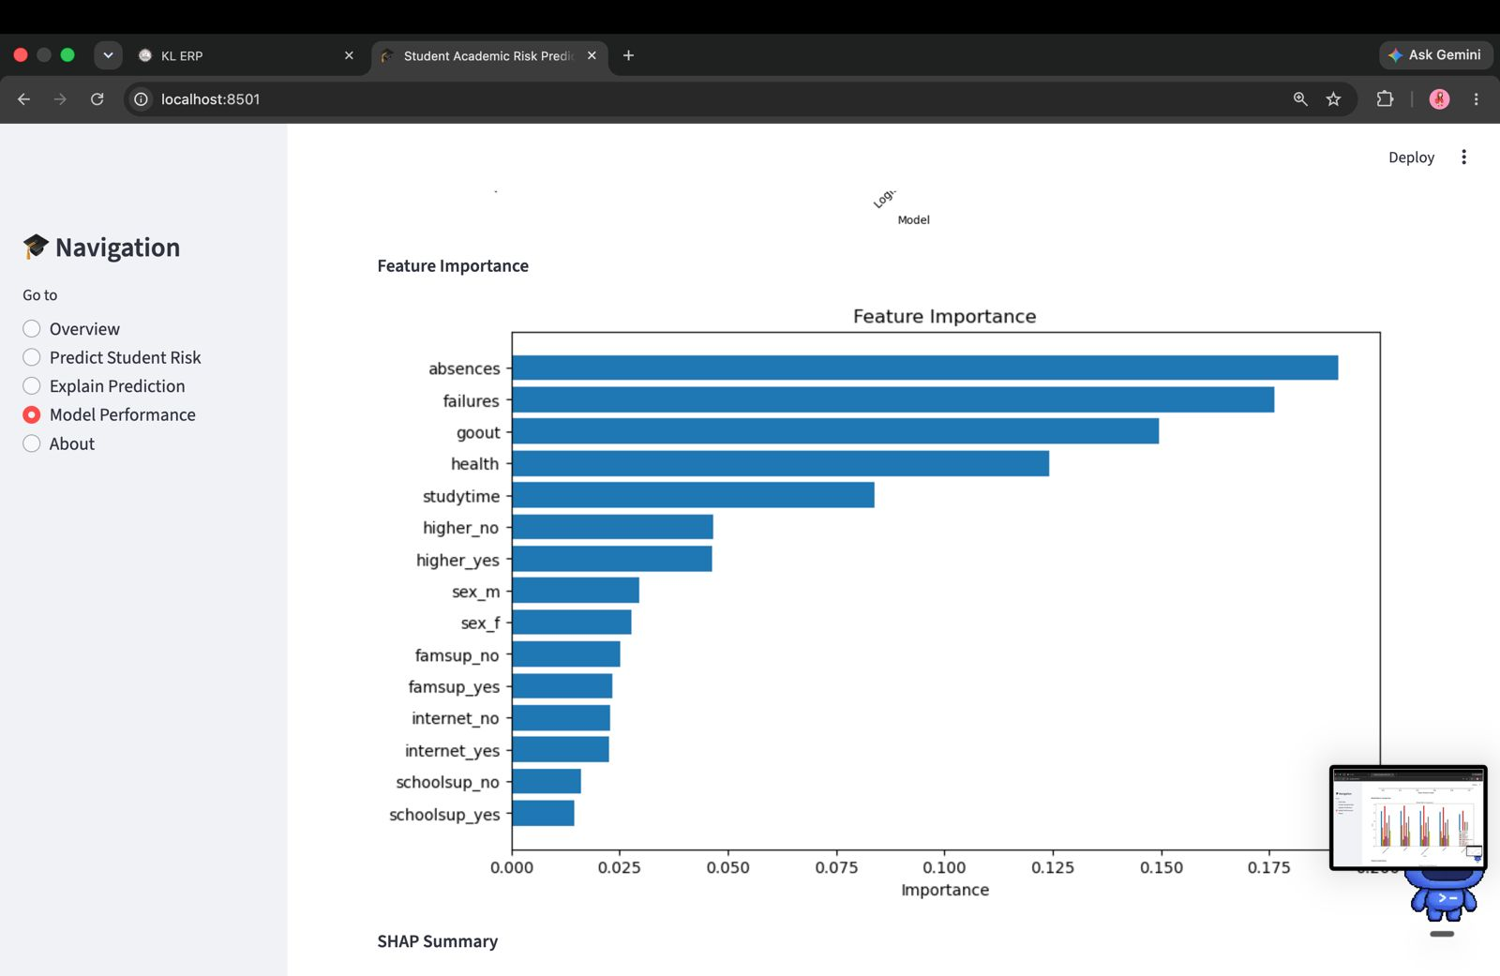
Fig. 7. Feature-importance output from the implemented dashboard.
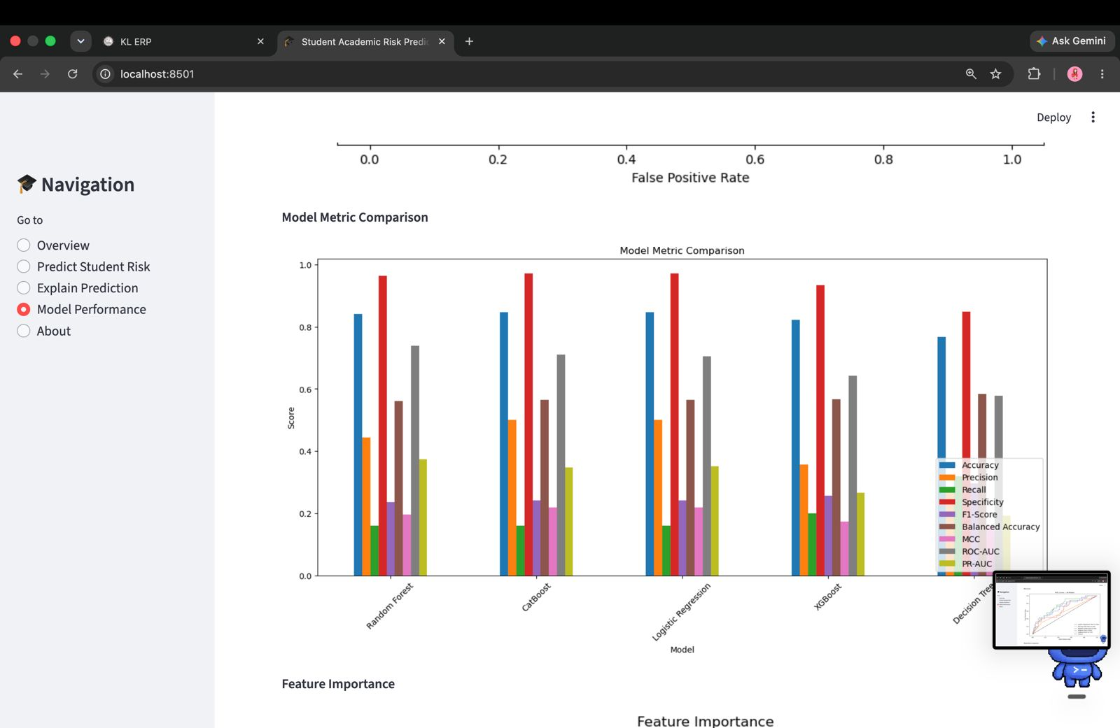
Fig. 8. Model metric comparison output across the reported predictive metrics.
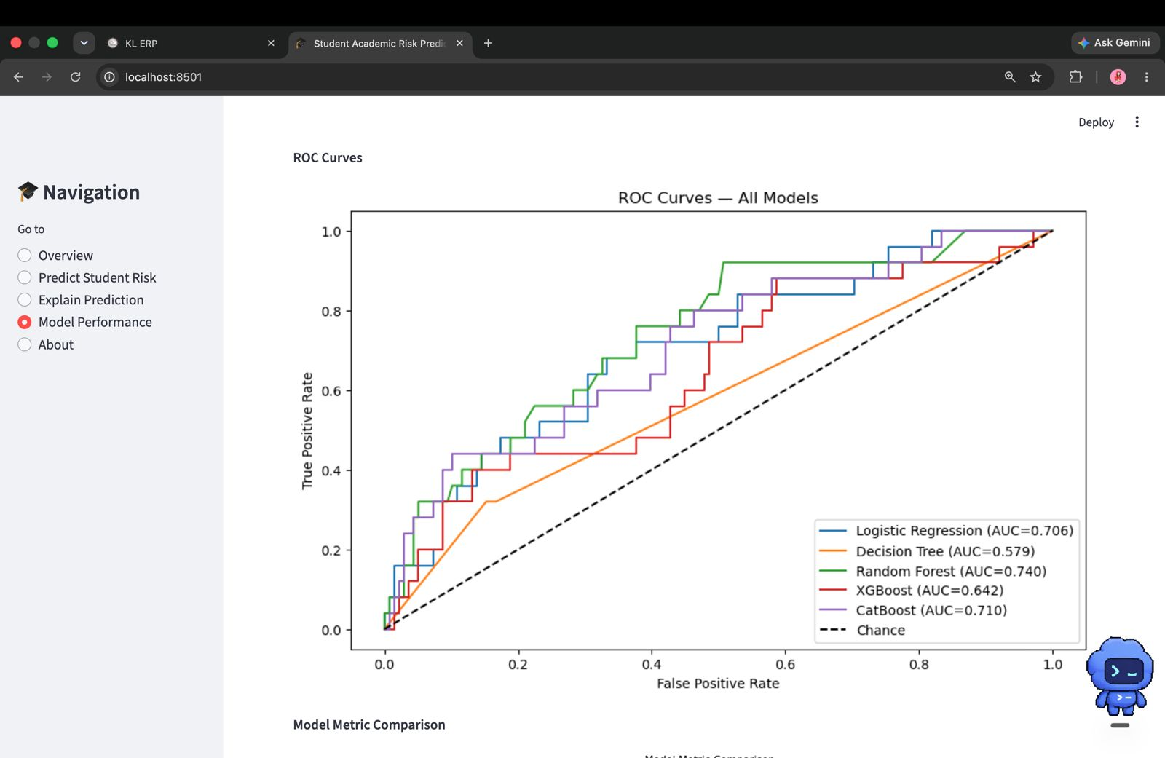
Fig. 9. ROC curves for the evaluated classifiers and hybrids.
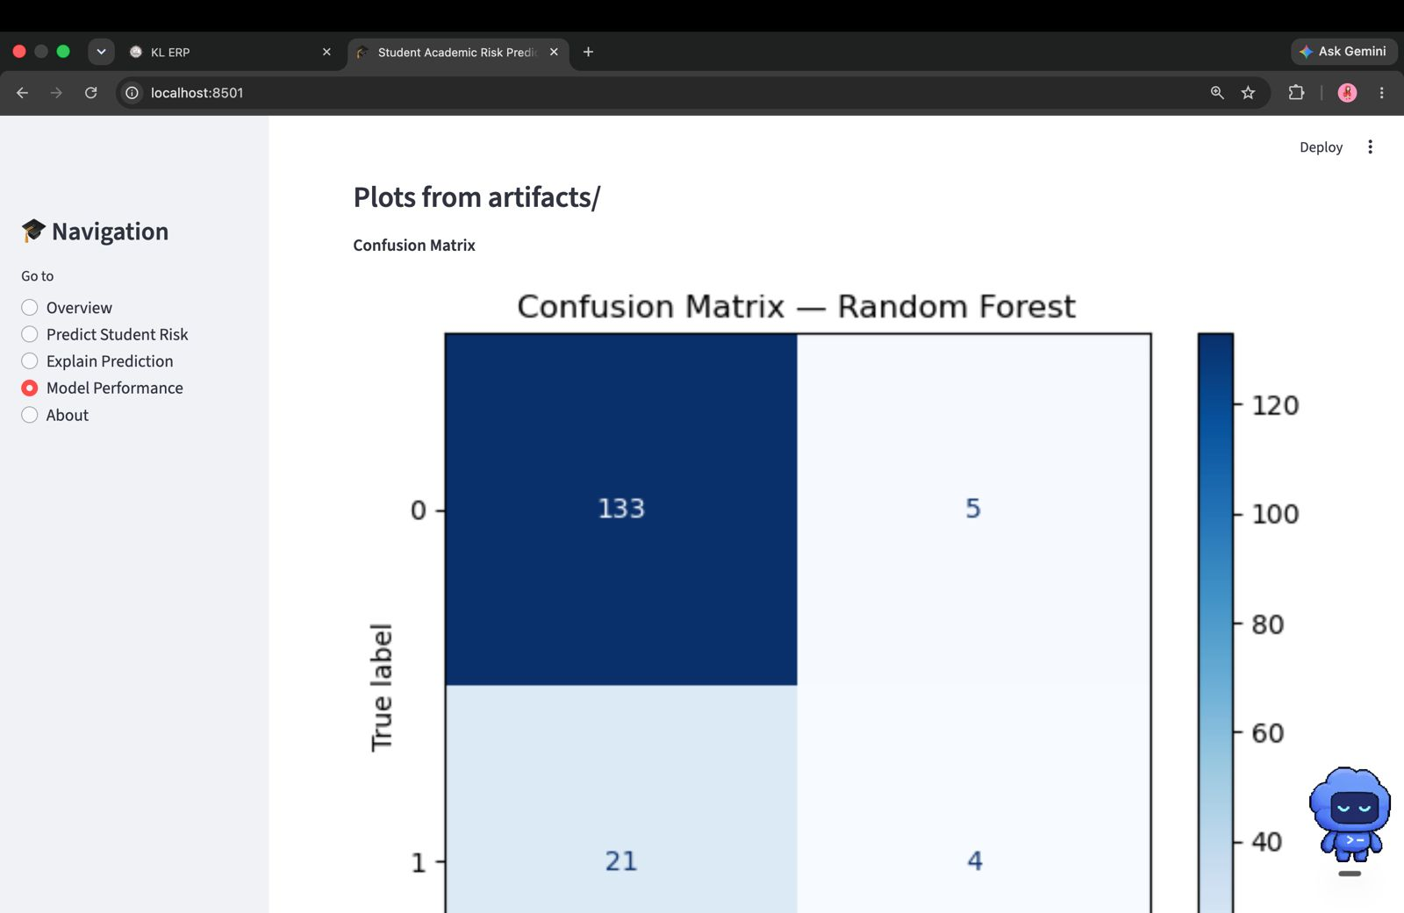
Fig. 10. Confusion matrix for the deployed hybrid model.
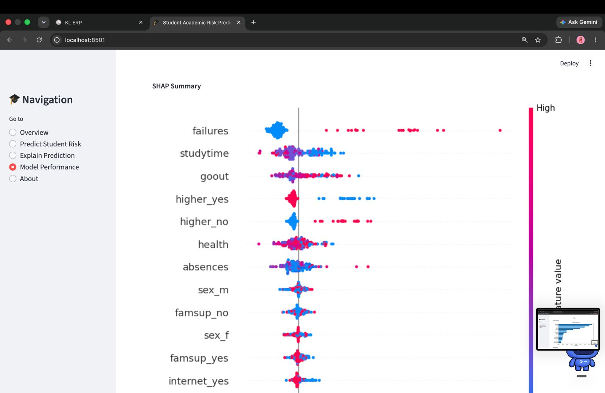
Fig. 11. SHAP summary output showing global feature contributions.
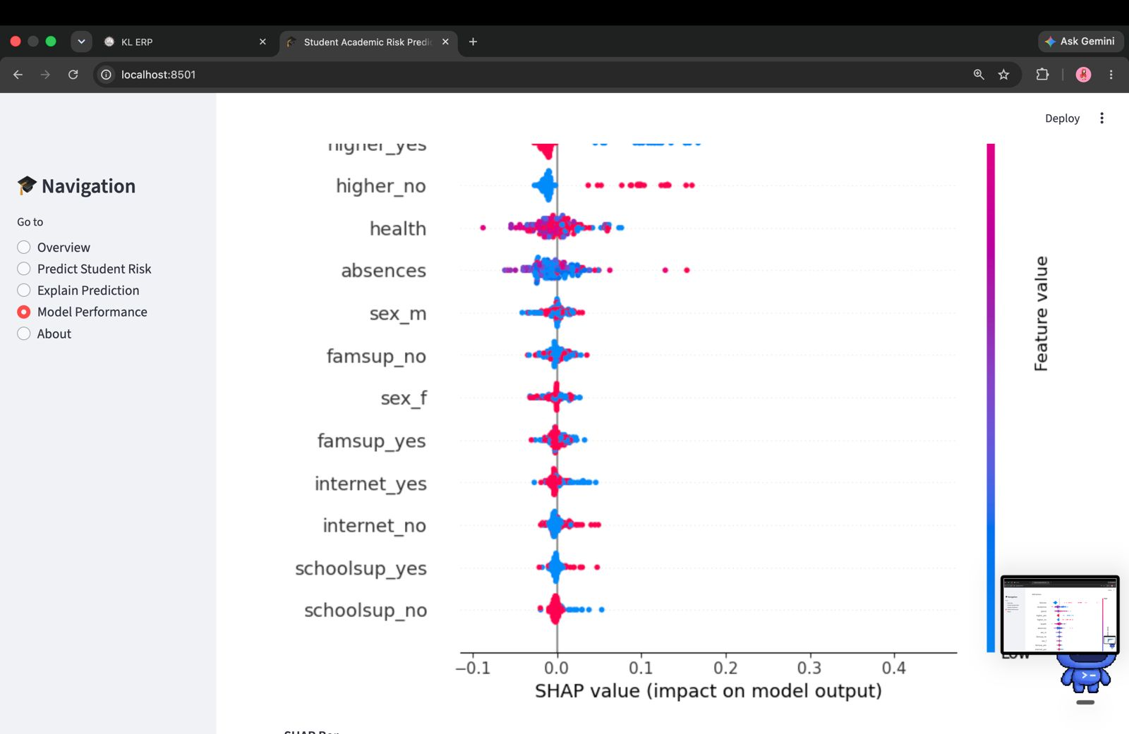
Fig. 12. Continuation of the SHAP summary output showing additional feature contributions.
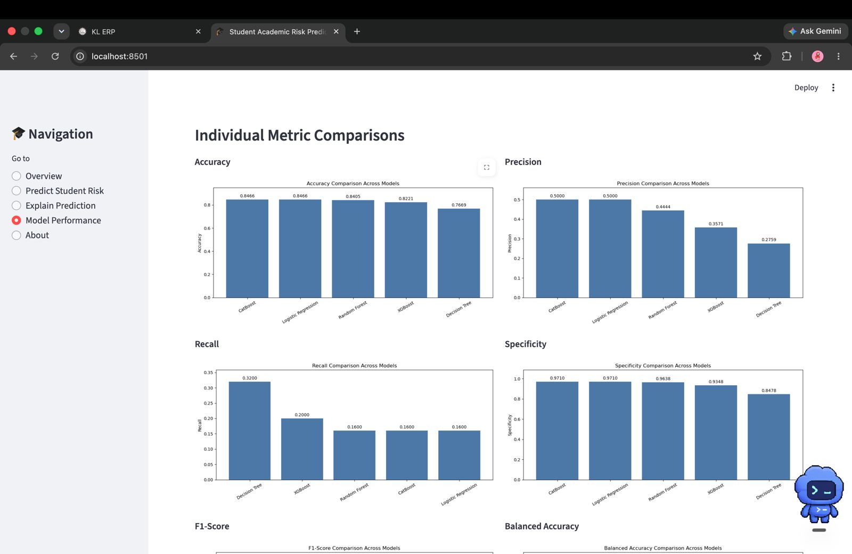
Fig. 13. Individual metric comparisons across the evaluated models.
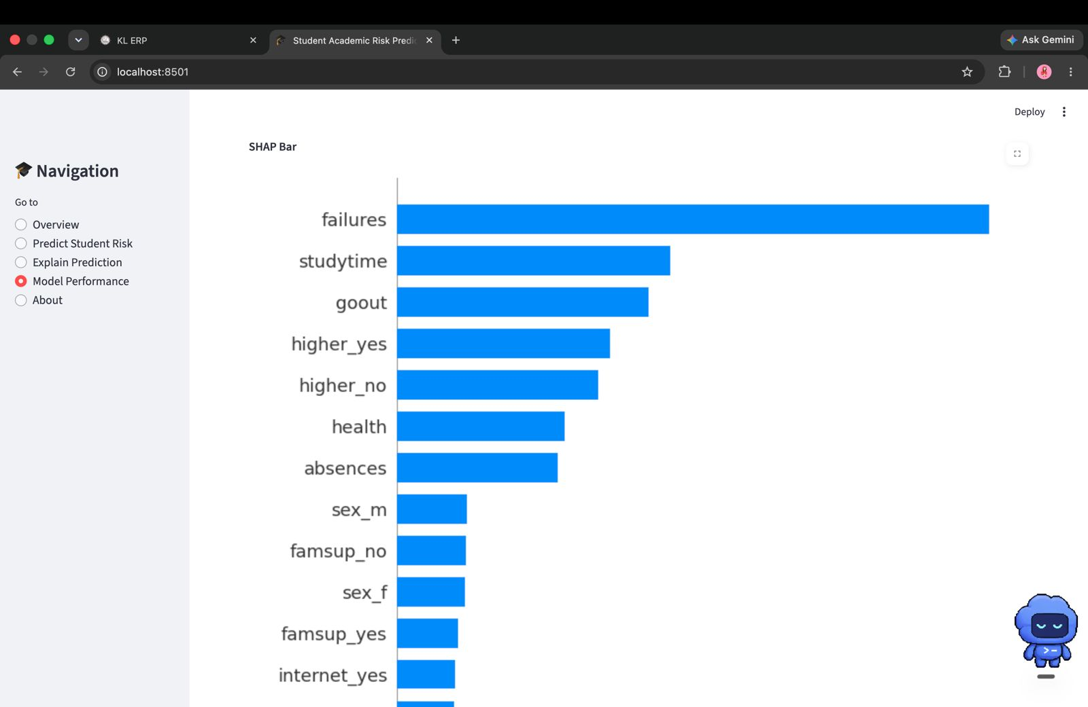
Fig. 14. SHAP bar plot showing global feature importance in the deployed model.
6. DISCUSSION
6.1 Interpretation of Findings
The results show that model selection depends on the intended operating objective. Dual-DNN voting ranked students most effectively across thresholds, as shown by its 0.7462 ROC-AUC, but detected only one third of failures at its training-selected threshold. LR+RF+HGB voting achieved a better operational balance for early warning, including 0.5088 recall and 0.5043 F1-score. Logistic Regression remained the strongest overall thresholded baseline, so the hybrid is selected as the project’s proposed hybrid rather than claimed to dominate every standalone model.
6.2 Comparison With Previous Studies
The current results are directionally consistent with the supplied literature in showing that algorithm performance is dataset- and evaluation-dependent. The literature reports strong results for XGBoost in a multi-dataset framework [4], strong balanced performance for CatBoost in another educational dataset [5], and useful performance from Logistic Regression for at-risk identification [9]. Studies focused on at-risk students [23], undergraduate performance [18], and global/local interpretation [21] further demonstrate that the predictive model and the explanation layer should be considered together. However, absolute scores from these studies are not directly comparable with the present UCI results because their datasets, target definitions, features, class distributions, and validation procedures differ.
6.3 Theoretical Implications
The findings support the view emphasized in the literature that educational prediction should be evaluated as more than a pure accuracy problem. Predictive discrimination, failure-class detection, model complexity, and interpretability should be considered together when a model is intended to support human intervention [1], [2], [8], [14]. The current results demonstrate this directly: the accuracy-leading models are not the same as the model with the highest ROC-AUC or the model with the highest failure recall.
6.4 Practical Implications
Educators or advisors could use the dashboard to prioritize students for further review and to guide follow-up questions or support planning. SHAP contributions make it possible to discuss why the model produced a particular risk estimate. The system should not be used to penalize students, deny opportunities, or infer causal blame from a feature contribution.
6.5 Unexpected Findings
A notable result is the separation between probability ranking and thresholded detection. The DL+DL ensemble achieved the best ROC-AUC and PR-AUC but weaker recall at its selected operating point. Optimization also did not guarantee dominance: grid-tuned DNN and Random Forest hybrids reached 0.5088 recall, while their F1-scores remained below the selected heterogeneous voting hybrid. These findings justify evaluating multiple hybrid categories rather than choosing one architecture in advance.
7. LIMITATIONS
- The primary dataset is limited in size and represents a particular secondary-school context; generalization to other populations is uncertain.
- The current implementation uses a compact feature set and cannot capture the full complexity of student circumstances.
- The experiment does not establish formal statistical significance or exhaustive optimization beyond the documented training-only grids.
- The proposed hybrid does not outperform Logistic Regression on every metric; its selection reflects the requirement to choose among hybrid candidates and its stronger recall/F1-weighted operational score within that group.
- The project roadmap identifies xAPI and OULAD for multi-dataset benchmarking, but the current numerical results are limited to UCI.
LIME is included in the project roadmap but is not implemented in the reported results; therefore, no SHAP-versus-LIME comparison is claimed.
- SHAP explanations describe model behavior and do not establish causal relationships.
8. CONCLUSION AND FUTURE WORK
This study implemented a leakage-controlled comparison of standalone models and seven hybrid candidates for early student-failure prediction. The experiment covers ML+DL, DL+DL, DL+optimization, and ML+optimization. Dual-DNN voting achieved the strongest probability ranking, whereas LR+RF+HGB voting provided the best recall/F1-weighted balance among hybrids and was therefore selected for deployment. The findings show that a proposed hybrid should be justified by its intended operating objective rather than by accuracy alone.
Future work:
- Complete the multi-dataset evaluation using xAPI Educational and OULAD in addition to UCI [15]–[17], with dataset-specific preprocessing and cross-dataset robustness analysis.
- Complete the planned 12-stage EDA workflow, systematic feature engineering and feature selection, repeated/5-fold cross-validation, hyperparameter tuning, and statistical model comparisons.
- Extend the completed class balancing, hyperparameter search, and threshold optimization experiments with repeated nested cross-validation and confidence intervals.
- Implement LIME alongside SHAP and compare their local explanations using appropriate explanation-stability, consistency, and usefulness measures, extending the explainer-comparison direction identified in [2] and [26].
- Add subgroup fairness analysis and additional dashboard visualizations such as learning curves, confusion matrices, ROC curves, heatmaps, and feature-importance views before considering real-world deployment.

DECLARATIONS
Funding
No external funding was received for this project.
Conflict of Interest
The authors declare no conflict of interest.
Ethics Statement
The work uses educational-performance data for research and decision-support prototyping. Any deployment involving real students should apply appropriate privacy, consent, access-control, fairness, and institutional ethics requirements.
Data Availability
The primary implemented data source is the UCI Student Performance dataset (dataset ID 320). The project roadmap also identifies the xAPI Educational Dataset and OULAD as benchmark sources for extended evaluation. Local CSV fallbacks or harmonized datasets may be used by the project environment where permitted.
Author Contributions
Naru Mokshita – Documentation and EDA
Ramayanam Vaishnavi – Front end and Model training
Thota Usha Sri Sai – Backend and Testing
Acknowledgements
The authors acknowledge the UCI Student Performance dataset and the researchers and repositories that make educational datasets available for research.

REFERENCES
[1] Carvalho, Mattos, and Aguiar, “Model Interpretability in the Educational Data Mining Context: A Systematic Literature Mapping,” Revista Brasileira de Informática na Educação, 2026.
[2] “Systematic Literature Review on Explainable Learning Analytics and Educational Data Mining,” IEEE Access, vol. 13, 2025.
[3] “Leveraging psychological data and transparent machine learning for student success prediction,” ScienceDirect, 2026.
[4] Almazroei, “Ensemble machine learning framework with SHAP and LIME for accurate early prediction of student success,” Scientific Reports / NIH, 2026.
[5] “Predicting student success with interpretable machine learning framework,” Frontiers in Education, 2026.
[6] Alamri and Alharbi, “Explainable student performance prediction models: A systematic review,” IEEE Access, 2021.
[7] “Tracking student progress using clustering and explainable AI,” Universal Access in the Information Society, Springer, 2026.
[8] Khosravi et al., “Explainable AI in education: A survey,” Computers and Education: Artificial Intelligence, 2022.
[9] Paul et al., “Analyzing dropout and explainable prediction using AI,” Frontiers in Education, 2025.
[10] “Predicting academic performance through lifestyle factors using interpretable ML,” International Journal on AI Tools, World Scientific, 2026.
[11] Bin Azmi et al., “A Novel Hybrid Feature Selection Framework for Enhancing Accuracy and Interpretability,” International Journal of Applied Mathematics, 2025.
[12] Talmoudi and Choukir, “From Predictive Analytics to Explainable AI in Higher Education,” Qubahan Academic Journal, 2026.
[13] P. Cortez and A. M. G. Silva, “Using data mining to predict secondary school student performance,” 2008. UCI Student Performance dataset, Dataset ID 320.
[14] S. M. Lundberg and S.-I. Lee, “A unified approach to interpreting model predictions,” Advances in Neural Information Processing Systems 30, 2017.

[15] UCI Machine Learning Repository, “Student Performance,” Dataset ID 320.
[16] Aljarah, “xAPI Educational Dataset,” Kaggle.
[17] Open University, “Open University Learning Analytics Dataset (OULAD).”
[18] F. T. Johora et al., “An explainable AI-based approach for predicting undergraduate students academic performance,” Array, vol. 26, p. 100384, 2025.
[19] M. H. Hoque, P. Brusilovsky, and B. Akram, “Analysis of an explainable student performance prediction model in an introductory programming course,” Proceedings of the 16th International Conference on Educational Data Mining, 2023.
[20] F. D. Pereira et al., “Explaining individual and collective programming students' behavior by interpreting a black-box predictive model,” IEEE Access, vol. 9, pp. 117097–117119, 2021.
[21] M. Adnan, M. I. Uddin, E. Khan, F. S. Alharithi, S. Amin, and A. A. Alzahrani, “Earliest possible global and local interpretation of students' performance in virtual learning environment by leveraging explainable AI,” IEEE Access, vol. 10, pp. 129843–129864, 2022.
[22] H.-C. Chen, E. Prasetyo, S.-S. Tseng, K. T. Putra, S. S. Kusumawardani, and C.-E. Weng, “Week-wise student performance early prediction in virtual learning environment using a deep explainable artificial intelligence,” Applied Sciences, vol. 12, no. 4, p. 1885, 2022.
[23] S. Alwarthan, N. Aslam, and I. U. Khan, “An explainable model for identifying at-risk student at higher education,” IEEE Access, vol. 10, pp. 107649–107668, 2022.
[24] M. Nagy and R. Molontay, “Interpretable dropout prediction: Towards XAI-based personalized intervention,” International Journal of Artificial Intelligence in Education, vol. 34, pp. 274–300, 2024.
[25] I. E. Livieris, N. Karacapilidis, G. Domalis, and D. Tsakalidis, “An advanced explainable and interpretable ML-based framework for educational data mining,” in International Conference on Methodologies and Intelligent Systems for Technology Enhanced Learning, Springer, 2023, pp. 87–96.
[26] V. Swamy et al., “Evaluating the explainers: Black-box explainable machine learning for student success prediction in MOOCs,” arXiv preprint arXiv:2207.00551, 2022.
[27] E. Alyahyan and D. Düştegör, “Predicting academic success in higher education: Literature review and best practices,” International Journal of Educational Technology in Higher Education, vol. 17, no. 3, 2020.
[28] N. Aslam, I. Khan, L. Alamri, and R. Almuslim, “An improved early student's academic performance prediction using deep learning,” International Journal of Emerging Technologies in Learning, vol. 16, no. 12, pp. 108–122, 2021.
[29] B. Alsubhi et al., “Effective feature prediction models for student performance,” Engineering, Technology & Applied Science Research, vol. 13, no. 5, pp. 11937–11944, 2023.
[30] H. Pallathadka et al., “Classification and prediction of student performance data using various machine learning algorithms,” Materials Today: Proceedings, vol. 80, pp. 3782–3785, 2023.
[31] D. T. Ha, P. T. T. Loan, C. N. Giap, and N. T. L. Huong, “An empirical study for student academic performance prediction using machine learning techniques,” International Journal of Computer Science and Information Security, vol. 18, no. 3, pp. 75–82, 2020.
[32] M. S. Zulfiker et al., “Predicting students' performance of the private universities of Bangladesh using machine learning approaches,” International Journal of Advanced Computer Science and Applications, vol. 11, no. 3, pp. 672–679, 2020.
[33] M. A. Hossen et al., “A web based four-tier architecture using reduced feature based neural network approach for prediction of student performance,” in 2021 2nd International Conference on Robotics, Electrical and Signal Processing Techniques (ICREST), IEEE, 2021, pp. 269–273.
[34] F. Janan and S. K. Ghosh, “Prediction of student's performance using support vector machine classifier,” in Proceedings of the International Conference on Industrial Engineering and Operations Management, 2021, pp. 7078–7088.
[35] M. Afzaal, A. Zia, J. Nouri, and U. Fors, “Informative feedback and explainable AI-based recommendations to support students' self-regulation,” Technology, Knowledge and Learning, vol. 29, no. 1, pp. 331–354, 2024.
[36] S. V. Samarasinghe Gunasekara and M. Saarela, “Systematic literature review on explainable learning analytics and educational data mining,” IEEE Access, vol. 13, 2025.
[37] L. Breiman, “Random forests,” Machine Learning, vol. 45, pp. 5–32, 2001.
[38] T. Chen and C. Guestrin, “XGBoost: A scalable tree boosting system,” in Proceedings of the 22nd ACM SIGKDD International Conference on Knowledge Discovery and Data Mining, 2016, pp. 785–794.
[39] L. Prokhorenkova et al., “CatBoost: Unbiased boosting with categorical features,” in Advances in Neural Information Processing Systems, vol. 31, 2018.
[40] N. V. Chawla, K. W. Bowyer, L. O. Hall, and W. P. Kegelmeyer, “SMOTE: Synthetic minority over-sampling technique,” Journal of Artificial Intelligence Research, vol. 16, pp. 321–357, 2002.

