PROJECT DOCUMENTATION
EXPLAINABLE STUDENT
FAILURE PREDICTION SYSTEM
Machine Learning-Based Early Academic Risk Identification

SUBJECT: Data Analytics and Visualization
COURSE CODE: 24SC2234
FACULTY: Dr. K. Swapnika
TEAM MEMBERS
Student Name | Registration Number
Thota Usha Sri Sai | 2420030033
Ramayanam Vaishnavi | 2420030371
Naru Mokshita Reddy | 2420030551

Table of Contents
- 1. Introduction
- 2. Abstract
- 3. Problem Statement
- 4. Project Objectives
- 5. Dataset Description
- 6. Input Features
- 7. Technologies Used
- 8. System Methodology
- 9. Machine Learning Models
- 10. Model Performance and Graphical Analysis
- 11. Dashboard Description and Screenshot Placeholders
- 12. System Requirements
- 13. Execution Procedure
- 14. Sample Execution
- 15. Testing
- 16. Advantages
- 17. Limitations
- 18. Future Enhancements
- 19. Conclusion
- 20. References
- Appendix A. Detailed Model Evaluation Visuals
- Appendix B. Interpretation Notes

1. Introduction
Students facing academic difficulties are often identified only after their examination results are released. At that stage, the opportunity for early academic support may already have been missed.
The Explainable Student Failure Prediction System is a machine learning-based web application developed to identify students who may be at risk of failing. It analyses factors such as study time, previous failures, attendance, family support, health, and interest in higher education.
A counsellor can enter a student’s details through an interactive dashboard. The system then displays the estimated probability of academic failure and classifies the student as either high risk or low risk.
The project also includes model-comparison graphs, feature importance, and SHAP visualizations. These help users understand model performance and the factors that influence model predictions. The system is intended to support teachers and counsellors and should not replace human judgement.

2. Abstract
This project uses machine learning to predict whether a student may be at risk of academic failure. The Mathematics and Portuguese datasets from the UCI Student Performance Dataset are used for model development.
Failure is defined as a final grade below 10 on a scale of 0 to 20. To support early prediction and prevent data leakage, the first-period, second-period, and final grades are not used as model inputs.
Several baseline and hybrid models were evaluated. The deployed model combines Logistic Regression, Random Forest, and Histogram Gradient Boosting through soft voting. The system is presented using a Streamlit dashboard that supports student-data entry, risk prediction, model comparison, and explainability.

3. Problem Statement
Educational institutions need a way to identify students who may require academic assistance before final examinations are completed.
The objective of this project is to develop an explainable machine learning system that:
- Accepts basic academic and personal information.
- Estimates the probability of student failure.
- Categorizes the student as high risk or low risk.
- Presents the result through an easy-to-use dashboard.
- Explains the important factors behind model predictions.

4. Project Objectives
- Prepare and combine student-performance datasets.
- Train and compare baseline and hybrid machine learning models.
- Predict academic failure without using examination grades as inputs.
- Develop a simple dashboard for entering student details.
- Display the predicted risk probability and category.
- Provide model-comparison and explainability graphs.
- Support teachers and counsellors in early academic intervention.

5. Dataset Description
The project uses the UCI Student Performance Dataset.
Dataset file | Subject | Records
student-mat.csv | Mathematics | 395
student-por.csv | Portuguese | 649
Total | Combined | 1,044

A student is considered at risk when the final grade (G3) is below 10.
Condition | Target label
G3 < 10 | fail = 1
G3 ≥ 10 | fail = 0

The grades G1, G2, and G3 are not used as prediction inputs. This helps the system provide an early prediction and prevents the model from directly learning the final result.

6. Input Features
The deployed model uses ten student attributes.
Input Feature | Description | Values
Weekly Study Time | Time spent studying each week | 1–4
Previous Class Failures | Number of previous failures | 0–4
School Absences | Number of absences | 0–93
Family Educational Support | Support provided by family | Yes/No
Internet Access | Internet availability at home | Yes/No
Higher Education | Intention to pursue higher education | Yes/No
Extra School Support | Additional support from school | Yes/No
Health Status | Current health condition | 1–5
Going Out with Friends | Level of social activity | 1–5
Student Sex | Sex recorded in the dataset | F/M

7. Technologies Used
Technology | Purpose
Python | Project development
Pandas and NumPy | Data processing
Scikit-learn | Model training and evaluation
CatBoost | Gradient-boosting model
SHAP | Prediction explanation
Matplotlib | Graph generation
Streamlit | Web dashboard
Joblib | Saving and loading the trained model
Google Chrome | Running the dashboard

8. System Methodology
The project follows the workflow below:
Student Datasets
↓
Data Cleaning and Preparation
↓
Feature Selection
↓
Model Training
↓
Model Evaluation
↓
Model Selection
↓
Streamlit Dashboard
↓
Risk Prediction and Explanation

8.1 Data Preprocessing
- Mathematics and Portuguese data are combined.
- Duplicate or invalid records are handled.
- Missing numerical and categorical values are processed.
- Numerical values are scaled.
- Categorical values are converted using one-hot encoding.
- The data is divided into training and testing sets.
- A stratified split is used to maintain the class distribution.
Setting | Value
Training data | 75%
Testing data | 25%
Random state | 42
Failure threshold | Final grade below 10

9. Machine Learning Models

9.1 Baseline Models
- Logistic Regression
- Decision Tree
- Random Forest
- Histogram Gradient Boosting
- CatBoost

9.2 Hybrid Models
- Soft-voting ensembles
- Stacking ensemble
- Random Forest and neural-network voting
- Dual neural-network voting
- Grid-tuned Random Forest
- Grid-tuned neural network

9.3 Deployed Model
The deployed model is Hybrid A: Logistic Regression + Random Forest + Histogram Gradient Boosting Voting.
This model combines predictions from three different algorithms using soft voting.

10. Model Performance and Graphical Analysis
The main evaluation results for the deployed Hybrid A model are listed below.
Evaluation Metric | Result
Decision Threshold | 0.53
Accuracy | 78.08%
Precision | 50.00%
Recall | 50.88%
Specificity | 85.71%
F1-Score | 50.43%
Balanced Accuracy | 68.30%
MCC | 0.3636
ROC-AUC | 71.86%
PR-AUC | 0.4619

The deployed model provides a hybrid approach by combining three algorithms through soft voting. Other evaluated models perform better on some individual metrics. The project selected Hybrid A based on a combined evaluation of recall, F1-score, balanced accuracy, PR-AUC, and MCC.

10.1 Overall Model Metric Comparison
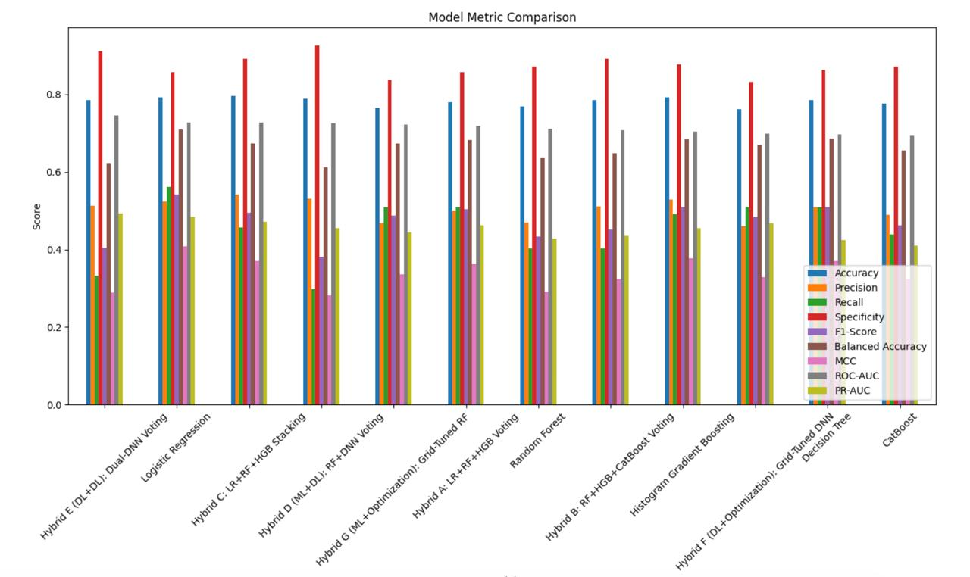
Figure 1. Model metric comparison across the evaluated baseline and hybrid models.
This graph compares accuracy, precision, recall, specificity, F1-score, balanced accuracy, MCC, ROC-AUC, and PR-AUC. It provides an overview of how the models perform across multiple evaluation measures.

10.2 Hybrid Model Comparison
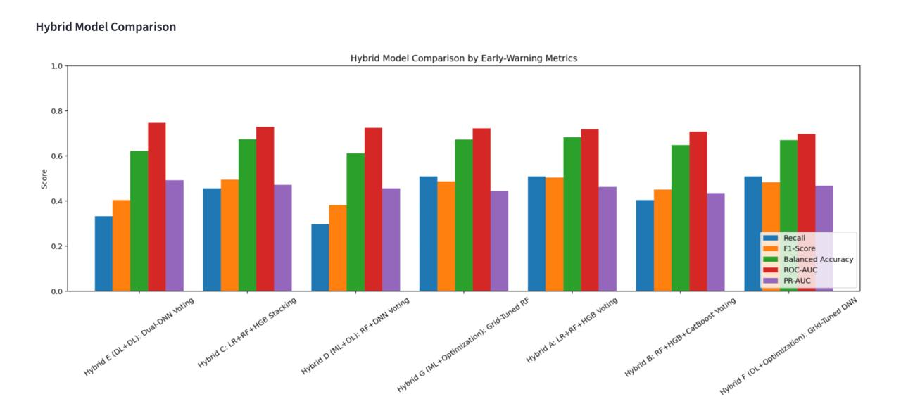
Figure 2. Comparison of hybrid models using early-warning evaluation metrics.
This graph focuses on recall, F1-score, balanced accuracy, ROC-AUC, and PR-AUC for the hybrid approaches. These measures help compare the models beyond overall accuracy.

10.3 Feature Importance
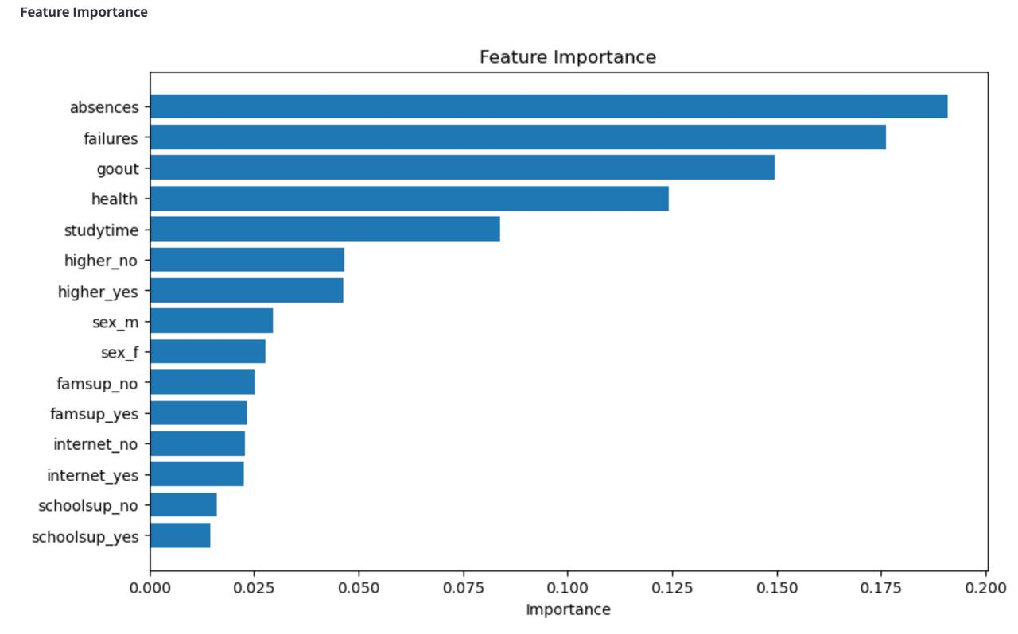
Figure 3. Feature-importance ranking for the model.
The displayed feature-importance graph ranks the input attributes by their relative importance in the model. In this result, absences, previous failures, going out with friends, health, and study time appear among the most influential features. Importance indicates model contribution, not proof of causation.

11. Dashboard Description and Screenshot Placeholders
The system is implemented as a Streamlit dashboard with the following pages.
Dashboard Page | Description
Overview | Displays the selected model and summary metrics
Predict Student Risk | Accepts student details and predicts risk
Explain Prediction | Explains factors influencing a prediction
Model Performance | Displays model comparisons and graphs
About | Provides information about the project

11.1 Prediction Process
- The counsellor opens the prediction page.
- Student details are entered using sliders and dropdown menus.
- The counsellor clicks Predict Risk.
- The saved model calculates the failure probability.
- The dashboard displays the risk category and probability.
- The explanation and performance pages provide additional details.

11.2 Dashboard Screenshots – Add Your Images
The following spaces are intentionally left blank so that the team can insert actual screenshots from the running Streamlit application.
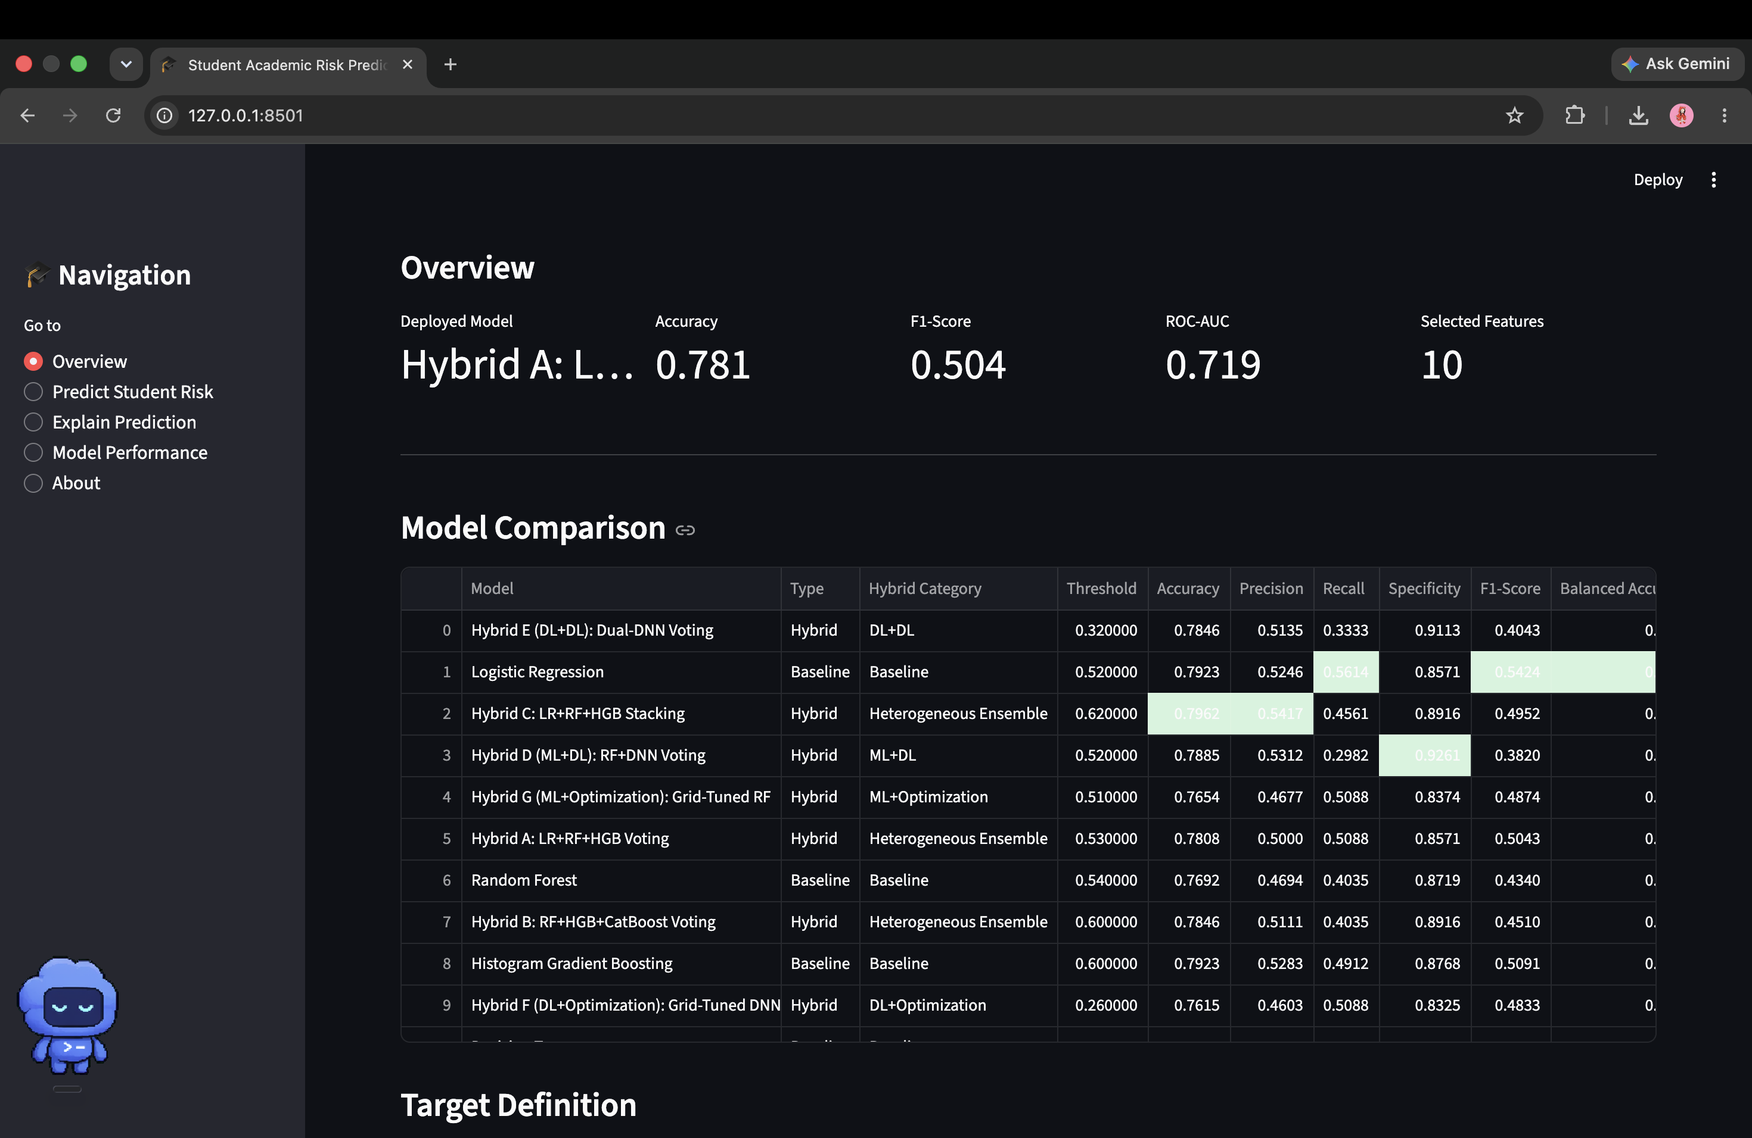
Figure 4. Dashboard Overview
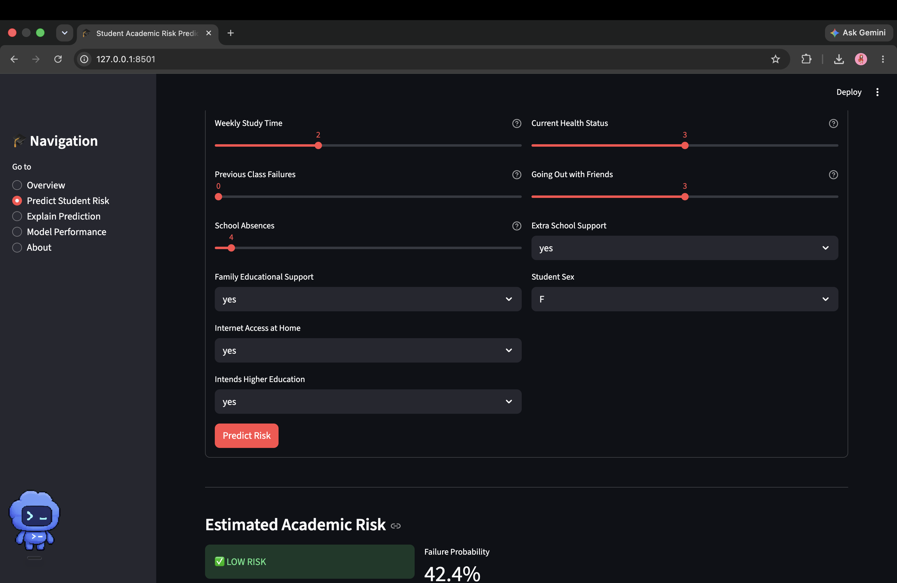
Figure 5. Student Risk Prediction Form

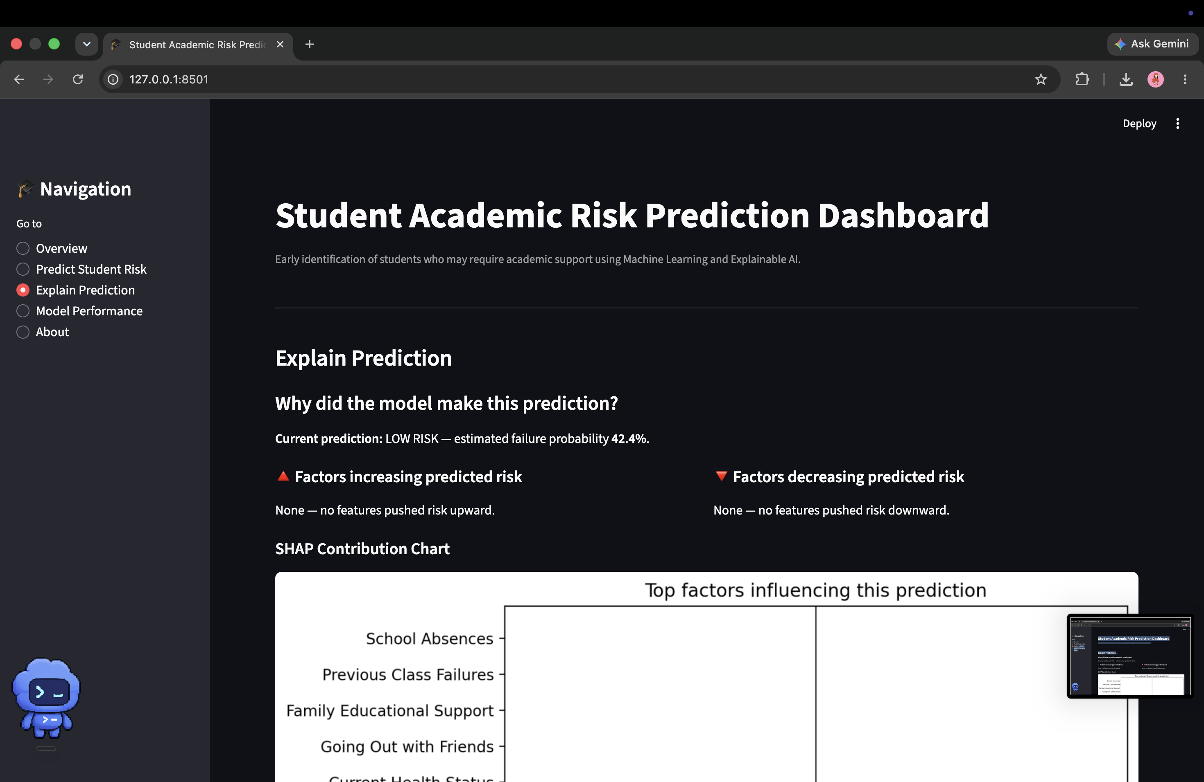
Figure 6. Explain Prediction Page
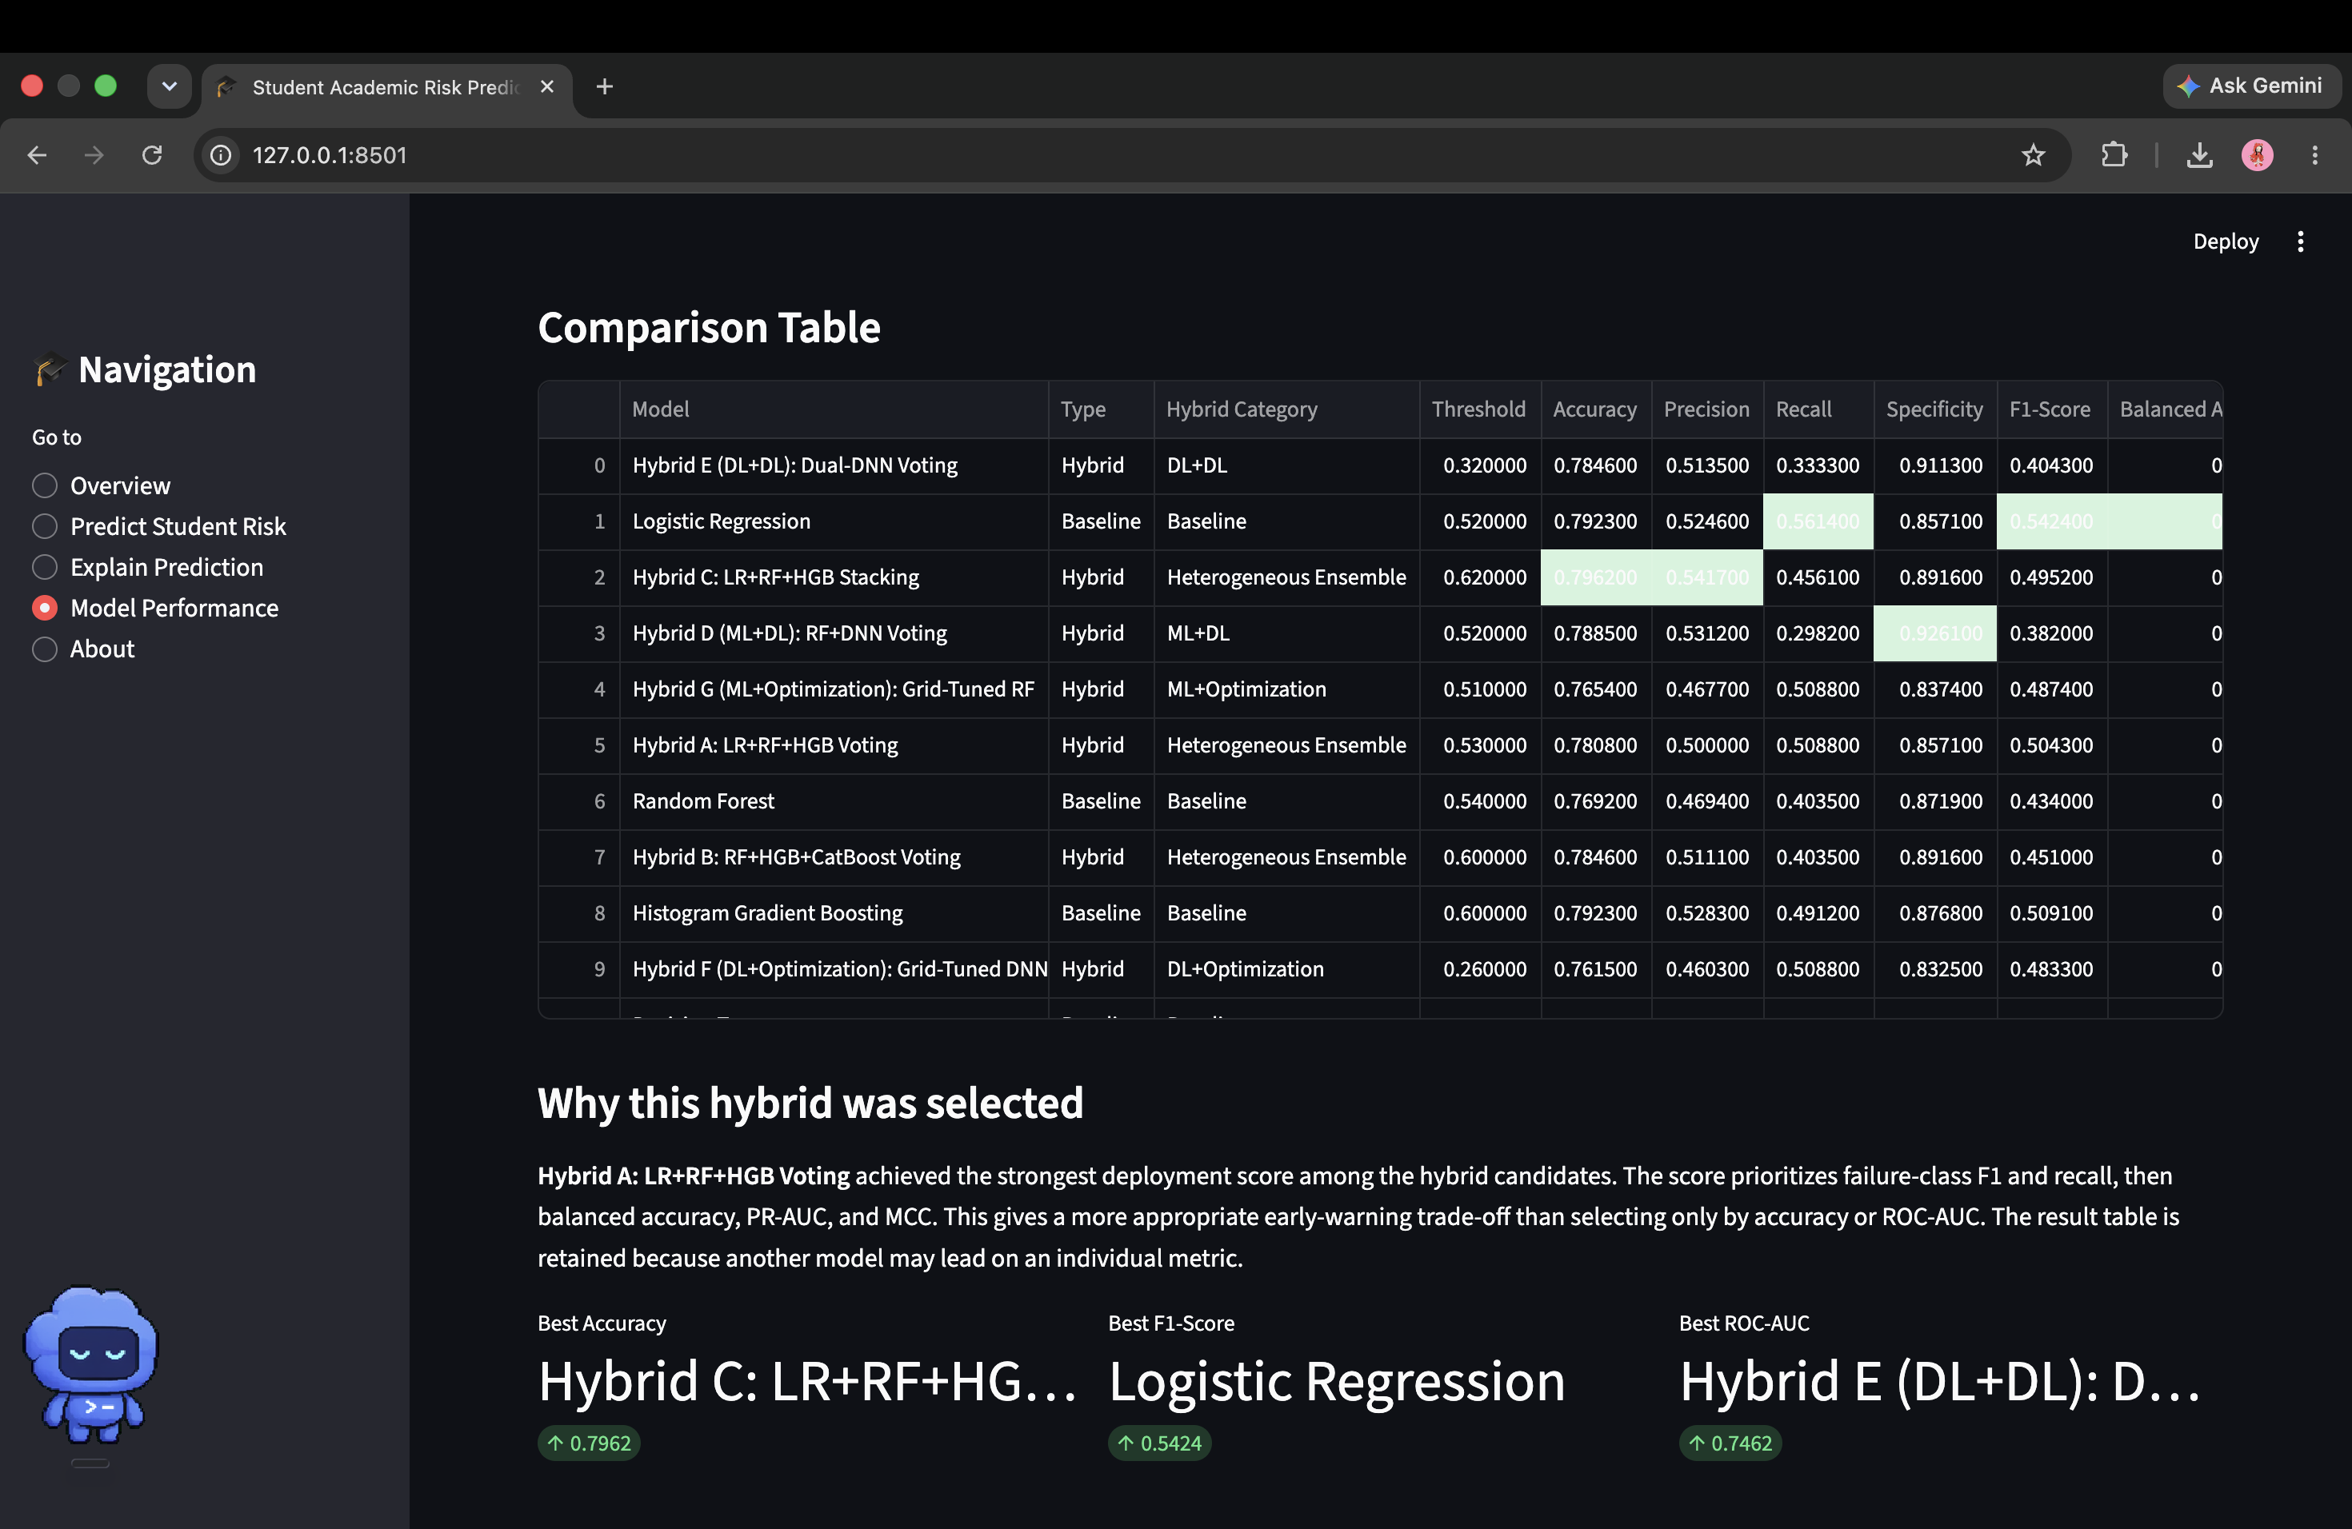
Figure 7. Dashboard Model Performance Page

12. System Requirements

12.1 Hardware Requirements
Component | Requirement
Processor | Dual-core processor or better
RAM | Minimum 4 GB
Storage | At least 1 GB free space
Display | 1366 × 768 or higher

12.2 Software Requirements
Software | Requirement
Operating System | Windows, macOS, or Linux
Python | Python 3.10 or later
Browser | Google Chrome
Python packages | Listed in requirements.txt

13. Execution Procedure
- Install dependencies by opening a terminal in the project folder and running:
pip install -r requirements.txt
- Train the model if the model artifacts have not been generated:
python train.py
- Start the dashboard:
streamlit run app.py
- Open the local Streamlit address in Google Chrome:
http://localhost:8501
- Select Predict Student Risk.
- Enter the required student details.
- Click Predict Risk.
- Review the probability and risk category.

14. Sample Execution

14.1 Sample Input
Field | Value
Weekly Study Time | 4
Previous Failures | 1
School Absences | 5
Family Support | Yes
Internet Access | Yes
Higher Education | Yes
Extra School Support | Yes
Health Status | 3
Going Out with Friends | 3
Student Sex | F

14.2 Sample Output
Output | Value
Risk Category | High Risk
Failure Probability | 60.6%
Model Threshold | 53%

Since the predicted probability is higher than the model’s threshold, the student is classified as high risk. This result should be considered together with teacher observations and academic counselling.

15. Testing
Test Case | Expected Result | Status
Start the Streamlit application | Dashboard opens successfully | Pass
Open prediction page | All input fields are displayed | Pass
Enter valid student details | Values are accepted | Pass
Click Predict Risk | Risk category and probability appear | Pass
Open Model Performance | Comparison table and graphs appear | Pass
Open explanation page | Explanation information is displayed | Pass

16. Advantages
- Helps identify students who may need early support.
- Does not depend on examination grades for prediction.
- Uses simple and understandable student inputs.
- Compares several machine learning models.
- Displays a probability instead of only a class label.
- Provides model-performance and explanation graphs.
- Offers a simple browser-based interface.

17. Limitations
- The model is trained using a dataset from a limited educational context.
- The results may not directly apply to every institution.
- Some at-risk students may not be detected.
- Prediction quality depends on the accuracy of the entered information.
- The current system is not connected to a live student database.
- The prediction represents statistical risk and not a guaranteed outcome.

18. Future Enhancements
- Connect the dashboard to a college student database.
- Add secure login for teachers and counsellors.
- Improve recall using additional training data.
- Generate downloadable student-risk reports.
- Add recommended academic interventions.
- Add fairness and bias evaluation.
- Deploy the application on a secure cloud platform.
- Retrain the model using data from multiple institutions.

19. Conclusion
The Explainable Student Failure Prediction System uses machine learning to identify students who may require academic support. It combines student data from Mathematics and Portuguese courses and predicts failure risk using ten practical inputs.
The selected hybrid model combines Logistic Regression, Random Forest, and Histogram Gradient Boosting. The model is deployed through a Streamlit dashboard that provides risk prediction, model comparison, and explanation features.
The system demonstrates how machine learning can support academic counselling and early intervention. However, the prediction should be treated only as a support signal and must be reviewed by teachers or counsellors before any action is taken.

20. References
- UCI Machine Learning Repository, “Student Performance Dataset.”
- P. Cortez and A. Silva, “Using Data Mining to Predict Secondary School Student Performance,” 2008.
- Scikit-learn Documentation.
- Streamlit Documentation.
- SHAP Documentation.
- CatBoost Documentation.

Appendix A. Detailed Model Evaluation Visuals
The following graphs provide additional detail for the metric comparisons summarized in Section 10.

A.1 Individual Metric Comparisons – Part 1
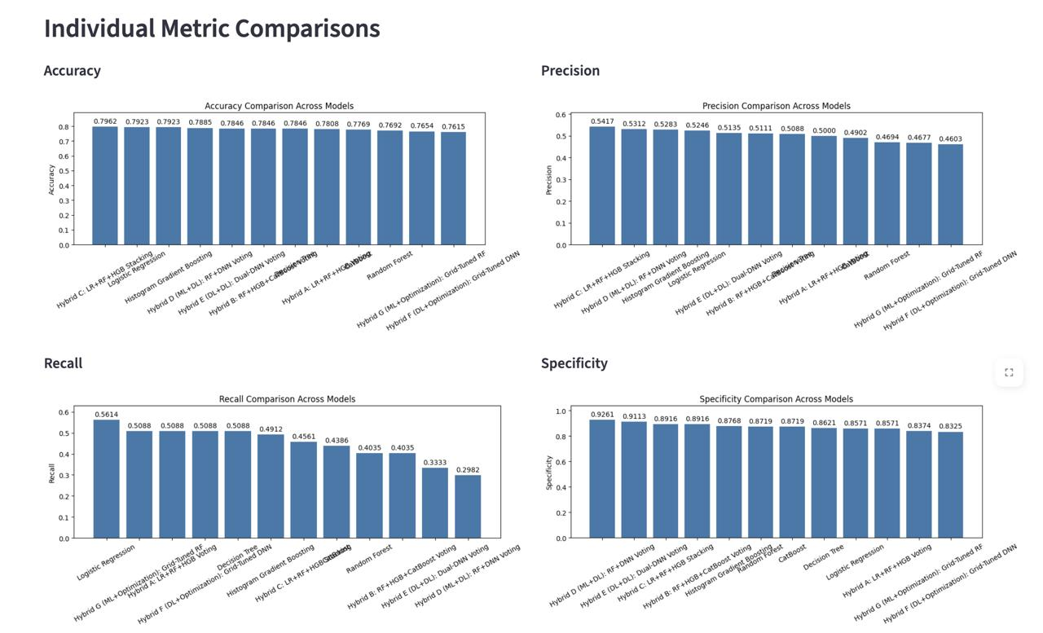
Figure A1. Accuracy, precision, recall, and specificity comparison across models.
The charts display the individual scores for each metric. They make it easier to see which models lead on accuracy, precision, recall, or specificity.

A.2 Individual Metric Comparisons – Part 2
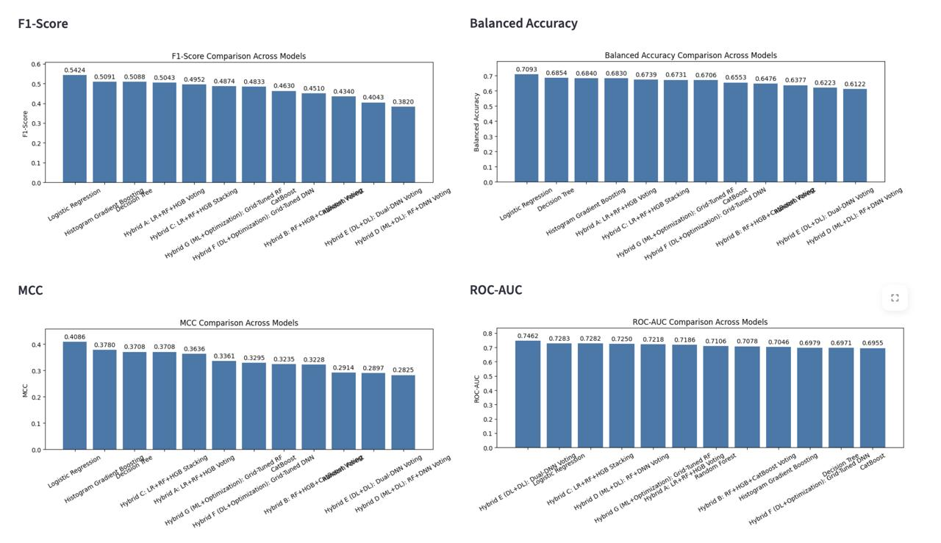
Figure A2. F1-score, balanced accuracy, MCC, and ROC-AUC comparison across models.
These metrics provide additional views of classification quality, including the balance between precision and recall and the agreement between predicted and actual labels.

A.3 Precision–Recall AUC Comparison
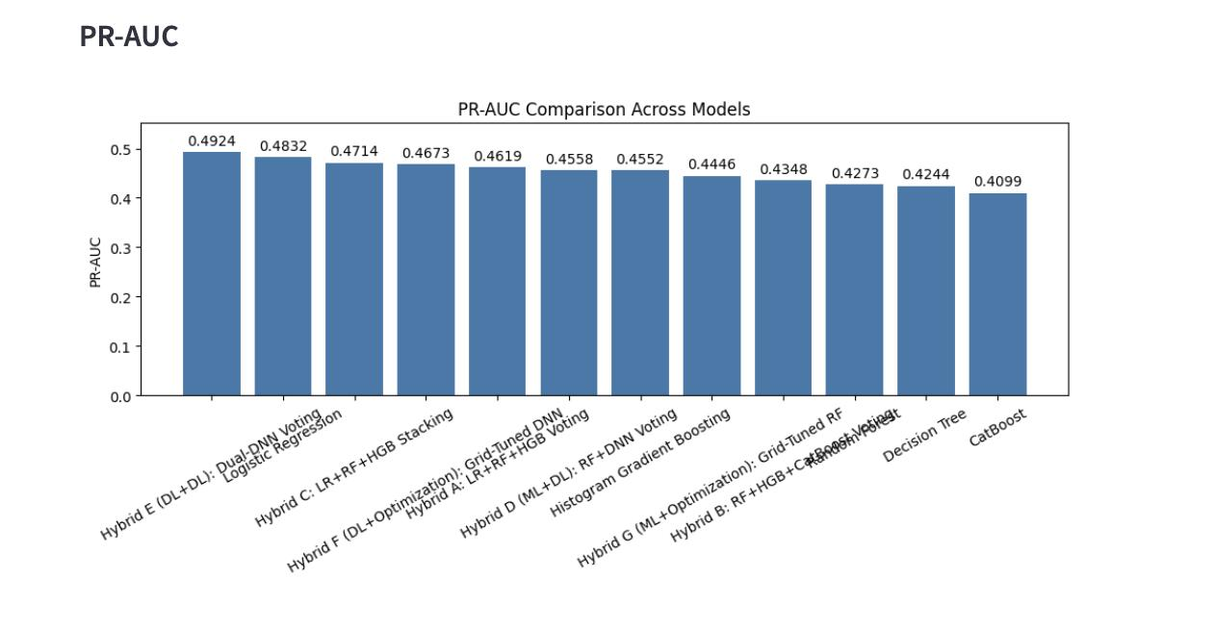
Figure A3. PR-AUC comparison across the evaluated models.
PR-AUC summarizes the precision–recall trade-off across classification thresholds and is useful when evaluating how well a model identifies the at-risk class.

A.4 ROC Curves
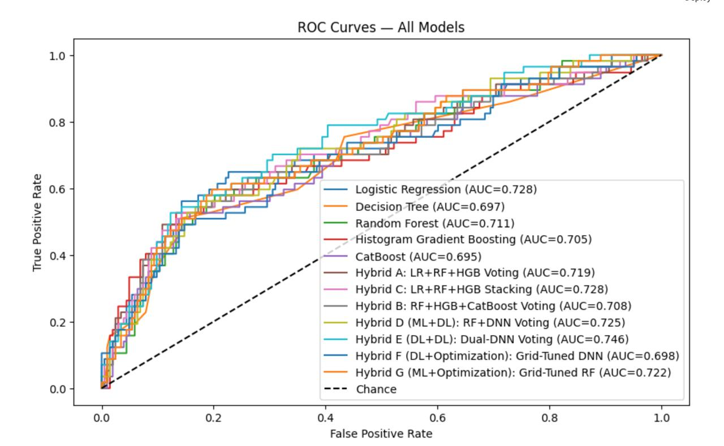
Figure A4. ROC curves for all evaluated baseline and hybrid models.
The ROC curves show the trade-off between true-positive rate and false-positive rate across classification thresholds. The diagonal line represents chance-level discrimination.

A.5 Detailed Model Comparison Table
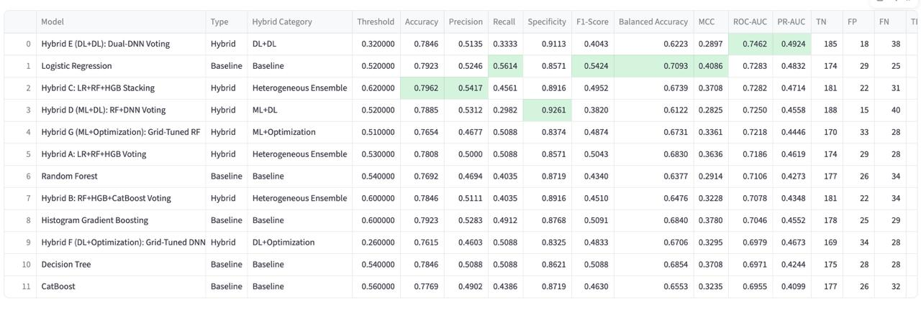
Figure A5. Detailed model comparison results, including thresholds, metrics, and confusion-matrix counts.
This table provides the detailed values used for model comparison. The deployed Hybrid A row reports a threshold of 0.53, accuracy of 0.7808, precision of 0.5000, recall of 0.5088, specificity of 0.8571, F1-score of 0.5043, balanced accuracy of 0.6830, MCC of 0.3636, ROC-AUC of 0.7186, and PR-AUC of 0.4619.

Appendix B. Interpretation Notes
- Hybrid A (Logistic Regression + Random Forest + Histogram Gradient Boosting Voting) is the deployed model described in this documentation.
- The comparison visuals show that other candidate models achieve higher values on some individual metrics. Hybrid A is presented as the selected model based on the combined evaluation approach stated in the project details.
- Feature-importance values describe the relative contribution assigned by the trained model. They should not be interpreted as proof that a feature causes academic failure.
- A risk prediction is an estimate, not a guaranteed outcome. Teachers and counsellors should use it as one input for supportive intervention, not as the sole basis for decisions.

