**Week-7_React_Hands_On**

**Exercise-9**

Create a React Application named “cricketapp”

**ListofPlayers.js**

import React from "react";

const ListofPlayers = () => {

const players = [

{ name: "Virat Kohli", score: 85 },

{ name: "Rohit Sharma", score: 90 },

{ name: "KL Rahul", score: 65 },

{ name: "Shikhar Dhawan", score: 72 },

{ name: "Hardik Pandya", score: 68 },

{ name: "Ravindra Jadeja", score: 74 },

{ name: "Rishabh Pant", score: 88 },

{ name: "Shreyas Iyer", score: 55 },

{ name: "Jasprit Bumrah", score: 95 },

{ name: "Bhuvneshwar Kumar", score: 63 },

{ name: "Yuzvendra Chahal", score: 60 }

];

const lowScorers = players.filter(player => player.score < 70);

return (

<div>

<h2>All Players</h2>

<ul>

{players.map((player, index) => (

<li key={index}>

{player.name} - {player.score}

</li>

))}

</ul>

<h2>Players with Score below 70</h2>

<ul>

{lowScorers.map((player, index) => (

<li key={index}>

{player.name} - {player.score}

</li>

))}

</ul>

</div>

);

};

export default ListofPlayers;

**IndianPlayers.js**

import React from "react";

const IndianPlayers = () => {

const oddTeam = ["Player1", "Player3", "Player5", "Player7", "Player9", "Player11"];

const evenTeam = ["Player2", "Player4", "Player6", "Player8", "Player10"];

const [odd1, odd2, odd3, odd4, odd5, odd6] = oddTeam;

const [even1, even2, even3, even4, even5] = evenTeam;

const t20Players = ["Virat Kohli", "Rohit Sharma", "Hardik Pandya"];

const ranjiPlayers = ["Ajinkya Rahane", "Cheteshwar Pujara"];

const allPlayers = [...t20Players, ...ranjiPlayers]; // Merge feature of ES6

return (

<div>

<h2>Odd Team Players</h2>

<ul>

<li>{odd1}</li>

<li>{odd2}</li>

<li>{odd3}</li>

<li>{odd4}</li>

<li>{odd5}</li>

<li>{odd6}</li>

</ul>

<h2>Even Team Players</h2>

<ul>

<li>{even1}</li>

<li>{even2}</li>

<li>{even3}</li>

<li>{even4}</li>

<li>{even5}</li>

</ul>

<h2>All Merged Players (T20 + Ranji)</h2>

<ul>

{allPlayers.map((player, index) => (

<li key={index}>{player}</li>

))}

</ul>

</div>

);

};

export default IndianPlayers;

**App.js**

import React from "react";

import ListofPlayers from "./components/ListofPlayers";

import IndianPlayers from "./components/IndianPlayers";

function App() {

const flag = true; // Change to false to see IndianPlayers

return (

<div style={{ padding: "20px" }}>

<h1>🏏 Cricket App</h1>

{flag ? <ListofPlayers /> : <IndianPlayers />}

</div>

);

}

export default App;

OUTPUT:

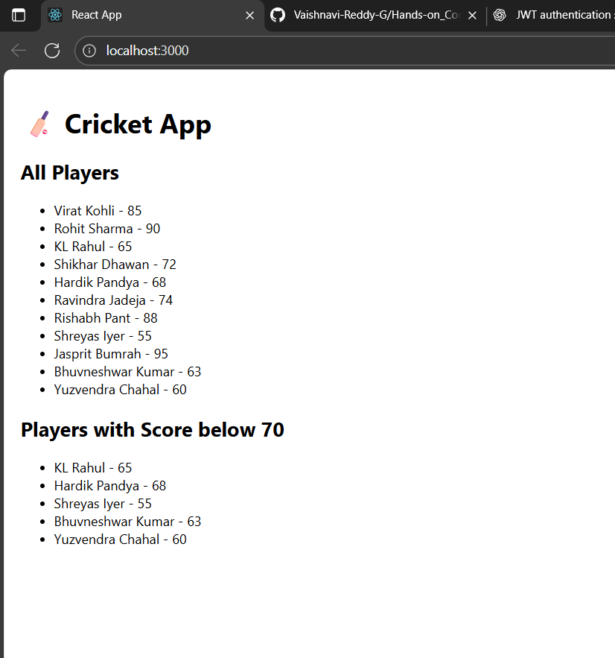

**Exercise-10**

Create a React Application named “officespacerentalapp” which uses React JSX to create elements, attributes and renders DOM to display the page.

Create an element to display the heading of the page.

Attribute to display the image of the office space

Create an object of office to display the details like Name, Rent and Address.

Create a list of Object and loop through the office space item to display more data.

To apply Css, Display the color of the Rent in Red if it’s below 60000 and in Green if it’s above 60000.

**App.js**

import React from "react";

import "./App.css";

function App() {

const offices = [

{ name: "DBS", rent: 50000, address: "Chennai", img: "https://via.placeholder.com/200x150" },

{ name: "Regus", rent: 75000, address: "Bangalore", img: "https://via.placeholder.com/200x150" },

{ name: "WeWork", rent: 60000, address: "Mumbai", img: "https://via.placeholder.com/200x150" },

]

return (

<div className="App">

<h1>Office Space , at Affordable Range</h1>

{offices.map((office, index) => {

let colorClass = office.rent <= 60000 ? "textRed" : "textGreen";

return (

<div key={index} className="office-card">

<img src={office.img} alt={office.name} width="25%" height="25%" />

<h2>Name: {office.name}</h2>

<h3 className={colorClass}>Rent: Rs. {office.rent}</h3>

<h3>Address: {office.address}</h3>

</div>

);

})}

</div>

);

}

export default App;

**App.css**

.App {

text-align: center;

font-family: Arial, sans-serif;

}

.office-card {

margin: 20px auto;

padding: 10px;

width: 300px;

border: 1px solid #ddd;

border-radius: 10px;

.textRed {

color: red;

}

.textGreen {

color: green;

}

**OUTPUT:**

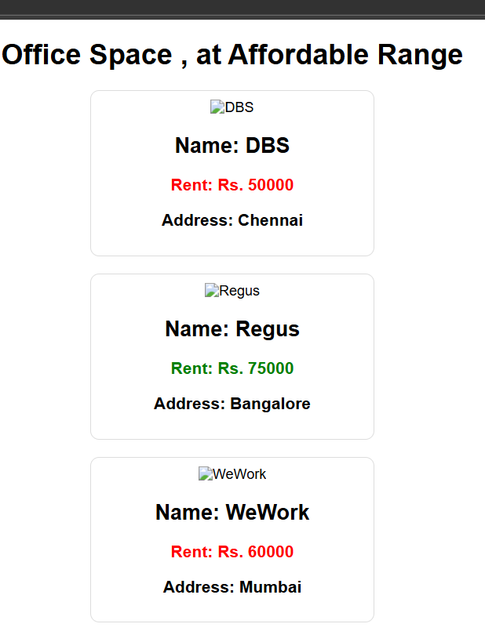

**Exercise-11**

Create a React Application “eventexamplesapp” to handle various events of the form elements in HTML.

1. Create “Increment” button to increase the value of the counter and “Decrement” button to decrease the value of the counter. The “Increase” button should invoke multiple methods.
   1. To increment the value
   2. Say Hello followed by a static message.

**App.js**

import React, { useState } from 'react';

import CurrencyConverter from './CurrencyConverter';

function App() {

const [count, setCount] = useState(0);

const increment = () => {

setCount(count + 1);

};

const decrement = () => {

setCount(count - 1);

};

const sayHello = () => {

console.log("Hello! This is a static message.");

alert("Hello! This is a static message.");

};

const sayWelcome = (message) => {

alert(message);

};

const handlePress = () => {

alert("I was clicked");

};

return (

<div style={{ textAlign: 'center', padding: '20px' }}>

<h1>Event Examples App</h1>

{/* Counter */}

<h2>Counter Value: {count}</h2>

<button onClick={() => { increment(); sayHello(); }}>Increment</button>

<button onClick={decrement}>Decrement</button>

<br /><br />

{/* Welcome Button */}

<button onClick={() => sayWelcome("Welcome!")}>Say Welcome</button>

<br /><br />

{/* Synthetic Event */}

<button onClick={handlePress}>OnPress Example</button>

<br /><br />

{/* Currency Converter */}

<CurrencyConverter />

</div>

);

}

export default App;

**CurrencyConverter.js**

import React, { useState } from 'react'

function CurrencyConverter() {

const [rupees, setRupees] = useState('');

const [euros, setEuros] = useState('');

const handleSubmit = (e) => {

e.preventDefault();

const conversionRate = 0.011; // Example: 1 INR = 0.011 EUR

setEuros((rupees * conversionRate).toFixed(2));

};

return (

<div style={{ marginTop: '20px' }}>

<h2>Currency Converter (INR ➡ EUR)</h2>

<form onSubmit={handleSubmit}>

<input

type="number"

value={rupees}

onChange={(e) => setRupees(e.target.value)}

placeholder="Enter amount in INR"

required

/>

<button type="submit">Convert</button>

</form>

{euros && <h3>{rupees} INR = {euros} EUR</h3>}

</div>

);

}

export default CurrencyConverter;

**index.js**

import React from 'react';

import ReactDOM from 'react-dom/client';

import App from './App';

import './App.css';

const root = ReactDOM.createRoot(document.getElementById('root'));

root.render(

<React.StrictMode>

<App />

</React.StrictMode>

);

**App.css**

button {

margin: 5px;

padding: 8px 12px;

background-color: #007bff;

color: white;

border: none;

cursor: pointer;

}

button:hover {

background-color: #0056b3;

}

input {

margin-right: 5px;

padding: 6px;

}

**OUTPUT:**

**Exercise-12**

Create a React Application named “ticketbookingapp” where the guest user can browse the page where the flight details are displayed whereas the logged in user only can book tickets.The Login and Logout buttons should accordingly display different pages. Once the user is logged in the User page should be displayed. When the user clicks on Logout, the Guest page should be displayed.

**App.js**

import React, { useState } from 'react';

function GuestGreeting() {

return (

<div>

<h2>Please sign up.</h2>

<p>You can browse available flights below:</p>

<ul>

<li>Flight 101: Delhi → Mumbai (₹3500)</li>

<li>Flight 202: Bangalore → Chennai (₹2800)</li>

<li>Flight 303: Hyderabad → Goa (₹3200)</li>

</ul>

</div>

);

}

function UserGreeting() {

return (

<div>

<h2>Welcome back</h2>

<p>You can now book tickets for the following flights:</p>

<ul>

<li>Flight 101: Delhi → Mumbai <button>Book</button></li>

<li>Flight 202: Bangalore → Chennai <button>Book</button></li>

<li>Flight 303: Hyderabad → Goa <button>Book</button></li>

</ul>

</div>

);

}

function Greeting(props) {

const isLoggedIn = props.isLoggedIn;

if (isLoggedIn) {

return <UserGreeting />;

}

return <GuestGreeting />;

}

function LoginButton(props) {

return (

<button onClick={props.onClick}>

Login

</button>

);

}

function LogoutButton(props) {

return (

<button onClick={props.onClick}>

Logout

</button>

);

}

function App() {

const [isLoggedIn, setIsLoggedIn] = useState(false);

const handleLoginClick = () => setIsLoggedIn(true);

const handleLogoutClick = () => setIsLoggedIn(false);

return (

<div style={{ textAlign: 'center', marginTop: '20px' }}>

<Greeting isLoggedIn={isLoggedIn} />

{isLoggedIn ? (

<LogoutButton onClick={handleLogoutClick} />

) : (

<LoginButton onClick={handleLoginClick} />

)}

</div>

);

}

export default App;

**index.js**

import React from 'react';

import ReactDOM from 'react-dom/client';

import App from './App';

const root = ReactDOM.createRoot(document.getElementById('root'));

root.render(<App />);

**OUTPUT:**

**Exercise-13**

Create a React App named “bloggerapp” in with 3 components.

1. Book Details
2. Blog Details
3. Course Details

Implement this with as many ways possible of Conditional Rendering

**App.js**

import React from "react";

import BookDetails from "./BookDetails";

import BlogDetails from "./BlogDetails";

import CourseDetails from "./CourseDetails";

import { books } from "./data/books";

import { blogs } from "./data/blogs";

import { courses } from "./data/courses";

function App() {

return (

<div>

<div className="st2">

<h1>Book Details</h1>

<BookDetails books={books} />

</div>

<div className="v1">

<h1>Blog Details</h1>

<BlogDetails blogs={blogs} />

</div>

<div className="mystyle1">

<h1>Course Details</h1>

<CourseDetails courses={courses} />

</div>

</div>

);

}

export default App;

**BookDetails.js**

import React from "react";

function BookDetails(props) {

const bookdet = (

<ul>

{props.books.map((book) => (

<div key={book.id}>

<h3>{book.bname}</h3>

<h4>{book.price}</h4>

</div>

))}

</ul>

);

return props.books.length > 0 ? bookdet : <p>No books available</p>;

}

export default BookDetails;

**BlogDetails.js**

import React from "react";

function BlogDetails({ blogs }) {

return blogs.length ? (

<ul>

{blogs.map((blog) => (

<div key={blog.id}>

<h3>{blog.title}</h3>

<p>{blog.content}</p>

</div>

))}

</ul>

) : (

<p>No blogs available</p>

);

}

export default BlogDetails;

**CourseDetails.js**

import React from "react";

function CourseDetails({ courses }) {

return courses.length ? (

<ul>

{courses.map((course) => (

<div key={course.id}>

<h3>{course.cname}</h3>

<p>{course.date}</p>

</div>

))}

</ul>

) : (

<p>No courses available</p>

);

}

export default CourseDetails;

**data/books.js**

export const books = [

{ id: 101, bname: "Master React", price: 670 },

{ id: 102, bname: "Deep Dive into Angular 11", price: 800 },

{ id: 103, bname: "Mongo Essentials", price: 450 },

];

**data/blogs.js**

export const blogs = [

{ id: 1, title: "React Learning", content: "Welcome to learning React!" },

{ id: 2, title: "Installation", content: "You can install React from npm." },

];

**data/courses.js**

export const courses = [

{ id: 1, cname: "Angular", date: "4/5/2021" },

{ id: 2, cname: "React", date: "6/3/2021" },

];

OUTPUT:

