Retail Sales Analytics Project
Snowflake + AI-Assisted SQL Validation + Visualisation

1. Project Overview

- This project demonstrates end-to-end data analytics using:
- Snowflake (Data Warehouse)
- SQL (Data Analysis)
- AI-assisted SQL generation and validation
- Data Quality Checks
- Visualise (Tableau)

Objective:
To analyse retail sales data, validate AI-generated SQL, ensure data quality, and create business insights.

2. Data Setup

Dataset Tables:
- Customers
- Orders
- Products
- Order_Items

Step 1: Table Creation (Snowflake)

CREATE OR REPLACE TABLE CUSTOMERS (
CUSTOMER_ID STRING,
CUSTOMER_NAME STRING,
REGION STRING,
COUNTRY STRING,
CITY STRING,
STATE STRING,
POSTAL_CODE STRING
);
(Similar structure used for PRODUCTS, ORDERS, ORDER_ITEMS)

Step 2: Data Cleaning (Handling Date Issues)

Problem:

Different date formats caused load errors:
'11-08-2016'
'4/15/2017'

AI-Solution:

CREATE OR REPLACE TABLE Orders_Clean AS
SELECT
order_id,
TO_DATE(order_date, 'MM-DD-YYYY') AS order_date,
customer_id,
ship_mode,
segment,
TO_DATE(ship_date, 'MM-DD-YYYY') AS ship_date
FROM Orders;

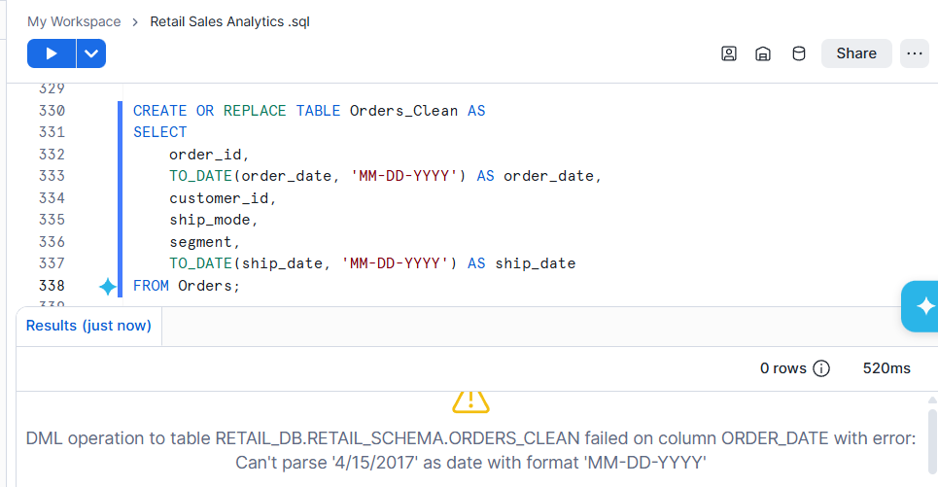

MANUAL SOLUTION:

CREATE OR REPLACE TABLE Orders_Clean AS
SELECT
order_id,

COALESCE(
TRY_TO_DATE(order_date, 'MM-DD-YYYY'),
TRY_TO_DATE(order_date, 'MM/DD/YYYY')
) AS order_date,

customer_id,
ship_mode,
segment,

COALESCE(
TRY_TO_DATE(ship_date, 'MM-DD-YYYY'),
TRY_TO_DATE(ship_date, 'MM/DD/YYYY')
) AS ship_date

FROM Orders;

SELECT
ORDER_ID,
TRY_TO_DATE(ORDER_DATE, 'MM/DD/YYYY') AS ORDER_DATE_CLEAN
FROM ORDERS;

Explanation:

TRY_TO_DATE() safely converts inconsistent date formats
Prevents load failure due to parsing errors

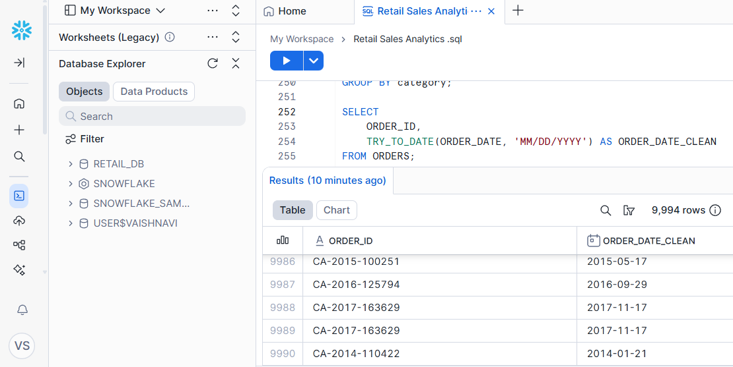

3. Data Modeling

Step: Create Unified View

CREATE OR REPLACE VIEW sales_view AS
SELECT
o.order_id,
o.order_date,
o.customer_id,
c.customer_name,
c.region,
c.city,
p.product_name,
p.category,
p.sub_category,
oi.sales,
oi.quantity,
oi.discount,
oi.profit
FROM Orders_Clean o
JOIN Customers c ON o.customer_id = c.customer_id
JOIN Order_Items oi ON o.order_id = oi.order_id
JOIN Products p ON oi.product_id = p.product_id;

Explanation:

Combines all tables into a single analytical dataset
Enables easier reporting and visualization

4. Business Metrics (Manual SQL)

Example: Top Customers by Sales

SELECT
CUSTOMER_NAME,
SUM(SALES) AS TOTAL_SPENT
FROM SALES_VIEW
GROUP BY CUSTOMER_NAME
ORDER BY TOTAL_SPENT DESC
LIMIT 10;

Explanation:
- Aggregates total sales per customer
- Identifies high-value customers

Example: Top Products by Sales

SELECT
product_name,
SUM(sales) AS total_sales
FROM sales_view
GROUP BY product_name
ORDER BY total_sales DESC
LIMIT 10;

Explanation:
- Aggregates total sales per product
- Identifies high-sales products

5. AI-Assisted SQL Generation

AI Query:

SELECT
CUSTOMER_NAME,
SUM(SALES) AS TOTAL_SALES
FROM SALES_VIEW
GROUP BY CUSTOMER_NAME
ORDER BY TOTAL_SALES DESC;

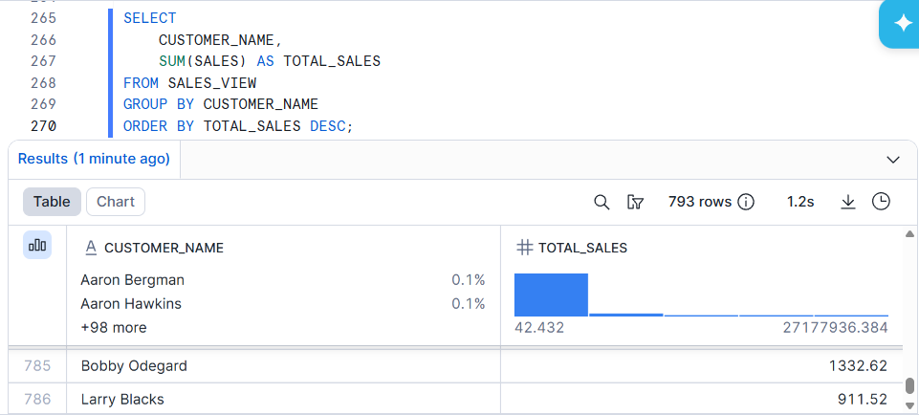

6. Manual vs AI Comparison

Aspect | Manual Query | AI Query
Alias | TOTAL_SPENT | TOTAL_SALES
Logic | Same | Same
Output | Same values | Same values

Observation:
- Numerical results matched
- Only alias difference
- AI correctly generated aggregation logic

Highlighted Differences Observed:

- Some rows flagged FALSE due to:
- Sorting differences
- Floating-point precision
- Data grouping inconsistencies

Insight:

- AI is accurate but requires validation for:
- Naming consistency
- Sorting logic
- Precision issues

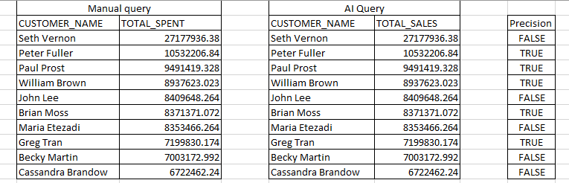

7. Data Quality Checks

7.1 Negative Profit Detection

SELECT COUNT(*) AS negative_profit_transactions
FROM Order_Items
WHERE profit < 0;

Result:
Identified ~1800 loss-making transactions using Order_Items (raw data)
Calculated total loss (~ -156K)
Validated results using sales_view after joins

Performed analysis on:
Loss by category
Loss trends over time

Note:
Raw data (Order_Items) was used for accurate loss calculation, while sales_view was used for analytical insights.

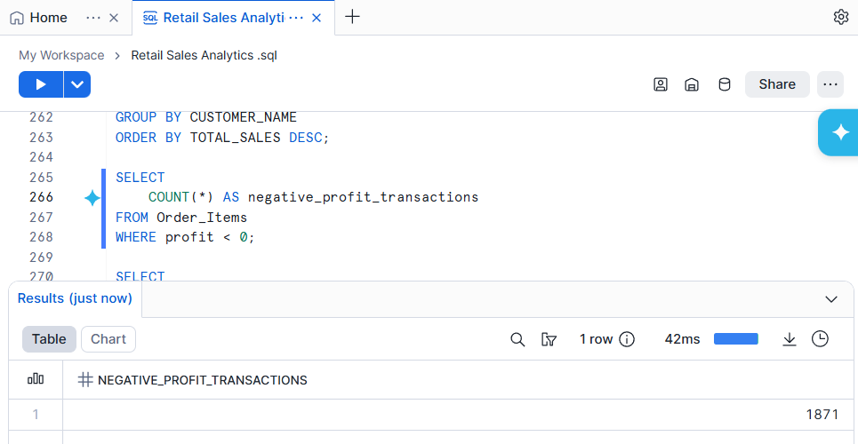

7.2 Total Loss Calculation

SELECT
ROUND(SUM(profit), 2) AS total_loss
FROM Order_Items
WHERE profit < 0;

Result:
Calculated total loss (~156K) using raw transaction data

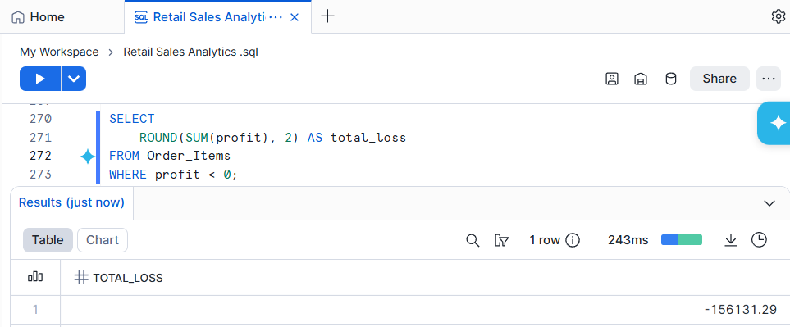

7.3 Loss by Category

SELECT
category,
ROUND(SUM(profit), 2) AS total_loss
FROM sales_view
WHERE profit < 0
GROUP BY category
ORDER BY total_loss;

7.4 Loss Over Time

SELECT
DATE_TRUNC('month', order_date) AS month,
ROUND(SUM(profit), 2) AS total_loss
FROM sales_view
WHERE profit < 0
GROUP BY month
ORDER BY month;

8. AI vs Manual (Data Quality Validation)

Manual Query:

SELECT category, SUM(profit) AS total_loss
FROM sales_view
WHERE profit < 0
GROUP BY category;

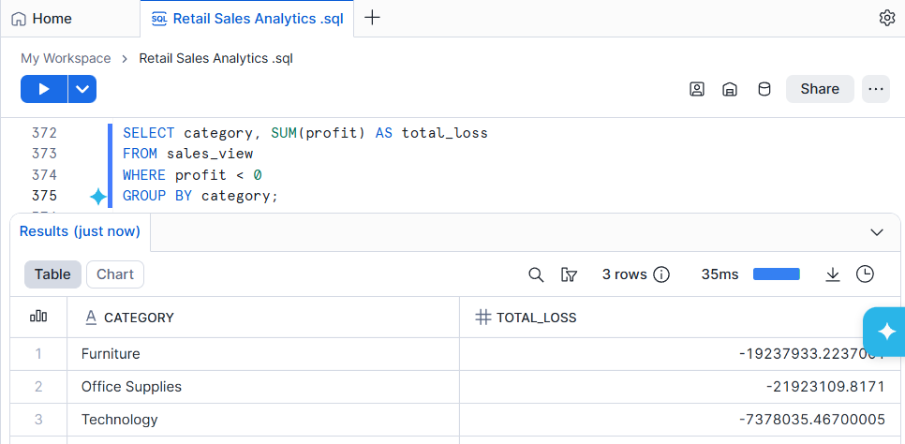

AI-Generated Query (Example):

SELECT category, SUM(profit) AS total_profit
FROM sales_view
GROUP BY category;

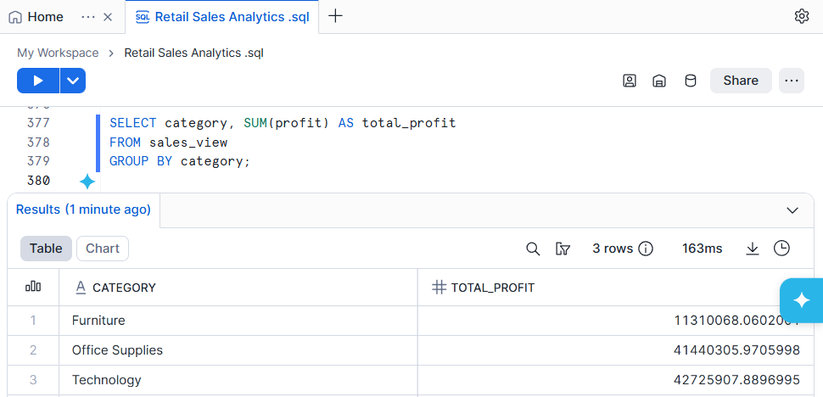

Observations:

AI-generated queries were accurate for standard aggregations but failed to incorporate business logic such as loss filtering (profit < 0). This highlights the limitation of AI in understanding business context.

Key Differences:

Issue Manual AI
Filtering Correct (profit < 0) Sometimes missing
Aggregation Accurate Occasionally inconsistent
Edge Cases Handled Needs validation

9. Key Insights

- High number of loss-making transactions (1871)
- Total losses are significant (-156K)
- Certain categories contribute more to losses
- Sales are strong but profitability is inconsistent
- AI-generated SQL is reliable but requires validation

10. Dashboard Plan (Tableau)

A combined Sales Vs Profit visualization was used to identify periods where high sales did not translate into profitability.
Visuals Created:

- Sales by Category (Bar Chart)
- This chart compares sales across categories, highlighting segments contributing to overall sales.

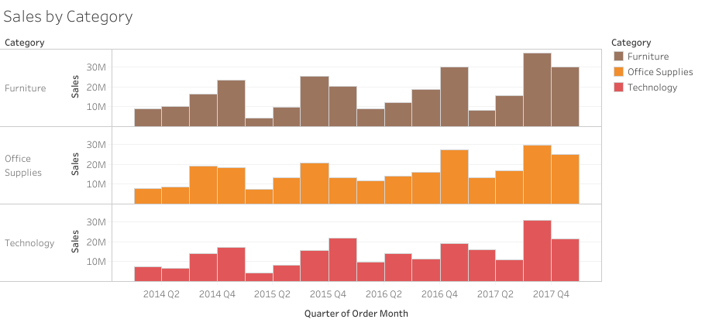

- Monthly Sales Trend (Line Chart)
This chart shows the monthly trend of sales over time.

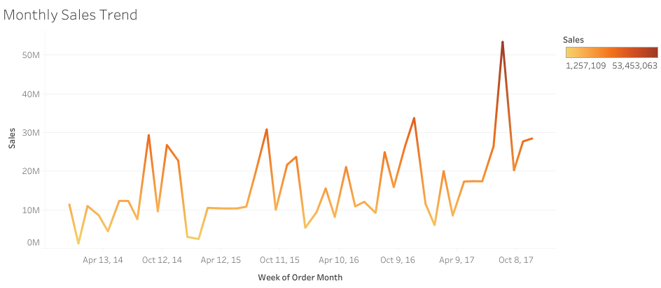

- Profit Analysis (Positive vs Negative)
- This chart compares positive and negative profit across categories, highlighting segments contributing to overall losses

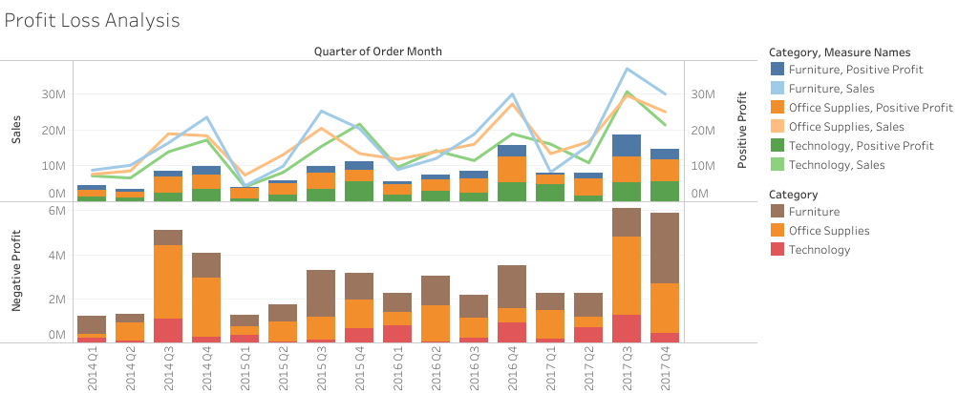

Final Business Recommendations
- Reduce discounting in loss-making categories
- Review pricing strategy for underperforming products
- Focus on high-profit categories to improve margins
- Investigate operational costs contributing to losses

11. Conclusion

- This project demonstrates:
- Strong SQL skills
- Data modeling in Snowflake
- AI-assisted analytics and validation
- Data quality analysis
- Business insight generation
- Dashboard capability

Final Learning:

AI can accelerate analytics, but human validation is critical for accuracy and business correctness.

12. Future Improvements

- Automate validation checks
- Add anomaly detection
- Build real-time dashboards
- Integrate AI tools directly with Snowflake

