Fanverse
Technical Report
Full-Stack Fan Community Platform
Architecture, Implementation, Testing and Deployment
Team members:
- Nandan Kamaraddi
- Neha Nayak
- Vajapeyayajula Sreelasya
- Vaishnavi Shetti

Contents
1. Project Overview
2. Technology Stack
3. System Architecture
4. Microservices Deep Dive
5. Database Design
6. API Design & Endpoints
7. Security Architecture
8. Messaging & Event-Driven Design
9. Frontend Architecture
10. Real-Time Communication
11. Configuration Management
12. Service Discovery & Registry
13. Containerisation & Docker
14. CI/CD Pipelines — Jenkins
15. Testing Strategy
16. Resilience & Fault Tolerance
17. Monitoring & Observability
18. Deployment Architecture
19. Known Issues, Limitations & Technical Debt
20. Recommendations & Future Roadmap
Appendix A. Testing Report Insertion Points
Appendix B. PlantUML Diagram Source

1. Project Overview

Problem Statement
Entertainment-focused online communities lack a unified, scalable space where fans of movies, TV shows, and other pop-culture content can engage meaningfully — create channels, publish posts, react, comment, moderate, and receive timely notifications — all within a single product.

Proposed Solution
FANVERSE is a full-stack, microservices-based fan-community platform. It provides themed channels (e.g., Inception, Marvel Universe, Anime World), inside which assigned Creators publish content, Members engage through reactions and comments, Moderators police content, Sub-Admins manage channel-level settings, and a platform-wide Admin oversees everything. An event-driven architecture with Apache Kafka propagates engagement data across services in near-real time.

Objectives
- Deliver a modular, independently deployable microservice system.
- Centralise authentication and API routing in a combined API Gateway + Auth Service.
- Enable real-time feed synchronisation via WebSocket.
- Propagate post-engagement events asynchronously via Kafka and the Transactional Outbox pattern.
- Provide instant and daily-summary engagement notifications to post authors.
- Support role-based access control (USER, SUB_ADMIN, CREATOR, MODERATOR, ADMIN) with dynamic channel-scoped validation.
- Allow Google OAuth2 login as a supplementary authentication path.
- Automate build, test, and deployment through individual per-service Jenkins pipelines.

Scope
In Scope | Out of Scope
Authentication, authorisation, user management | Payment/subscription features
Channel management (CRUD, archiving, genre tags) | Live video streaming
Post management (text + media uploads) | Mobile native applications
Reactions and threaded comments | External analytics dashboards
Engagement notifications | AI/ML recommendation engine
Admin dashboard | Kubernetes production deployment
Jenkins-based CI/CD | AWS deployment (referenced, not implemented)
Google OAuth2 login | Social graph / follower model

Target Users
- Fans / Members: General users who join channels and engage with content.
- Creators: Assigned users who publish posts within channels.
- Moderators: Users who review and act on reported content.
- Sub-Admins: Users managing individual channels on behalf of the Admin.
- Admins: Platform-level administrators with full system access.

Key Features (Observed in Code)
- Email + password registration and login; Google OAuth2 login (OAuth2AuthenticationSuccessHandler).
- JWT-based stateless authentication with role-based endpoint protection.
- OTP-based password reset via email (Spring Mail / Gmail SMTP).
- Channel creation, update, and archiving with genre tags (JSON column).
- Channel member management with join/leave and active status.
- Channel assignments: CREATOR, MODERATOR, SUB_ADMIN, with revocation support.
- Post CRUD — text posts and multipart media uploads (images/videos).
- Post types: TEXT, MEDIA; status: PUBLISHED.
- Reactions and comments with event-driven outbox publishing.
- Transactional Outbox pattern for reliable Kafka event publishing.
- Kafka consumer (Community Service) maintaining per-post daily engagement checkpoints.
- Immediate engagement notifications (author notified on reaction/comment).
- Daily engagement summary notifications (cron at 02:00 UTC).
- Top-engagement-post notification per daily scheduler cycle.
- Content moderation: reports with admin actions (NONE, WARNING, SUSPEND_USER, UNSUSPEND_USER).
- Trending channel scheduler in Channel Service.
- Real-time feed synchronisation via WebSocket (/ws/content-sync).
- Redux-managed frontend state with WebSocket reconnection and context-aware refresh.
- Admin panel for user management (suspend/unsuspend, role assignment/revocation).
- Spring Cloud Config Server backed by a remote GitHub repository.

Project Benefits
- Loose coupling: Each microservice owns its domain; communicates via REST or Kafka.
- Independent deployability: Each service has its own Jenkinsfile, Dockerfile, and Docker image.
- Reliability: Transactional Outbox + Kafka DLT prevent message loss.
- Developer experience: H2 in-memory database for tests; Config Server/Eureka disabled automatically during test execution via Surefire system properties.

2. Technology Stack

Backend
Component | Technology | Version / Notes
Language | Java | 21 (Eclipse Temurin JDK/JRE)
Framework | Spring Boot | 4.1.1 (parent BOM)
Build Tool | Apache Maven | Wrapper (mvnw.cmd) per service
Spring Cloud | Spring Cloud | 2025.1.3 BOM
API Gateway | Spring Cloud Gateway (Web MVC) | spring-cloud-starter-gateway-server-webmvc
Service Discovery | Spring Cloud Netflix Eureka | Client + Server
Config Server | Spring Cloud Config | Backed by GitHub
Security | Spring Security 6 | Stateless JWT + OAuth2 Client
JWT Library | JJWT | 0.13.0 (jjwt-api, jjwt-impl, jjwt-jackson)
ORM / Persistence | Spring Data JPA + Hibernate | ddl-auto=update
Database | MySQL 8.0 | Single shared schema fanverse
Messaging | Apache Kafka | 3.8.0 (KRaft mode, no Zookeeper)
HTTP Client | Spring RestClient | Internal service-to-service calls
Email | Spring Mail | SMTP (Gmail)
Validation | Spring Boot Validation | Bean Validation 3
Resilience | Resilience4j (circuit breaker) | Community Service outbound calls
Retry | Spring Retry | Config Server import retry
WebSocket | Spring WebSocket | TextWebSocketHandler
Code Generation | Lombok | 1.18.42
Code Coverage | JaCoCo | 0.8.15
Static Analysis | SonarQube Maven Plugin | 5.5.0.6356

Frontend
Component | Technology | Version
Language | JavaScript (ES2022+) | —
UI Framework | React | 19.2.8
Routing | React Router DOM | 6.28.2
State Management | Redux Toolkit | 2.12.0
React-Redux binding | react-redux | 9.3.0
Charts | Recharts | 3.10.1
Icons | Lucide React, React Icons | 1.31.0 / 5.7.0
CSS Framework | Tailwind CSS | 3.4.19 (PostCSS)
Testing | React Testing Library, Jest | —
Build | Create React App (react-scripts 5.0.1) | —
Dev Mock Server | json-server | db.json on port 5001

Infrastructure / DevOps
Component | Technology | Details
Containerisation | Docker | Multi-stage builds per service
Orchestration (local) | Docker Compose | Single docker-compose.yml at repo root
Orchestration (prod intent) | Kubernetes | Referenced in README; not configured in workspace
CI/CD | Jenkins (Declarative Pipeline) | One Jenkinsfile per service
Nginx | Nginx Alpine | React SPA serving + React Router fallback
OS (Jenkins agent) | Windows | All Jenkins bat commands

3. System Architecture

High-Level Architecture
Browser / React SPA (localhost:3000 via Nginx :80)
|
| HTTP / WebSocket
v
+------------------------------------------------------------+
| API Gateway + Auth Service (fanverse-apigateway :6001) |
| - JWT authentication filter (JwtAuthenticationFilter) |
| - Google OAuth2 login |
| - WebSocket endpoint: /ws/content-sync |
| - Spring Cloud Gateway MVC routing to downstream |
+---+-------------------+--------------------+---------------+
| | |
v REST v REST v REST
+--------+ +---------+ +-----------+
|Content | | Channel | | Community |
|Service | | Service | | Service |
| :8087 | | :8088 | | :8089 |
+---+----+ +---------+ +-----+-----+
| Outbox relay to Kafka | Kafka consumer
v |
+----------------------------------------------+
| Apache Kafka 3.8.0 (KRaft) :9092 |
| Topic: post-events |
| DLT: post-events.DLT |
+----------------------------------------------+
All services register with Eureka:
+------------------------------------------+
| Eureka Discovery Server :8666 |
+------------------------------------------+
All services fetch config from:
+---------------------------------------------------+
| Spring Cloud Config Server :8888 |
| <- GitHub: nandankamaraddi/fanverse-config |
+---------------------------------------------------+
All services share:
+------------------------------------------+
| MySQL 8.0 (fanverse-mysql :3307) |
| Database: fanverse |
| Init from: database/fanverse_backup.sql |
+------------------------------------------+

Communication Patterns
Pattern | Used Between | Details
Synchronous REST | Frontend -> API Gateway | All API calls via port 6001
Synchronous REST | Content Service -> Channel Service | Member list + assignment checks via RestClient
Synchronous REST | Content Service -> Community Service | Broadcast notification for new posts
Synchronous REST | Auth Service -> Channel Service | Dynamic SUB_ADMIN channel-scope verification
WebSocket (server-push) | API Gateway -> Frontend | /ws/content-sync live feed updates
Async Kafka (at-least-once) | Content Service -> Community Service | post-events topic via Transactional Outbox
Async Kafka (DLT) | Consumer -> Kafka | post-events.DLT on 3 failed retries

4. Microservices Deep Dive

4.1 API Gateway + Auth Service (auth_api_gateway)
Artifact: apigateway-0.0.1-SNAPSHOT.jar
Container: fanverse-apigateway Port: 6001
Spring Boot: 4.1.1 Spring Cloud: 2025.1.3
Responsibilities
- JWT Authentication Filter (JwtAuthenticationFilter): OncePerRequestFilter before UsernamePasswordAuthenticationFilter. Extracts Bearer token from Authorization header, validates with JwtUtil, checks account_status == ACTIVE, populates SecurityContextHolder.
- JWT Utility (JwtUtil): JJWT 0.13.x. Claims: sub (username), userId, email, roles. Expiry via JWT_EXPIRATION env var (default 86,400,000 ms = 24 h).
- API Routing: Spring Cloud Gateway MVC routes to downstream services by Eureka service ID.
- Authentication Controller (AuthController, base path /api/auth):
- POST /register — new user registration
- POST /login — credential login, returns JWT
- POST /logout — session invalidation
- PATCH /profile/{userId} — update bio, full name, profile image
- POST /forgot-password — send OTP email
- POST /verify-otp — verify OTP code
- POST /reset-password — change password post-OTP
- PATCH /preferences/{userId} — update genre/actor/director preferences
- PATCH /users/{userId}/status — admin: suspend/unsuspend account
- GET /users — admin: list all users
- GET /users/{userId} — get user profile
- GET /users/{userId}/roles — get user role list
- POST /users/{userId}/roles/{roleId} — assign role (admin)
- DELETE /users/{userId}/roles/{roleId} — revoke role (admin)
- Google OAuth2 (OAuth2AuthenticationSuccessHandler): On successful Google login, calls authService.loginWithGoogle(email) — looks up existing FANVERSE user, generates JWT, redirects to http://localhost:5173/oauth-success?token=...&user_id=.... Never auto-creates users. On failure, redirects to http://localhost:5173/login?oauth2Error=....
- WebSocket (ContentSyncWebSocketHandler): Extends TextWebSocketHandler. Maintains ConcurrentHashMap<String, WebSocketSession>. Broadcasts ContentSyncEvent JSON to all connected clients. Closed/failed sessions removed via removeIf.
- Email OTP Service: Spring Mail (Gmail SMTP) for OTP dispatch.
- Global Exception Handler (GlobalExceptionHandler, @ControllerAdvice): Handles ResourceNotFoundException (404), ForbiddenException (403), ValidationException (400).
CORS Configuration (CorsConfig)
Setting | Value
Allowed Origins | http://localhost:5173, http://localhost:3000
Allowed Methods | GET, POST, PUT, PATCH, DELETE, OPTIONS
Allowed Headers | *
Exposed Headers | Authorization
Allow Credentials | true

Public Endpoints (no auth required in SecurityConfig)
/api/auth/login, /api/auth/register
/api/auth/forgot-password, /api/auth/verify-otp, /api/auth/reset-password
/oauth2/**, /login/oauth2/**, /ws/**
/api/posts/**, /api/comments/**, /api/reactions/**
/api/channels/**, /api/users/**, /api/channel-assignments/**
/api/channel-members/**, /api/notifications/**, /api/reports/**
/actuator/**

Method-level security enabled via @EnableMethodSecurity.
Key Dependencies (pom.xml)
Dependency | Purpose
spring-cloud-starter-gateway-server-webmvc | API Gateway routing
spring-cloud-starter-netflix-eureka-client | Eureka service registration
spring-cloud-starter-config | Config Server import
spring-boot-starter-security | Spring Security framework
spring-boot-starter-oauth2-client | Google OAuth2
spring-boot-starter-websocket | WebSocket support
spring-boot-starter-data-jpa | JPA / Hibernate
spring-boot-starter-mail | OTP email dispatch
jjwt-api/impl/jackson 0.13.0 | JWT library
mysql-connector-j | MySQL JDBC driver
h2 (test) | In-memory DB for unit tests
cucumber-java / cucumber-junit 7.15.0 | BDD testing
selenium-java / selenium-chrome-driver 4.35.0 | UI automation
jacoco-maven-plugin 0.8.15 | Code coverage
sonar-maven-plugin 5.5.0.6356 | SonarQube integration

4.2 Content Service (content-service)
Artifact: content-service-0.0.1-SNAPSHOT.jar
Container: content-service (alias: fanverse-content-service) Port: 8087
Config import: configserver:http://fanverse-config-server:8888
Responsibilities
- Post CRUD (PostController, base path /api/posts):
- GET /api/posts — all posts
- GET /api/posts/{postId} — single post
- GET /api/posts/channel/{channelId}?status=PUBLISHED&sort=latest|relevant — posts by channel
- POST /api/posts — create text post (JSON body)
- POST /api/posts/with-media — create media post (multipart; files + form fields)
- PATCH /api/posts/{postId}?userId= — owner-only update (title, content, postType, status)
- DELETE /api/posts/{postId}?userId= — owner-only delete
- Engagement Scoring (PostService): Sort score = (likes x 1) + (active_comments x 2). Tie-breaker: createdAt descending.
- Media Storage (FileStorageService, PostMediaService): Files stored locally; post_media records store URL, type (IMAGE/VIDEO), and displayOrder.
- Kafka Producer (KafkaProducerConfig): acks=all, retries=3, enable.idempotence=true, StringSerializer + JsonSerializer, type headers disabled.
- Transactional Outbox (EngagementOutboxEntity, OutboxWriterService, OutboxRelayScheduler): Domain events (POST_CREATED, REACTION_ADDED, REACTION_REMOVED, COMMENT_ADDED, COMMENT_REMOVED) insert PENDING rows into engagement_outbox within the same DB transaction. OutboxRelayScheduler polls every 10 s (configurable via engagement.outbox.relay.interval-ms), publishes to post-events, marks rows PUBLISHED.
- New-Post Notification: After DB commit (TransactionSynchronization.afterCommit()), a 4-thread executor pool calls Community Service POST /notifications/broadcast for ACTIVE channel members. Triggered only when posting user is CREATOR/SUB_ADMIN/channel owner (verified via RestClient call to Channel Service).
- Content-Sync WebSocket (ContentSyncPublisherClient): After every write, posts a ContentSyncEvent to the API Gateway WebSocket handler via internal REST call.
- Security (SecurityConfig): anyRequest().permitAll(), CSRF disabled. Trusts the API Gateway for access control.

4.3 Channel Service (channelservice)
Artifact: com.fanverse.channelservice
Container: fanverse-channelservice (aliases: channel-service, fanverse-channel) Port: 8088
Config import: configserver:http://fanverse-config-server:8888 (fail-fast; retry up to 6 attempts)
Responsibilities
- Channel CRUD (ChannelController, base path /api/channels):
- GET /api/channels — all channels
- GET /api/channels/active — active channels
- GET /api/channels/{channelId} — single channel (includes createdBy)
- POST /api/channels — create channel (CreateChannelRequest, @Valid)
- PUT /api/channels/{channelId} — update channel (UpdateChannelRequest, @Valid)
- DELETE /api/channels/{channelId} — archive channel (soft delete: status = ARCHIVED)
- Channel Entity (Channel): channelId, channelName (unique, max 150 chars), description, channelImage, genreTags (JSON), status (ACTIVE/ARCHIVED), createdBy, createdAt, updatedAt.
- Channel Memberships: channel_members table; unique constraint on (channel_id, user_id).
- Channel Assignments: channel_assignments table; roles CREATOR/MODERATOR/SUB_ADMIN; statuses ACTIVE/REVOKED.
- Content-Sync Integration: Each mutating channel operation emits ContentSyncEvent (CHANNEL_CREATED, CHANNEL_UPDATED, CHANNEL_ARCHIVED) via ContentSyncPublisherClient.
- Trending Scheduler: Scheduled job identifies trending channels based on recent engagement.
- Explore Feature: Endpoint(s) for channel discovery by genre or activity.
- Config Retry: max-attempts=6, initial interval 3 s, multiplier 1.5, max interval 10 s.

4.4 Community Service (communityservice)
Artifact: community-service-0.0.1-SNAPSHOT.jar
Container: community-service (alias: fanverse-community) Port: 8089
Config import: configserver:http://fanverse-config-server:8888
Responsibilities
- Kafka Consumer (EngagementEventConsumer):
- Group ID: community-service-engagement
- Topic: post-events; auto.offset.reset=earliest
- enable.auto.commit=false; BATCH ack mode
- DefaultErrorHandler + FixedBackOff(3000 ms, 3 retries) + DeadLetterPublishingRecoverer -> post-events.DLT
- Event Processing:
- POST_CREATED — idempotent upsert of EngagementSummaryCheckpoint
- REACTION_ADDED — +1 new_likes; immediate POST_REACTION notification to author
- REACTION_REMOVED — -1 new_likes (floored at 0)
- COMMENT_ADDED — +1 new_comments (top-level only); immediate POST_COMMENT notification
- COMMENT_REMOVED — -1 new_comments (floored at 0)
- REPLY_ADDED and unrecognised types — silently ignored
- 7-Day Window: Checkpoint aggregation skipped for posts older than 7 days (604,800 s). Immediate notifications still fire regardless of post age.
- Idempotent Notifications: notificationRepo.existsByEventId(event.getEventId()) prevents duplicate notifications on Kafka redelivery. Actor username resolved via raw JDBC: SELECT username FROM users WHERE user_id = ?.
- Daily Engagement Summary Scheduler (EngagementSummaryScheduler): Cron 0 0 2 * * * (UTC, configurable). Closes expired 7-day windows. Processes pending checkpoints; when engagement.summary.notifications.enabled=false (current setting), stamps checkpoints without creating summary notifications. Identifies top-engagement post and sends TOP_ENGAGEMENT notification (with deduplication).
- Notifications (notifications table): Fields: notification_id, user_id, sender_id, type, message, reference_id, is_read, created_at, event_id.
- Resilience4j Circuit Breaker: Failure rate 50%, slow-call 4 s / 80%, open-state wait 10 s, window 10 calls, min calls 5, half-open 3 calls.
- Moderation/Reports (reports table): action enum: NONE/WARNING/SUSPEND_USER/UNSUSPEND_USER; fields: report_id, reported_by, post_id, comment_id, reason, description, status, handled_by, handled_at.

4.5 Eureka Discovery Server (discovery-server)
Container: fanverse-discoveryserver Port: 8666 App name: eureka
Standalone Eureka server. registerWithEureka=false, fetchRegistry=false. Jenkins pipeline publishes JUnit XML and verifies container health via docker inspect --format={{.State.Running}}. Restart policy: --restart unless-stopped.

4.6 Config Server (config-server)
Container: fanverse-config-server Port: 8888 App name: config-server
Setting | Value
Git URI | https://github.com/nandankamaraddi/fanverse-config.git
Default label | main
Clone on start | true
Refresh rate | 300 s
Force pull | true

Also registers with Eureka. Exposes health and info actuator endpoints; health.show-details=always.

5. Database Design

Overview
All microservices share a single MySQL 8.0 database named fanverse. Schema is initialised from database/fanverse_backup.sql (MySQL dump 8.0.36). Hibernate ddl-auto=update manages the engagement_outbox and engagement_summary_checkpoint tables added by Content and Community services.

Complete Table Inventory
Table | Domain Owner | Description
users | Auth/Gateway | Core user accounts
roles | Auth/Gateway | Platform roles
user_roles | Auth/Gateway | User-role many-to-many with history
channels | Channel Service | Fan channels
channel_members | Channel Service | Channel membership records
channel_assignments | Channel Service | Functional role assignments per channel
posts | Content Service | Fan posts
reactions | Content Service | Post reactions
comments | Content Service | Post comments
post_media | Content Service | Media attachments for posts
engagement_outbox | Content Service | Transactional Outbox rows for Kafka
notifications | Community Service | All notification records
engagement_summary_checkpoint | Community Service | Daily engagement counters per post
reports | Community Service | Content moderation reports

Key Table Schemas
users
CREATE TABLE `users` (
`user_id` bigint NOT NULL AUTO_INCREMENT PRIMARY KEY,
`username` varchar(255) NOT NULL UNIQUE,
`email` varchar(255) NOT NULL UNIQUE,
`password_hash` varchar(255) NOT NULL,
`full_name` varchar(255),
`bio` varchar(255),
`profile_image` varchar(255),
`account_status` varchar(255)
CHECK (account_status IN ('ACTIVE','INACTIVE','SUSPENDED')),
`favorite_genres` json,
`favorite_actors` json,
`favorite_directors` json,
`created_at` datetime(6),
`updated_at` datetime(6)
);

roles (seed data)
role_id | role_name | description
--------|------------|----------------------------------
1 | USER | Normal platform user
2 | SUB_ADMIN | Manages assigned channels
3 | CREATOR | Creates content in assigned channels
4 | MODERATOR | Moderates assigned channels
5 | ADMIN | Full platform administrator

user_roles
CREATE TABLE `user_roles` (
`user_role_id` bigint NOT NULL AUTO_INCREMENT PRIMARY KEY,
`user_id` bigint NOT NULL REFERENCES users(user_id),
`role_id` bigint NOT NULL REFERENCES roles(role_id),
`assigned_by` bigint REFERENCES users(user_id),
`status` varchar(255), -- ACTIVE / REVOKED
`assigned_at` datetime(6),
`revoked_at` datetime(6)
);

channels
CREATE TABLE `channels` (
`channel_id` bigint NOT NULL AUTO_INCREMENT PRIMARY KEY,
`channel_name` varchar(150) NOT NULL UNIQUE,
`description` text,
`channel_image` text,
`genre_tags` json,
`status` varchar(20) NOT NULL, -- ACTIVE / ARCHIVED
`created_by` bigint NOT NULL,
`created_at` datetime(6) NOT NULL,
`updated_at` datetime(6) NOT NULL
);

channel_members
CREATE TABLE `channel_members` (
`membership_id` bigint NOT NULL AUTO_INCREMENT PRIMARY KEY,
`channel_id` bigint NOT NULL REFERENCES channels(channel_id),
`user_id` bigint NOT NULL,
`status` varchar(20) NOT NULL, -- ACTIVE
`joined_at` datetime(6) NOT NULL,
UNIQUE KEY `uq_channel_member` (channel_id, user_id)
);

channel_assignments
CREATE TABLE `channel_assignments` (
`assignment_id` bigint NOT NULL AUTO_INCREMENT PRIMARY KEY,
`channel_id` bigint NOT NULL REFERENCES channels(channel_id),
`user_id` bigint NOT NULL,
`assignment_role` varchar(30) NOT NULL, -- CREATOR / MODERATOR / SUB_ADMIN
`status` varchar(20) NOT NULL, -- ACTIVE / REVOKED
`assigned_by` bigint NOT NULL,
`assigned_at` datetime(6) NOT NULL
);

posts
CREATE TABLE `posts` (
`post_id` bigint NOT NULL AUTO_INCREMENT PRIMARY KEY,
`user_id` bigint NOT NULL,
`channel_id` bigint NOT NULL,
`title` varchar(255) NOT NULL,
`content` text NOT NULL,
`post_type` varchar(255), -- TEXT / MEDIA
`status` varchar(255), -- PUBLISHED
`created_at` datetime(6),
`updated_at` datetime(6)
);

reactions
CREATE TABLE `reactions` (
`reaction_id` bigint NOT NULL AUTO_INCREMENT PRIMARY KEY,
`post_id` bigint NOT NULL,
`user_id` bigint NOT NULL,
`reaction_type` varchar(255),
`created_at` datetime(6)
);

reports
CREATE TABLE `reports` (
`report_id` bigint NOT NULL AUTO_INCREMENT PRIMARY KEY,
`reported_by` bigint NOT NULL,
`post_id` bigint,
`comment_id` bigint,
`reason` varchar(255) NOT NULL,
`description` varchar(255),
`status` varchar(255) NOT NULL,
`action` enum('NONE','SUSPEND_USER','UNSUSPEND_USER','WARNING'),
`handled_by` bigint,
`handled_at` datetime(6),
`created_at` datetime(6) NOT NULL
);

Seed Data Highlights
- 28 users: Admin (nehanayak@gmail.com) + 27 regular/creator users with named personas.
- 16 channels: Inception, Interstellar, The Dark Knight (ARCHIVED), Marvel Universe, Anime World, Bollywood Beats, Horror Central, Fantasy Realm, Hollywood Hub, Thriller Zone, and others.
- 48 channel assignments covering CREATOR, MODERATOR, SUB_ADMIN.
- 51 active channel memberships.
- 5 roles fully seeded.
- 50+ user_role records, several REVOKED.

6. API Design & Endpoints

API Gateway Base URL
- Local: http://localhost:6001
- Docker network: http://fanverse-apigateway:6001

Auth & User Management (/api/auth)
Method | Path | Auth | Description
POST | /api/auth/register | No | Register new user
POST | /api/auth/login | No | Credential login — returns JWT
POST | /api/auth/logout | JWT | Invalidate session
PATCH | /api/auth/profile/{userId} | JWT | Update bio, name, profile image
POST | /api/auth/forgot-password | No | Send OTP email
POST | /api/auth/verify-otp | No | Verify OTP code
POST | /api/auth/reset-password | No | Reset password post-OTP
PATCH | /api/auth/preferences/{userId} | JWT | Update genre/actor/director preferences
PATCH | /api/auth/users/{userId}/status | JWT (ADMIN) | Suspend/unsuspend account
GET | /api/auth/users | JWT (ADMIN) | List all users
GET | /api/auth/users/{userId} | JWT | Get user profile
GET | /api/auth/users/{userId}/roles | JWT | Get user role list
POST | /api/auth/users/{userId}/roles/{roleId} | JWT (ADMIN) | Assign role
DELETE | /api/auth/users/{userId}/roles/{roleId} | JWT (ADMIN) | Revoke role

Posts (/api/posts — Content Service via Gateway)
Method | Path | Description
GET | /api/posts | All posts
GET | /api/posts/{postId} | Single post by ID
GET | /api/posts/channel/{channelId} | Posts by channel (`?status=PUBLISHED&sort=latest\ | relevant`)
POST | /api/posts | Create text post (JSON body)
POST | /api/posts/with-media | Create media post (multipart: files + form fields)
PATCH | /api/posts/{postId}?userId= | Owner-only update (title, content, postType, status)
DELETE | /api/posts/{postId}?userId= | Owner-only delete

Channels (/api/channels — Channel Service via Gateway)
Method | Path | Description
GET | /api/channels | All channels
GET | /api/channels/active | Active channels only
GET | /api/channels/{channelId} | Single channel
POST | /api/channels | Create channel
PUT | /api/channels/{channelId} | Update channel
DELETE | /api/channels/{channelId} | Archive channel (soft delete)

WebSocket
Endpoint | Description
ws://localhost:6001/ws/content-sync | Server-push content sync. Client sends optional AUTH frame (JWT) and SUBSCRIBE frame (activeContext). Server broadcasts ContentSyncEvent JSON on write operations.

7. Security Architecture

Authentication Flow
1. Client -> POST /api/auth/login {username, password}
2. Gateway: SELECT user by username; BCrypt.matches(password)
3. Gateway: Generate JWT (sub, userId, email, roles); 200 OK {token, userId, roles}
Subsequent requests:
4. Client -> Authorization: Bearer <token>
5. JwtAuthenticationFilter:
a. Extract token from Authorization header
b. validateToken() via JwtUtil
c. Check UserEntity.account_status == ACTIVE
d. Populate SecurityContextHolder
6. Request proceeds to controller / forwarded to downstream service

JWT Structure
Claim | Value
sub | Username
userId | User ID (Long)
email | User email
roles | List of role name strings
Signature algorithm | HMAC-SHA with JWT_SECRET environment variable
Default expiry | 86,400,000 ms (24 hours)

Role Hierarchy
Role | Scope | Capabilities
ADMIN | Platform-wide | Full access; user/role/report management
SUB_ADMIN | Per-channel | Manage assigned channels; dynamically validated at runtime
CREATOR | Per-channel | Create/manage posts in assigned channels
MODERATOR | Per-channel | Content moderation in assigned channels
USER | Platform | Join channels, react, comment, receive notifications

Dynamic SUB_ADMIN Validation
AuthService calls Channel Service via RestClient at request time to verify the user holds an ACTIVE SUB_ADMIN assignment for the specific channel. Prevents a single token from conferring broad channel privileges.

Google OAuth2 Flow
- GET /oauth2/authorization/google — initiates Google login
- Callback: /login/oauth2/code/google
- OAuth2AuthenticationSuccessHandler extracts Google email
- authService.loginWithGoogle(email) — finds existing FANVERSE user; rejects if not found or SUSPENDED
- Generates FANVERSE JWT; redirects to http://localhost:5173/oauth-success?token=...&user_id=...
- On error: http://localhost:5173/login?oauth2Error=...
Note (from code comments): The URL query-parameter token handoff is a development implementation only. A one-time-code exchange is recommended before production deployment.

Content Service Security
SecurityConfig uses anyRequest().permitAll() with CSRF disabled. Content Service relies on the API Gateway for authentication enforcement. Ownership checks (e.g., post.getUserId().equals(requestUserId)) are enforced in service-layer methods.

8. Messaging & Event-Driven Design

Kafka Cluster
- Apache Kafka 3.8.0, KRaft mode (no Zookeeper)
- Container: kafka (alias: fanverse-kafka) Port: 9092
- Bootstrap servers: KAFKA_BOOTSTRAP_SERVERS=kafka:9092 (within Docker network)

Kafka Producer Configuration (Content Service — KafkaProducerConfig)
Setting | Value
Key Serializer | StringSerializer
Value Serializer | JsonSerializer
acks | all
retries | 3
enable.idempotence | true
Type info headers | Disabled (ADD_TYPE_INFO_HEADERS=false)

Transactional Outbox Pattern
Business Transaction (Content Service):
1. Save domain entity (Post / Reaction / Comment) to MySQL
2. INSERT INTO engagement_outbox:
event_id (UUID), event_type, post_id, actor_id,
post_author_id, post_created_at, occurred_at, payload JSON, status='PENDING'
--> COMMIT (entity + outbox row atomically)
OutboxRelayScheduler (every 10 s, configurable):
1. SELECT * FROM engagement_outbox WHERE status = 'PENDING'
2. KafkaTemplate.send("post-events", PostEngagementEvent)
3. UPDATE engagement_outbox SET status = 'PUBLISHED'

PostEngagementEvent Fields
Field | Type | Description
eventId | UUID | Unique identifier for idempotency
eventType | String | POST_CREATED / REACTION_ADDED / REACTION_REMOVED / COMMENT_ADDED / COMMENT_REMOVED
postId | Long | Target post
actorId | Long | User who performed the action
postAuthorId | Long | Post author (notification recipient)
postCreatedAt | LocalDateTime | For 7-day window calculation
occurredAt | LocalDateTime | Event occurrence timestamp
payload | String | JSON string with additional context

Consumer Configuration (Community Service — KafkaConsumerConfig)
Setting | Value
Group ID | community-service-engagement
Auto Offset Reset | earliest
Enable Auto Commit | false
Ack Mode | BATCH
Error Handler | DefaultErrorHandler + DeadLetterPublishingRecoverer
Retry | FixedBackOff(3000 ms, 3 attempts)
DLT Topic | post-events.DLT

Event Processing Summary
Event Type | Checkpoint Action | Notification Created
POST_CREATED | Upsert checkpoint row (idempotent) | None
REACTION_ADDED | +1 new_likes | POST_REACTION to author (no self-notify)
REACTION_REMOVED | -1 new_likes (floor 0) | None
COMMENT_ADDED | +1 new_comments | POST_COMMENT to author (no self-notify)
COMMENT_REMOVED | -1 new_comments (floor 0) | None
REPLY_ADDED | Ignored | Ignored

9. Frontend Architecture

Technology
React 19 SPA (Create React App 5). Served via Nginx Alpine in Docker (container :80; Docker Compose host :3000; Jenkins pipeline maps to 5173:80).

Directory Structure
fanverse/frontend/src/
App.js Root component + React Router route definitions
components/ Reusable UI components
pages/ Route-level page components
services/ API service layer modules
store/
store.js Redux store (configureStore, single 'content' reducer)
contentSlice.js Async thunks: fetchHomeFeed, fetchChannelPosts, fetchPostDetail
useContentWebSocket.js WebSocket hook (reconnect, context-aware refresh)
useSyncPolling.js Polling fallback hook
images/

Redux State Management
Single Redux slice content with async thunks:
- fetchHomeFeed({ userId, sort }) — personalised home feed
- fetchChannelPosts({ channelId, sort, currentUserId }) — channel post feed
- fetchPostDetail({ postId, currentUserId }) — single post with comments/reactions
activeContext in state: { type: "home"|"channel"|"postDetail", ...ids } — determines WebSocket refresh scope.

Real-Time Feed Sync (useContentWebSocket)
- Opens WebSocket to ws://localhost:6001/ws/content-sync (env: REACT_APP_CONTENT_WS_URL).
- On open: sends AUTH frame (JWT from localStorage.getItem("fanverse_token")), then SUBSCRIBE frame with activeContext.
- On message: parses JSON payload; contextMatches() checks type + IDs; if not in IGNORE_EVENT_TYPES, dispatches appropriate Redux thunk.
- On close: exponential backoff reconnect: delay = min(1000 * 2^attempt, 10000) ms.
- Cleanup on unmount: cancels pending reconnect timers, closes socket cleanly.
Ignored types: CONNECTED, SUBSCRIBED, AUTH_OK, PING, PONG, HEARTBEAT.

JWT Storage
Stored in localStorage under key fanverse_token. Used for WebSocket AUTH frame and API Authorization headers.

Charts
recharts 3.10.1 is present as a dependency — used in the admin dashboard for engagement data visualisation.

10. Real-Time Communication

WebSocket Architecture
Content Service / Channel Service
| REST POST (ContentSyncPublisherClient)
v
API Gateway (auth_api_gateway)
| ContentSyncWebSocketHandler.broadcast(ContentSyncEvent)
| ConcurrentHashMap<String, WebSocketSession>
| ObjectMapper -> TextMessage -> all sessions
| (removeIf: closed/failed sessions pruned)
v ws://localhost:6001/ws/content-sync
React Frontend (useContentWebSocket hook)
| Parses JSON -> contextMatches() check
v Dispatches Redux thunk -> re-fetch from API

ContentSyncEvent Fields
Field | Type | Values
eventType | String | POST_CREATED, POST_UPDATED, POST_DELETED, CHANNEL_CREATED, CHANNEL_UPDATED, CHANNEL_ARCHIVED
entityType | String | post, channel
userId | Long | Actor user ID
channelId | Long | Target channel ID
postId | Long | Target post ID
actorId | Long | User who triggered the event
commentId | Long | Target comment ID (if applicable)
message | String | Human-readable description

Event Triggers
- Content Service PostController: POST_CREATED (text), POST_CREATED (media), POST_UPDATED, POST_DELETED.
- Channel Service ChannelController: CHANNEL_CREATED, CHANNEL_UPDATED, CHANNEL_ARCHIVED.
- All published via ContentSyncPublisherClient (internal REST call to the API Gateway's WebSocket handler).

Fallback
useSyncPolling.js provides an HTTP polling fallback for environments where WebSocket is unavailable.

11. Configuration Management

Spring Cloud Config Server
Centrally manages all microservice properties via a remote GitHub repository.
Setting | Value
Git URI | https://github.com/nandankamaraddi/fanverse-config.git
Branch | main
Clone on start | true
Refresh rate | 300 s (5 min)
Force pull | true (recovers from dirty local clone)

Client import:
spring.config.import=configserver:http://fanverse-config-server:8888
# Auth Gateway uses optional: to allow standalone startup
spring.config.import=optional:configserver:http://fanverse-config-server:8888

Environment Variables
Variable | Consumed By | Description
DB_USERNAME | All services | MySQL username
DB_PASSWORD | All services | MySQL password
MYSQL_DATABASE | MySQL container | Database name (fanverse)
JWT_SECRET | Auth Gateway | HMAC signing key for JWT
JWT_EXPIRATION | Auth Gateway | Token TTL in milliseconds
MAIL_USERNAME | Auth Gateway | SMTP sender email address
MAIL_PASSWORD | Auth Gateway | SMTP app password
GATEWAY_ADMIN_USERNAME | Auth Gateway | Bootstrap admin username
GATEWAY_ADMIN_PASSWORD | Auth Gateway | Bootstrap admin password
GOOGLE_CLIENT_ID | Auth Gateway | OAuth2 client ID
GOOGLE_CLIENT_SECRET | Auth Gateway | OAuth2 client secret
KAFKA_BOOTSTRAP_SERVERS | Content, Community | Kafka broker address
EUREKA_CLIENT_SERVICEURL_DEFAULTZONE | All services | Eureka registry URL
API_GATEWAY_URL | Content, Community | Gateway base URL for internal REST calls
GIT_USERNAME | Config Server | GitHub username
GIT_PASSWORD | Config Server | GitHub Personal Access Token

Per-Service Notable Properties
Service | Notable Settings
auth_api_gateway | server.port=6001; optional config import; api.gateway.url
content-service | engagement.outbox.relay.interval-ms=10000; ddl-auto=update
communityservice | engagement.summary.cron=0 0 2 * * *; engagement.summary.notifications.enabled=false; Resilience4j CB props
channelservice | spring.cloud.config.retry.max-attempts=6; initial 3 s, multiplier 1.5, max 10 s; fail-fast=true
config-server | server.port=8888; Git URI; management.endpoints.web.exposure.include=health,info
discovery-server | server.port=8666; registerWithEureka=false; fetchRegistry=false

12. Service Discovery & Registry
Eureka Server: http://fanverse-discoveryserver:8666/eureka/
Service | Eureka App Name | Port
API Gateway + Auth | apigateway | 6001
Config Server | config-server | 8888
Content Service | content-service | 8087
Channel Service | channelservice | 8088
Community Service | community-service | 8089

Discovery Server does NOT self-register. eureka.instance.prefer-ip-address=true is set in Config Server config. API Gateway uses Eureka service IDs for load-balanced routing to downstream services.

13. Containerisation & Docker

Docker Images Summary
Service | Build Base | Runtime Base | Exposed Port
auth_api_gateway | maven:3.9.9-eclipse-temurin-21 | eclipse-temurin:21-jre | 6001
content-service | maven:3.9.11-eclipse-temurin-21 | eclipse-temurin:21-jre | 8087
communityservice | maven:3.9.11-eclipse-temurin-21 | eclipse-temurin:21-jre | 8089
channelservice | maven + temurin-21 | eclipse-temurin:21-jre | 8088
discovery-server | maven + temurin-21 | eclipse-temurin:21-jre | 8666
config-server | maven + temurin-21 | eclipse-temurin:21-jre | 8888
frontend | node:20-alpine | nginx:alpine | 80
database | mysql:8.0 (init via SQL) | — | 3306

All Java Dockerfiles use multi-stage builds: Stage 1 compiles with Maven (mvn clean package -DskipTests); Stage 2 runs with JRE only (java -jar /app/app.jar). Content/Community services additionally run mvn dependency:go-offline -B to maximise layer caching. The frontend Dockerfile copies nginx.conf for React Router history-API fallback support.

Docker Compose Port Mapping
Container | Host Port | Container Port
fanverse-mysql | 3307 | 3306
kafka | 9092 | 9092
fanverse-discoveryserver | 8666 | 8666
fanverse-config-server | 8888 | 8888
fanverse-apigateway | 6001 | 6001
content-service | 8087 | 8087
fanverse-channelservice | 8088 | 8088
community-service | 8089 | 8089
fanverse-frontend | 3000 | 80

All containers connect to fanverse-network (Docker bridge). Environment variables are injected from the root .env file.

14. CI/CD Pipelines — Jenkins
Each service has its own independent Declarative Jenkinsfile. All pipelines run on Windows Jenkins agents (all shell commands use bat).

API Gateway (auth_api_gateway/Jenkinsfile)
Stage | Command
Checkout | checkout scm
Compile | mvnw.cmd clean compile -DskipTests
Test | mvnw.cmd test
Build Docker Image | docker build -t fanverse-apigateway:latest .
Docker Image Check | docker images fanverse-apigateway
Stop Existing | Stops containers named fanverse-apigateway, fanverse-api-gateway, fanverse-authapigateway; also stops any container on port 6001
Remove Existing | Removes same containers
Create and Run | docker run -d --name fanverse-apigateway --network fanverse-network -p 6001:6001 -e <all env vars>
Container Check | docker ps

Post actions: Email to nehanayak246@gmail.com on both success and failure.
Environment variables injected: DB_USERNAME, DB_PASSWORD, JWT_SECRET, MAIL_USERNAME, MAIL_PASSWORD, GATEWAY_ADMIN_USERNAME, GATEWAY_ADMIN_PASSWORD, GOOGLE_CLIENT_ID, GOOGLE_CLIENT_SECRET.

Content Service (content-service/JenkinsFile)
Stage | Command
Checkout | checkout scm
Build | mvnw.cmd clean package -DskipTests
Test | mvnw.cmd test
Verify Build | dir target\*.jar
Docker Build | docker build -t content-service:latest .
Stop/Remove Existing | Targets content-service, fanverse-content, fanverse-content-service; port 8087 filter
Run Container | docker run -d --name content-service --network fanverse-network -p 8087:8087 -e SERVER_PORT=8087
Verify | docker ps + docker logs content-service

Community Service (communityservice/Jenkinsfile)
Stage | Command
Compile | .\mvnw.cmd clean compile -DskipTests
Test | .\mvnw.cmd test
Package | .\mvnw.cmd package -DskipTests
Verify Build | dir target\*.jar
Docker Build | docker build -t community-service:latest .
Stop/Remove | Targets community-service, fanverse-community; port 8089 filter
Run Container | docker run -d --name community-service --network fanverse-network -p 8089:8089 -e SERVER_PORT=8089
Verify | docker ps + docker logs community-service

Channel Service (channelservice/jenkinsfile)
Stage | Command
Compile | .\mvnw.cmd clean compile -DskipTests
Test | mvnw.cmd test
Build Docker Image | docker build -t fanverse-channelservice:latest .
Docker Image Check | docker images fanverse-channelservice
Stop/Remove | Targets fanverse-channelservice, fanverse-channel; port 8088 filter
Create and Run | Port 8088:8088; network aliases channel-service, fanverse-channel
Container Check | docker ps

Post actions: Email to vaishshetti17@gmail.com on both success and failure.

Discovery Server (discovery-server/Jenkinsfile)
Pipeline options: skipDefaultCheckout(true), disableConcurrentBuilds(), timestamps().
Stage | Command
Checkout | checkout scm
Compile | .\mvnw.cmd clean compile
Test | .\mvnw.cmd test (publishes JUnit XML: target/surefire-reports/*.xml)
Build Docker Image | docker build -t %DOCKER_IMAGE% .
Docker Image Inspect | docker image inspect %DOCKER_IMAGE%
Stop/Remove Existing | docker stop %DOCKER_CONTAINER% + docker rm %DOCKER_CONTAINER%
Create and Run | Port 8666:8666, --restart unless-stopped
Container Health Check | docker inspect --format={{.State.Running}} %DOCKER_CONTAINER% — exits non-zero if not running

Post: Success -> email to nehanayak246@gmail.com. Failure -> email to amishkulkarni03@gmail.com.

Config Server (config-server/Jenkinsfile)
Stage | Command
Build & Package | .\mvnw.cmd clean package -DskipTests
Build Docker Image | docker build -t fanverse-config-server:latest .
Docker Image Check | docker images fanverse-config-server
Stop/Remove | Targets fanverse-config-server, config-server; port 8888 filter
Create and Run | Port 8888:8888; alias config-server
Container Check | docker ps

Frontend (fanverse/frontend/Jenkinsfile)
Environment: CI=false (suppresses CRA warnings-as-errors in build).
Stage | Command
Checkout | checkout scm
Install Dependencies | npm ci (inside frontend/ directory)
Build React Application | npm run build
Build Docker Image | docker build -t fanverse-frontend:latest .
Docker Image Check | docker images fanverse-frontend
Stop/Remove Existing | docker stop fanverse-frontend + docker rm fanverse-frontend
Create and Run | docker run -d --name fanverse-frontend -p 5173:80 fanverse-frontend:latest
Container Check | docker ps

15. Testing Strategy

Backend — Unit and Integration Tests
- Framework: JUnit 5 (spring-boot-starter-test), Mockito, AssertJ, Hamcrest.
- WebMVC tests: spring-boot-starter-webmvc-test for @AutoConfigureMockMvc.
- Security tests: spring-security-test + spring-boot-starter-security-test for @WithMockUser.
- In-memory DB: H2 (test scope) substitutes MySQL for all unit and integration tests.
- Cloud isolation via Surefire system properties in pom.xml:
<systemPropertyVariables>
<spring.cloud.config.enabled>false</spring.cloud.config.enabled>
<spring.cloud.config.discovery.enabled>false</spring.cloud.config.discovery.enabled>
<spring.cloud.config.import-check.enabled>false</spring.cloud.config.import-check.enabled>
<spring.config.import>optional:configserver:</spring.config.import>
<eureka.client.enabled>false</eureka.client.enabled>
<spring.cloud.discovery.enabled>false</spring.cloud.discovery.enabled>
</systemPropertyVariables>

Backend — BDD / Cucumber Tests (Auth Gateway)
- Cucumber 7.15.0 (cucumber-java, cucumber-junit).
- JUnit Vintage Engine bridges JUnit 4 @RunWith(Cucumber.class) runner to JUnit 5 platform.
- TestRunner.java is excluded from default Surefire execution — requires a live frontend + backend. Manual execution: mvnw.cmd test -Dtest=TestRunner.

Backend — Selenium UI Automation (Auth Gateway)
- selenium-java 4.35.0 + selenium-chrome-driver 4.35.0 (both test scope).
- Step definitions in StepDefinitions/ package; excluded from CI default test phase.
- Intended for end-to-end validation against a running environment.

Code Coverage & Quality
- JaCoCo 0.8.15: prepare-agent + report goals configured; HTML report generated in target/site/jacoco/ during verify phase.
- SonarQube Maven Plugin 5.5.0.6356: configured in Auth Gateway pom.xml. Invoked with mvn sonar:sonar against an external SonarQube server.

Frontend Tests
- React Testing Library (@testing-library/react 16.3.2, @testing-library/dom, @testing-library/user-event) + Jest (via CRA).
- Test files observed:
- src/ForgotPassword.test.js — 23 KB, comprehensive password reset flow coverage
- src/Login.test.js — 4.7 KB
- src/Register.test.js — 14.4 KB

16. Resilience & Fault Tolerance

Kafka Dead Letter Topic (Community Service)
- DefaultErrorHandler with FixedBackOff(3000 ms, 3 attempts).
- On exhaustion: DeadLetterPublishingRecoverer forwards the record to post-events.DLT.
- Prevents poison-pill messages from blocking the consumer partition indefinitely.

Transactional Outbox (Content Service)
- Guarantees Kafka messages are never lost if the broker is temporarily unavailable.
- OutboxRelayScheduler retries on every 10 s cycle until publish succeeds.

Producer Idempotence
- enable.idempotence=true prevents duplicate Kafka messages from producer-side retries within a session.

Consumer-Side Idempotency
Mechanism | Location | Purpose
Upsert on (post_id, reporting_date) UNIQUE KEY | EngagementEventConsumer POST_CREATED handler | No duplicate checkpoint rows
notificationRepo.existsByEventId(eventId) | Immediate notification creation | No duplicate notifications on Kafka redelivery
existsByUserIdAndTypeAndReferenceId() | EngagementSummaryScheduler TOP_ENGAGEMENT | No duplicate top-engagement notifications
AtomicBoolean running | EngagementSummaryScheduler | Prevents overlapping scheduler invocations

Resilience4j Circuit Breaker (Community Service)
Property | Value
Failure rate threshold | 50%
Slow-call duration | 4 s
Slow-call rate threshold | 80%
Wait duration in OPEN state | 10 s
Sliding window size | 10 calls
Minimum calls to trip | 5
Permitted calls in HALF-OPEN | 3

Config Server Retry (Channel/Community Services)
Up to 6 retry attempts; exponential backoff starting at 3 s, multiplier 1.5, max interval 10 s. Prevents startup failure when the Config Server is briefly unavailable.

WebSocket Reconnection (Frontend)
Exponential backoff: delay = min(1000 * 2^attempt, 10000) ms. Infinite retry until component unmount. Pending reconnect timers cancelled on cleanup.

Notification Executor Graceful Shutdown (Content Service)
@PreDestroy on PostService.shutdownNotificationExecutor() ensures the 4-thread notification thread pool is shut down cleanly when the service stops.

17. Monitoring & Observability

Spring Boot Actuator
Service | Status
auth_api_gateway | spring-boot-starter-actuator dependency present
config-server | management.endpoints.web.exposure.include=health,info; management.endpoint.health.show-details=always
Other services | Inherit actuator config from remote Config Server (not directly visible in local property files)

Logging
- Framework: SLF4J + Logback (Spring Boot default).
- Log prefixes used consistently across services:
- [CONSUMER] — Kafka event consumer processing
- [SUMMARY-SCHEDULER] — daily engagement summary cron job
- [POST-NOTIFY] — new-post notification dispatch
- Log levels: INFO for business events; DEBUG for verbose tracing; WARN for non-fatal errors; ERROR for scheduler/processing failures.
- A log file is present at content-service/logs/content-service.log.

SonarQube
sonar-maven-plugin 5.5.0.6356 configured in Auth Gateway pom.xml. Invoked via mvn sonar:sonar against an external SonarQube server (server URL not observed in workspace files).

Not Observed
Prometheus, Grafana, Zipkin, OpenTelemetry, or ELK Stack configurations were not found in the inspected workspace. No centralised log aggregation is configured.

18. Deployment Architecture

Local Docker Compose
Logical startup order (respecting depends_on chain in docker-compose.yml):
MySQL
-> Kafka
-> Eureka Discovery Server
-> Config Server
-> API Gateway + Auth Service
-> Content Service
-> Channel Service
-> Community Service
-> Frontend (Nginx)

Local access points:
Service | URL
Frontend | http://localhost:3000
API Gateway | http://localhost:6001
Eureka Dashboard | http://localhost:8666
Config Server | http://localhost:8888
Content Service (direct) | http://localhost:8087
Channel Service (direct) | http://localhost:8088
Community Service (direct) | http://localhost:8089
MySQL | localhost:3307
Kafka | localhost:9092

Jenkins Individual Pipeline Deployment
Each pipeline idempotently creates the shared Docker network (fanverse-network) before starting containers, then:
- Checks out source from SCM.
- Compiles and runs tests.
- Builds a Docker image tagged :latest.
- Stops and removes any existing container (by name or port filter).
- Starts new container connected to fanverse-network.

Production Intent
- Kubernetes deployment referenced in project README as the target production orchestrator. No Kubernetes manifests (YAML, Helm charts) were observed in the workspace during inspection.
- AWS deployment mentioned in documentation but no Terraform, CloudFormation, or deployment scripts were found.
- Only the Eureka Discovery Server has --restart unless-stopped for automatic restart on host reboot or crash.

19. Known Issues, Limitations & Technical Debt

Security Concerns
Issue | Location | Detail
No JWT validation in Content Service | content-service/SecurityConfig.java | anyRequest().permitAll() — unauthenticated access possible if service is contacted directly, bypassing the API gateway.
OAuth2 redirect URL hardcoded | OAuth2AuthenticationSuccessHandler.java | http://localhost:5173/oauth-success — will not work in staging or production environments. Code comment acknowledges this.
JWT token exposed in URL query parameter | OAuth2AuthenticationSuccessHandler.java | ?token=... in redirect URL — visible in server access logs, browser history, and HTTP referrer headers. Code comment marks this as development-only.
Secrets hardcoded in Jenkinsfile | auth_api_gateway/Jenkinsfile | JWT_SECRET, DB_PASSWORD, GOOGLE_CLIENT_SECRET, etc. stored as plain-text in the environment {} block.
GitHub PAT stored in application.properties | config-server/application.properties | spring.cloud.config.server.git.password contains a plaintext GitHub Personal Access Token.
CORS allows localhost origins only | CorsConfig.java | localhost:5173 and localhost:3000 only — no production domain configured.

Architecture Limitations
Issue | Detail
Single shared MySQL database | All microservices share the fanverse schema — tight data coupling, violates microservice isolation principles. Schema changes risk cross-service breakage.
No inter-service authentication | Internal REST calls (Content -> Channel/Community, Auth -> Channel) carry no service-level credentials. Any process on the Docker network can call internal endpoints.
Approximate engagement counters | Counter increments/decrements (REACTION_ADDED/REMOVED) are not fully idempotent on exactly duplicate Kafka messages (code comment explicitly notes this trade-off).
Engagement summary scheduler disabled | engagement.summary.notifications.enabled=false — scheduler stamps checkpoints but no summary notifications are sent. Immediate notifications are the active path.
Actor username resolved via raw JDBC | EngagementEventConsumer queries the users table directly with JdbcTemplate, crossing service domain boundaries.
No pagination on list endpoints | getAllPosts(), getActiveChannels(), getUsers() return all records — potential performance issue at scale.
Dev mock server in production build | json-server + db.json are present in the frontend alongside the real backend, which can confuse contributors.

Operational Issues
Issue | Detail
No Docker Compose health checks | depends_on without condition: service_healthy — services may start before dependencies are truly ready.
ddl-auto=update in containers | Content Service and Community Service use Hibernate auto-DDL — risky for production schema management.
Only Discovery Server has restart policy | --restart unless-stopped is set only for Eureka. Other containers do not auto-restart on failure.
No centralised log aggregation | Each container writes logs locally; no ELK, Loki, or CloudWatch Logs integration.
JUnit XML published only by Discovery Server pipeline | Other Jenkins pipelines do not publish test results for trend reporting.

20. Recommendations & Future Roadmap

Security Hardening (High Priority)
- Validate JWT in Content/Channel/Community Services: Add a shared JWT validation filter, or have the API Gateway inject a trusted X-Auth-UserId header after token validation.
- Fix OAuth2 token handoff: Implement server-side one-time code exchange — store JWT behind a short-lived code, redirect with the code, exchange via POST. Remove URL-exposed tokens.
- Move secrets to Jenkins Credentials or HashiCorp Vault: Replace plain-text Jenkinsfile environment {} variables with credentials() bindings. Rotate the exposed GitHub PAT immediately.
- Encrypt Config Server credentials: Use Spring Cloud Config's {cipher} encryption or inject GIT_PASSWORD via environment variable instead of committing it to application.properties.
- Add service-to-service authentication: Implement mutual TLS or a shared API key mechanism for internal REST calls between microservices.
- Configure production CORS origins: Update CorsConfig to include production domain(s) instead of localhost only.

Architecture Improvements (Medium Priority)
- Database-per-service isolation: Move towards separate MySQL schemas or separate instances per microservice to enforce true data isolation.
- Paginate all list endpoints: Apply Pageable parameters to all collection-returning endpoints (posts, channels, users, notifications).
- Full idempotency for counter updates: Use a processed_event_ids set (DB or Redis SETNX) to make REACTION_ADDED/COMMENT_ADDED counter increments fully idempotent on exact duplicate messages.
- Enable engagement summary notifications: Set engagement.summary.notifications.enabled=true once validated in staging, to provide authors with daily engagement digests.
- Separate mock server tooling: Move json-server and db.json to a docker-compose override file; remove from production build.

Operational Improvements (Medium Priority)
- Docker Compose health checks: Add healthcheck blocks + condition: service_healthy in depends_on to enforce proper startup ordering.
- Migrate to Flyway or Liquibase: Replace ddl-auto=update with versioned migration scripts for reproducible, auditable schema changes.
- Centralised logging: Integrate ELK Stack or AWS CloudWatch Logs; configure Logback with a JSON encoder for structured log output.
- Distributed tracing: Add OpenTelemetry (or Spring Cloud Sleuth + Zipkin) to trace requests across microservices and Kafka events.
- Prometheus + Grafana dashboards: Expose /actuator/prometheus on all services; build dashboards for JVM metrics, Kafka consumer lag, HTTP error rates, and circuit breaker state.
- Monitor DLT queue depth: Alert on growing post-events.DLT message count as an early signal of persistent consumer failures.
- Apply `--restart unless-stopped` to all containers: Not just the Discovery Server.
- Publish JUnit XML in all Jenkins pipelines: Enable test trend tracking and failure history in Jenkins for every service.

Feature Roadmap
- OAuth2 user auto-provisioning: Create a new FANVERSE user automatically when Google email is not yet registered.
- Full-text post/channel search: Elasticsearch integration for cross-channel content discovery.
- Channel analytics dashboard: Surface engagement_summary_checkpoint data via the already-present Recharts library.
- Bulk mark-as-read notifications: Efficient endpoint to mark all notifications as read.
- WebSocket authentication on handshake: Validate JWT in the WebSocket HTTP upgrade request rather than via a post-connection AUTH frame (the WebSocket endpoint is currently in the public permit list).
- Hot config refresh: Expose /actuator/refresh or implement Spring Cloud Bus to push config changes to all services without container restart.
- Kubernetes Helm chart: Package the entire stack for one-command cluster deployment.
- Media CDN / cloud storage: Replace local file storage with Amazon S3 or equivalent for media uploads, enabling horizontal scaling.
- Rate limiting at the API Gateway: Add per-user and per-IP rate limiting to prevent API abuse.
- Pagination for notifications endpoint: Add cursor-based or offset pagination to the notification list.

Appendix A. Testing Reports

A.1 JaCoCo Code Coverage Report

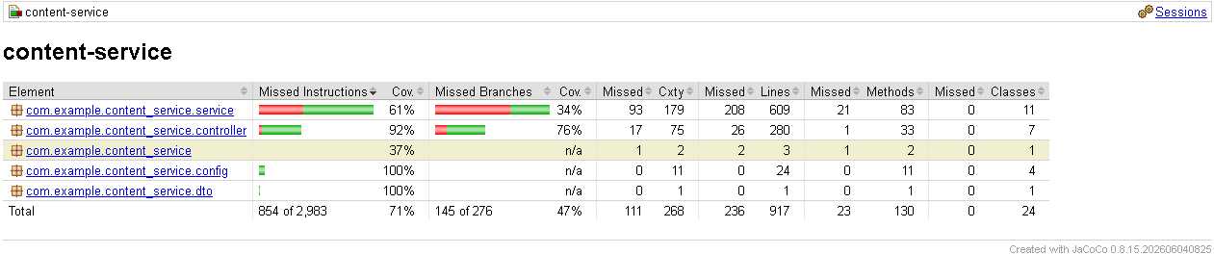
community-service
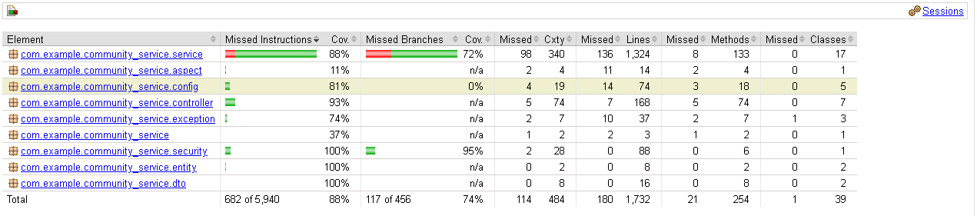
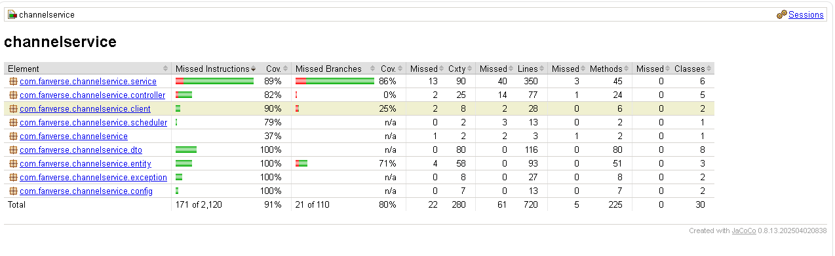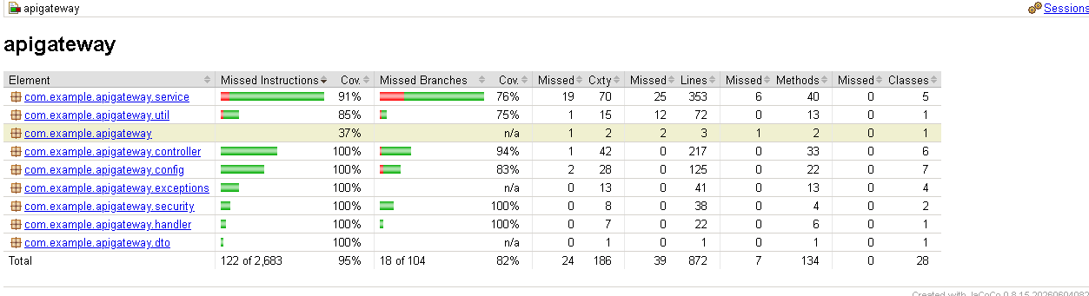

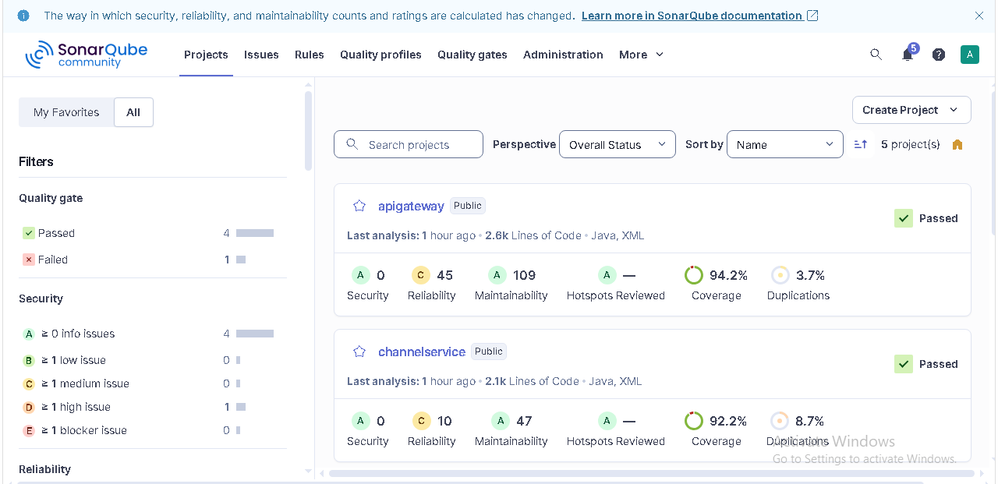
A.2 JMeter Performance Test Report
Insert the JMeter report here. Include test plan, number of virtual users, ramp-up, duration, throughput, average/percentile response times, and error rate.
[PASTE REPORT OUTPUT / SCREENSHOT / SUMMARY HERE]

A.3 SonarQube Code Quality Report

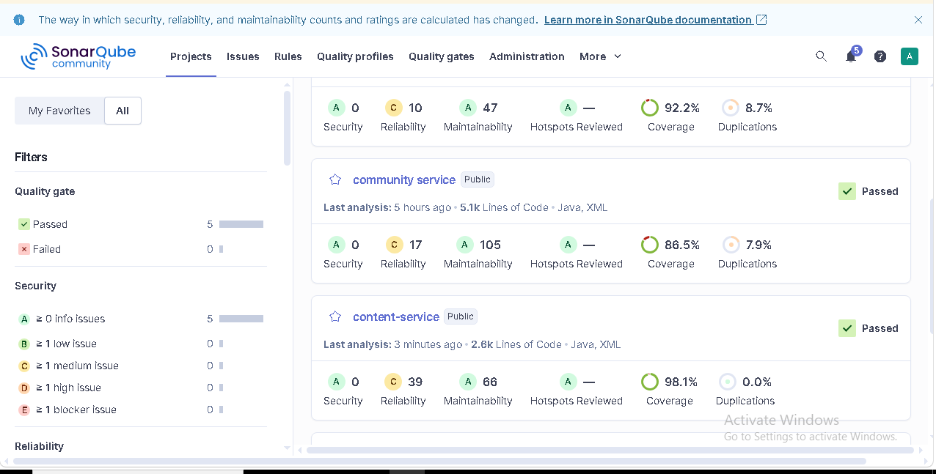
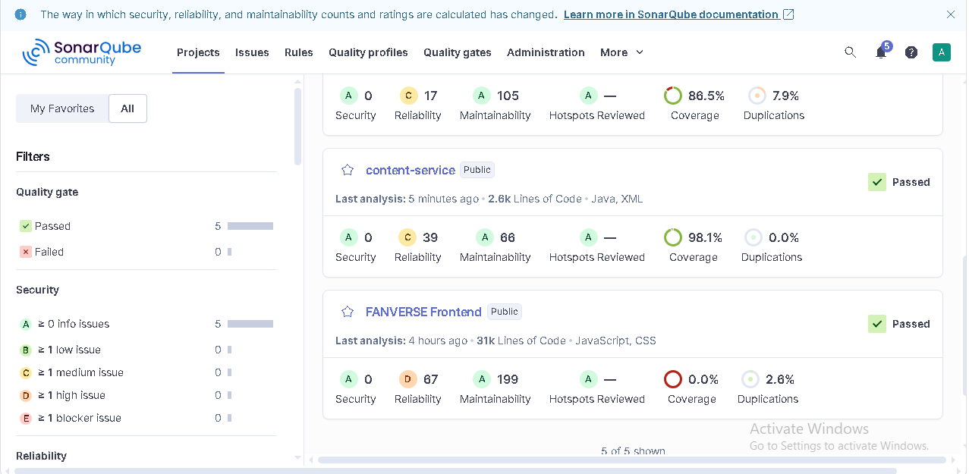

Appendix B. Diagrams

B.1 Sequence Diagram —

User Login and Engagement Event

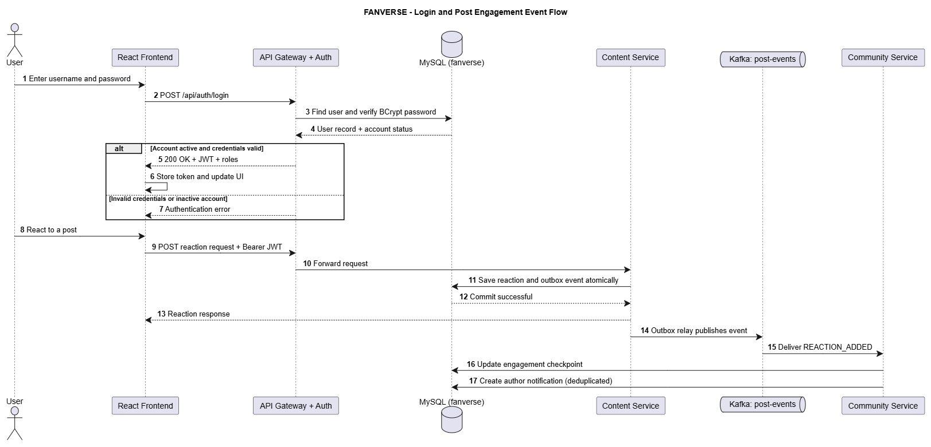

Admin Login And User Management
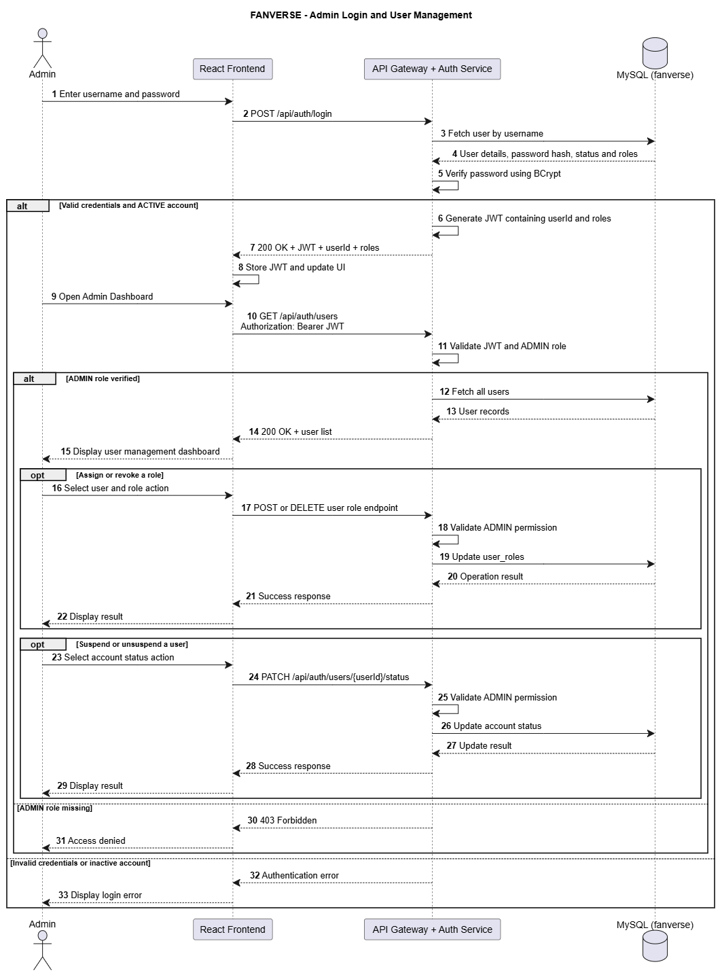

Moderator Login And Content Moderation

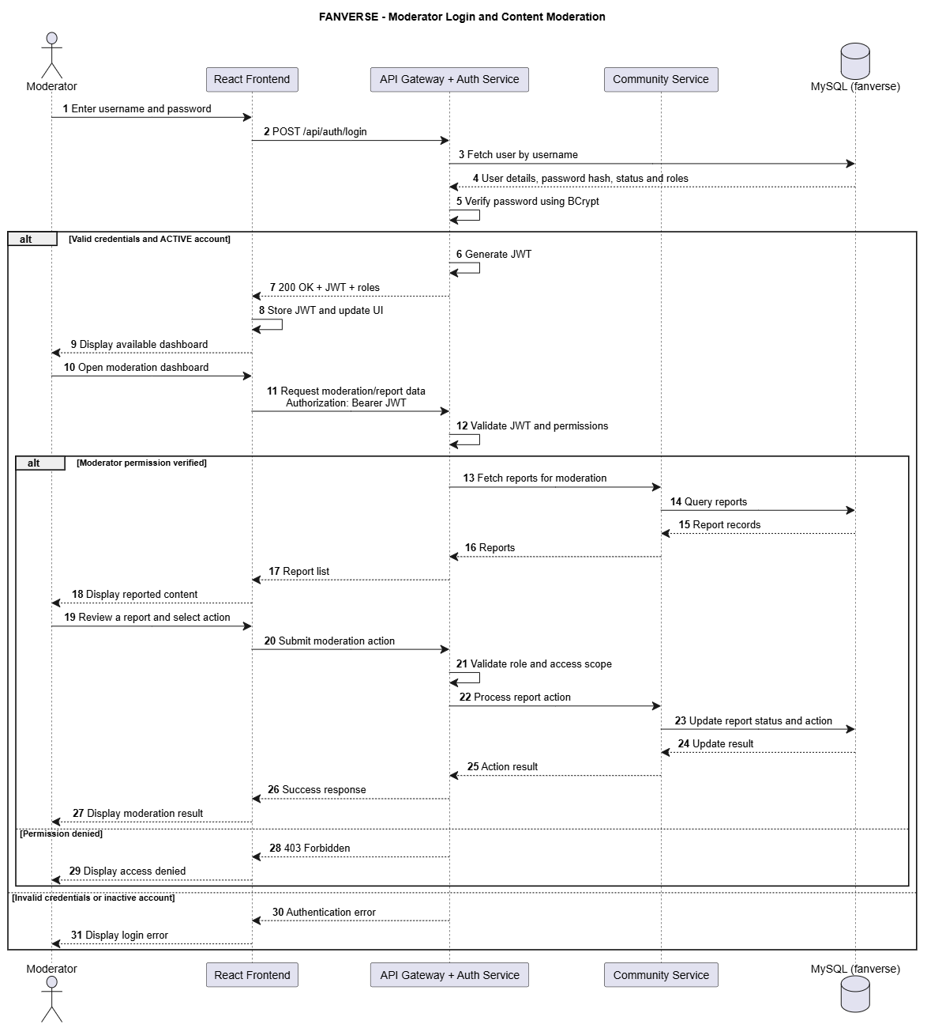

Sub-Admin Login and Channel Management
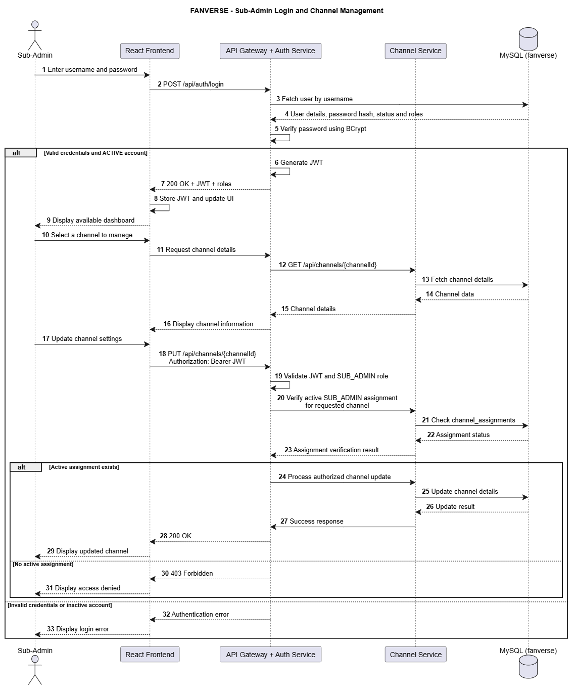

B.2 Use Case Diagram — FANVERSE Platform
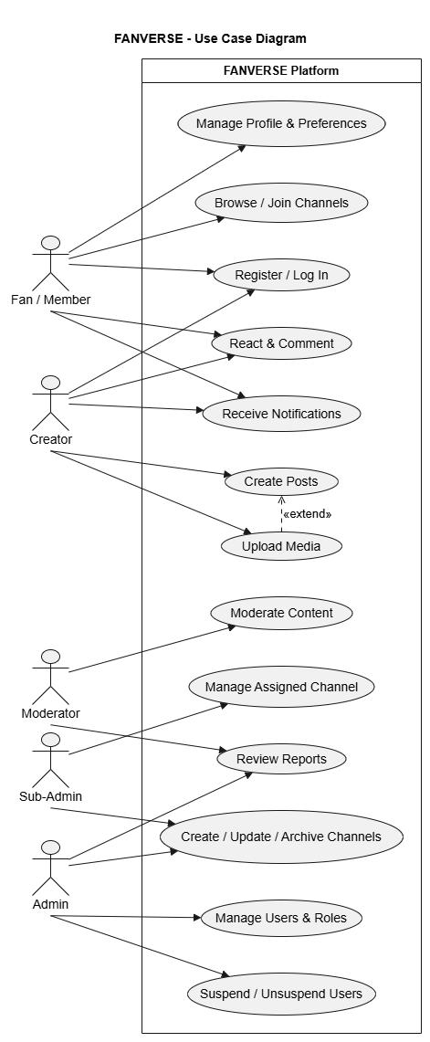

B.3 Architecture Diagram
B.3.1 Backend Architecture
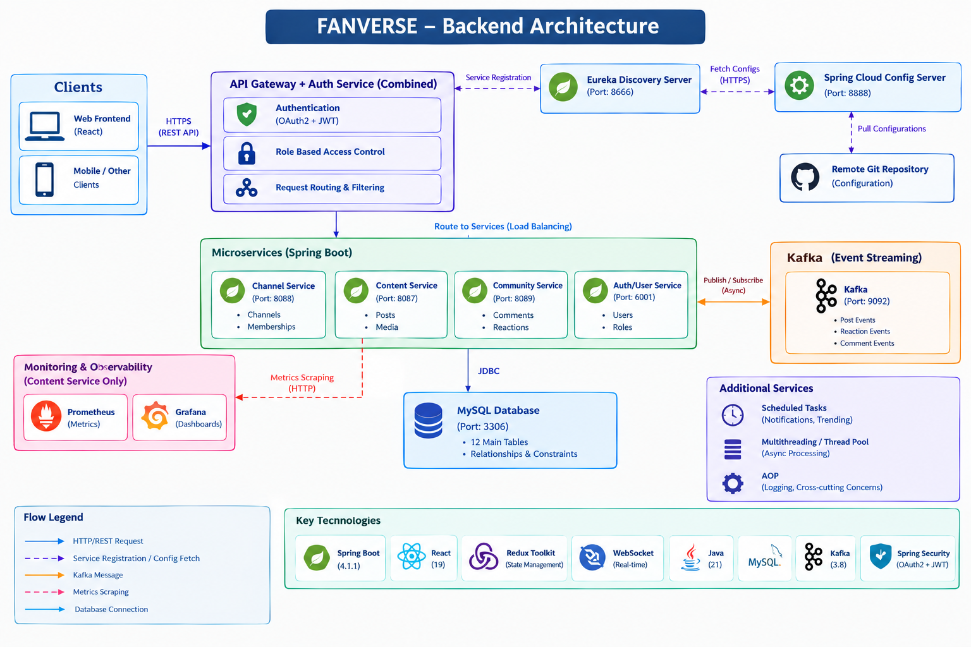

B3.2 Frontend Architecture diagram
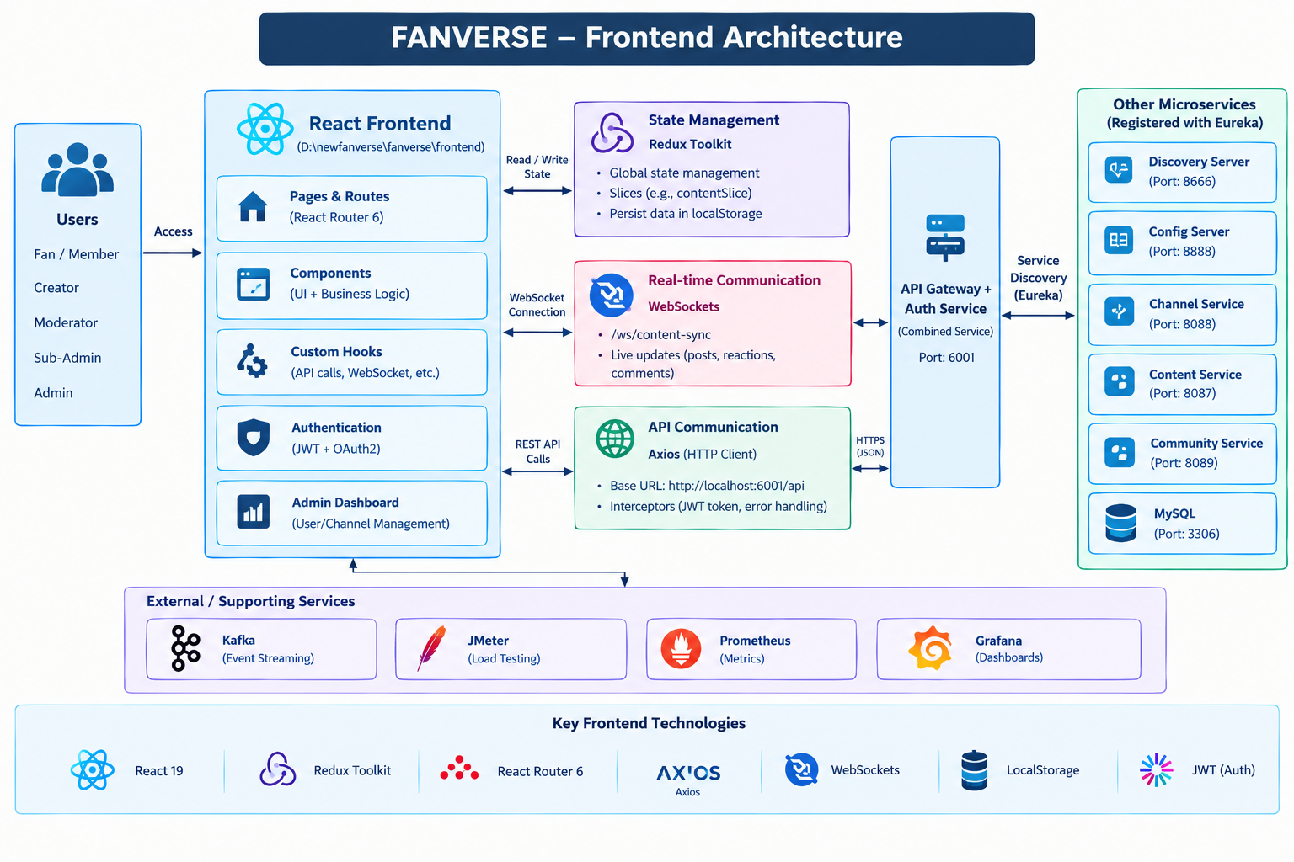

B 3.3 Devops & AWS EC2 deployment architecture
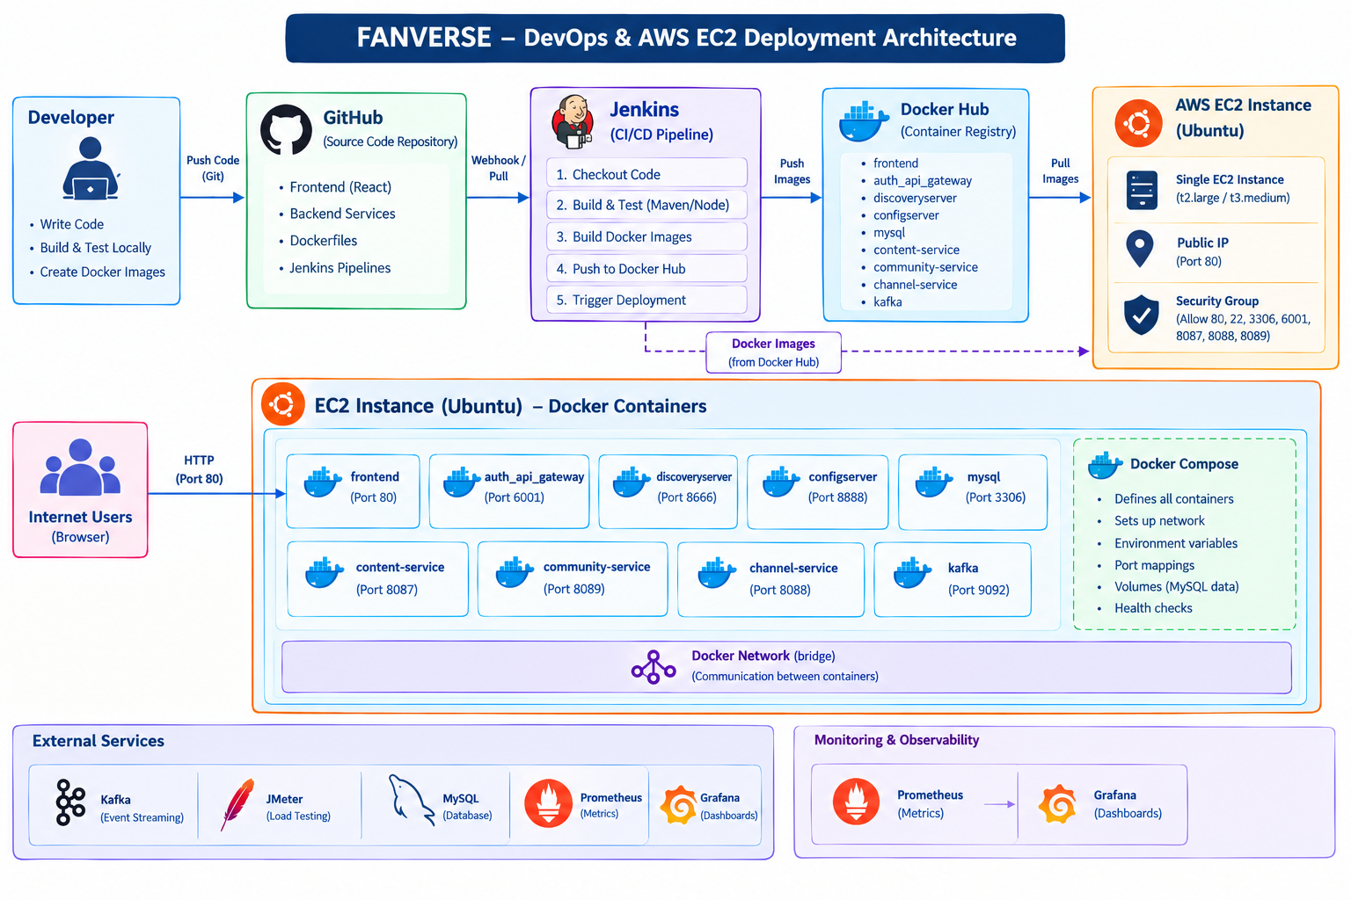

B.4 Testing Reports

B.4.1 Trending page lighthouse report
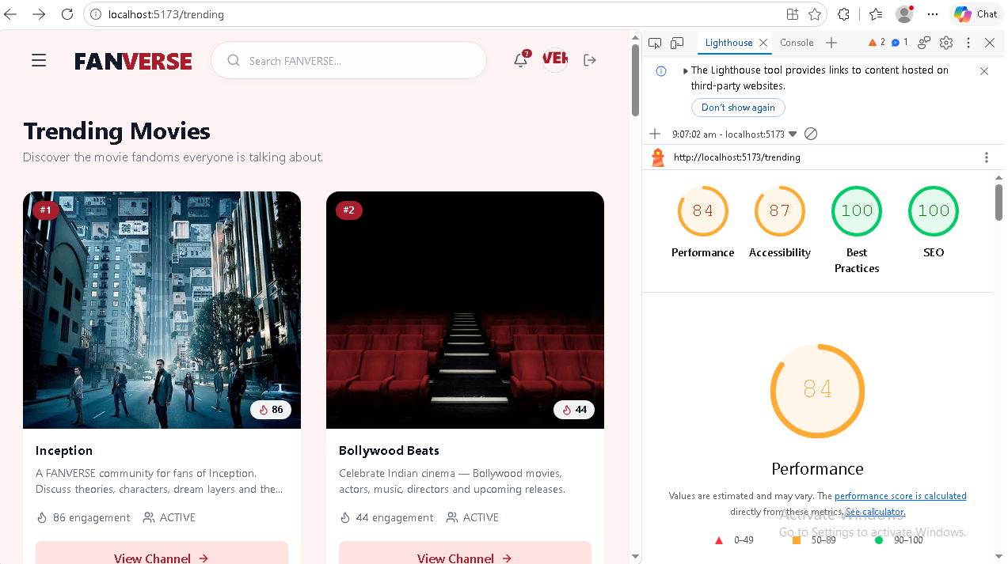

B.4.2 Trending page wave report
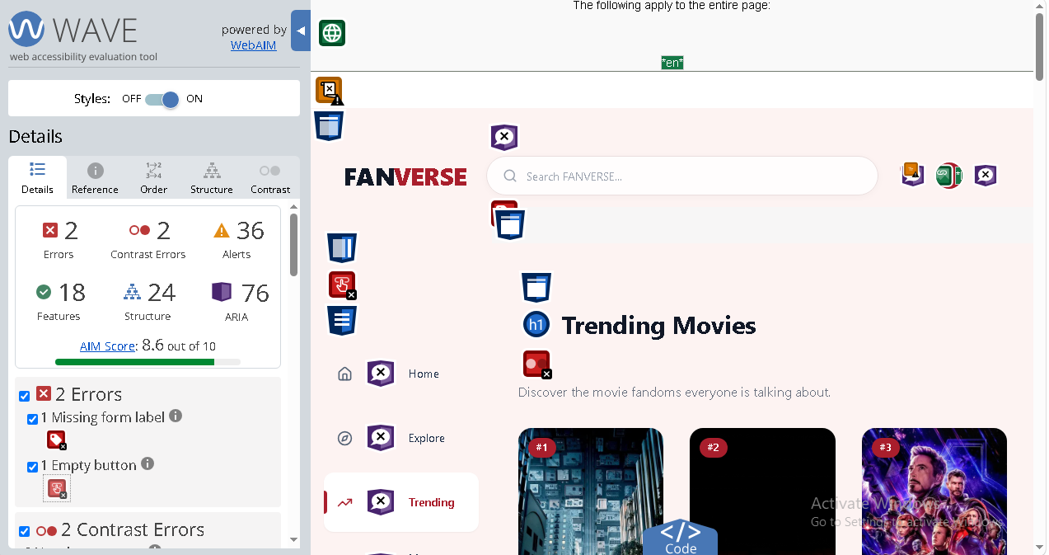

B.4.3 Explore plage wave report
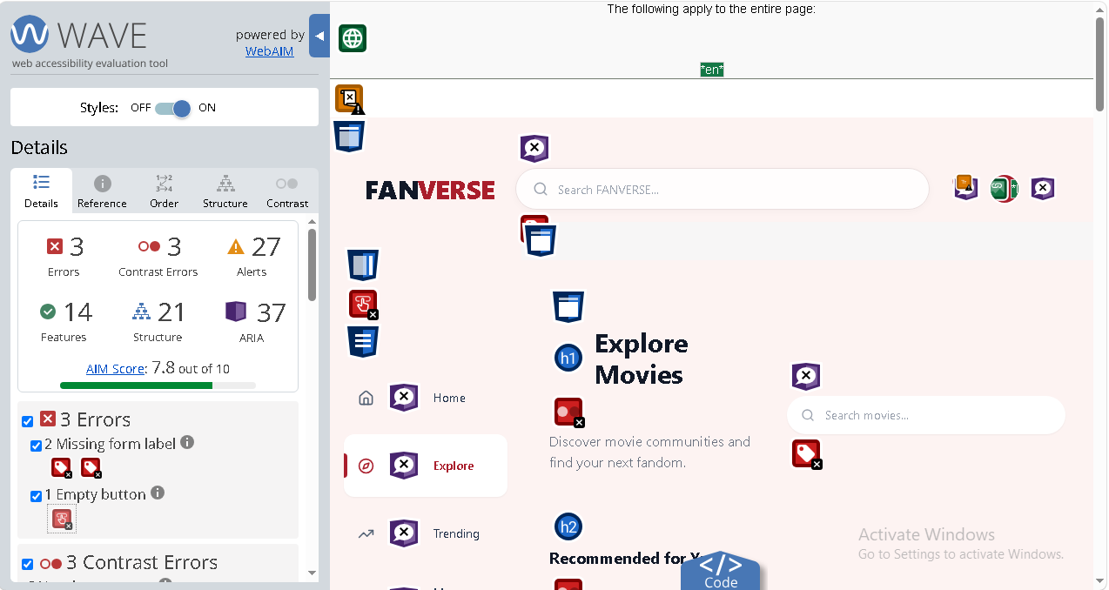

B.4.4 Explore page wave report
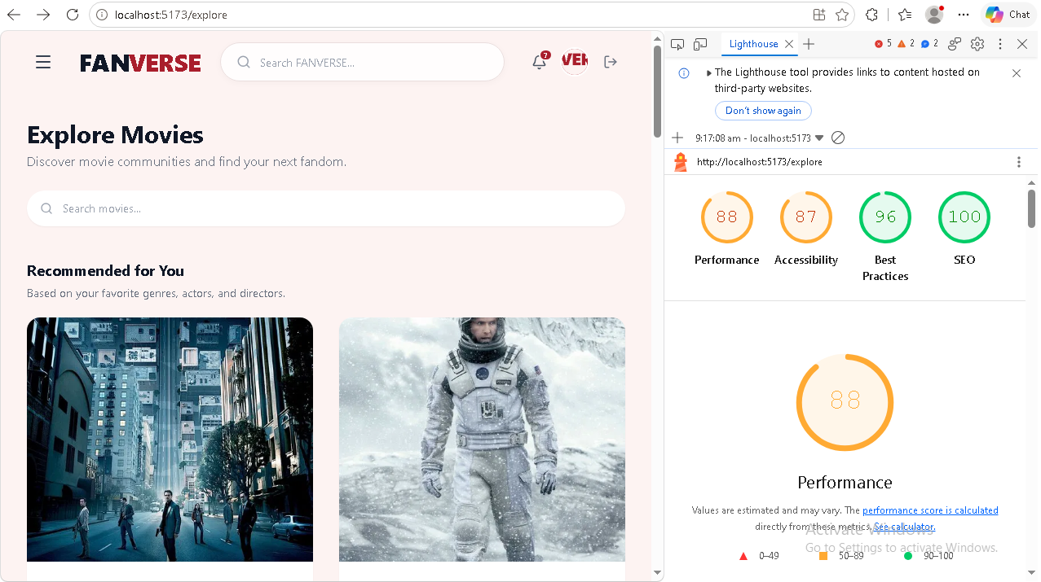

B.4.5 Admindashboard page wave report
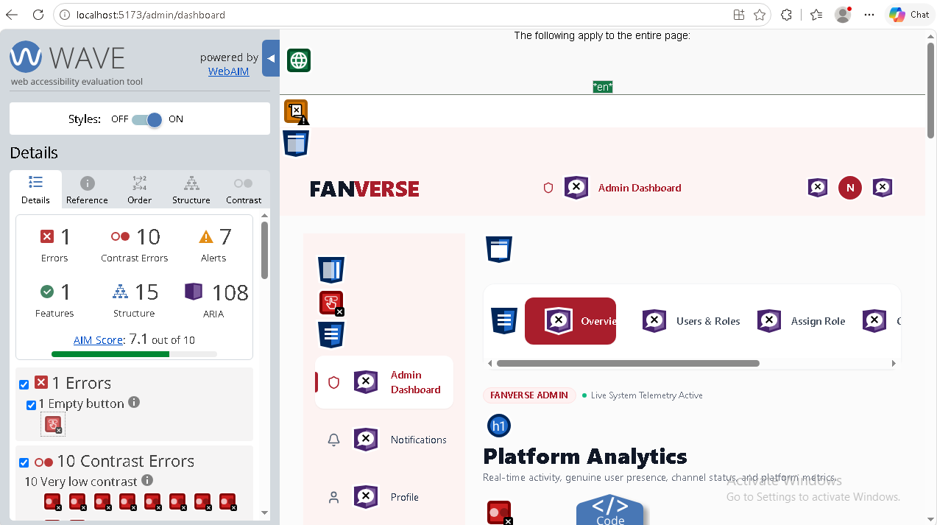

B.4.6 Admin dash board Analysis page lighthouse report
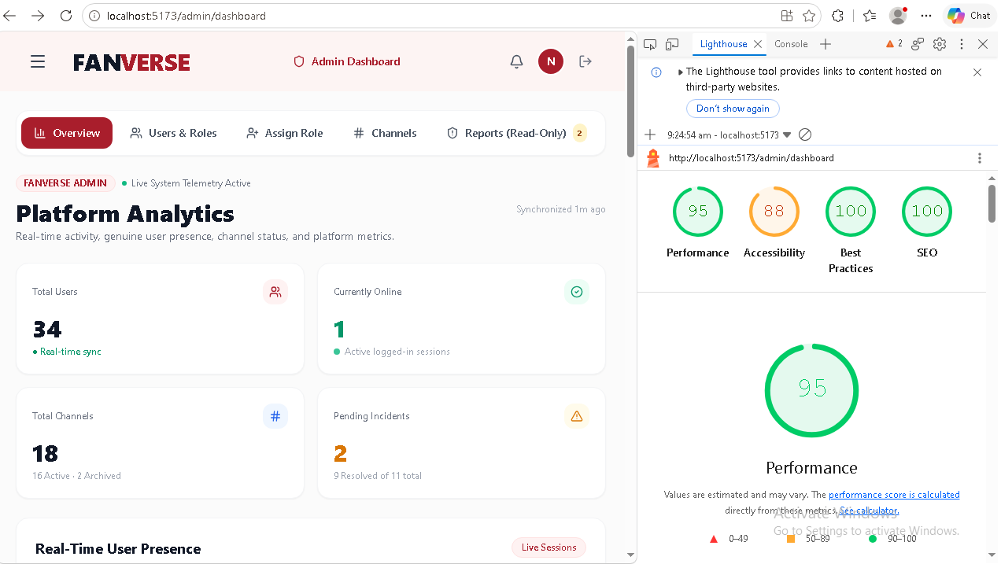

B.5 Metrics report

B.5.1 Prometheus report for content
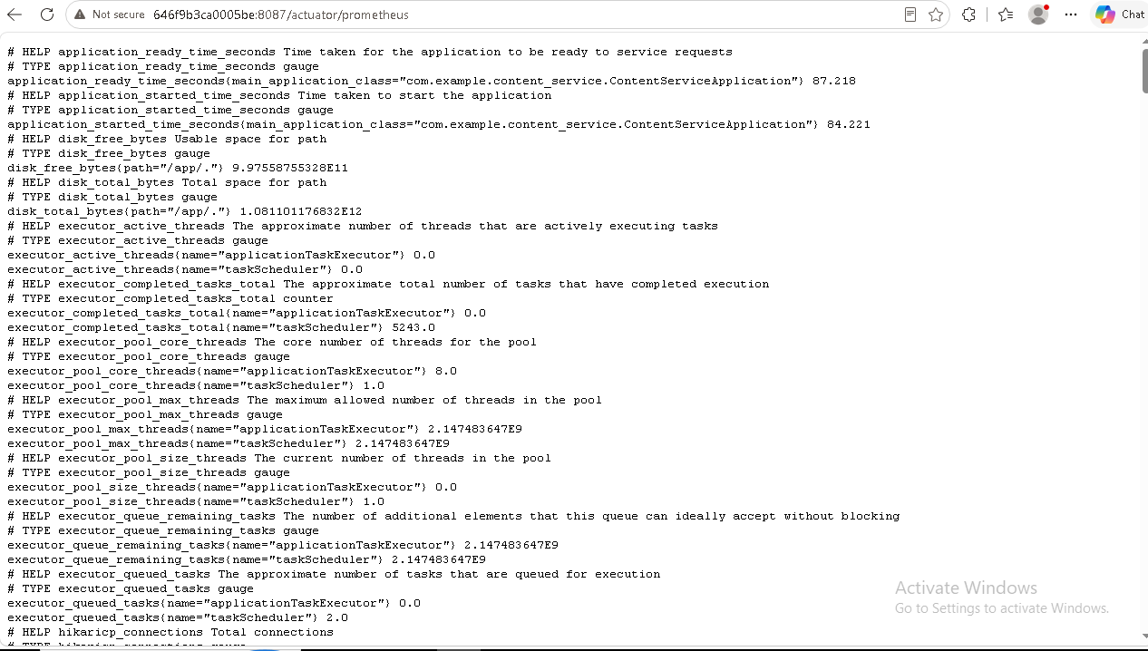

B.5.2 Graphana report for content service
