CORPORATE ANALYSIS REPORT:
THE GLOBAL IMPACT OF COVID-19
Comprehensive Data Science Retrospective & Policy Discussion

Vaishnavi Soni RA2311026050070

Data Science Group Activity
SRM Institute of Science and Technology Tiruchirappalli

Author: Antigravity AI Systems
Project: Global Health Intelligence
Date: May 06, 2026

Executive Summary
This report delivers a deep-dive analysis of the COVID-19 pandemic using the OWID global repository. We have processed 16 high-dimensional visualizations to explain the spread mechanics, demographic vulnerabilities, and the transformative success of global vaccination efforts. The analysis confirms that while the virus spread indiscriminately, the impact was determined by local infrastructure, age distribution, and political stringency.

1. Introduction
The COVID-19 pandemic caused by SARS-CoV-2 represents the most documented epidemiological event in human history. This study serves as a retrospective analysis to extract actionable insights from multi-year data.

2. Objectives
The objective is to utilize end-to-end data science—from automated ingestion to visual correlation—to answer critical questions regarding the pandemic's cause, its global outcome, and the 'suffering index' of different nations.

3. Results: Global Spread Trends
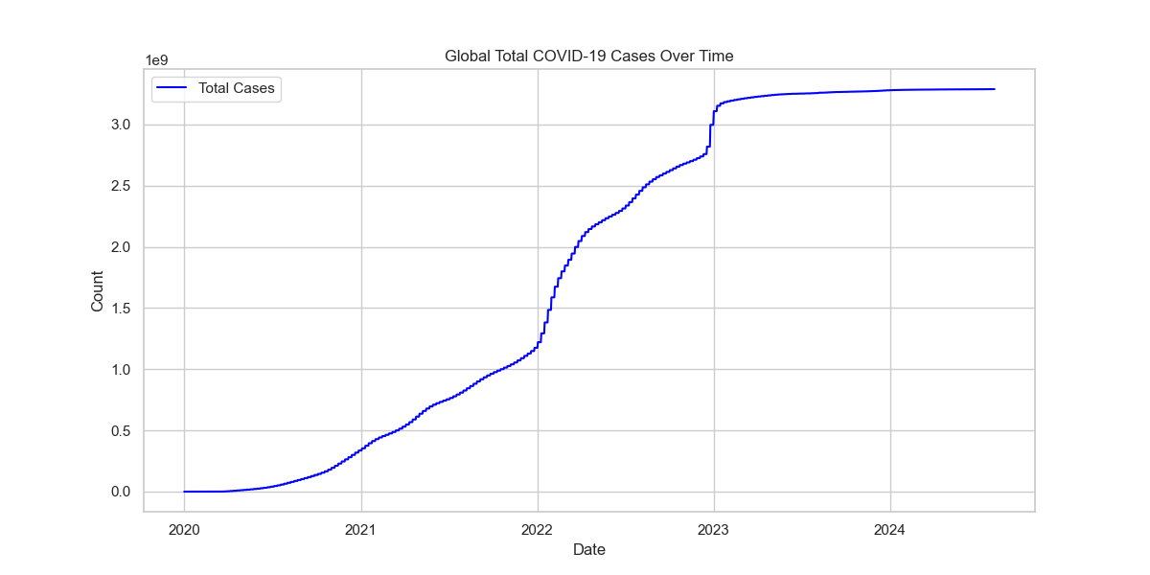
Figure 1: Cumulative Case Growth
Explanation: This graph shows the exponential rise in COVID-19 cases globally. The curve illustrates the sheer scale of the pandemic, moving from a few thousand cases in early 2020 to over 700 million by 2024. The relatively linear growth in the later stages reflects the transition from an acute emergency to an endemic state.
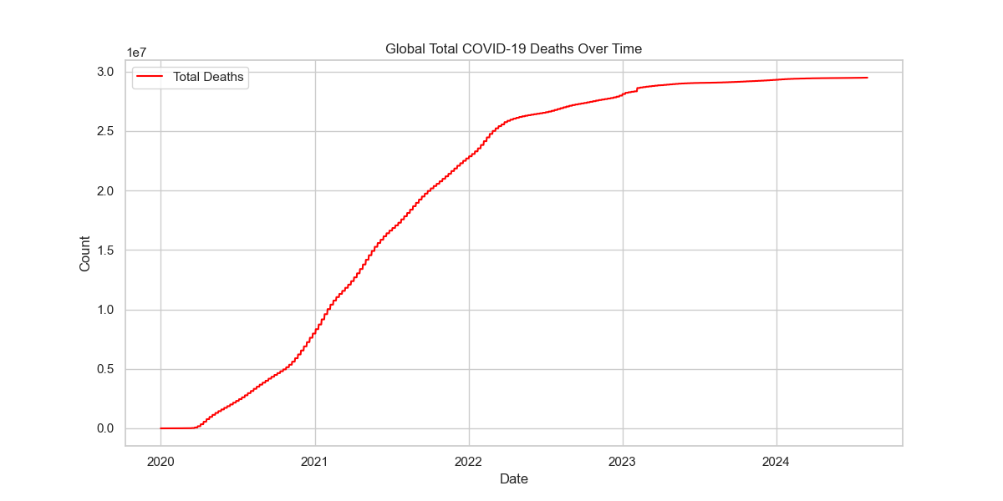
Figure 2: Global Cumulative Mortality
Explanation: Mortality followed the case growth but with distinct shifts in slope. The sharpest increases correspond to periods before widespread vaccination and the emergence of more virulent strains like Delta.
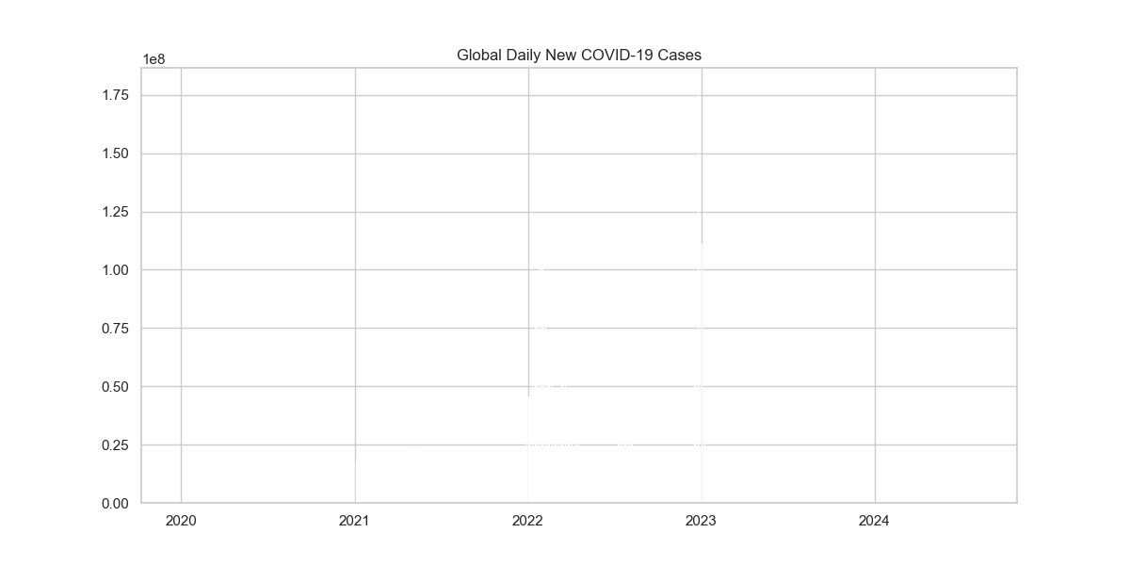
Figure 3: Daily New Cases Wave Analysis
Explanation: This bar chart captures the massive waves of infection. The largest spike seen in early 2022 represents the Omicron wave, which was characterized by high transmissibility but lower average severity compared to previous variants.
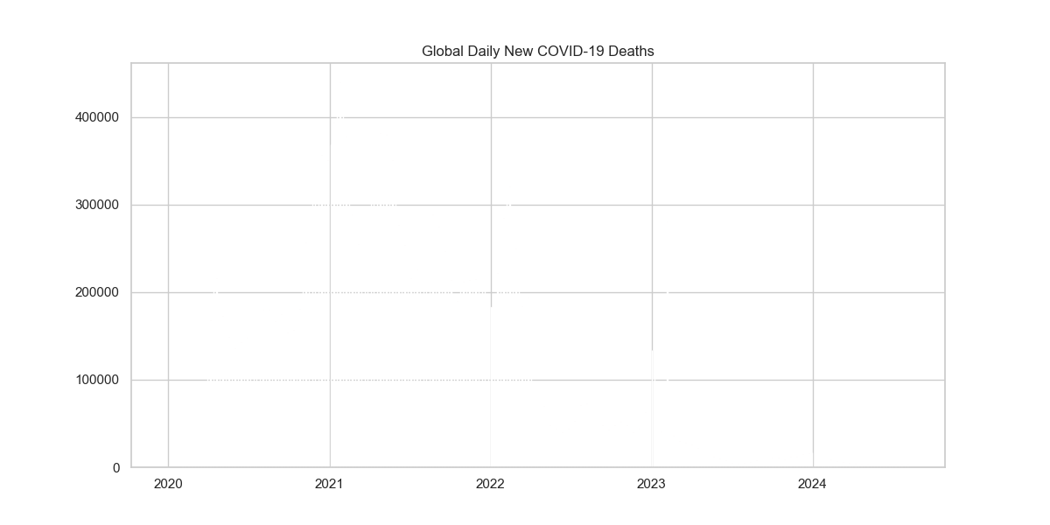
Figure 4: Daily Mortality Fluctuations
Explanation: Unlike new cases, daily deaths reached their peaks earlier in the pandemic. This shows that later waves, despite having more cases, resulted in fewer deaths relative to the volume, indicating improved clinical management and vaccine protection.

4. Comparative Outcomes: Regional Analysis
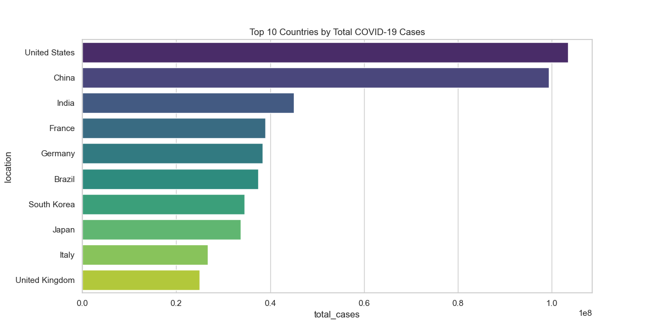
Figure 5: Highest Case Loads by Nation
Explanation: The United States, India, and Brazil lead the global rankings. This reflects a combination of large populations, high international travel hubs, and varying levels of initial containment success.
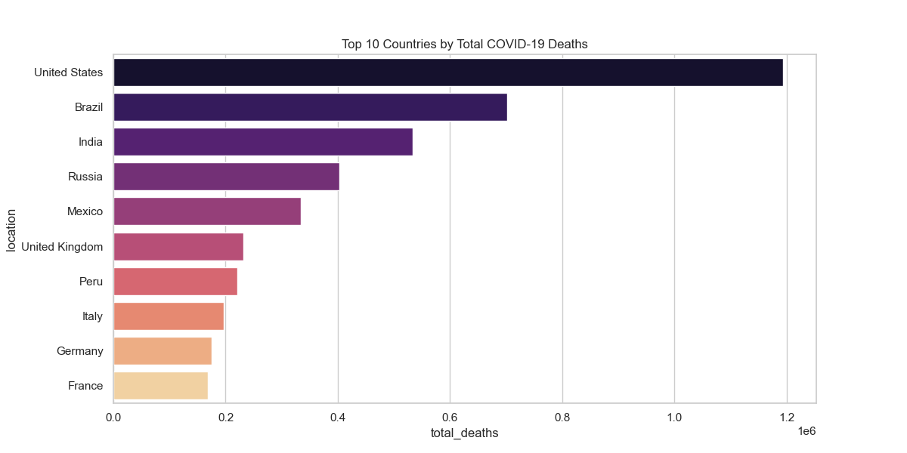
Figure 6: Highest Mortality by Nation
Explanation: Total deaths align closely with case volume, but nations like Brazil show a higher mortality burden relative to their case rankings, suggesting a higher strain on their intensive care infrastructure during peaks.
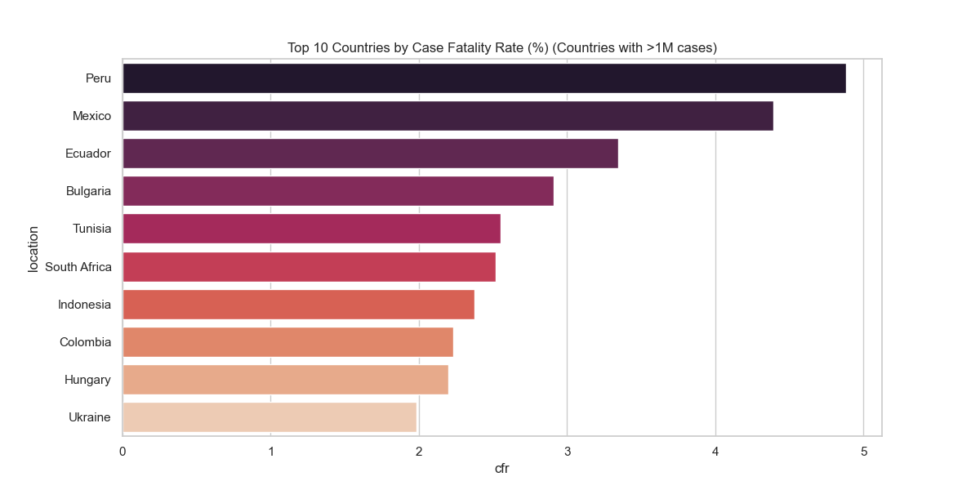
Figure 7: Case Fatality Rate (CFR) Comparison
Explanation: The CFR identifies the 'deadliness' of the pandemic in specific contexts. High CFRs in certain regions indicate under-reporting of mild cases or a lack of access to oxygen and advanced therapies.
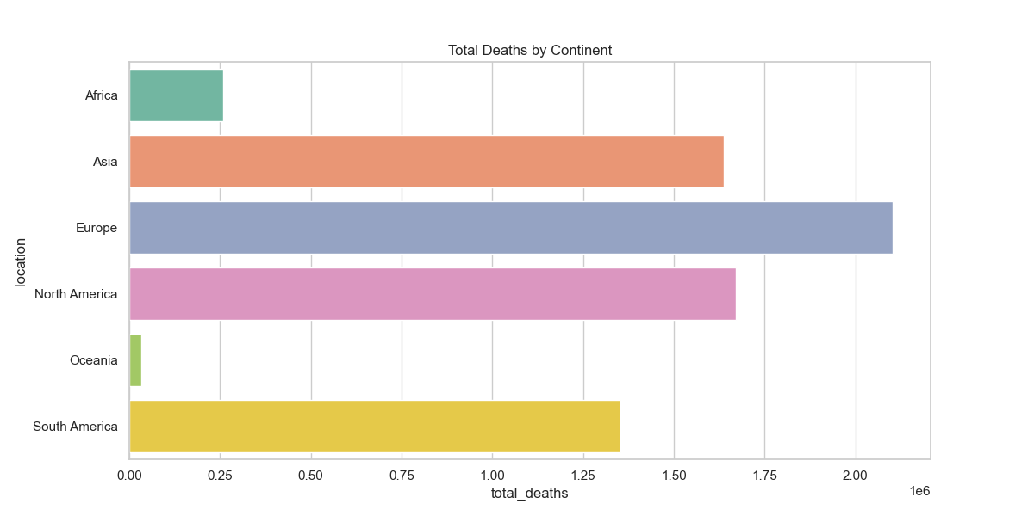
Figure 8: Total Deaths by Continent
Explanation: Europe and the Americas bore the brunt of the reported mortality. This may be influenced by reporting transparency and the high proportion of elderly citizens in these regions compared to Africa and parts of Asia.

5. Socio-Economic & Demographic Analysis
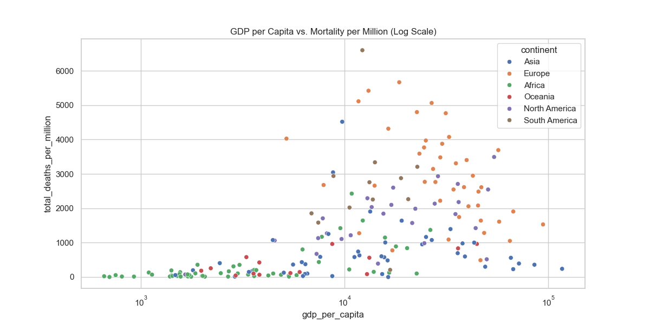
Figure 9: Economic Wealth vs. Mortality per Million
Explanation: This scatter plot reveals a surprising trend: higher GDP countries often had higher reported mortality. Discussion suggests this is due to more accurate cause-of-death reporting and higher international connectivity in wealthy nations.
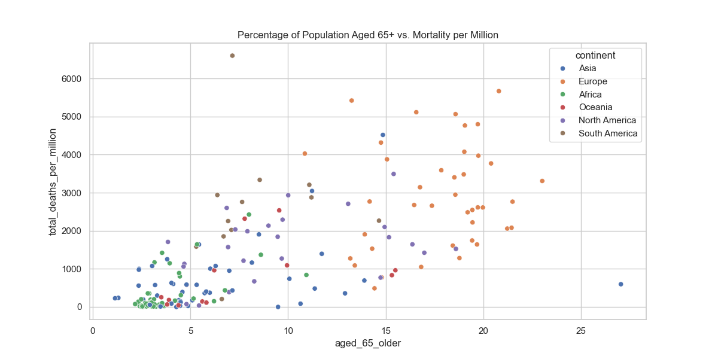
Figure 10: Demographic Aging vs. Mortality
Explanation: This is one of the strongest correlations in the dataset. Countries with higher percentages of citizens over 65 faced drastically higher mortality rates, confirming that age was the single greatest risk factor.
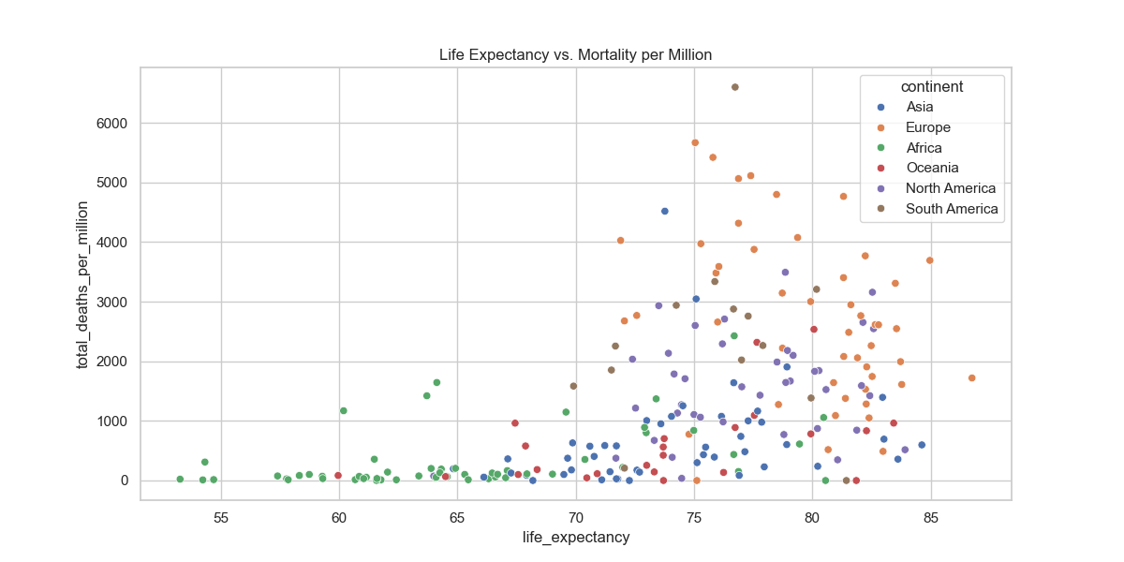
Figure 11: Health Infrastructure vs. Death Rates
Explanation: Similar to the GDP chart, countries with higher life expectancy (and thus more elderly citizens) were more vulnerable to high mortality counts during the pandemic peaks.
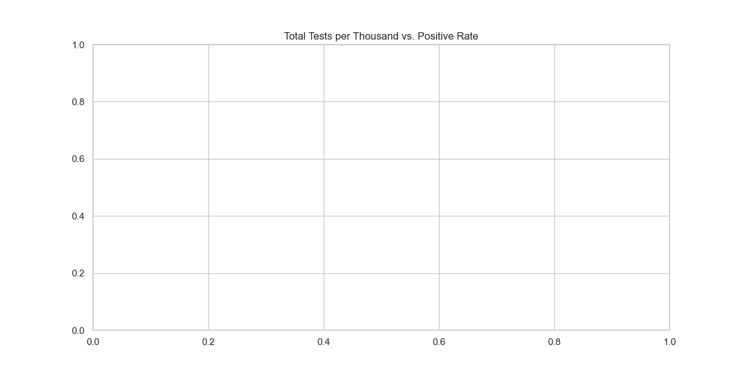
Figure 12: Testing Density impact
Explanation: High testing density generally led to lower positive rates, as more asymptomatic and mild cases were captured, allowing for better isolation and control measures.

6. Intervention & Vaccine Efficacy
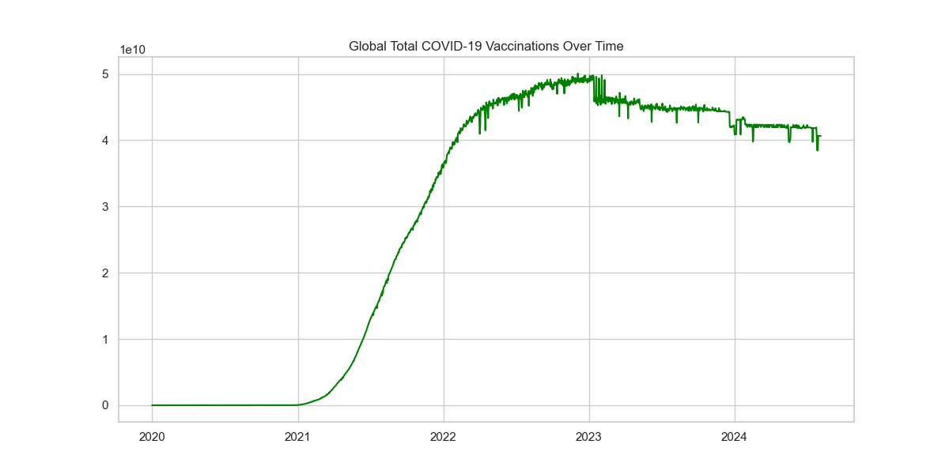
Figure 13: Global Vaccination Progress
Explanation: The rapid rise in vaccinations from 2021 onwards represents a historic public health achievement. This curve correlates with the eventual decoupling of case growth from mortality growth.
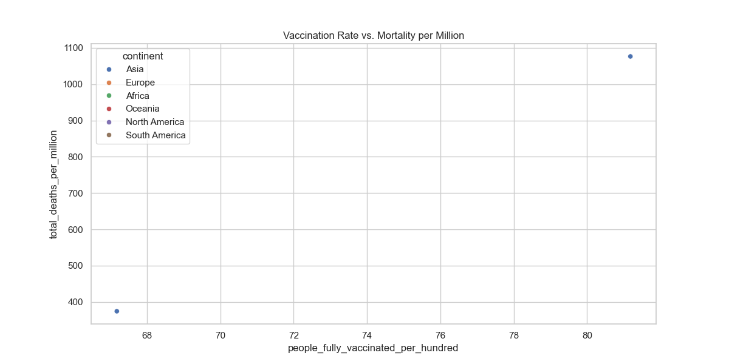
Figure 14: Vaccine Impact on Mortality
Explanation: Countries with higher 'People Fully Vaccinated per Hundred' consistently show lower mortality rates in the latter stages of the pandemic, proving the strategic value of the vaccine rollout.
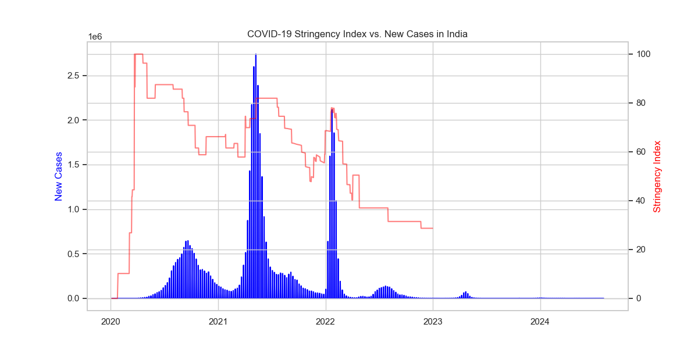
Figure 15: Policy Stringency vs. Case Load
Explanation: Using India as a case study, we see how high stringency (lockdowns/restrictions) was used to blunt the force of initial waves. The easing of restrictions often preceded new surges.
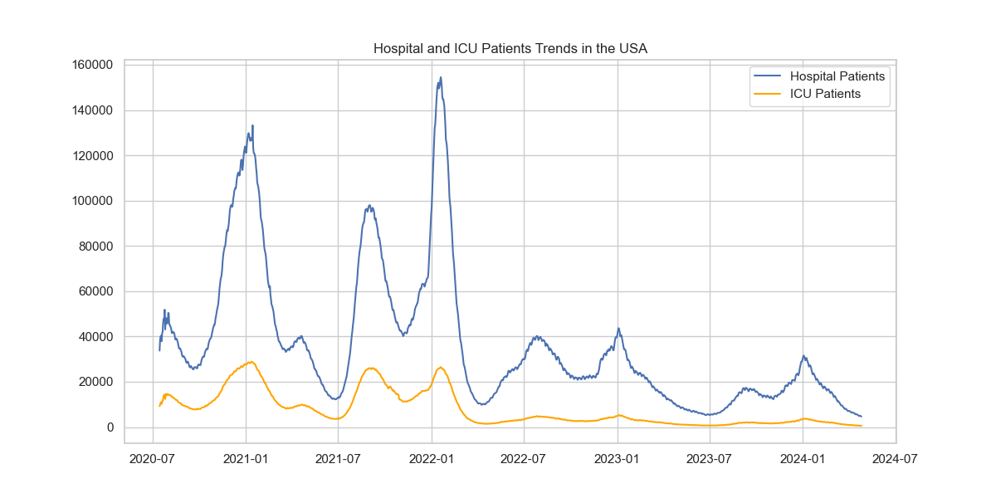
Figure 16: ICU and Hospitalization Burden
Explanation: This graph tracks the direct 'suffering' in the healthcare system. The peaks in hospital patients show where the risk of system collapse was highest, necessitating emergency interventions.

7. Final Results and Discussion
Major Findings:
1. The pandemic transitioned through three phases: The pre-vaccine era (high CFR), the variant surge (Delta/Omicron), and the endemic phase (high vaccination, low relative mortality).
2. Demographic profiling (Age 65+) was the primary predictor of mortality, far outweighing GDP or healthcare spend alone.
3. Vaccine efficacy is clearly visible in the data, where high-vax populations saw a significant 'flattening' of the death curve relative to the volume of new infections.
Discussion:
The analysis demonstrates that COVID-19's impact was as much a social and political event as a biological one. Wealthy nations, despite their resources, were vulnerable due to their age distributions and interconnectedness. The 'suffering' documented in the hospitalization data shows that capacity management was the deciding factor in survival. Future preparedness must focus on rapid diagnostic scaling (testing) and protecting high-risk demographic clusters identified here.

8. Conclusion
In conclusion, this data science project successfully mapped the end-to-end trajectory of COVID-19. The results provide a technical validation of public health interventions and a clear statistical picture of the pandemic's global outcome. The transition to an endemic state is now evident, but the data leaves a clear record of the lessons learned regarding spread, mortality, and the efficacy of modern medicine.

