


SYNOPSIS
For the
PG Management System

Submitted by:
Name: Suthar Vaishnavi Hitulkumar
Enrollment No.: 3060821027
Semester: 7TH
Course Code: PRJT 411
Date: 22/09/2025

Name of Guide: Dr.X.U.Shukla _{(Asst. Prof. CAIT)}
Signature of Guide: _______________

College of Agricultural Information Technology
Anand Agricultural University,
Anand

INDEX

Table of Contents
No. | Contents | Page No.
1 | Project Title | 3
2 | Introduction | 3
3 | Purpose | 3
4 | Objectives | 3
5 | Platform/Hardware and Software | 3
6 | Functionality | 4
7 | Context level Data Flow Diagram | 5
8 | E – R Diagram | 5
9 | Data Dictionary | 6

- PROJECT TITLE:

“PG Management System”

- INTRODUCTION:

The PG Management System is a web-based application designed to manage the operations of a Paying Guest facility. It automates record-keeping of tenants, rooms, and payments, reducing manual work and improving efficiency. The system is implemented using Python Flask (backend), HTML/CSS/JS (frontend), and SQLite (database).
- PURPOSE:

The purpose of this project is to provide a computerized PG Management System for administrators to manage rooms, occupancy, tenant records, and payment tracking efficiently. The system also generates QR codes for simple scan-and-pay rent collection.

- OBJECTIVE:

- Secure login for Admin
- Manage rooms & categories
- Track occupancy (available vs booked rooms)
- Handle payments (with QR code/scan for rent collection)
- Maintain user/tenant history

- PLATFORM / HARDWARE & SOFTWARE:

- Hardware: 12th Gen Intel(R) Core(TM) i7-12700F 2.10 GHzusable) 32.0 GB (31.9 GB usable).
- Front – End: Tkinter (desktop) / HTML, CSS, JS (web)
- Code – Behind: Python Flask
- Back – End: SQLite
- Developing Tool: Visual Studio 2022

- FUNCTIONALITY:

- Administrator module

The Administrator Module is the core of the PG Management System. It provides the administrator with secure access to manage all system operations. The admin can perform the following tasks:

- Authentication & Security
- Admin login with username and password
- Session-based authentication to prevent unauthorized access

- Room Management
- Add, update, and delete rooms
- Define categories of rooms (Single, Double, AC/Non-AC)
- Mark rooms as Available or Occupied

- Tenant Management
- Register new tenants with personal details and ID proof
- Allocate rooms to tenants
- Track check-in and check-out dates
- Maintain complete tenant records

- Occupancy Tracking
- Monitor the status of each room (vacant/occupied)
- Generate reports of room utilization

- Payment Management
- Record tenant rent payments
- Generate and display QR codes for scan-and-pay facility
- Track paid and pending payments
- Maintain monthly payment history

- Reports & History
- Generate reports of tenants, rooms, and payments
- Maintain tenant stay history
- View financial records for analysis

- CONTEXT LEVEL DATA FLOW DIAGRAM:
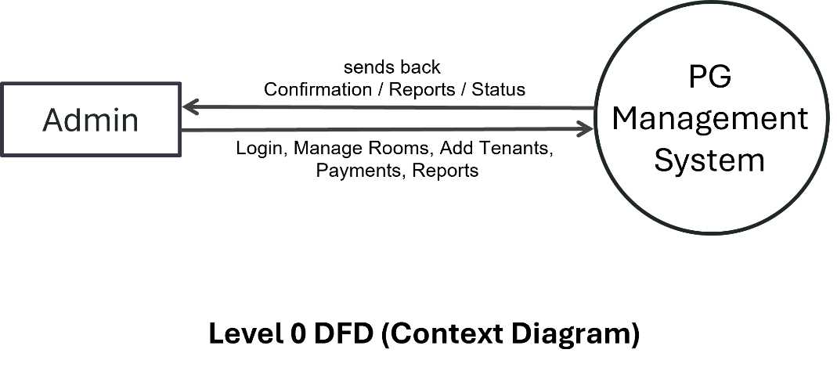

- ER DIAGRAM:
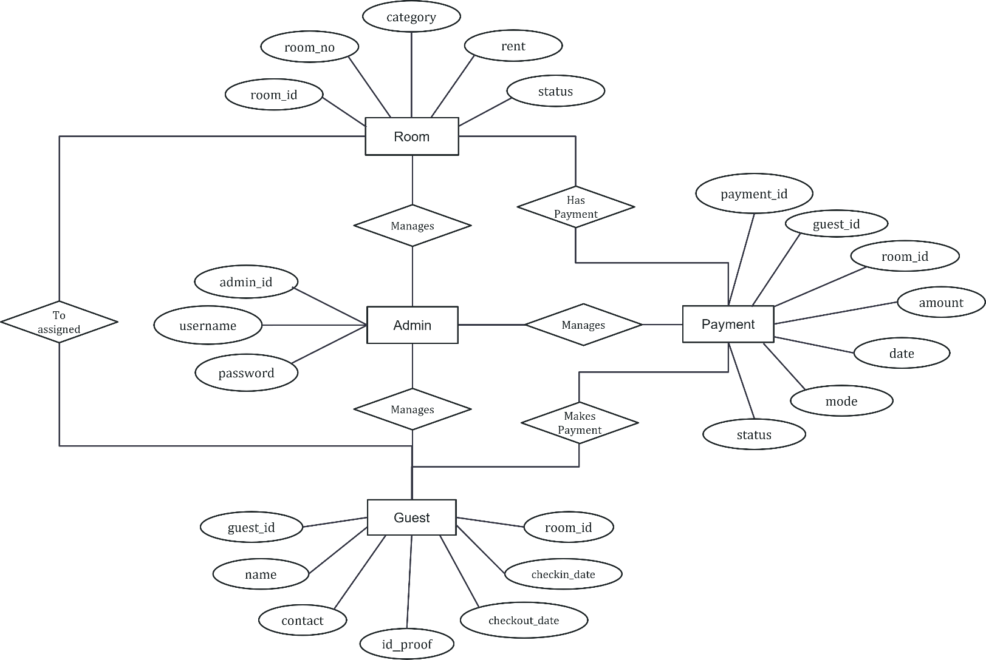

ER Diagram

- DATA DICTIONARY:

- Admin

Field Name | Data Type | Constraint | Description
admin_id | Int | PK | Unique identifier for each admin user.
username | Varchar | Not Null | Login username for admin authentication.
password | Varchar | Not Null | Hashed password for secure admin login.

- Rooms

Field Name | Data Type | Constraint | Description
room_id | Int | PK | Unique identifier for each room.
room_no | Varchar | Not Null | Room number assigned to each room.
category | Varchar | Not Null | Category of the room (e.g., Single, Double, Deluxe).
rent | Real | Not Null | Monthly rent for the room.
status | Varchar | Check | Current availability status of the room.

- Guest

Field Name | Data Type | Constraint | Description
guest_id | Int | PK | Unique identifier for each tenant.
name | Varchar | Not Null | Full name of the tenant..
contact | Varchar | Not Null | Contact number of the tenant.
id_proof | Varchar | Not Null | ID proof document (e.g., Aadhaar, Passport).
checkin_date | Date | Not Null | Date when the tenant checked in.
checkout_date | Date | Not Null | Date when the tenant checked out.
room_id | Int | FK | References room_id from Rooms table.

- Payment

Field Name | Data Type | Constraint | Description
payment_id | Int | PK | Unique identifier for each payment record.
guest_id | Int | FK | References tenant_id from Tenant table.
room_id | Int | FK | References room_id from Rooms table.
amount | Real | Not Null | Amount paid by the tenant.
date | Date | Not Null | Date of payment transaction.
mode | Varchar | Check | Mode of payment (QR code scan, Cash, or Online).
status | Varchar | Check | Current payment status.

