Chanakya University
School of Engineering



Fundamentals of Computer Architecture
Assignment - 01

Submitted by:

TeamName: RocketByte

Vaishnavi – 24UG00389
Deepika M – 24UG00504
Veena V – 24UG00603

Branch: Computer Science and Engineering

Semester: V

Experiment 1: Build a Stopwatch You Can Trust
1. Aim
To measure CPU cycles on the ESP32 and understand how loop overhead and compiler optimization affect the results.
2. Background
The ESP32 has a cycle counter that helps us measure CPU cycles. Our board was running at 240 MHz. We used a baseline loop for comparison and tested both volatile and normal variables.
3. Prediction
We expected repeated tests to give similar results after resetting the board. We also expected the volatile and normal variable tests to give different cycle counts.
Use this prediction only if it matches what your team expected before testing.
4. Method
- Connected the ESP32 board and opened Arduino IDE.
- Set the board to ESP32 Dev Module and used a CPU frequency of 240 MHz.
- Used ESP.getCycleCount() to measure CPU cycles.
- Tested 10 and 1,000 operations, with five trials for each.
- Reset the board and repeated the test.
- Compared addition using volatile and normal variables.
- Recorded the Serial Monitor output.
5. Observations
A. Repeatability test
Operations | Baseline cycles | Total cycles | Estimated cycles/op
10 | 93 | 187 | 9.400
1,000 (usual trials) | 9,003 | 18,007 | 9.004
1,000 (Trial 2) | 9,920 | 18,007 | 8.087
- The final result was 30 in every test.
- After resetting the board, the results were almost the same.
- Trial 2 had a different baseline reading.

B. Volatile test
Variable type | Measured cycles | Result
Volatile | 13,288 | 30
Non-volatile | 15 | 30
The non-volatile test took much fewer measured cycles than the volatile test.
6. Analysis
The repeatability test gave mostly similar results before and after resetting the board. The estimated cost was around 9 cycles per operation in the 1,000-operation test. The volatile test took more cycles because the compiler must respect volatile memory accesses. These measurements also include loop and measurement overhead, so they are not the exact cost of one addition.
7. What We Learnt
We learnt how to measure CPU cycles using the ESP32. Repeating tests helps us check whether results are consistent. We also learnt that compiler optimization can affect measured execution time.
8. LLM Log
Prompt used: “Explain how to measure CPU cycles on the ESP32 and why loop overhead and the volatile keyword matter.”
LLM response: The LLM explained how to use ESP.getCycleCount() to measure CPU cycles and how a baseline loop helps estimate the cost of an operation. It also explained that volatile prevents the compiler from treating a variable as an ordinary value that never changes unexpectedly.
Verification: We ran the tests on the ESP32, recorded the Serial Monitor results, and compared the measured cycle counts. The actual board measurements were used to analyse repeatability, loop overhead, and compiler optimization.
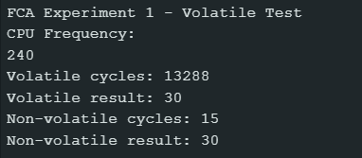

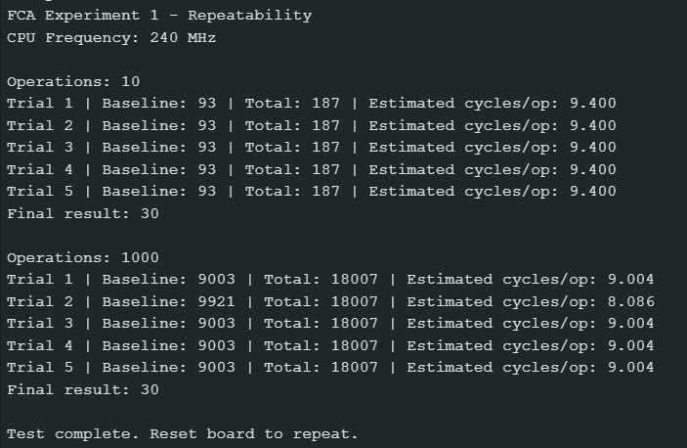

Experiment 2: Is Smaller Faster?
1. Aim
To find out whether the size of an integer affects the speed of addition, multiplication, and division on the ESP32.
2. Background
Computers represent numbers using different sizes, such as 8-bit, 16-bit, 32-bit, and 64-bit integers. The ESP32 uses a 32-bit processor. Therefore, operations on different integer sizes may take different amounts of time. We conducted this experiment to compare their performance.
3. Prediction
Before running the experiment, our prediction was that smaller integer types would be faster than larger integer types. We also expected 64-bit operations, especially division, to take more time.
4. Method
- We connected the ESP32 board to the computer using a USB cable.
- We opened the program in Arduino IDE and set the CPU frequency to 240 MHz.
- We tested addition, multiplication, and division using different integer types: int8_t, int16_t, int32_t, int64_t, and uint32_t.
- Each test performed 10,000 operations and was repeated five times.
- We measured the CPU cycles and subtracted a baseline to estimate the cost per operation.
- We recorded the results shown in the Serial Monitor.

5. Observations
The ESP32 operated at 240 MHz. Each test used 10,000 iterations and was repeated five times. The reported values are median estimated cycles per operation after approximate baseline subtraction.
Addition
Integer type | Estimated cycles/op | Result
8-bit | 13.002 | 12
16-bit | 16.098 | 1005
32-bit | 13.093 | 100010
64-bit | 24.091 | 1000000010

Multiplication
Integer type | Estimated cycles/op | Result
8-bit | 14.003 | 20
16-bit | 17.096 | 5000
32-bit | 14.003 | 1000000
64-bit | 26.093 | 10000000000
Division
Integer type | Estimated cycles/op | Result
8-bit signed | 23.090 | 5
16-bit signed | 26.093 | 200
32-bit signed | 19.097 | 10000
64-bit signed | 117.478 | 100000000
32-bit unsigned | 19.180 | 10000
The 8-bit and 32-bit addition measurements were very close. The same was observed for multiplication. The 64-bit operations took more estimated cycles, especially division. Signed and unsigned 32-bit division had almost identical estimated costs.
6. Analysis
The 8-bit and 32-bit addition and multiplication timings were almost the same. The 16-bit operations took slightly more cycles, while 64-bit operations were slower.
64-bit division was the slowest operation, taking 117.478 estimated cycles per operation. Signed and unsigned 32-bit division had nearly identical timings of 19.097 and 19.180 cycles per operation.
These results show that smaller integer types are not always faster. The timings are estimates because baseline subtraction is approximate.
7. What We Learnt
- Smaller integer types are not always faster than 32-bit integers.
- The size of an integer can affect the performance of arithmetic operations.
- The ESP32 is a 32-bit processor, so 64-bit operations may require extra processing.
- Repeated measurements and baseline subtraction help us estimate operation costs.
- Results must be interpreted carefully because measurement overhead can affect timing.
- 64-bit division was the most expensive operation among the tested operations.
- Signed and unsigned 32-bit division had very similar measured costs.

8. LLM Log
Prompt used: “Explain how integer size can affect the speed of addition, multiplication, and division on a 32-bit ESP32.”
LLM response: The LLM explained that the ESP32 is a 32-bit processor and that smaller integer types are not always faster. It also explained that 64-bit arithmetic may require more processing than 32-bit arithmetic.
Verification: We ran addition, multiplication, and division tests using different integer types on the ESP32. We recorded the measured cycle counts and compared them to understand how integer size affected performance in our experiments.

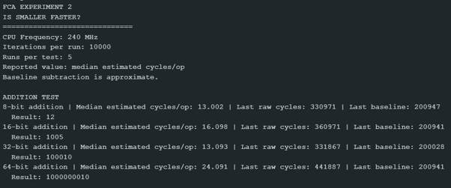
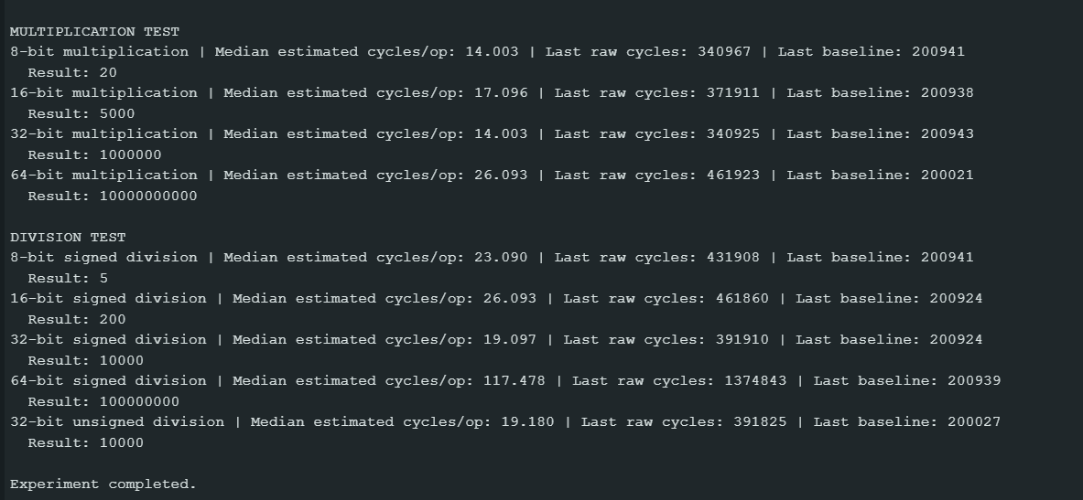

Experiment 3: Float versus Double
1. Aim
To compare the speed of float and double operations on the ESP32 and compare floating-point operations with 32-bit integer addition.
2. Background
Float and double store decimal numbers. We tested addition, multiplication, division, and square root using both types. The ESP32 CPU frequency was 240 MHz.
3. Prediction
We expected float operations to be faster than double operations. We also expected multiplication to be faster than division and square root.
4. Method
- Connected the ESP32 and opened Arduino IDE.
- Set the CPU frequency to 240 MHz and Serial Monitor to 115200 baud.
- Repeated each main operation 1,000 times.
- Measured CPU cycles using ESP.getCycleCount().
- Compared float and double addition, multiplication, division, and square root.
- Compared x * 0.5f with x * 0.5 and tested 32-bit integer addition.
- Recorded the output from Serial Monitor.
5. Observations
A. Float and Double Operations
Operation | Float (estimated cycles/op) | Double (estimated cycles/op)
Addition | 3.245 | 57.484
Multiplication | 3.572 | 108.562
Division | 50.562 | 509.405
Square root | 80.933 | 731.779
Float operations had lower estimated cycle counts than double operations in all four tests.
B. Other Tests
Test | Raw cycles
x * 0.5f | 11,294
x * 0.5 | 11,004
Int32 addition | 13,288
The integer addition result was 13023. The float and double calculations produced the expected numerical results.
6. Analysis
Float operations were faster than double operations in our measurements. The largest difference was in square root and division. Multiplication was faster than division and square root for both types. The 0.5 test was slightly faster than the 0.5f test in this run, but both timings include loop overhead. The integer test also includes overhead, so its raw timing cannot be directly compared with the baseline-adjusted results.
7. What We Learnt
We learnt that the data type affects calculation speed on the ESP32. Float operations were faster than double operations in our tests. We also learnt that loop overhead must be considered when comparing timings.
8. LLM Log
Prompt used: “Explain the difference between float and double and how to compare their operation speeds using CPU cycle measurements.”
LLM response: The LLM explained that float and double represent decimal numbers and that their processing costs can differ on the ESP32. It suggested comparing operations such as addition, multiplication, division, and square root using CPU cycle measurements.
Verification: We executed the tests on the ESP32 and recorded the estimated cycles per operation. Our measurements showed lower estimated cycle counts for float operations than double operations in the tested cases.

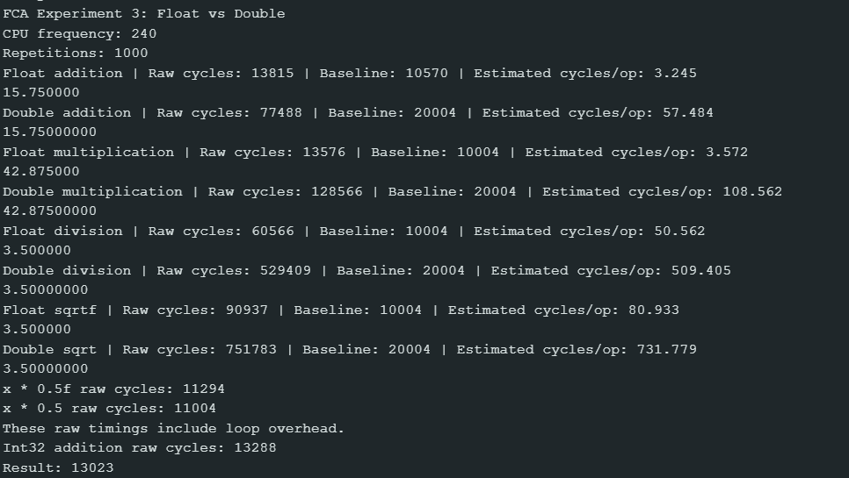

Experiment 4: Are Bit Tricks Really Faster?
1.Aim
To compare the execution time of division and remainder operations with bitwise operations on the ESP32.
2.Background
Bitwise operators work directly on the bits of a number. The right-shift operator (>>) shifts bits to the right, and the AND operator (&) compares bits.
Division by 8 can often be replaced with right shift by 3, and remainder by 16 can often be replaced with bitwise AND using 15 for positive integers. A volatile variable tells the compiler that its value may change unexpectedly.
3.Prediction
I predicted that right shift and bitwise AND would be faster than division and remainder. I also expected division using a volatile divisor to take more time than division using a constant divisor. I expected the results of -9 / 8 and -9 >> 3 to be different.
4.Method
- Connected the ESP32 to the computer and selected ESP32 Dev Module in Arduino IDE.
- Set the Serial Monitor baud rate to 115200.
- Executed each operation 1000 times.
- Measured CPU cycles using ESP.getCycleCount().
- Measured the baseline and calculated the estimated cycles per operation.
- Compared division with right shift, remainder with bitwise AND, and constant division with volatile-divisor division.
- Tested division and right shift using the negative number -9.
- Recorded the Serial Monitor output.
5.Observations
Operation | Raw Cycles | Baseline | Estimated Cycles/Op
x / 8 | 13283 | 8003 | 5.280
x >> 3 | 11283 | 8003 | 3.280
x % 16 | 16282 | 8003 | 8.279
x & 15 | 11283 | 8003 | 3.280
x / 8 (constant) | 14179 | 8003 | 6.176
x / divisor (volatile) | 19000 | 8003 | 10.997
Negative number results:
- -9 / 8 = -1
- -9 >> 3 = -2
6.Analysis
In Test A, right shift took 3.280 estimated cycles per operation, while division by 8 took 5.280. Both produced the result 15432.
In Test B, bitwise AND took 3.280 estimated cycles per operation, while remainder took 8.279. Both produced the result 0.
In Test C, division using a constant divisor took 6.176 estimated cycles per operation, while division using a volatile divisor took 10.997. This shows that the volatile-divisor version was slower in our measurement.
In Test D, -9 / 8 produced -1, while -9 >> 3 produced -2. Integer division truncates toward zero, whereas right-shifting a negative signed integer can behave differently.
These timings are estimates based on baseline subtraction. Compiler optimizations and measurement overhead may affect the results.
7.What We Learnt
- Right shift was faster than division by 8 in our measurements.
- Bitwise AND was faster than remainder by 16 in our measurements.
- Division using a volatile divisor took more estimated cycles than division using a constant divisor.
- Integer division and right shift can produce different results for negative numbers.
- Performance measurements should be interpreted carefully because compiler optimizations can affect execution time.
8. LLM Log
Prompt used: “Explain how right shift and bitwise AND can be compared with division and remainder, and why negative numbers may produce different results.”
LLM response: The LLM explained that right shift can sometimes replace division by a power of two, and bitwise AND can sometimes replace remainder for positive integers. It also explained that signed right-shift behaviour can differ from integer division for negative numbers.
Verification: We measured the operations on the ESP32 and compared their estimated cycles per operation. Our results showed that right shift and bitwise AND were faster in the tested cases. We also checked that -9 / 8 produced -1, while -9 >> 3 produced -2 in our test.
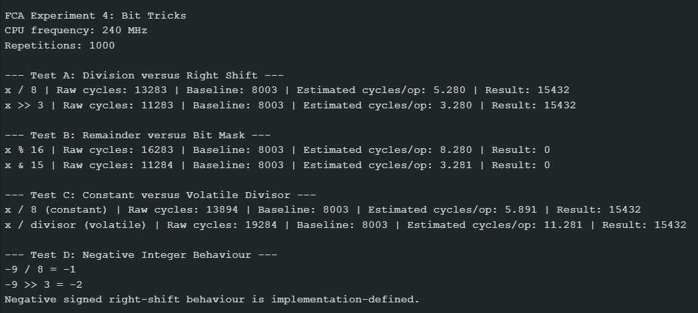

Experiment 5: Invent Your Own Fractions
1. Aim
To represent decimal numbers using Q16.16 fixed-point format and compare fixed-point arithmetic with floating-point arithmetic for speed and accuracy.
2. Background
Q16.16 stores numbers in a 32-bit integer, using 16 bits for the whole-number part and 16 bits for the fractional part. A number is multiplied by 65536 to encode it and divided by 65536 to decode it.
3. Prediction
We expected fixed-point arithmetic to be faster because it uses integers. We expected both methods to produce similar results for simple calculations.
4. Method
- We connected the ESP32 to the computer and set the CPU frequency to 240 MHz.
- We encoded 3.75 and −1.25 using Q16.16.
- We checked the minimum and maximum representable values.
- We performed addition, multiplication and division using fixed-point and float values.
- We measured the total CPU cycles for 10,000 iterations.
- We compared the division results with a double-precision reference to check the error.
5. Observations
Q16.16 representation
Measurement | Output
3.75 encoded | 245760
−1.25 encoded | −81920
Minimum value | −32768.00000
Maximum value | 32767.99998

Arithmetic results and timing
Operation | Fixed-point result | Float result | Fixed-point cycles | Float cycles
Addition | 3.5000 | 3.5000 | 131212 | 151110
Multiplication | 3.0000 | 3.0000 | 241187 | 151202
Division | 0.7500 | 0.7500 | 1114897 | 583595

Division accuracy
Measurement | Value
Double reference | 0.75000000
Fixed-point absolute error | 0.00000000
Float absolute error | 0.00000000

6. Analysis
Fixed-point addition was faster than float addition in this run, but fixed-point multiplication and division were slower. Both methods produced the same displayed results. The division accuracy test showed zero error at the printed precision. The timings include loop overhead, so they are estimates rather than exact operation costs.
7. What We Learnt
- Q16.16 can represent fractional values using integers.
- Fixed-point addition was faster than float addition in our measurements.
- Fixed-point multiplication and division were slower than their float equivalents in this run.
- The measured division results matched the double reference at the displayed precision.
- Timing overhead must be considered when comparing performance.
8. LLM Log
Prompt used: “Explain how to represent decimal numbers using Q16.16 fixed-point format and compare fixed-point arithmetic with floating-point arithmetic.”
LLM response: The LLM explained that Q16.16 represents numbers using a 32-bit integer scaled by 65536. It also explained that fixed-point arithmetic can have different speed and accuracy characteristics from floating-point arithmetic, and that intermediate multiplication results must be handled carefully.
Verification: We implemented the fixed-point calculations and compared them with floating-point calculations on the ESP32. We used the program output to examine the results, speed, and accuracy rather than relying only on the LLM's explanation.
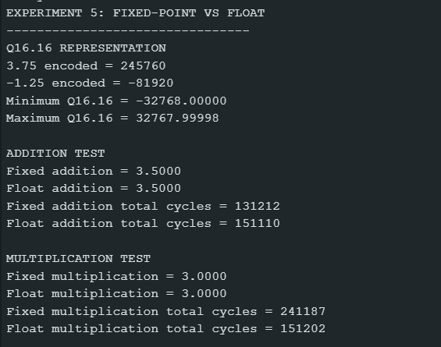

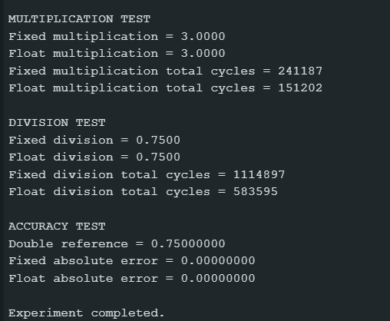

Experiment 6: The Hidden Cost of Printing
1. Aim
To measure the number of CPU cycles required to convert integers and floating-point numbers into text. To understand the time required for Serial transmission and compare printing numbers in decimal, hexadecimal and binary formats.
2. Background
The snprintf() function converts numbers into text and stores the result in a character buffer without sending it through Serial. The ESP32 uses CPU cycles to perform this conversion.
Serial communication at 115200 baud sends data one bit at a time. With standard 8N1 settings, each character requires 10 bits, including the start and stop bits. Therefore, converting a number into text and transmitting that text are two different operations.
3. Prediction
We expected integer-to-text conversion to take fewer CPU cycles than floating-point conversion. We also expected Serial transmission to take longer than conversion because characters are sent one bit at a time. Numbers printed in different formats may take different amounts of time because their text representations have different lengths.
4. Method
- We used an ESP32 Dev Module with Arduino IDE at a CPU frequency of 240 MHz.
- We used snprintf() to convert the integer 12345 and the float 123.456 into text.
- Each conversion was repeated 1000 times, and the total CPU cycles were measured using ESP.getCycleCount().
- We calculated the average cycles per conversion by dividing the total cycles by 1000.
- The program was designed to compare decimal, hexadecimal and binary printing and measure Serial transmission time using micros() and Serial.flush().
5. Observations
Measurement | Observed result
Integer text | 12345
Float text | 123.456
Integer total cycles (1000 conversions) | 1,726,327
Integer average cycles | 1,726.33
Float total cycles (1000 conversions) | 5,159,092
Float average cycles | 5,159.09

The average float conversion cost is calculated as 5,159,092 ÷ 1000 = 5,159.09 cycles.
6. Analysis
The results show that converting the float 123.456 into text took approximately three times as many CPU cycles as converting the integer 12345. This is because floating-point conversion must handle the fractional part and format the digits after the decimal point.
The experiment also shows that converting a number into text is different from transmitting it through Serial. Serial transmission depends on the number of characters sent and the baud rate. The transmission and number-format timing results must be recorded separately to complete the comparison.
7. What We Learnt
We learnt that converting numbers into text requires CPU processing. Floating-point-to-text conversion took more cycles than integer-to-text conversion in our measurements. We also learnt that Serial transmission has a separate time cost because each character is transmitted as bits. When writing real-time programs, we should avoid unnecessary printing inside time-critical code.
8. LLM Log
Prompt used: “Help us check the Experiment 6 code and explain how to measure number-to-text conversion and Serial transmission time.”
LLM response: The LLM explained that snprintf() measures conversion without transmitting the text, and that Serial transmission should be measured separately using micros() and Serial.flush().
Verification: We ran the program on the ESP32 and recorded the conversion cycle counts from the Serial Monitor. The board measurements were used as the experimental results rather than relying only on the LLM's predictions.

