<html>
<head>
<title>sop3 of html</title>
<link rel="stylesheet" type="text/css" href="external.css">
</head>
<body>
<h1> TRAVELLER FORM </H1>
<form name="f1">
NAME OF TRAVELLER:<INPUT TYPE="TEXT" NAME="T1"><BR><br><br>
DATE OF TRAVEL<INPUT Type="DATE" NAME="D1"><BR><br><br>
TEL NO.<INPUT TYPE="TEL" NAME="T2"><BR<br><br>
<INPUT TYPE="image" src="C:\Users\IT DJC COMP 21\Desktop\VAISHNAVI.B\download (1).jpg" height="100"
width="100"><br><br><br>
</form>
<a href="p2.html">transportion details</a>
</body>
</html>

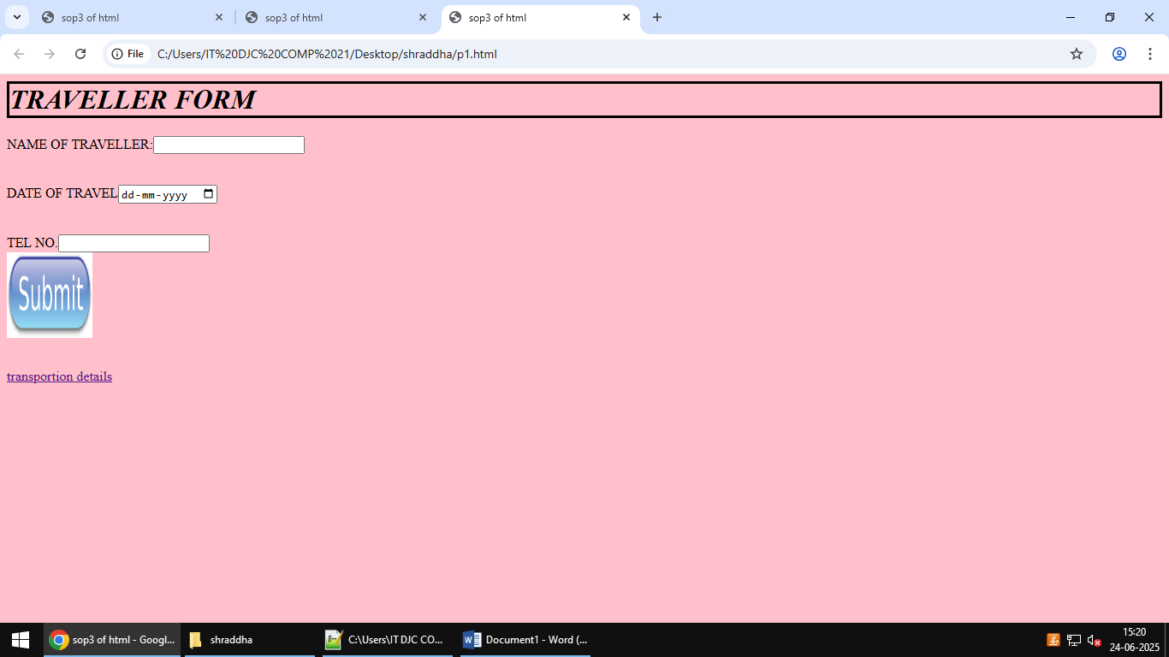

<html>
<head>
<title>sop 2 of html</title>
<link rel="stylesheet" type="text/css" href="external.css">
</head>
<body>
<h1>TRAVELLER DETAILS</H1>
<UL>
<LI>NAME OF TRANSPORTER-AIR ASIA</LI>
<LI>TIME-9:30AM</LI>
<LI>DESTINATION-DELHI</LI>
</UL>
<a href="p1.html">BACK</a>
</body>
</html>

