**Employee Onboarding Application-Phase 5**

Phase 5 — Apex Programming:

1. Setup (gear) → Developer Console.

2. Developer Console → File → New → Apex Class.

3. Name it Employee Profile Trigger Handler .

4. File → Save.

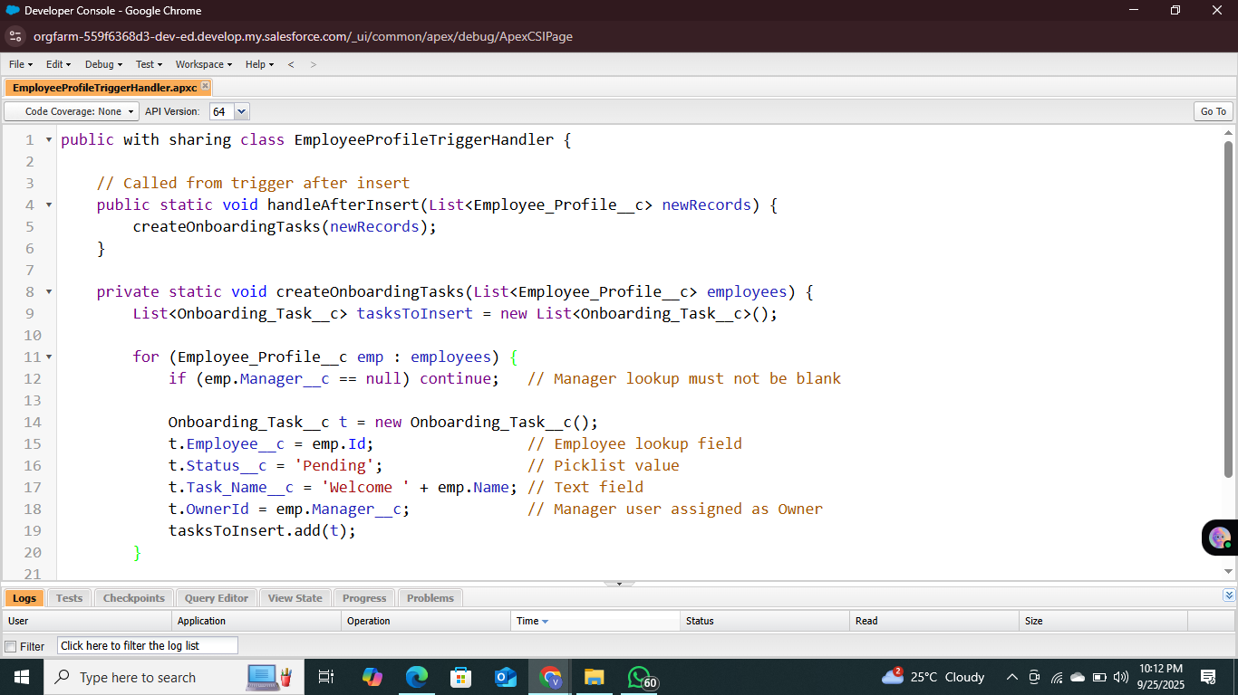

Create the trigger

