#include<iostream.h>
#include<graphics.h>
#include<dos.h>
#include<conio.h>
void circlePoints(int x,int y,int x_centre,int y_centre)
{
putpixel(x+x_centre,y+y_centre,RED);
delay(100);
putpixel(-x+x_centre,y+y_centre,RED);
delay(100);
putpixel(x+x_centre,-y+y_centre,RED);
delay(100);
putpixel(-x+x_centre,-y+y_centre,RED);
delay(100);
putpixel(y+y_centre,x+x_centre,RED);
delay(100);
putpixel(-y+y_centre,x+x_centre,RED);
delay(100);
putpixel(y+y_centre,-x+x_centre,RED);
delay(100);
putpixel(-y+y_centre,-x+x_centre,RED);
delay(100);
}
void midPointCircle(int r,int x_centre,int y_centre)
{
int x=0;
int y=r;
double d=3-2*r;
while(y>x)
{
if(d<0)
d=d+4*x+6.0;
else
{
d=d+4*(x-y)+10.0;
y=y-1;
}
x++;
circlePoints(x,y,x_centre,y_centre);
}
return;
}

void main()
{
int i,gd=DETECT,gm;
int x,y,r;
initgraph(&gd,&gm,"C:\\TURBOC3\\BGI");
cout<<"Enter the centre coordinates:\n";
cout<<"x: ";
cin>>x;
cout<<"y: ";
cin>>y;
cout<<"Enter radius: ";
cin>>r;
setbkcolor(WHITE);
midPointCircle(r,x,y);
getch();

}
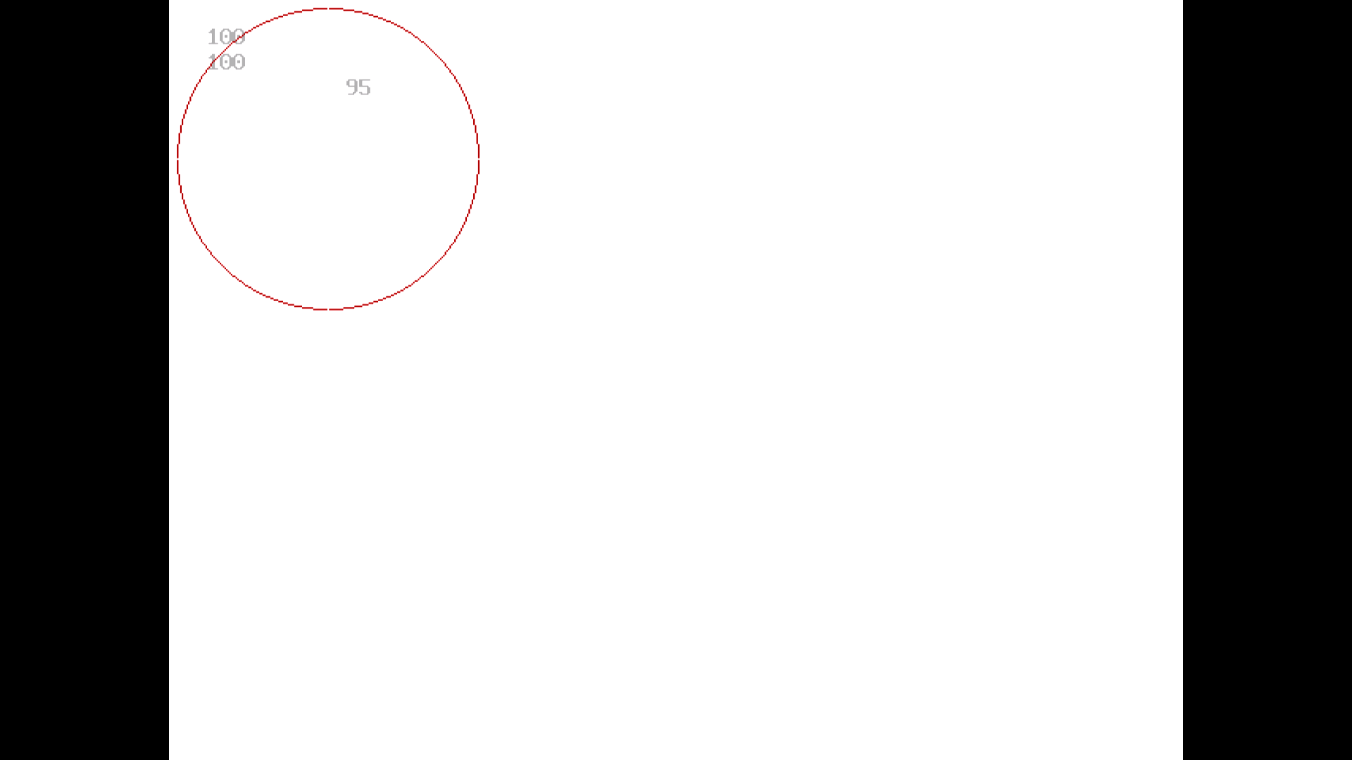

#include<iostream.h>
#include<graphics.h>
#include<conio.h>
#include<dos.h>
#include<math.h>

#define pi 3.14285714

class projections
{
double vertices[8][4]; //matrix contains vertices of the triangle
double t_matrix[4][4]; //transformation matrix
double result[8][4];

public:
projections(){};

void get_vertices();
void display_cube();

void multiplication();
void copyback();

void axonometric(double angle_x,double angle_y);

};

void projections::get_vertices()
{
for(int i=0;i<8;i++)
{
cout<<"\nEnter vertex "<<i+1<<"...";
cout<<"\nx : ";
cin>>vertices[i][0];
result[i][0]=vertices[i][0];

cout<<"y : ";
cin>>vertices[i][1];
result[i][1]=vertices[i][1];

cout<<"z : ";
cin>>vertices[i][2];
result[i][2]=vertices[i][2];

vertices[i][3]=result[i][3]=1;
}
}

void projections::display_cube()
{
int i=0;

for(i=0;i<3;i++)
line(result[i][0],result[i][1],result[i+1][0],result[i+1][1]);
line(result[i][0],result[i][1],result[0][0],result[0][1]);

for(i=4;i<7;i++)
line(result[i][0],result[i][1],result[i+1][0],result[i+1][1]);
line(result[i][0],result[i][1],result[4][0],result[4][1]);

for(i=0;i<4;i++)
line(result[i][0],result[i][1],result[i+4][0],result[i+4][1]);
}

void projections::copyback()
{
int i=0,j=0;

for(i=0;i<8;i++)
for(j=0;j<4;j++)
result[i][j]=vertices[i][j];
}

void projections::multiplication()
{
double r[8][4];
int i=0,j=0,k=0;

for(i=0;i<8;i++)
{
for(j=0;j<4;j++)
{
r[i][j]=0;
for(k=0;k<4;k++)
r[i][j]+=result[i][k]*t_matrix[k][j];
}
}

for(i=0;i<8;i++) //Copying back the result
for(j=0;j<4;j++)
result[i][j]=r[i][j];
}

//AXONOMETRIC PROJECTION..................................................................
void projections::axonometric(double angle_x,double angle_y)
{
angle_x=((pi/180)*angle_x); //tan inverse(slope)=angle
angle_y=((pi/180)*angle_y);

cleardevice();
clearviewport();
cout<<"\tAXONOMETRIC PROJECTION...........";

copyback();

t_matrix[0][0]=cos(angle_y); //[T] for parallel projection on plane z=0
t_matrix[0][1]=(sin(angle_y))*(sin(angle_x));
t_matrix[0][2]=0;
t_matrix[0][3]=0;

t_matrix[1][0]=0;
t_matrix[1][1]=cos(angle_x);
t_matrix[1][2]=0;
t_matrix[1][3]=0;

t_matrix[2][0]=sin(angle_y);
t_matrix[2][1]=(-1)*(cos(angle_y)*sin(angle_x));
t_matrix[2][2]=0;
t_matrix[2][3]=0;

t_matrix[3][0]=0;
t_matrix[3][1]=0;
t_matrix[3][2]=0;
t_matrix[3][3]=1;

multiplication();

setcolor(GREEN);
display_cube();
delay(20);
getch();
}

void main()
{
clrscr();
int gd=DETECT,gm;
projections t1;

double angle_x,angle_y,angle,ratio,ratio1,ratio2,ratio3;

cout<<"\n\n\t ........PROJECTIONS OF 3D OBJECTS........\n";
cout<<"\nEnter the details of a cube(i.e. 3D object).....";
t1.get_vertices();

initgraph(&gd,&gm,"C:\\Turboc3\\BGI");

cout<<"\n\nFOR AXONOMETRIC PROJECTION..........";
cout<<"\nEnter the angle of rotation about :-";
cout<<"\nx-axis : ";
cin>>angle_x;
cout<<"And, y-axis : ";
cin>>angle_y;

t1.axonometric(angle_x,angle_y);

closegraph();

}

