

**Sri Sivasubramaniya Nadar College of Engineering, Kalavakkam**

**Department of CSE**

**UCS 2501 Computer Networks**

**Team Project**

**Members**

**Shreyas 3122 21 5001 103**

**Vaishnavi S 3122 21 5001 120**

**Vaishnavi T 3122 21 5001 121**

**Vishvasri J S 3122 21 5001 123**

**INDEX**

|  |  |  |
| --- | --- | --- |
| **S.NO.** | **TITLE** | **PAGE NO.** |
| 1. | Problem Statement | 4 |
| 2. | Protocol | 4 |
| 3. | Method Explanation | 6 |
| 4. | Topology | 8 |
| 5. | Code | 8 |
| 6. | Output | 11 |
| 7. | Learning Outcome | 11 |

**PROBLEM STATEMENT:**

This lab exercise helps to get familiar with the benefits of a VLAN and also in understanding the process to configure a router and a switch to support VLANs.

**PROTOCOL:**

**1. *Router Configuration (R1):\***

- *Protocol Used:* The configuration of the router is typically done using the Cisco IOS command-line interface (CLI). The protocol used for management and configuration here is typically SSH (Secure Shell) or Telnet.

**2. *Workstation Configuration (WS1 and WS2):\***

- *Protocol Used:* The configuration of the workstations can be done through the graphical user interface (GUI) or command-line interface (CLI) provided by the simulation tool or operating system. In a real-world scenario, management protocols like SSH or Telnet could be used.

**3. *Ping Testing:\***

- *Protocol Used:* ICMP (Internet Control Message Protocol) is used for the ping tests. ICMP is commonly employed to test the reachability of a host on an Internet Protocol (IP) network.

**4. *Switch Configuration (SW1):\***

- *Protocol Used:* The configuration of the switch is done using the Cisco IOS CLI. In this context, the protocols used might include SSH or Telnet for management.

**5. *VLAN Configuration and Port Assignment:\***

- *Protocol Used:* The VLAN configuration and port assignment are done using the Cisco IOS CLI on the switch. The management protocol involved is typically SSH or Telnet.

**6. *Show Commands on Switch:\***

- *Protocol Used:* The show commands to view VLAN port assignments on the switch are typically performed using the CLI. The management protocols involved are SSH or Telnet.

**7. *Ping Testing after VLAN Configuration:\***

- *Protocol Used:* ICMP is used for testing connectivity between devices after VLAN configuration on the switch.

**8. *Modify VLAN Configuration on Switch:\***

- *Protocol Used:* The modification of VLAN configuration on the switch is done using the Cisco IOS CLI, and the management protocol involved could be SSH or Telnet.

**9. *Show VLAN Port Assignments:\***

- *Protocol Used:* The show commands to view VLAN port assignments on the switch are performed using the Cisco IOS CLI. The management protocols involved are SSH or Telnet.

**10. *Assign Another Port to VLAN:\***

- *Protocol Used:* The assignment of another port to a VLAN is done using the Cisco IOS CLI on the switch. The management protocol involved could be SSH or Telnet.

**11. *Ping Testing after Port Assignment:\***

- *Protocol Used:* ICMP is used for testing connectivity between devices after assigning another port to a VLAN on the switch.

In summary, the primary protocols involved are SSH, Telnet, and ICMP, depending on the context of configuration, management, and testing in a Cisco networking environment.

**METHOD EXPLANATION:**

1. Connect to R1 and configure the IP address of 192.168.200.1 255.255.255.0 on the fastethernet interface and set the interface up by issuing no shutdown command.

2. Connect to workstation WS1 and set its IP address to 192.168.200.3 255.255.255.0 and default-gateway to 192.168.200.1, and then connect to WS2 and set its IP address to 192.168.200.4 255.255.255.0 and default-gateway to 192.168.200.1.

3. Ping R1 and WS1 from WS2 and see that the ping is successful.

4. Connect to Switch SW1 and set up the VLANs. Start by creating VLAN 20 to set up a separate VLAN for the WRS (workstations).

5. Now assign ports to the new VLAN , assign port 1 for WS1 to VLAN 20.

6. Connect to WS2 again and try to ping R1 and WS1

Ping is success from WS2 to R1 but not from WS2 to WS1, this is because on the switch, VLAN 20 is set to cover only port 1).

7. Connect to SW1 again and now configure port 2 wherein WS2 is connected, to be included in VLAN 20.

8. Repeat the pings from WS2 to R1 and WS1.This time ping to WS1 would be successful but not to R1 (This is because when the ping packets came in, they were tagged with VLAN 20. Consequently, the packets could only travel out port 1 to WS1).

9. Connect to SW1 again and issue appropriate show commands to view the VLAN port assignments.

10. Now on SW1, assign fastethernet 0/12 to VLAN 20 . This would allow to ping all of the devices.

11. Issue pings from R1 to WS1 and WS2 and from WS1 and WS2 to R1 and check the connectivity.

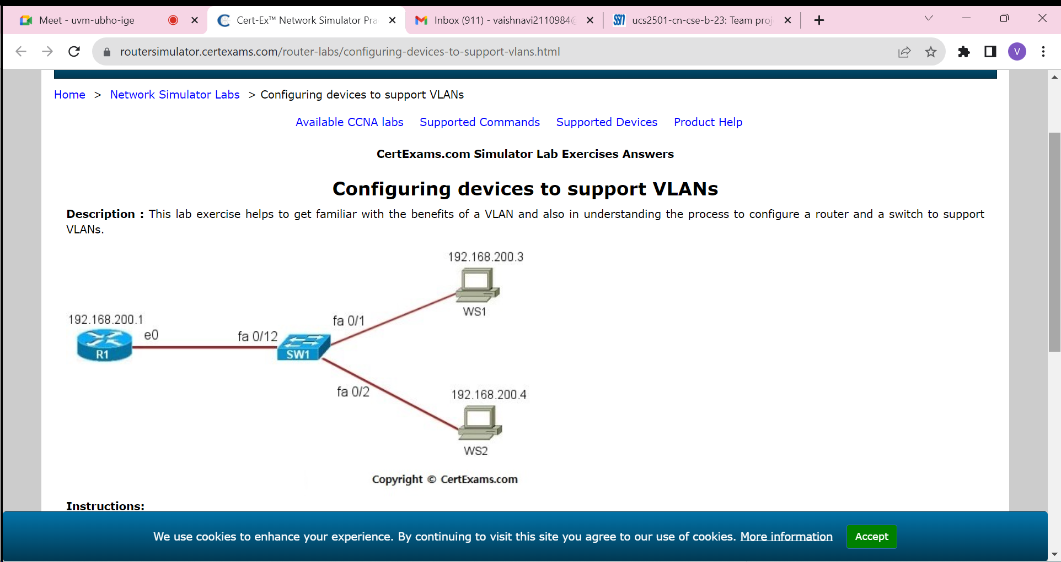**TOPOLOGY:**

**CODE:**

**### 1. Configure R1:**

bash

enable

configure terminal

interface FastEthernet0/0

ip address 192.168.200.1 255.255.255.0

no shutdown

exit

**### 2. Configure WS1 and WS2:**

#### WS1:

bash

configure terminal

interface GigabitEthernet0/0 # Assuming GigabitEthernet interface

ip address 192.168.200.3 255.255.255.0

exit

ip default-gateway 192.168.200.1

#### WS2:

bash

configure terminal

interface GigabitEthernet0/0 # Assuming GigabitEthernet interface

ip address 192.168.200.4 255.255.255.0

exit

ip default-gateway 192.168.200.1

**### 3. Ping from WS2:**

bash

ping 192.168.200.1 # Ping R1

ping 192.168.200.3 # Ping WS1

**### 4. Configure SW1:**

bash

enable

configure terminal

vlan 20

name WRS

exit

interface range FastEthernet0/1, FastEthernet0/2

switchport mode access

switchport access vlan 20

exit

**### 5. Ping from WS2:**

bash

ping 192.168.200.1 # Ping R1 (should still work)

ping 192.168.200.3 # Ping WS1 (should fail)

**### 6. Update VLAN assignment for port 2:**

bash

enable

configure terminal

interface FastEthernet0/2

switchport mode access

switchport access vlan 20

exit

**### 7. Ping from WS2:**

bash

ping 192.168.200.1 # Ping R1 (should fail)

ping 192.168.200.3 # Ping WS1 (should work)

**### 8. View VLAN port assignments on SW1:**

bash

show vlan brief

**### 9. Assign FastEthernet 0/12 to VLAN 20:**

bash

enable

configure terminal

interface FastEthernet0/12

switchport mode access

switchport access vlan 20

exit

### 10. Ping from all devices:

- Ping from R1 to WS1 and WS2.

- Ping from WS1 and WS2 to R1.

**### 11. Check connectivity:**

Ensure that all pings are successful after the VLAN configuration is complete. If there are issues, double-check the VLAN configurations and port assignments on SW1.

**OUTPUT:**

https://drive.google.com/drive/folders/1n-7ozx0l4CcSXOmbykBueJ7wTgCQS3a8?usp=drive_link

**LEARNING OUTCOMES:**

* Implemented configuring devices to support VLANs.
* Understood how to configure a router and a switch to support VLANs using Cisco Packet Tracer.