Embeddings:
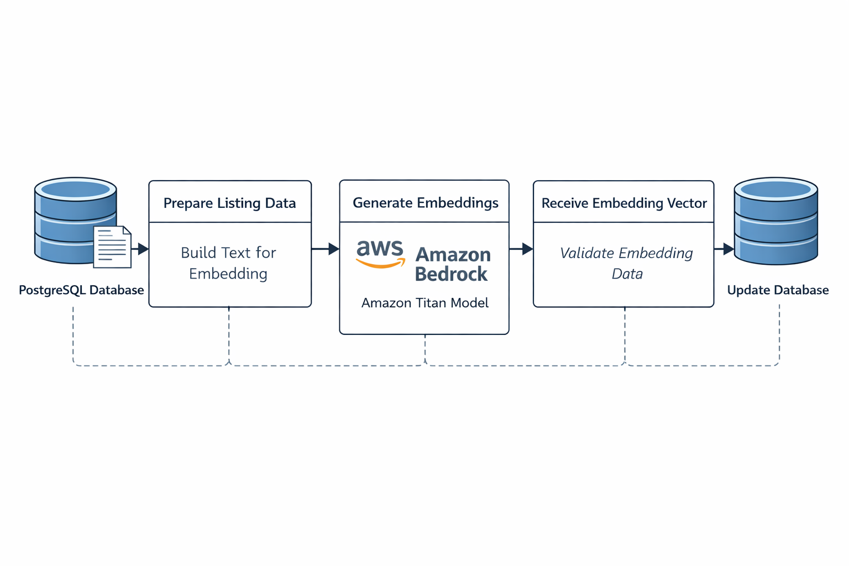
FUNCTIONS:

RAG:
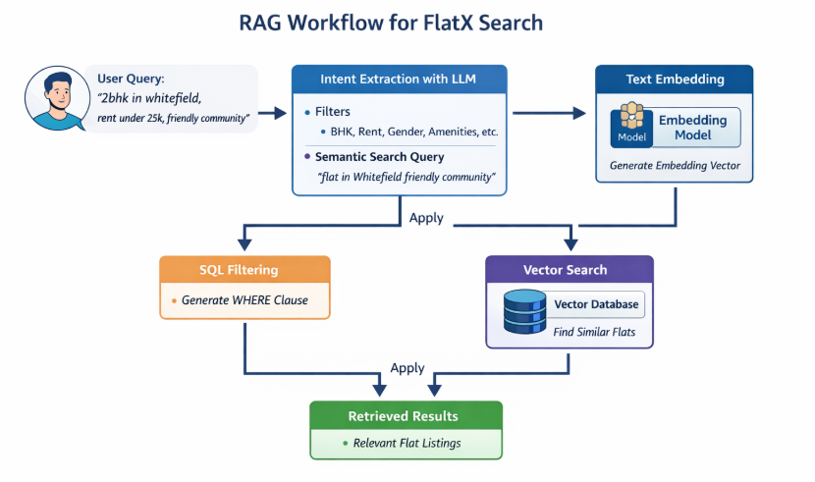

- _sanitize_json(text)
Escapes special characters (newlines, tabs) inside JSON strings to prevent parse failures.
- Input: Raw JSON string
- Output: Sanitized JSON string

- _parse_json(raw, label)
Parses a JSON string from LLM output with multiple fallback strategies (strip markdown fences → sanitize → regex extract).
- Input: raw (LLM response string), label (for error logging)
- Output: Parsed dict or None on failure

AWS Bedrock API Calls
- _embed_query_async(text)
Calls the Amazon Titan embedding model to convert text into a vector.
- Input: text (string to embed)
- Output: list[float] — the embedding vector
- _invoke_llm_async(system_msg, user_msg)
Calls the Amazon Nova Pro LLM with a system + user message.
- Input: system_msg (string), user_msg (string)
- Output: LLM response json string

Intent & Filter Processing
1) extract_intent_async(user_query)
Uses the LLM to parse a natural language query into structured SQL filters and a semantic search string.
- Input: user_query (string)
- Output: (filters: dict, search_query: str)
  - Example: {"exact_bhk": 2, "max_rent": 25000}, "flat in Whitefield friendly community"
2) _merge_with_baseline(user_filters)
Merges user-provided filters with default baseline filters (e.g. max rent 50k, washing machine required). User values override baseline, amenities are combined.
- Input: user_filters (dict)
- Output: Merged dict
build_where_clause(filters)
Converts a filters dict into a parameterized PostgreSQL WHERE clause string.
- Input: filters (dict with keys like exact_bhk, max_rent, amenities, etc.)
- Output: (sql_string: str, params: list) — ready for asyncpg

Data Conversion
- _rows_to_docs(rows)
Converts raw database rows into LangChain Document objects, parsing JSON fields and flattening them into metadata.
- Input: rows (list of asyncpg Row objects)
- Output: List[Document] with page_content = description, metadata = all flat fields

Core Pipeline
- retrieve_async(search_query, where_sql, where_params, precomputed_vector)
The main retrieval function — generates an embedding, then runs a pgvector cosine similarity search in PostgreSQL with SQL filters.
- Input:
  - search_query (string)
  - where_sql, where_params (from build_where_clause)
  - precomputed_vector (optional, skips re-embedding)
- Output: (docs: List[Document], embed_time_ms: float, db_time_ms: float)
run_query_async(user_query, page)
Orchestrates the full RAG pipeline end-to-end and prints paginated results to console.
- Input: user_query (string), page (int, default 1)
- Output: List[Document] (retrieved document for the current page)
Total time taken for a single query = ~ 0.71 ms - 0.85 ms
- need flat with 1bhk in hsr layout, deposit unde...
- Intent extraction - 614.5ms
Query embedding - 34.5ms
- Db retrieval - 57.0ms
- Total = 706.0ms

- Use these numeric fields (only when mentioned):
Bhk
Rent
Bathroom_count
Flatmates
Floor
Is furnished
Gender preference
Amenities
Deposit

