NAME SPECIALIZATI

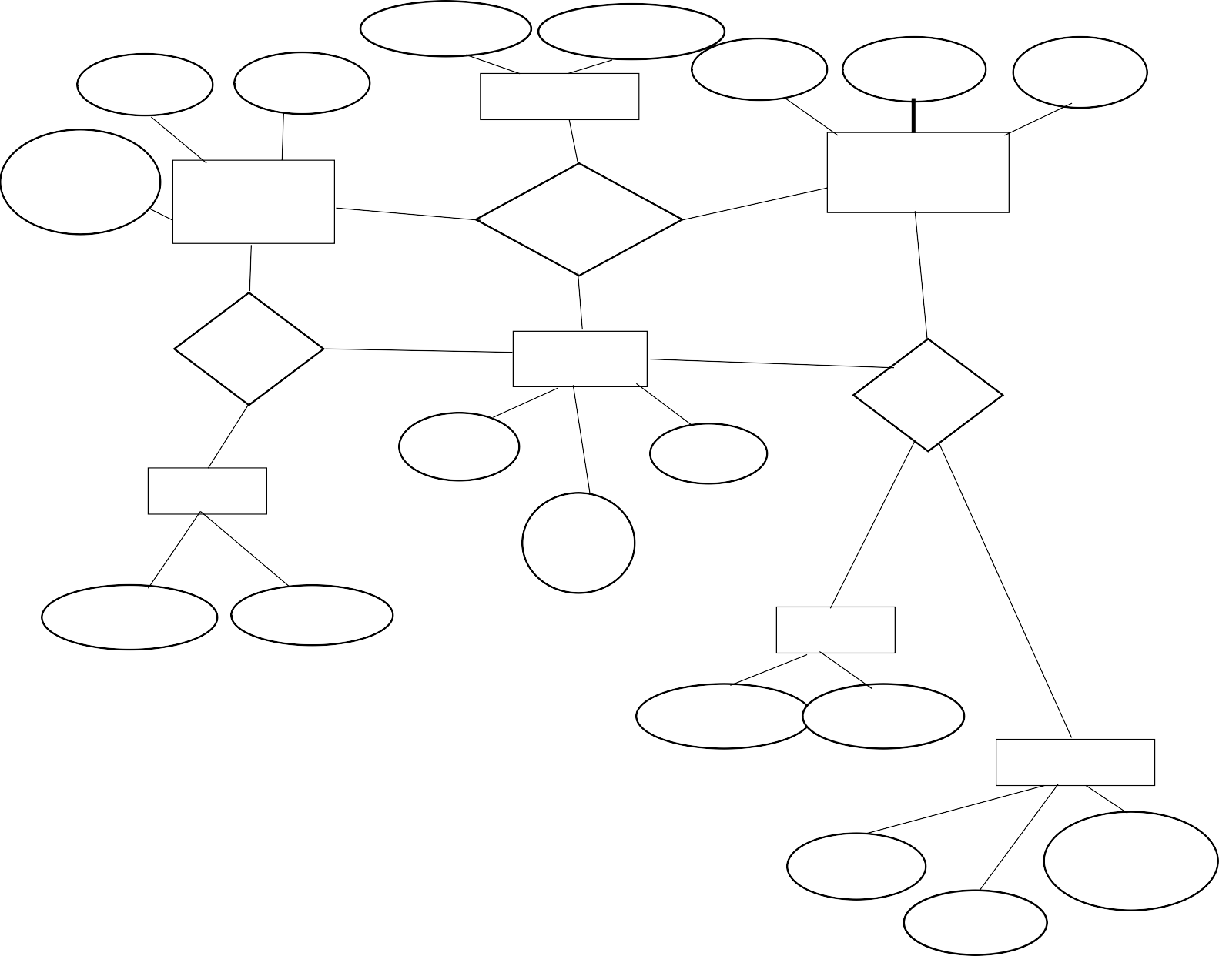

ON

DR_ID

# Doctor

PRES_NO MEDICINES

TREATMENT

TREATS

NAME PAT_ID

# Patient

AGE

HAS

# SLOTS

HAS

D_LOGIN

TIME

SLOT NO

DATE

D_LOG_ID D_PSWD

P_LOGIN

P_LOG_ID P_PSWD

REVIEWS

COMMMENTS

DR_ID

PAT_ID