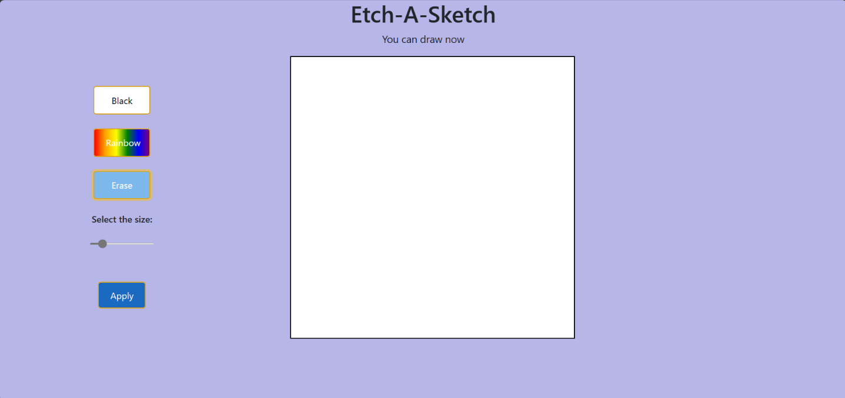**Etch-a-Sketch Website Documentation**

**Introduction:**

The Etch-a-Sketch website is a simple web application that allows users to draw and sketch on a digital canvas. It provides features such as changing the drawing color, applying a rainbow effect, erasing the drawing, and adjusting the size of the drawing grid.

**Table of Contents:**

* [HTML Structure](https://chat.openai.com/#html-structure)
* [CSS Styling](https://chat.openai.com/#css-styling)
* [JavaScript Functionality](https://chat.openai.com/#javascript-functionality)

**HTML Structure:**

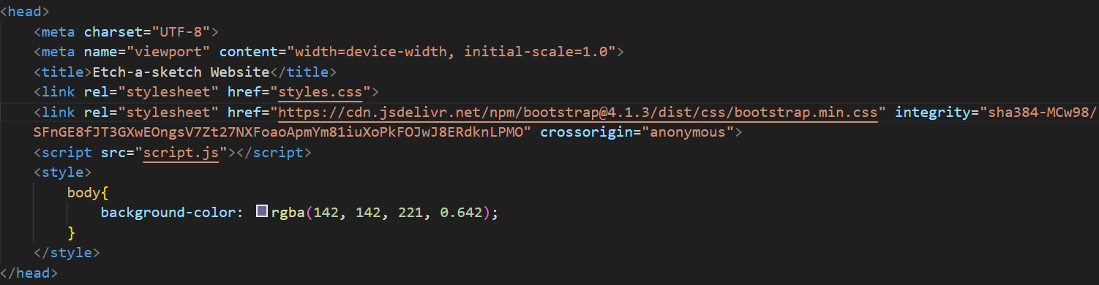**Head section**

It contains meta tags, link to bootstrap css styling, link to styles.css file, linking of javascript file and styling background color of the body.

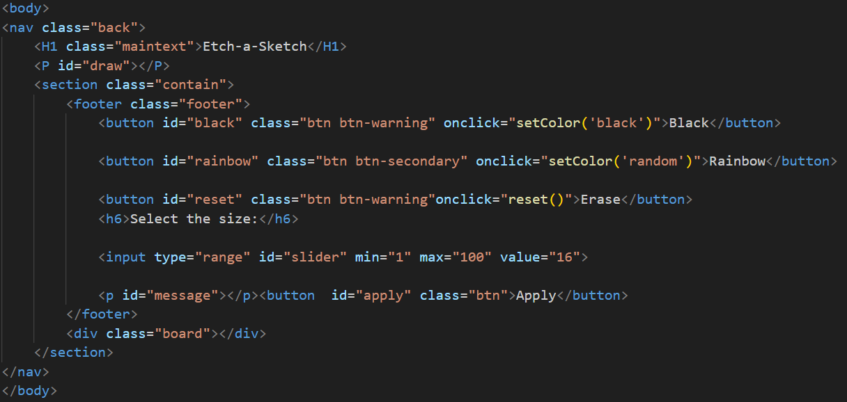**Body section**

The body section contains

Nav tag:

Inside nav tag all elements of etch a sketch website.

Inside nav tag first tag is h1 with class maintext which is used for styling text present in h1 tag.It will display Etch-A-Sketch.

<p id=”draw”></p> is used to display message if a user can draw or not.

Section tag contains all button and board.

<footer class=”footer”></footer> contains all buttons used for drawing the sketch, erasing the sketch and resizing the sketch board.

div.board contains the board where we can do sketches.

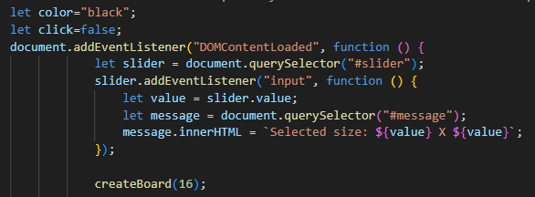**Javascript Structure:**

This function creates a default 16x16 grid of squares on an HTML webpage. The size of the grid can be changed using a slider. createBoard function is called.

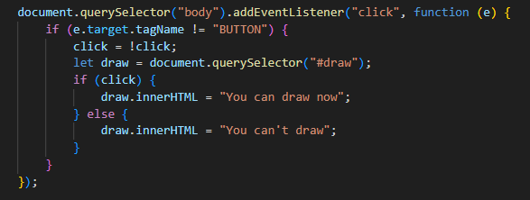This code adds a click event listener to the body of the document. When the user clicks anywhere on the page , the click variable is toggled to either true or false. The innerHTML of the element with the ID of "draw" is then updated to display a message indicating whether the user can draw or not. If the user right clicks first when the page is opened, then click event listener will display message you can draw and again if user right clicks then it will display you can’t draw.

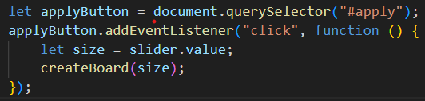

This js code adds an event listener to the "apply" button. When the user clicks the button, the value of the "size" slider is retrieved and passed to the createBoard function. The createBoard function then creates a grid of squares on the HTML webpage with the specified size by the user.

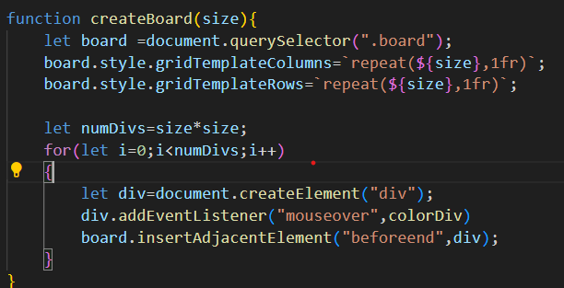

The createBoard function takes a size parameter and creates a grid of squares on the HTML webpage with the specified size. The function first sets the grid-template-columns and grid-template-rows properties of the board element to repeat the specified size. This creates a grid of squares with the specified number of columns and rows. The function then creates a loop that iterates through the number of squares in the grid. For each square, the function creates a div element and adds it to the board element. The function also adds a mouseover event listener to each div element. When the user hovers over a div element, the colorDiv function is called.

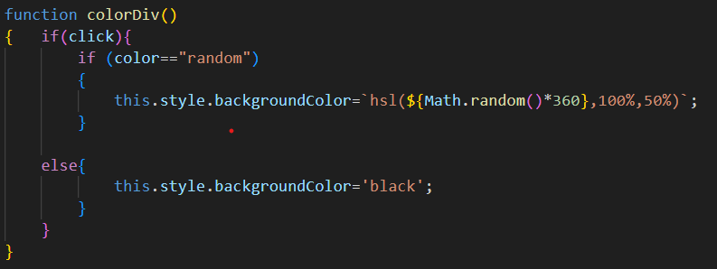

The colorDiv() function changes the background color of a element on sketch board. If the `click` parameter is true (i.e if we click rainbow button on the page), the function will change the background color of the element to a random color. If the `click` parameter is false, the function will change the background color of the element to black.

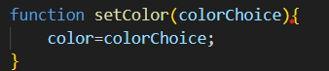The `setColor()` function is a simple function that takes a single parameter, `colorChoice`, and sets the value of the global variable `color` to that value. This function does not return anything.

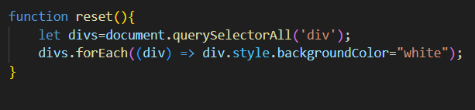

The `reset()` function is a simple function that resets the background color of all elements to white. This function does not take any parameters and does not return anything. Using querySelectorAll is sets all div to white.