Week1_SaiVaishnavi_DataExploration_Report
WEEK 1 DATA EXPLORATION & EDA REPORT
DePaul Dataset
Excelerate Data Visualization Trainee Internship
Prepared by: G SAI VAISHNAVI

Executive Summary
This report presents an exploratory analysis of the DePaul Dataset containing 7,543 records and 80 variables related to university applicants. The objective of this analysis was to understand the dataset structure, assess data quality, identify trends and patterns, and generate insights through exploratory data analysis and visualizations.
The analysis identified 5,000 unique applicants representing 95 countries, demonstrating significant international diversity within the dataset. Applicant interest was highly concentrated in technology and business-related disciplines, with Computer Science and Business Analytics emerging as the most popular programs. The Jarvis College of Computing and Digital Media and the Kellstadt Graduate School of Business together accounted for more than 84% of all first-choice college selections.
The findings from this report establish a foundation for deeper analysis and data-driven decision-making in subsequent stages of the internship project.

1. Dataset Familiarization Summary
Metric | Value
Total Records | 7,543
Total Variables | 80
Unique Applicants | 5,000
Countries Represented | 95
Unique Colleges | 19
Program/Intake Combinations | 583
The dataset contains applicant information, academic preferences, application sources, and administrative records.

2. Data Dictionary
Key variables analyzed: Reference_ID, Country, College, University, Intake, College_1st_Choice, Application_Source, Email_ID, City, Region, Postal, Comments, Admit_Date, Created_At, Modified_At.
Figure 1: Top 10 Countries by Applicants
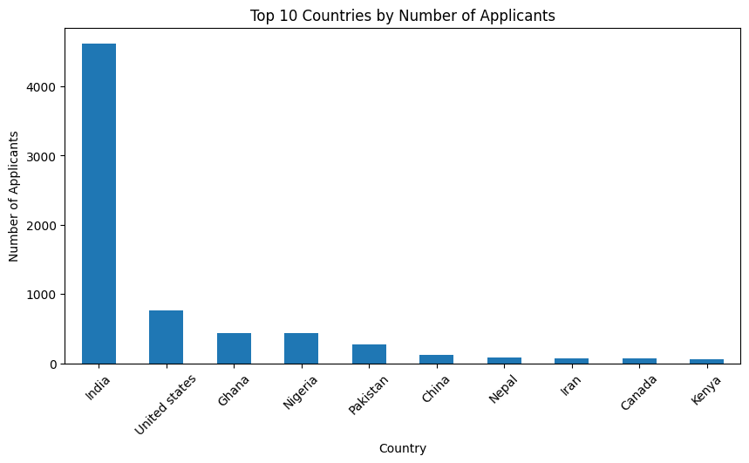

3. Data Quality Report
Missing Values Findings
- Multiple variables contain 100% missing values.
- Important fields such as Degree_Type, Major, Citizenship, Status, and Date_of_Birth contained no usable data.
- These variables were excluded from further analysis.
Duplicate Analysis
- No fully duplicated rows were detected.
- However, 2,543 duplicate Reference_ID entries were identified.
- Only 5,000 unique applicants were found among 7,543 records.
- This suggests the dataset records multiple interactions or events for the same applicant.
Data Quality Implications
- Data cleaning is recommended before advanced analytics.
- Missing-value treatment and applicant-level consolidation should be considered in future work.
- Figure 2: Top Programs / Intakes
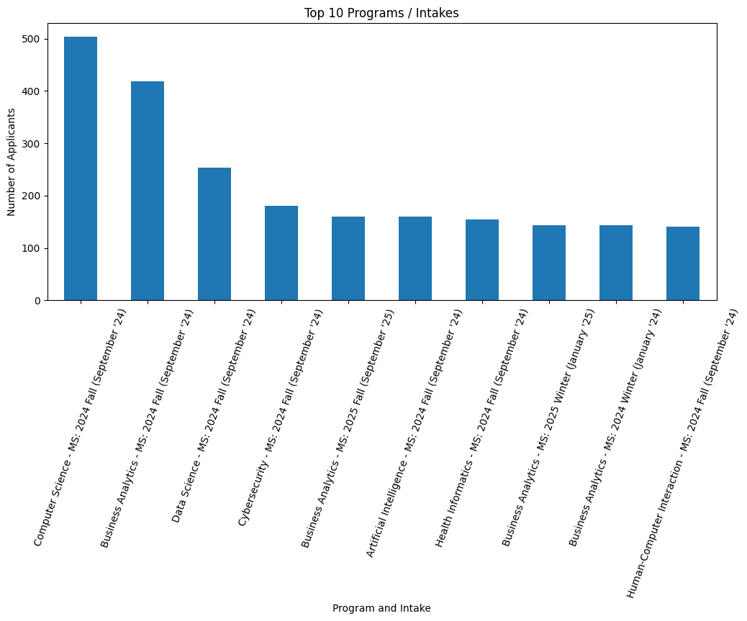
Insights
- Computer Science (MS) – Fall 2024 is the most popular program.
- Business Analytics (MS) – Fall 2024 ranks second.
- Data Science, Cybersecurity, Artificial Intelligence, and Health Informatics also attract strong applicant interest.
- Technology-oriented programs dominate application demand.

- Figure 4: Top Colleges by Applications
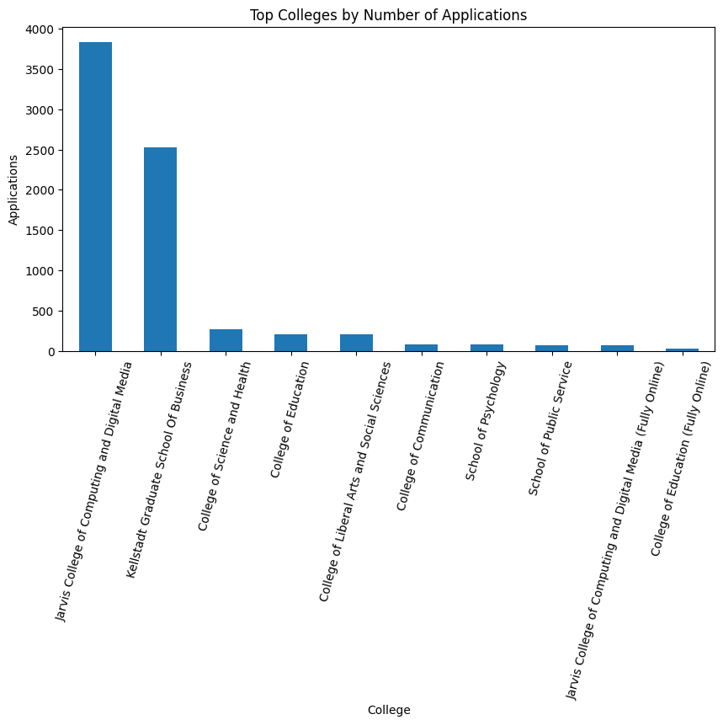

Insights
- Jarvis College of Computing and Digital Media received 50.84% of all first-choice selections.
- Kellstadt Graduate School of Business received 33.48%.
- Together these two colleges account for approximately 84.3% of all first-choice preferences.

4. Exploratory Data Analysis
Insights
- Applicants originate from 95 countries.
- India is the largest applicant source with 4,617 applicants.
- The United States ranks second with 764 applicants.
- Ghana and Nigeria are also major contributor countries.
- Applicant distribution is highly concentrated in a small number of countries.
Statistical Insight
- Mean applicants per country: 79.28
- Median applicants per country: 5
- Maximum applicants from a single country: 4,617

Figure 3: Application Source Distribution
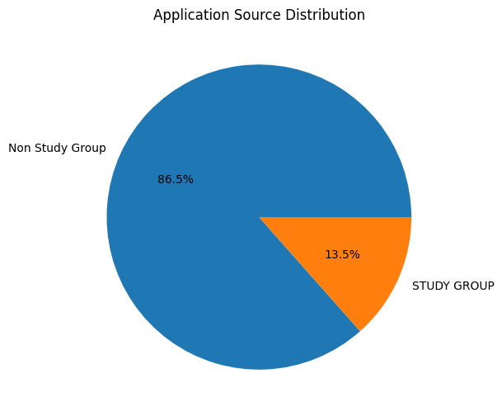
Insights
- NonStudy Group applications account for 86.5% of all records.
- STUDY GROUP applications account for 13.5%.

5. Key Insights
• The dataset contains 7,543 records representing 5,000 unique applicants.
• Applicants originate from 95 countries, demonstrating significant international reach.
• India is the dominant source country, contributing more than 4,600 applicants.
• Technology-focused programs show the highest demand among applicants.
• Computer Science and Business Analytics are the most popular programs.
• Jarvis College and Kellstadt Graduate School of Business account for over 84% of first-choice selections.
• Most applications originate through NonStudy Group channels.
• Several variables contain 100% missing values and require further investigation.
• Duplicate applicant identifiers indicate that the dataset records multiple events or interactions per applicant.

6. Conclusion
The exploratory analysis of the DePaul Dataset provided valuable insights into applicant demographics, academic preferences, and application sources. The dataset contained 7,543 records representing 5,000 unique applicants from 95 countries, highlighting the institution's broad international reach and diverse applicant base.
The analysis revealed that applicant interest is strongly concentrated in technology and business-related disciplines. Computer Science and Business Analytics emerged as the most popular programs, while the Jarvis College of Computing and Digital Media and the Kellstadt Graduate School of Business together accounted for more than 84% of all first-choice college selections. These findings indicate a strong preference for computing, analytics, and business-oriented educational pathways.
The data quality assessment identified several challenges, including multiple variables with 100% missing values and 2,543 repeated applicant identifiers. Although these issues may limit certain forms of advanced analysis, the core variables contained sufficient information to support meaningful exploratory analysis and insight generation.
Overall, the dataset provides a strong foundation for future analytical work. Further efforts should focus on data cleaning, handling repeated applicant records, and exploring applicant progression patterns to enable deeper analysis and more informed decision-making in subsequent stages of the project.

References
Tools Used:
• Python
• Pandas
• Matplotlib
• Jupyter Notebook (VS Code)
Dataset:
• DePaul Dataset provided by Excelerate Internship Program

