INTERNSHIP PROJECT DOCUMENTATION

SAKSHA
A Practice Management System for Chartered Accountancy Firms
Less chasing. More filing.
Submitted as part of Internship Project
Project Documentation

1. Problem We Are Solving
A CA firm does the same work for many clients, again and again. GST every month. TDS every quarter. Income tax and audits every year. Each job needs files from the client, work by a staff member, and a final check by the CA.
Most small firms run all of this on spreadsheets, WhatsApp and memory. The problems are the same everywhere:
- The same cycle is typed out by hand every period, so a missed filing is found only after the due date.
- Files arrive on WhatsApp and email. Nobody is sure which copy is the latest one.
- “What is pending for this client?” cannot be answered without asking two or three people.
- Work is passed to the CA for checking by word of mouth. Nothing records that it was actually checked.
- Clients cannot see what has been asked from them, so the firm keeps chasing.
- If a staff member leaves, the real status of their work is lost with them.
2. The Traditional Way
Firms manage the practice with general tools instead of a system built for the work.
How it is done today | What goes wrong
Excel tracker per staff member | Two people edit two copies. Neither is correct.
WhatsApp group per client | Files get lost when a phone changes. No record of what was approved.
Email and local folders | Versions named final, final2, final_revised.
Diary or register for due dates | Nothing warns you. You have to remember to look.
Asking people in person | Status lives in someone’s head, not in a system.
Table 1 — Current methods and their weak points.
A spreadsheet also has no permission control and no history. Either a staff member sees every client, or they cannot use the tracker at all.
3. Our Unique Approach
Clients, tasks, deadlines and file requests are common to every product in this market. Two things in SAKSHA are not common, and both matter more to a CA firm than another feature would.
3.1 An assistant that cannot make things up
A CA’s work has to stand up to scrutiny. An assistant that invents a client name or a number is worse than no assistant at all. In most business apps the AI writes the answer itself. In SAKSHA the AI only chooses which action to run — our own code does the rest.
 | Usual AI feature | SAKSHA
What the AI is given | the question, often with raw records | a short text summary only — no files, no messages, no PAN or GSTIN
What the AI decides | the whole answer | which one of four fixed actions to run
Who reads the database | the AI, or a query the AI wrote | our code, using the signed-in user’s own permissions
If it invents a client name | the made-up name reaches the answer | the name is checked against the real list and dropped
If the AI service is down | the feature stops working | keyword rules take over; search and summaries still work
Six months later | no way to tell why it answered that | the records used, the model and the prompt version are stored with the answer
Table 2 — How the assistant is built differently.
It can be clumsy about wording. It cannot be wrong about the records. Section 5 shows how this works.
3.2 A record nobody can change
A CA firm is trusted because its records hold up. SAKSHA treats its own history the same way.
- The activity log cannot be edited or deleted — not by staff, not by the CA, not even by the database owner. Removing one line would mean visibly switching off a database rule.
- A file the CA has accepted can never be deleted by anyone.
- Every rejection carries a written reason, kept with the file for good.
- Every AI answer is saved with the exact records it used, so it can be checked months later.
That is the difference between a log and evidence.
3.3 One rule behind everything else
The everyday features are held together by a single permission rule, written once in the database and applied to every page, every file and every query — including pages written months later.
- Work is generated, not typed. A cycle written once becomes every dated task and file request in one click.
- Review is enforced, not assumed. A task that needs checking cannot be closed by the person who did it.
- Clients have their own portal. They see only their own business, and upload exactly what was asked for.
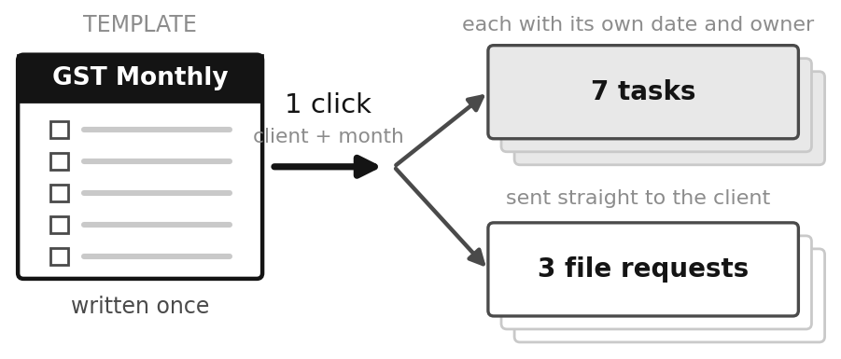
Figure 1 — One template creates a full month of work.
4. Features & Services
Three types of user. What each one can do is decided by their role.
4.1 Chartered Accountant (Admin)
- Add and manage clients, with PAN and GSTIN checks.
- Create staff logins and assign staff to clients.
- Create tasks, reassign them, approve or return submitted work.
- Build workflow templates and generate a full cycle in one click.
- Request files, and accept or reject each version.
- Message clients and read the full activity history.
- Use the AI assistant for summaries, searches and reminder drafts.
4.2 Staff
- See only the clients they are assigned to.
- Move their own tasks forward and submit them for review.
- Request files and upload on the client’s behalf.
- Message clients about ongoing work.
- Get a notification when a task is given to them.
4.3 Client
- See only their own business.
- See the work being done for them and its status.
- See which files are needed, and by when.
- Upload files, and send a new version if one is returned.
- Message the firm in one thread.
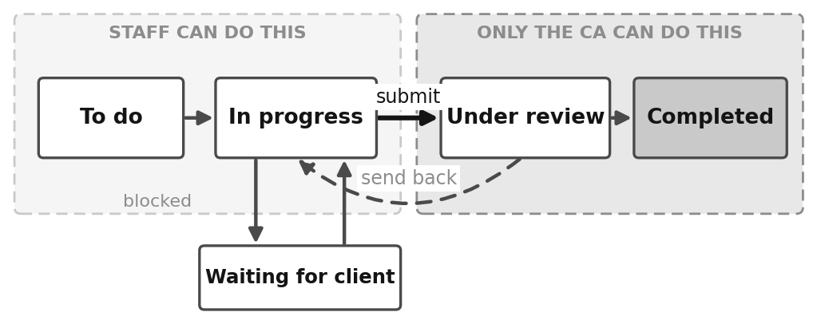
Figure 2 — A task moves left to right; only the CA can approve it.
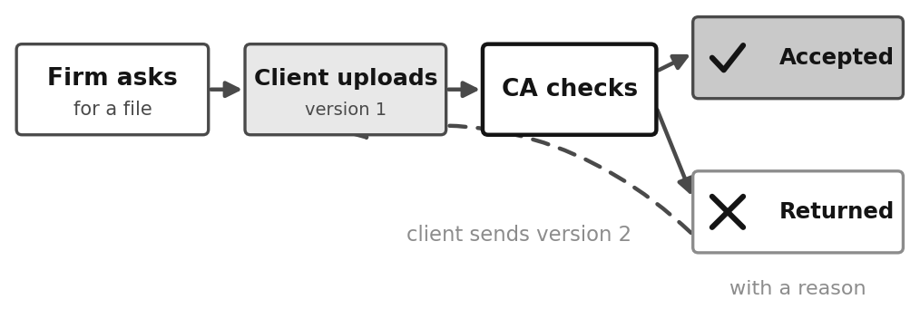
Figure 3 — A file is asked for, sent, and checked until accepted.
5. AI Implementation
No model is built or trained. An existing AI service is called through an API and given two small jobs: pick which action the user meant, and write the final sentence. Everything else is normal code.
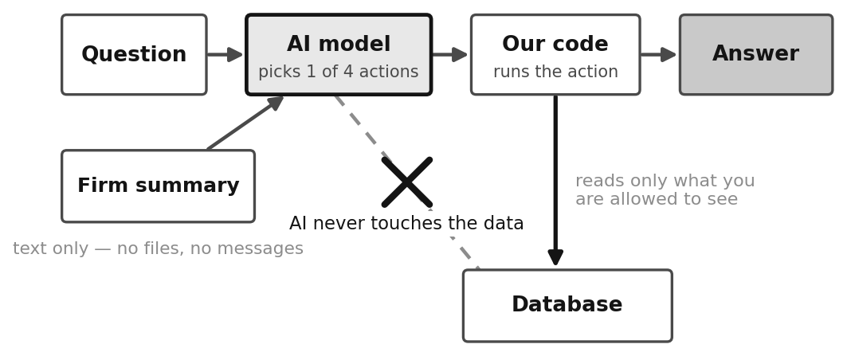
Figure 4 — The AI chooses the action; our code reads the data.
- The firm’s position is turned into plain text: open tasks, overdue work, files awaited, staff load.
- The question and that summary go to the AI, which replies with one action and its settings.
- Every client or staff name it returns is checked against the real list. Unknown names are dropped.
- Our code, not the AI, runs the search and builds the answer.
- The answer is saved with the data it used, so it can be checked later.
Safety
Risk | How it is handled
Data sent outside | Only a text summary of work status. No files, no messages, no PAN or GSTIN.
Made-up client names | Checked against the firm’s real list and removed if unknown.
Database access | The AI never writes a query. It only suggests filters.
Service down or rate limited | Keyword rules answer instead, so the feature keeps working.
Wrong advice | The assistant is told never to give tax, accounting or legal advice.
Quality drops | A test set of 18 real questions is run; the build fails below 85%.
Table 3 — AI risks and the controls used.
For firms that want nothing to leave the office, a local AI can be used instead by changing one setting.
6. Technology Stack
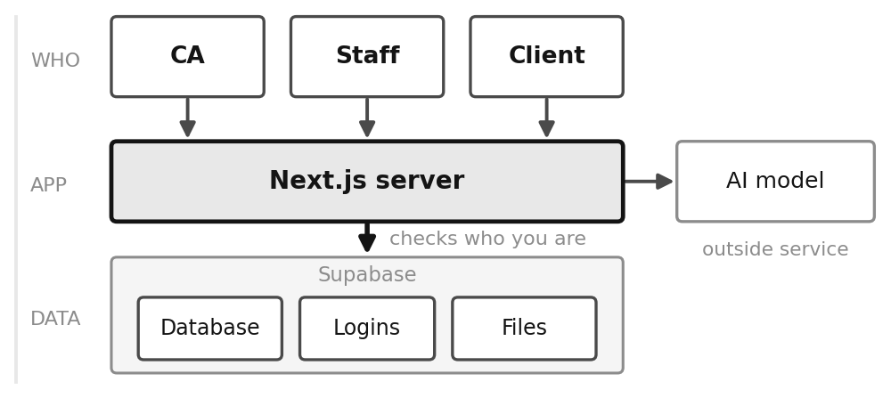
Figure 5 — People, application and data.
Layer | Technology | Why this was chosen
Framework | Next.js 15 | A page can read the database directly, so no separate API is needed. One place to write a feature instead of two.
UI library | React 19 | Builds the screen from small reusable parts, and handles form state without an extra library.
Language | TypeScript | Catches wrong values while coding instead of in front of a client.
Database | PostgreSQL | The data is linked — clients, tasks, files. Keys stop broken links, and it supports row-level security.
Platform | Supabase | Gives hosted Postgres plus logins and file storage that share one permission system.
Access control | Row Level Security | The rule sits on the table, so every query is filtered, even in pages written later.
Business rules | SQL functions | A rule is written once and applies to every caller. The log is written in the same step.
File storage | Supabase Storage | Private files use the same rule as the tables, so access is always in step.
Validation | Zod | Checks form input and gives the message the user reads.
AI service | Groq | Fast, has a free tier, and uses a standard API so it can be swapped by editing settings.
Local AI option | Ollama | Runs on the firm’s own machine when no data may leave the office.
Styling | Plain CSS | The design had to match exactly, and the whole theme changes from one set of variables.
Charts | SVG in code | Only four simple charts are needed, so nothing extra is downloaded.
Hosting | Vercel | Made for Next.js. Pushing the code deploys it.
Table 4 — Technology used and the reason for each.
Not used, on purpose
Not used | Reason
An ORM (Prisma) | Business rules live in the database, which an ORM cannot express.
Tailwind or Bootstrap | The design is specific, and CSS variables already control the theme.
A component library | Bigger than the whole project, for parts that are a few lines each.
A chart library | Too much download weight for four small charts.
Redux or Zustand | Data comes from the server, so there is little to manage in the browser.
A custom AI model | A ready model does the job with no training data and no upkeep.
Table 5 — Options considered and rejected.
7. Phase-wise Development
The internship runs from 12 September to 7 October. The work is planned week by week.
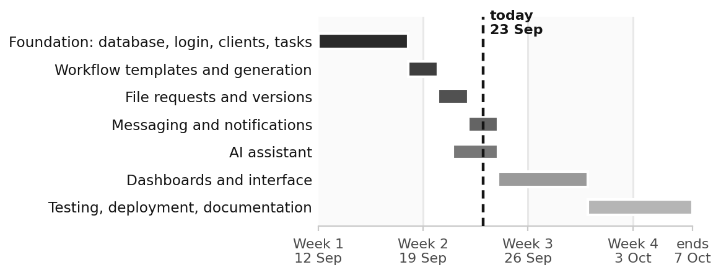
Figure 6 — Internship timeline, 12 September to 7 October.
Week | Dates | What was built
Week 1 | 12 – 18 Sept | Database, roles and permissions, login, client list, staff assignment, tasks, activity log.
Week 2 | 19 – 25 Sept | Workflow templates and generation, file requests and versions, messaging, notifications, AI assistant.
Week 3 | 26 Sept – 2 Oct | Dashboards for each role, client portal, visual design, security testing.
Week 4 | 3 – 7 Oct | Deployment, final testing, documentation and demo.
Table 6 — Weekly plan.
Status
Area | Status | Note
Database, roles and permissions | Complete | Nine security tests.
Clients, staff and tasks | Complete | Full review cycle.
Workflows and documents | Complete | Templates and versions.
Messaging and notifications | Complete | Created by the database.
AI assistant | Complete | With fallback and tests.
Deployment | Remaining | Hosting setup.
Table 7 — Current status.
8. Expected Outcome
One screen shows the whole practice: what is open, what is late, which files are owed, and what is waiting for the CA. The system is built to be used by a real firm, not only demonstrated.
- Fewer missed deadlines. Every step becomes a dated task by itself, and late work is calculated, not tracked.
- Less chasing. Clients see what is needed in their own portal and are told when it is raised.
- Proof of review. Work that needs checking cannot be closed by the person who did it.
- Complete file history. Every version is kept and each decision carries its reason.
- Accountability. Every change is written to a log that cannot be edited.
- Safe delegation. Staff see only their own clients, decided by the database.
- Faster answers. The assistant answers questions about the firm’s own work in plain English.

