**SOFTWARE DEVELOPMENT**

**SOFTWARE ENGINEERING**

 A branch of engineering related to the evolution of software product using well-defined scientific principles, techniques, and procedures.

**SOFTWARE PROCESSES**

**A set of activities whose goal is the development or evolution of the software**

1. **Software specifications:** The functionality of the software and constraints on its operation must be defined.
2. **Software development:** The software to meet the requirement must be produced.
3. **Software validation:** The software must be validated to ensure that it does what the customer wants.
4. **Software evolution:** The software must evolve to meet changing client needs.

**SDLC**

The SDLC is a structured process that enables the production of high-quality, low-cost software, in the shortest possible production time. The goal of SDLC is to produce superior software that meets and exceeds all customer expectations and demands.

**WHY SDLC?**

Without proper planning, we cant come up with a successful project.

**Software Development Lifecycle (SDLC)**

**Stage1: Planning and requirement analysis**

**Stage2: Defining Requirements**

**Stage3: Designing the Software**

**Stage4: Developing the project**

**Stage5: Testing**

**Stage6: Deployment**

**Stage 7: Maintenance**

**Why we need software development and its importance?**

* **Reduces complexity**
* **To minimize software cost**
* **To decrease time**
* **Handling big projects**
* **Reliable software**
* **Effectiveness**

**SDLC MODELS**

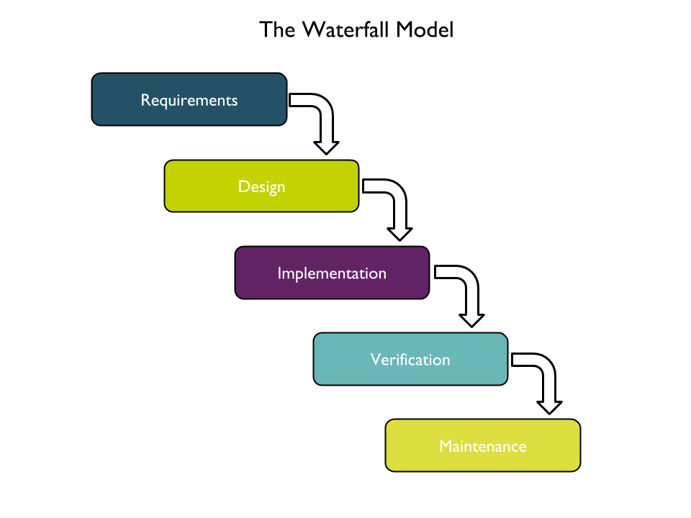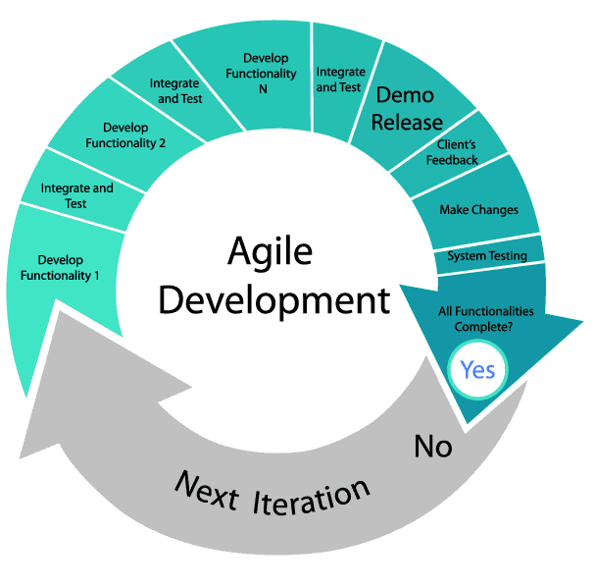

**DEVOPS**

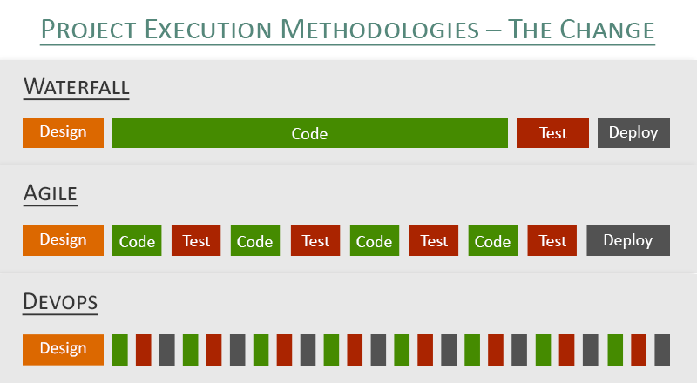

**DEVOPS**

**DEVELOPMENT + OPERATIONS**

DevOps is a philosophy of the efficient development , deployment and operations of the highest quality software possible, used in entire development lifecycle when creating and operating a service with the help of two different professionals i.e., Developer and Operational team.

“**AUTOMATE EVERYTHING**” is the key principle of DevOps.

It is not a tool, not a technology, not a framework , it is a methodology. The aim of this methodology is to bridge the gap between developers team and Operations team.

**DEVOPS COMPRISES FOUR KEY PRINCIPLES**

* AUTOMATION OF SOFTWARE DEVELOPMENT LIFECYCLE
* COLLABORATION AND COMMUNICATION
* CONTINUOUS IMPROVEMENT AND MINIMIZATION OF WASTE
* HYPERFOCUS ON USER NEEDS WITH SHORT FEEDBACK LOOPS

By adopting these principles , Organizations can improve code quality, achieve a faster time to market and engage in better application planning.

**How DevOps Works?**

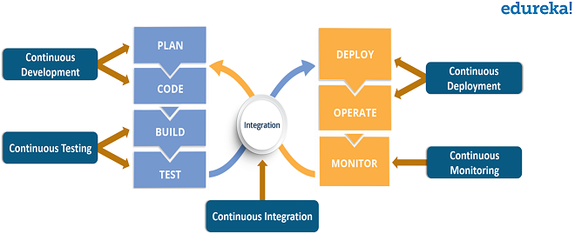

**WHY DEVOPS?**

* Testing and verifying everything manually , was a big deal.
* For each and every bugs, developer was the only person who was responsible, which was a very big headache for the developers.
* Since everything has become automated through devops, The project team is able to work efficiently and quickly to attain customer satisfaction.

**DEVOPS TOOLS**

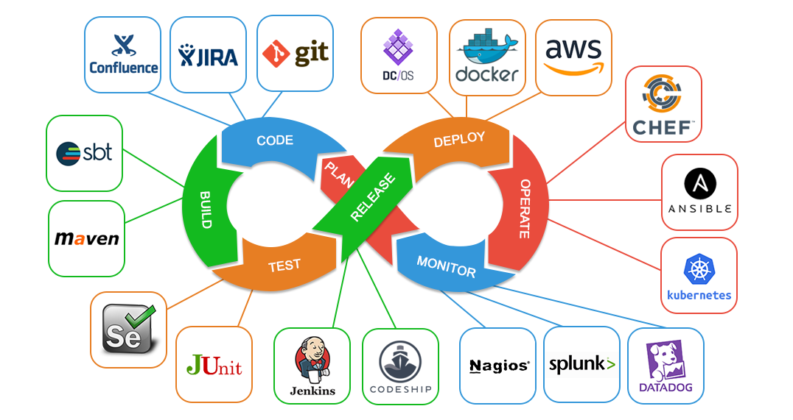

**AWS**

The AWS service is provided by the Amazon that provides on-demand cloud computing platform & different IT resources to individuals, companies and governments. It provides different services such as infrastructure as a service (IaaS), platform as a service (PaaS) and software as a service (SaaS).

Companies like Amazon & Netflix are completely dependent on AWS infrastructure.

Based on the concept of Pay-As-You-Go, AWS provides the services to the customers.

**Why AWS?**

* It reduced the cost of installation of server rooms for small to big IT industries.
* If an individual needs to host an application, he should also buy lot of servers spending more money. But AWS contains stack of servers , users don’t need to buy them, they can just rent them, use them and return them. And there is no need to worry about maintenance. AWS does it.

**AWS provides various services such as,**

* Compute services
* Storage
* Network
* Migration
* Analytics
* Media etc

**Advantages of AWS**

* Flexibility
* Cost-effectiveness
* Scalability/elasticity
* Security

**USECASE**

**Let us Consider,**

**A customer wants a application like Amazon,**

* Senior member or Project Organizer has to setup a meeting with the Client along with the business analyst and take the inputs from the customer and understand what are his expectations.
* Proper planning has to be done, planning in the sense not thinking more on how the application will look or how we will program it. Should think in the way like Is there any app with same functionality? How will be the scope of the app in the market? Are there people willing to use the app? Pay for the app etc etc… everything should be discussed. And also want to decide in what platform the app will be available for (ios, Android, Web).
* Business Analyst will document all those requirement in the format of SRS.
* Design all those requirements.
* According to the programming language which the customer wants, the development team has to be setup.
* Once the development is completed , the app is tested to check whether it is meeting the requirements or not.
* If there is no bugs, the app is then deployed into the cloud. The customer will look into the application, if he wants to add some more features, again the task will be assigned to the developer team, then it will be tested and then it will be deployed.
* This process continues until the software product attains the good quality and better customer satisfaction.