First tried on doesn’t give proper solution for neutral tweets:
from flask import Flask, request, jsonify, render_template
from textblob import TextBlob
from flask_cors import CORS

app = Flask(__name__)
CORS(app) # allow frontend JS to talk to backend

@app.route('/')
def index():
return render_template('index.html')

@app.route('/analyze', methods=['POST'])
def analyze():
data = request.json
text = data.get('text', '')
blob = TextBlob(text)
polarity = blob.sentiment.polarity

if polarity > 0.1:
sentiment = 'positive'
elif polarity < -0.1:
sentiment = 'negative'
else:
sentiment = 'neutral'

return jsonify({'sentiment': sentiment})

if __name__ == "__main__":
app.run(debug=True)

comparision:
Input
- Dataset:
  - tweet_eval sentiment subset (first 200 tweets for testing).
  - Each sample has:
    - text → the tweet content
    - label → 0 (negative), 1 (neutral), 2 (positive)
- Models:
  - CardiffNLP RoBERTa: pre-trained on Twitter sentiment.
  - BERTweet: another pre-trained Twitter sentiment model.
- Other inputs:
  - Batch size (batch_size = 32)
  - Label mapping (for BERTweet)

Process
- Load dataset and convert numeric labels → text labels (negative, neutral, positive).
- For each model:
  - Break tweets into batches.
  - Run model inference → get predicted labels.
  - Map labels to negative/neutral/positive if needed.
- Compare predictions with true labels using classification_report.

Output
- Classification Report for each model:
  - Precision: correctness of predicted labels per class
  - Recall: coverage of actual labels per class
  - F1-score: balance between precision and recall
  - Support: number of samples per class
  - Accuracy / macro avg / weighted avg
- Example Output (from your run):
=== CardiffNLP (RoBERTa) ===
Accuracy: 76.5%
F1-score: weighted avg = 0.765

=== BERTweet ===
Accuracy: 85%
F1-score: weighted avg = 0.850

💡 Summary:
- Input → 200 tweets (text)
- Processing → sentiment prediction by two models
- Output → performance metrics comparing predictions vs true labels
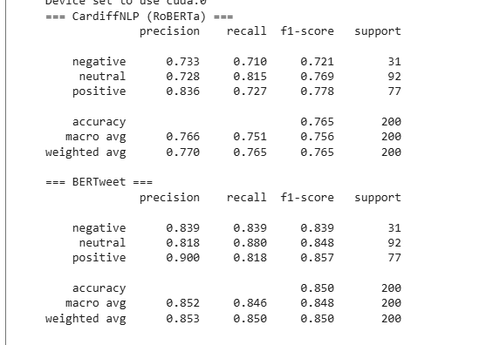
For 64 batch size and 1000 samples

1. CardiffNLP (RoBERTa)
- Accuracy: 76.3%
- Negative class recall improved (0.795) → fewer missed negative tweets.
- Positive class has slightly lower recall than precision → some positives are misclassified.
- Overall, weighted F1-score: 0.764
2. BERTweet
- Accuracy: 85.1% → consistently better than Cardiff.
- All classes have balanced precision and recall.
- Positive class has very high F1-score (0.872).
- Weighted F1-score: 0.851 → solid performance on this 1000-sample subset.
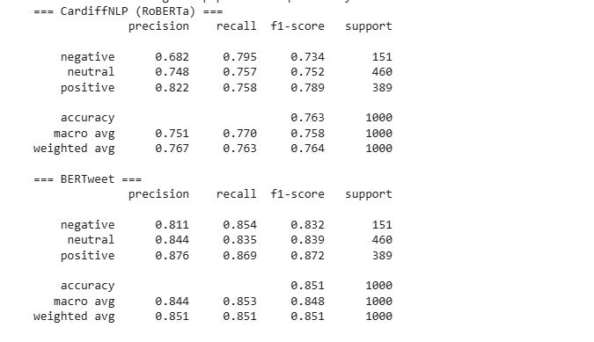
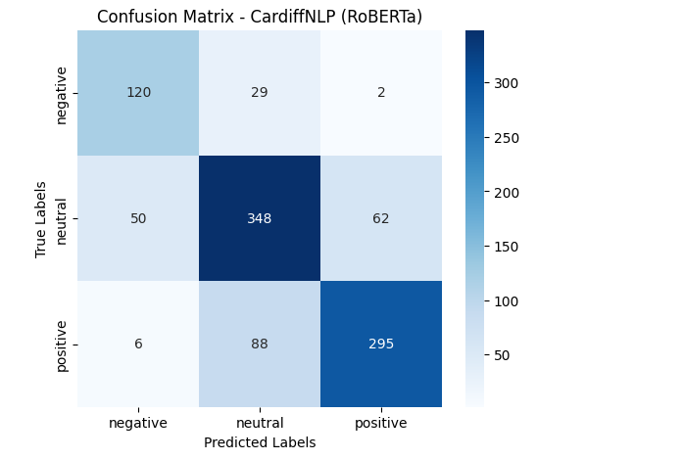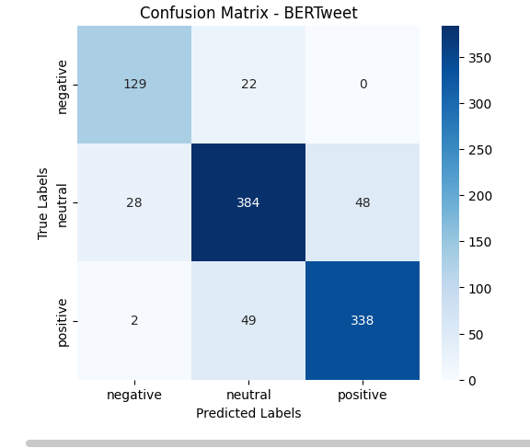

Code use:
import torch
from transformers import pipeline
from datasets import load_dataset
from sklearn.metrics import classification_report
import matplotlib.pyplot as plt
from sklearn.metrics import confusion_matrix
import seaborn as sns

# -------------------------------
# Step 1: Setup device
# -------------------------------
device = 0 if torch.cuda.is_available() else -1
print(f"Device set to use: {'cuda:0' if device==0 else 'cpu'}")

# -------------------------------
# Step 2: Load Models
# -------------------------------
cardiff = pipeline(
"sentiment-analysis",
model="cardiffnlp/twitter-roberta-base-sentiment-latest",
framework="pt",
device=device
)

bertweet = pipeline(
"sentiment-analysis",
model="finiteautomata/bertweet-base-sentiment-analysis",
framework="pt",
device=device
)

# -------------------------------
# Step 3: Load Dataset (tweet_eval sentiment subset)
# -------------------------------
dataset = load_dataset("tweet_eval", "sentiment", split="train[:1000]") # first 200 samples for testing
texts = dataset["text"]
labels_map = {0: "negative", 1: "neutral", 2: "positive"}
true_labels_str = [labels_map[l] for l in dataset["label"]]

# -------------------------------
# Step 4: Get Predictions in batches
# -------------------------------
batch_size = 64

# BERTweet - use_map=True because labels are 'pos', 'neu', 'neg'
bertweet_label_map = {
"neg": "negative",
"neu": "neutral",
"pos": "positive"
}

# Updated get_predictions function
def get_predictions(model, texts, use_map=False, label_map=None):
preds = []
for i in range(0, len(texts), batch_size):
batch_texts = texts[i:i+batch_size]
outputs = model(batch_texts)
for o in outputs:
label = o['label']
if use_map:
label = label_map[label.lower()] # convert to lowercase before mapping
preds.append(label)
return preds

# CardiffNLP - labels already 'positive', 'neutral', 'negative'
cardiff_preds = get_predictions(cardiff, texts, use_map=False)

# BERTweet - use mapping
bertweet_preds = get_predictions(bertweet, texts, use_map=True, label_map=bertweet_label_map)

# -------------------------------
# Step 5: Evaluate
# -------------------------------
print("=== CardiffNLP (RoBERTa) ===")
print(classification_report(true_labels_str, cardiff_preds, digits=3))

print("=== BERTweet ===")
print(classification_report(true_labels_str, bertweet_preds, digits=3))

# -------------------------------
# Step 6: Confusion Matrix
# -------------------------------
def plot_confusion_matrix(true_labels, pred_labels, model_name):
cm = confusion_matrix(true_labels, pred_labels, labels=["negative", "neutral", "positive"])
plt.figure(figsize=(6,5))
sns.heatmap(cm, annot=True, fmt="d", cmap="Blues", xticklabels=["negative", "neutral", "positive"],
yticklabels=["negative", "neutral", "positive"])
plt.xlabel("Predicted Labels")
plt.ylabel("True Labels")
plt.title(f"Confusion Matrix - {model_name}")
plt.show()

# Plot for CardiffNLP
plot_confusion_matrix(true_labels_str, cardiff_preds, "CardiffNLP (RoBERTa)")

# Plot for BERTweet
plot_confusion_matrix(true_labels_str, bertweet_preds, "BERTweet")

