OPERATING SYSTEMS LAB
Cycle 1:
- Write a program to simulate the following CPU Scheduling algorithms. a) FCFS b) SJF c) Round Robin d) priority

a) FCFS:
Program:
#include <stdio.h>
void bubbleSort(int n, int arrival_time[], int burst_time[], int process[]) {
for (int i = 0; i < n - 1; i++) {
for (int j = 0; j < n - i - 1; j++) {
if (burst_time[j] > burst_time[j + 1] ||
(burst_time[j] == burst_time[j + 1] && arrival_time[j] > arrival_time[j + 1])) {
int temp = burst_time[j];
burst_time[j] = burst_time[j + 1];
burst_time[j + 1] = temp;
temp = arrival_time[j];
arrival_time[j] = arrival_time[j + 1];
arrival_time[j + 1] = temp;
temp = process[j];
process[j] = process[j + 1];
process[j + 1] = temp;
}
}
}
}

int main() {
int n, i;
float total_waiting_time = 0, total_turnaround_time = 0;
printf("Enter the number of processes: ");
scanf("%d", &n);
int arrival_time[n], burst_time[n], waiting_time[n], turnaround_time[n], process[n];
printf("Enter Arrival Time and Burst Time for each process:\n");
for (i = 0; i < n; i++) {
process[i] = i + 1;
printf("Process %d - Arrival Time: ", i + 1);
scanf("%d", &arrival_time[i]);
printf("Process %d - Burst Time: ", i + 1);
scanf("%d", &burst_time[i]);
}
bubbleSort(n, arrival_time, burst_time, process);
waiting_time[0] = 0;
for (i = 1; i < n; i++) {
waiting_time[i] = waiting_time[i - 1] + burst_time[i - 1] - (arrival_time[i] - arrival_time[i - 1]);
if (waiting_time[i] < 0) {
waiting_time[i] = 0;
}
}
for (i = 0; i < n; i++) {
turnaround_time[i] = waiting_time[i] + burst_time[i];
total_waiting_time += waiting_time[i];
total_turnaround_time += turnaround_time[i];
}

printf("\nProcess\tArrival Time\tBurst Time\tWaiting Time\tTurnaround Time\n");
for (i = 0; i < n; i++) {
printf("%-7d\t%-12d\t%-10d\t%-12d\t%-15d\n", process[i], arrival_time[i], burst_time[i], waiting_time[i], turnaround_time[i]);
}
printf("\nAverage Waiting Time: %.2f", total_waiting_time / n);
printf("Average Turnaround Time: %.2f\n", total_turnaround_time / n);
return 0;
}

Output:

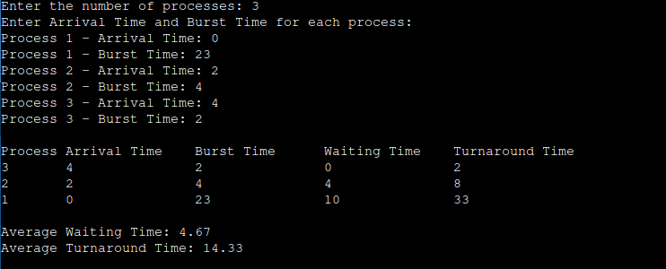

b)Shortest Job First(SJF):
Program:
#include <stdio.h>
int main() {
int n;
printf("Enter the number of processes: ");
scanf("%d", &n);
int processID[n], burstTime[n], arrivalTime[n];
int waitingTime[n], turnaroundTime[n];
int totalWaitingTime = 0, totalTurnaroundTime = 0;
for (int i = 0; i < n; i++) {
processID[i] = i + 1;
printf("Enter burst time for process %d: ", i + 1);
scanf("%d", &burstTime[i]);
printf("Enter arrival time for process %d: ", i + 1);
scanf("%d", &arrivalTime[i]);
}
for (int i = 0; i < n - 1; i++) {
for (int j = 0; j < n - i - 1; j++) {
if (burstTime[j] > burstTime[j + 1] ||
(burstTime[j] == burstTime[j + 1] && arrivalTime[j] > arrivalTime[j + 1])) {
int temp = processID[j];
processID[j] = processID[j + 1];
processID[j + 1] = temp;
temp = burstTime[j];
burstTime[j] = burstTime[j + 1];
burstTime[j + 1] = temp;

temp = arrivalTime[j];
arrivalTime[j] = arrivalTime[j + 1];
arrivalTime[j + 1] = temp;
}
}
}
int completionTime = 0;
for (int i = 0; i < n; i++) {
if (completionTime > arrivalTime[i]) {
waitingTime[i] = completionTime - arrivalTime[i];
} else {
waitingTime[i] = 0;
}
turnaroundTime[i] = waitingTime[i] + burstTime[i];
completionTime += burstTime[i];
totalWaitingTime += waitingTime[i];
totalTurnaroundTime += turnaroundTime[i];
}
float avgWaitingTime = (float)totalWaitingTime / n;
float avgTurnaroundTime = (float)totalTurnaroundTime / n;
printf("\nProcess Burst Time Arrival Time Waiting Time Turnaround Time\n");
for (int i = 0; i < n; i++) {
printf("P%-8d%-12d%-14d%-14d%-16d\n", processID[i], burstTime[i], arrivalTime[i], waitingTime[i], turnaroundTime[i]);
}
printf("\nAverage Waiting Time: %.2f\n", avgWaitingTime);
printf("Average Turnaround Time: %.2f\n", avgTurnaroundTime);

return 0;
}

Output:

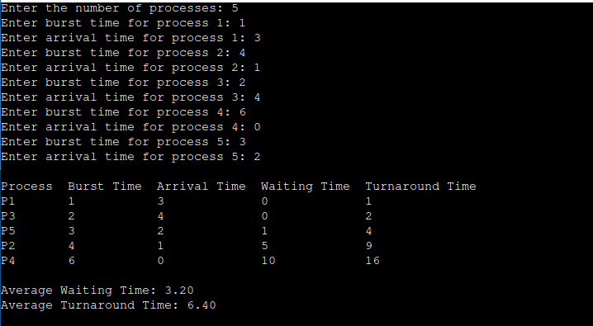

c)Round Robin:
Program:
#include <stdio.h>
#define MAX 100

int main() {
int n, timeQuantum,i;
int burstTime[MAX], arrivalTime[MAX], waitingTime[MAX], turnAroundTime[MAX], remainingBurstTime[MAX], completionTime[MAX];
int pid[MAX];
int totalWaitingTime = 0, totalTurnAroundTime = 0, currentTime = 0, processesRemaining;
printf("Enter the number of processes: ");
scanf("%d", &n);
printf("Enter the time quantum: ");
scanf("%d", &timeQuantum);
for (i = 0; i < n; i++) {
pid[i] = i + 1;
printf("Enter burst time for process %d: ", i + 1);
scanf("%d", &burstTime[i]);
printf("Enter arrival time for process %d: ", i + 1);
scanf("%d", &arrivalTime[i]);
remainingBurstTime[i] = burstTime[i];
waitingTime[i] = 0;
completionTime[i] = 0;
}
processesRemaining = n;
while (processesRemaining > 0) {
for (i = 0; i < n; i++) {
if (arrivalTime[i] <= currentTime && remainingBurstTime[i] > 0) {
if (remainingBurstTime[i] > timeQuantum) {
currentTime += timeQuantum;
remainingBurstTime[i] -= timeQuantum;
} else {
currentTime += remainingBurstTime[i];
completionTime[i] = currentTime;
waitingTime[i] = currentTime - burstTime[i] - arrivalTime[i];
if (waitingTime[i] < 0) {
waitingTime[i] = 0;
}
turnAroundTime[i] = waitingTime[i] + burstTime[i];
remainingBurstTime[i] = 0;
processesRemaining--;
}
}
}
}
for ( i = 0; i < n; i++) {
totalWaitingTime += waitingTime[i];
totalTurnAroundTime += turnAroundTime[i];
}
printf("\nProcesses\tBurst Time\tArrival Time\tCompletion Time\tWaiting Time\tTurn-Around Time\n");
for (i = 0; i < n; i++) {
printf("%d\t\t%d\t\t%d\t\t%d\t\t%d\t\t%d\n", pid[i], burstTime[i], arrivalTime[i], completionTime[i], waitingTime[i], turnAroundTime[i]);
}
printf("\nAverage waiting time = %.2f\n", (float)totalWaitingTime / n);
printf("Average turn-around time = %.2f\n", (float)totalTurnAroundTime / n);
return 0;
}
Output:
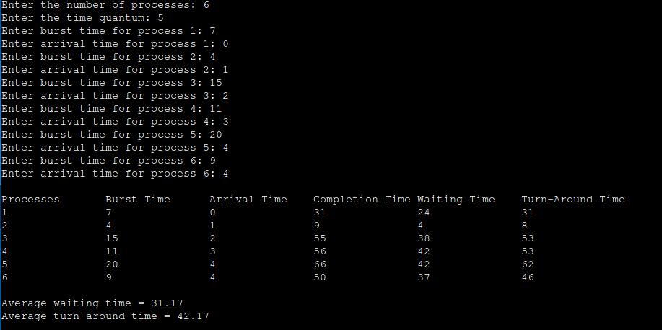

d)Priority:
Program:
#include <stdio.h>
void calculateWaitingTime(int n, int arrivalTime[], int burstTime[], int waitingTime[]) {
int currentTime = 0;
for (int i = 0; i < n; i++) {
if (currentTime < arrivalTime[i]) {
currentTime = arrivalTime[i];
}
waitingTime[i] = currentTime - arrivalTime[i];
if (waitingTime[i] < 0) {
waitingTime[i] = 0;
}
currentTime += burstTime[i];
}
}
void calculateTurnaroundTime(int n, int burstTime[], int waitingTime[], int turnaroundTime[]) {
for (int i = 0; i < n; i++) {
turnaroundTime[i] = waitingTime[i] + burstTime[i];
}
}
void sortByPriorityAndArrival(int n, int process[], int arrivalTime[], int burstTime[], int priority[]) {
for (int i = 0; i < n - 1; i++) {
for (int j = i + 1; j < n; j++) {
if (priority[i] > priority[j] || (priority[i] == priority[j] && arrivalTime[i] > arrivalTime[j])) {
int temp = priority[i];
priority[i] = priority[j];
priority[j] = temp;
temp = arrivalTime[i];
arrivalTime[i] = arrivalTime[j];
arrivalTime[j] = temp;
temp = burstTime[i];
burstTime[i] = burstTime[j];
burstTime[j] = temp;
temp = process[i];
process[i] = process[j];
process[j] = temp;
}
}
}
}
void displayResults(int n, int process[], int arrivalTime[], int burstTime[], int priority[], int waitingTime[], int turnaroundTime[]) {
printf("Process\tArrival Time\tPriority\tBurst Time\tWaiting Time\tTurnaround Time\n");
for (int i = 0; i < n; i++) {
printf("P%d\t\t%d\t\t%d\t\t%d\t\t%d\t\t%d\n", process[i], arrivalTime[i], priority[i], burstTime[i], waitingTime[i], turnaroundTime[i]);
}
}
void displayAverages(int n, int waitingTime[], int turnaroundTime[]) {
double totalWaitingTime = 0, totalTurnaroundTime = 0;
for (int i = 0; i < n; i++) {
totalWaitingTime += waitingTime[i];
totalTurnaroundTime += turnaroundTime[i];
}
printf("\nAverage Waiting Time: %.2lf\n", totalWaitingTime / n);
printf("Average Turnaround Time: %.2lf\n", totalTurnaroundTime / n);
}
int main() {
int n;
printf("Enter the number of processes: ");
scanf("%d", &n);
int process[n], arrivalTime[n], burstTime[n], priority[n];
int waitingTime[n], turnaroundTime[n];
for (int i = 0; i < n; i++) {
process[i] = i + 1;
printf("Enter arrival time for process P%d: ", process[i]);
scanf("%d", &arrivalTime[i]);
printf("Enter burst time for process P%d: ", process[i]);
scanf("%d", &burstTime[i]);
printf("Enter priority for process P%d: ", process[i]);
scanf("%d", &priority[i]);
}
sortByPriorityAndArrival(n, process, arrivalTime, burstTime, priority);
calculateWaitingTime(n, arrivalTime, burstTime, waitingTime);
calculateTurnaroundTime(n, burstTime, waitingTime, turnaroundTime);
displayResults(n, process, arrivalTime, burstTime, priority, waitingTime, turnaroundTime);
displayAverages(n, waitingTime, turnaroundTime);
return 0;
}

Output:
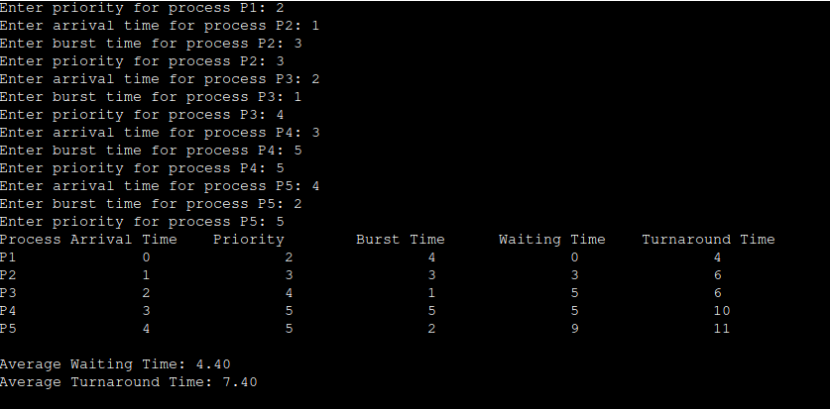

2. a) Write a program to implement Process management system calls viz., fork, exit, wait,
waitpid, exec.
Program:
#include<stdio.h>
#include<sys/types.h>
#include<sys/wait.h>
#include<stdlib.h>
#include<unistd.h>
int main()
{
pid_t pid;
pid=fork();
if(pid<0)
{
printf("Fork Failed");
exit(-1);
}
else if(pid==0)
{
execlp("ls","ls","-l",NULL);
}
else{
wait(NULL);
printf("Parent Process PID =%d\n",getpid());
printf("Child process created with PID = %d\n",pid);
printf("Child Complete");
exit(0);
}
}
Output:
