PLACEMENT MANAGEMENT SYSTEM
A
OOP Course Base Project Report

Submitted in partial fulfilment of the Requirements for the award of the Degree of

BACHELOR OF ENGINEERING

IN

INFORMATION TECHNOLOGY

By

SAIRAM KANATHALA (1602-24-737-166)

VAISHNAVI MEDICHARLA (1602-24-737-187)


Department of Information Technology Vasavi College of Engineering (Autonomous)
ACCREDITED BY NAAC WITH 'A++' GRADE

(Affiliated to Osmania University and Approved by AICTE) Ibrahimbagh, Hyderabad-31
2025-2026

Vasavi College of Engineering (Autonomous)

ACCREDITED BY NAAC WITH 'A++' GRADE

(Affiliated to Osmania University and Approved by AICTE) Hyderabad-500 031
Department of Information Technology

DECLARATION BY THE CANDIDATE

We, SAIRAM KANATHALA and VAISHNAVI MEDICHARLA
bearing hall ticket numbers, 1602-24-737-166 and 1602-24-737-187 declare that the project report entitled is PLACEMENT MANAGEMENT SYSTEM submitted in partial fulfilment of the requirement for the award of the degree of Bachelor of Engineering in Information Technology.

This is a record of bonafide work carried out by us and the results embodied in this project report have not been submitted to any other university or institute for the award of any other degree or diploma.

Sairam Kanathala
1602-24-737-166
Vaishnavi Medicharla
1602-24-737-187

Faculty In-Charge Head,Dept of IT
(Dr.S.Aruna) (Dr.K.RamMohanRao)

ACKNOWLEDGMENT

We extend our sincere thanks to Dr. S. V. Ramana, Principal, Vasavi College of Engineering for his encouragement.
We express our sincere gratitude to Dr. K. Ram Mohan Rao, Professor & Head, Department of Information Technology, Vasavi College of Engineering
We also want to thank and convey our gratitude towards our OOPS Faculty, S.Aruna for guiding us in understanding the process of project development & giving us timely suggestions at every phase.

Abstract:
The Placement Management System is a Java-based application designed to automate and streamline the end-to-end campus recruitment process. The system manages student profiles, company details, required skills, eligibility criteria, and placement records in an efficient and user-friendly manner. It provides separate modules for adding, updating, viewing, and removing both student and company information. The application evaluates the eligibility of students for different companies by comparing their CGPA and skills with the company’s minimum requirements. It also supports managing placement drives, generating results, and maintaining historical placement records.
The project integrates graphical user interface components using Java Swing and ensures reliable data persistence through object serialization. By offering a structured, easy-to-use interface, the Placement Management System enhances transparency, reduces manual effort, and simplifies the overall coordination of placement activities in educational institutions.

INTRODUCTION:

Campus placements play a crucial role in bridging the gap between students and the corporate world. Traditionally, managing placement data—including student registration, company requirements, eligibility checks, and drive results—requires extensive manual coordination, which is both time-consuming and prone to error. To address these challenges, the Placement Management System provides a digital platform that automates the complete placement workflow.
This system is developed in Java using an object-oriented approach and features a modern, interactive GUI built with Java Swing. It allows the placement team to maintain comprehensive student and company databases, including attributes such as branch, CGPA, skills, job roles, and minimum requirements. The application ensures accurate eligibility matching by verifying student CGPA and skill sets against company expectations. It also supports the addition of required skills for companies, student skill profiles, and real-time updates to placement records.
Furthermore, the system incorporates persistent data storage using serialization, allowing all information to be saved and reloaded across multiple sessions. Placement drives can be initiated from within the application, generating instant selection or rejection outcomes for each eligible student. With well-structured modules, simple navigation, and clean output displays, the Placement Management System not only reduces administrative effort but also provides a reliable and efficient mechanism for managing placement operations in academic institutions.

CODE:

import java.io.*;
import java.util.*;

abstract class Person implements Serializable {
protected String id, name;

public Person(String id, String name) {
this.id = id;
this.name = name;
}
public String getId() { return id; }
public String getName() { return name; }
}

class Skill implements Serializable {
private String name;

public Skill(String name) { this.name = name; }
public String getName() { return name; }
public String toString() { return name; }
}

class Student extends Person {
private String branch;
private float cgpa;
private List<Skill> skills = new ArrayList<>();

public Student(String id, String name, String branch, float cgpa) {
super(id, name);
this.branch = branch;
this.cgpa = cgpa;
}

public float getCgpa() { return cgpa; }
public String getBranch() { return branch; }
public List<Skill> getSkills() { return skills; }
public void addSkill(Skill s) { skills.add(s); }

public String toString() {
return id + " " + name + " " + branch + " CGPA: " + cgpa + " Skills: " + skills;
}
}
class Company implements Serializable {
private String id, name, role;
private float minCgpa;
private List<Skill> requiredSkills = new ArrayList<>();

public Company(String id, String name, String role, float minCgpa) {
this.id = id; this.name = name; this.role = role; this.minCgpa = minCgpa;
}

public float getMinCgpa() { return minCgpa; }
public List<Skill> getRequiredSkills() { return requiredSkills; }
public void addRequiredSkill(Skill s) { requiredSkills.add(s); }

public String toString() {
return id + " " + name + " Role: " + role + " Min CGPA: " + minCgpa +
" Required: " + requiredSkills;
}
}

class PlacementRecord implements Serializable {
private String studentId, companyId, status;
private Date date = new Date();

public PlacementRecord(String s, String c, String status) {
this.studentId = s; this.companyId = c; this.status = status;
}

public String toString() {
return studentId + " -> " + companyId + " : " + status + " (" + date + ")";
}
}

class PlacementManager {
private Map<String, Student> students = new HashMap<>();
private Map<String, Company> companies = new HashMap<>();
private List<PlacementRecord> records = new ArrayList<>();

public void addStudent(Student s) { students.put(s.getId(), s); }
public void addCompany(Company c) { companies.put(c.getId(), c); }

private boolean hasRequiredSkills(Student s, Company c) {
for (Skill req : c.getRequiredSkills()) {
boolean found = false;
for (Skill st : s.getSkills())
if (st.getName().equalsIgnoreCase(req.getName())) found = true;
if (!found) return false;
}
return true;
}

public List<Student> getEligibleStudents(String companyId) {
Company c = companies.get(companyId);
List<Student> list = new ArrayList<>();
for (Student s : students.values())
if (s.getCgpa() >= c.getMinCgpa() && hasRequiredSkills(s, c))
list.add(s);
return list;
}

public void startDrive(String companyId) {
Company c = companies.get(companyId);
List<Student> eligible = getEligibleStudents(companyId);

for (Student s : eligible) {
String result = Math.random() > 0.5 ? "Selected" : "Rejected";
records.add(new PlacementRecord(s.getId(), c.getId(), result));
System.out.println(s.getName() + " -> " + result);
}
}

// Show functions
public void showStudents() { students.values().forEach(System.out::println); }
public void showCompanies() { companies.values().forEach(System.out::println); }
public void showRecords() { records.forEach(System.out::println); }
}

public class PlacementManagementSystem {
public static void main(String[] args) {
PlacementManager pm = new PlacementManager();

Student s1 = new Student("101", "Vaishnavi", "IT", 8.7f);
s1.addSkill(new Skill("Java"));
pm.addStudent(s1);

Company c1 = new Company("C01", "Google", "SDE", 8.5f);
c1.addRequiredSkill(new Skill("Java"));
pm.addCompany(c1);

System.out.println("\nEligible Students:");
pm.getEligibleStudents("C01").forEach(System.out::println);

System.out.println("\nStarting Drive:");
pm.startDrive("C01");

System.out.println("\nPlacement Records:");
pm.showRecords();
}

}

Sample output:
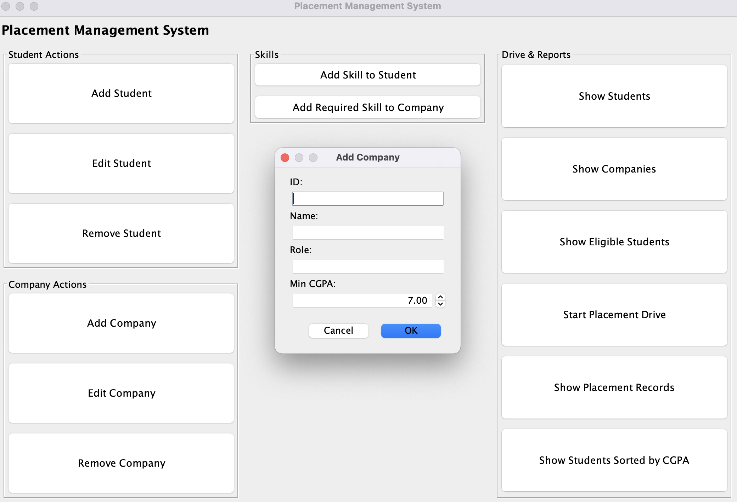

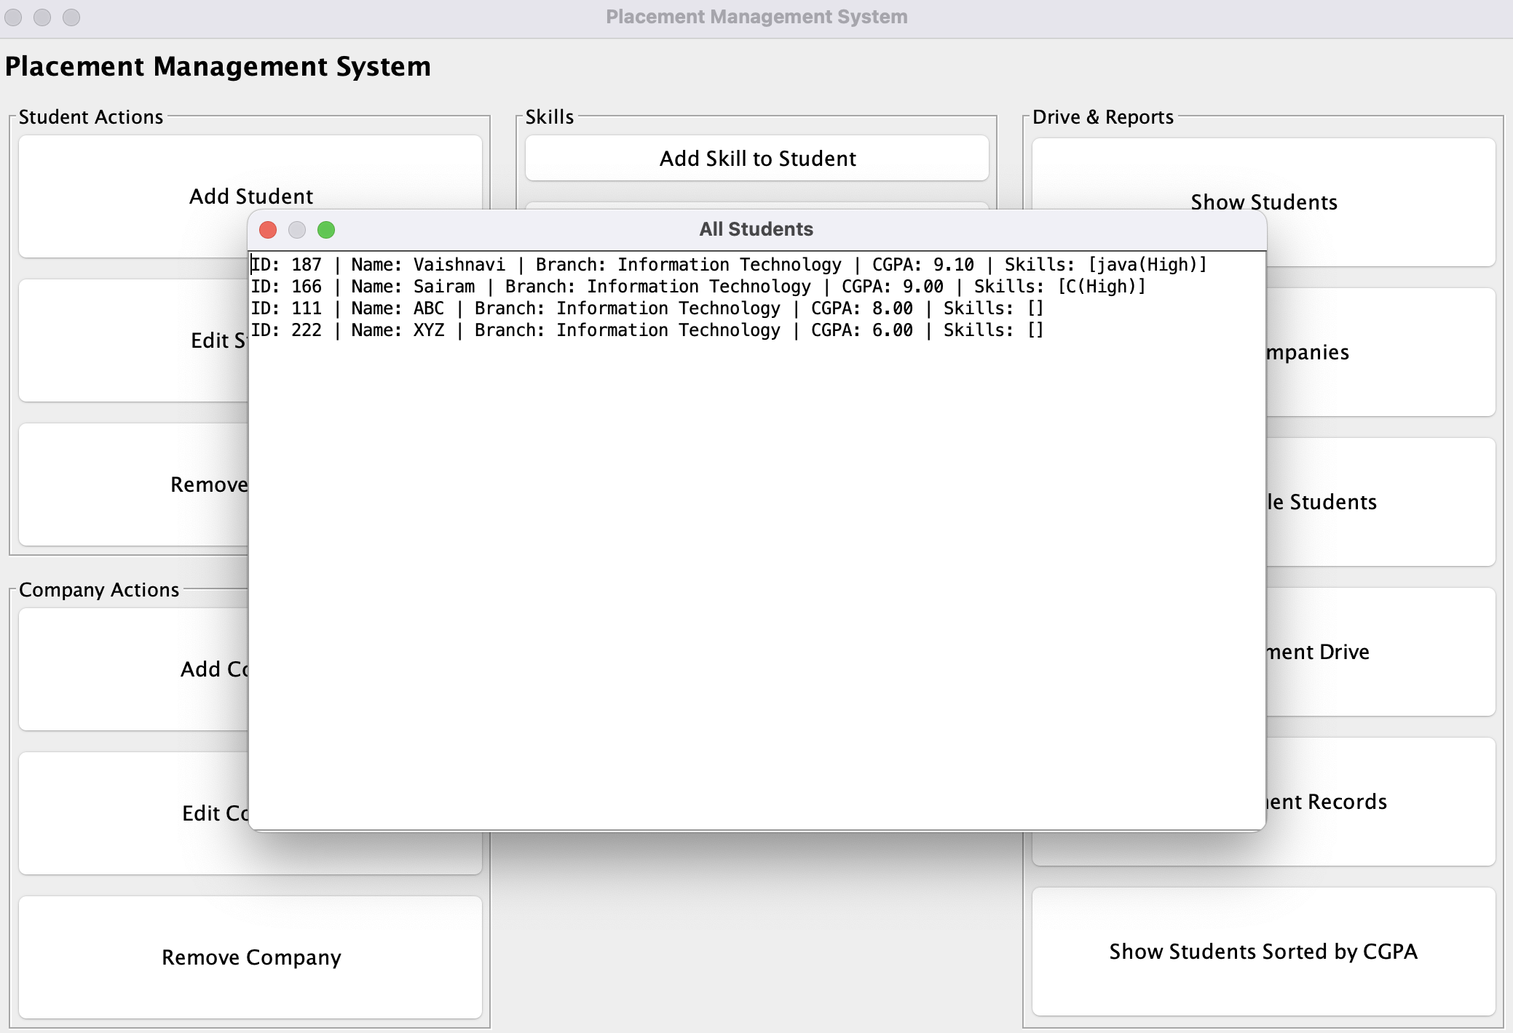
CONCLUSION:
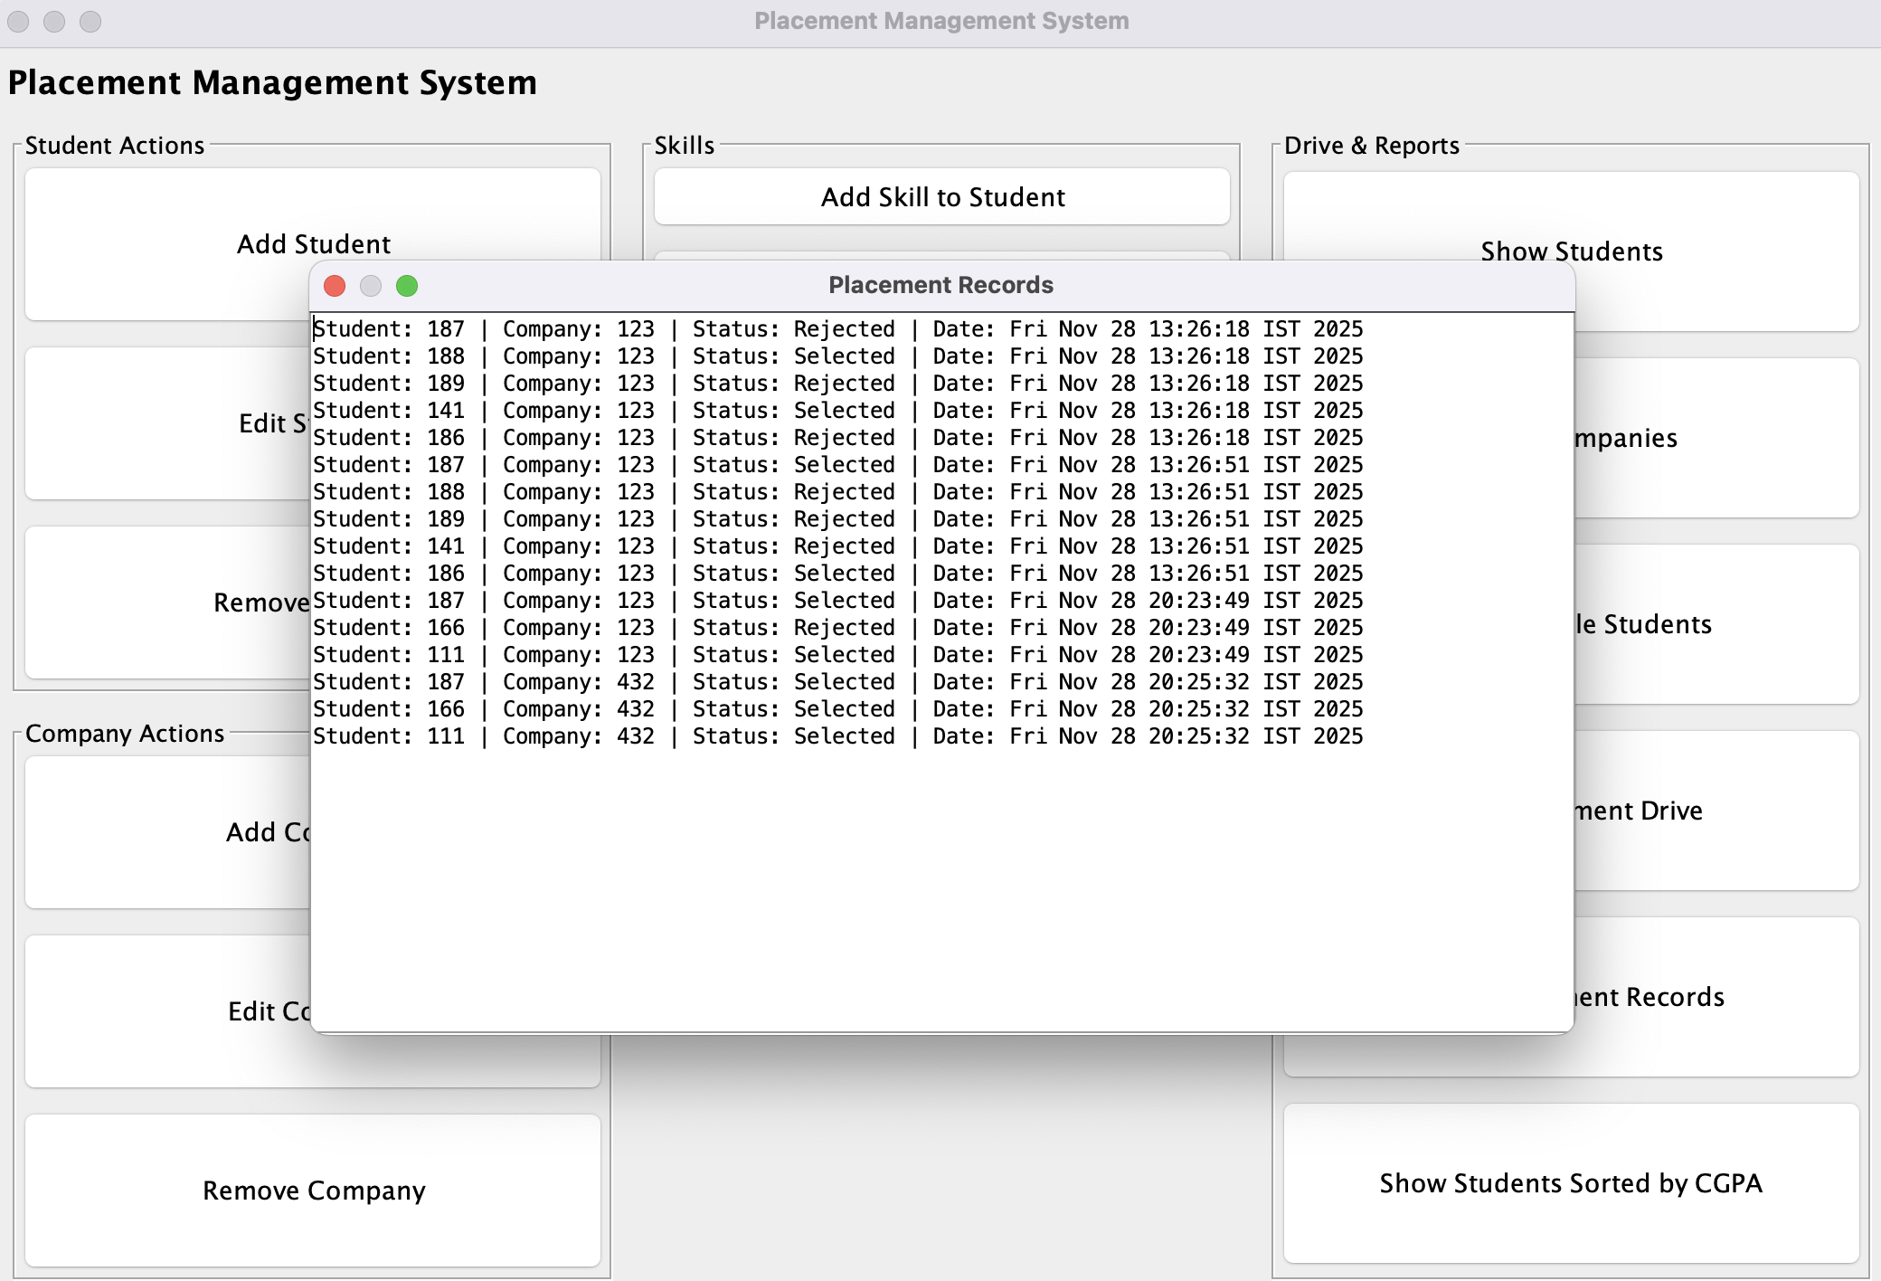
The Placement Management System successfully automates and streamlines the end-to-end campus recruitment process. By digitizing student and company records and integrating features such as eligibility verification, skill management, and placement drive execution, the system minimizes manual work and reduces human errors. The use of Java, Object-Oriented Programming, Swing-based GUI, and serialization ensures that the system is user-friendly, maintainable, and capable of preserving data across sessions.
Through modules that support adding, editing, and viewing student and company information, the system improves the efficiency and transparency of the placement workflow. The automatic generation of placement results and maintenance of historical records further enhance its utility for academic institutions. Overall, the Placement Management System provides a reliable, scalable, and effective solution for managing placement operations and can be extended in the future with features such as online registrations, resume generation, analytics dashboards, and integration with institutional databases.

