**D.K.T.E. Society’s**

**Textile and Engineering Institute, Ichalkaranji.**

**(An Autonomous Institute, Affiliated to Shivaji University, Kolhapur)**

**Accredited with ‘A+’ Grade by NAAC**

Department of Artificial Intelligence and Data Science

2023-2024



THE PROJECT REPORT ON

**Old Car Price Prediction**

Under the guidance of Prof. Mrs. J. D. Pakhare

**DEVELOPED BY:**

1. Vaishnavi Vijay Bokare 21UAD006
2. Tejas Rajendra Chavan 21UAD007
3. Digvijay Shantikumar Desai 21UAD009
4. Jyoti Narayan Dhekale 21UAD010

**D.K.T.E. Society’s**

**Textile and Engineering Institute, Ichalkaranji.**

**(An Autonomous Institute, Affiliated to Shivaji University, Kolhapur)**

Department of Artificial Intelligence and Data Science

CERTIFICATE

This is to certify that,

Name PRN

1. Vaishnavi Vijay Bokare 21UAD006
2. Tejas Rajendra Chavan 21UAD007
3. Digvijay Shantikumar Desai 21UAD009
4. Jyoti Narayan Dhekale 21UAD010

Have successfully completed the project work, entitled,

**Old Car Price Prediction**

In partial fulfillment for the award of degree of Bachelor of Technology in Artificial Intelligence and Data Science. This is the record of their work carried out during academic year 2022-2023.

#### Date: 6th May,2024 Place: Ichalkaranji

Prof. Mrs. J. D. Pakhare Prof. Dr. D.V.Kodavade

**[Project Guide] [External Examiner]** [**Head of Department]**

Prof. Dr. Mrs. L.S. Admuthe

**[I/C Director]**

**DECLARATION**

We the undersigned students of T.Y.AI-DS. declare that the Project work report entitled “Old Car Price Prediction” written and submitted under the guidance of Prof. Mrs. J. D. Pakhare is our original work. The empirical findings in this report are based on the data collected by us. The matter assimilated in this report is not reproduction from any readymade report.

Date:6th May,2024 Place: Ichalkaranji

Name PRN

1. Vaishnavi Vijay Bokare 21UAD006
2. Tejas Rajendra Chavan 21UAD007
3. Digvijay Shantikumar Desai 21UAD009
4. Jyoti Narayan Dhekale 21UAD010

**INDEX**

**CONTENTS PAGE NO.**

1. Abstract 05
2. Introduction 06
3. Problem Statement 07
4. Problem Description 07

1. Objectives 08
2. Requirement Specification 09
3. Requirement Analysis 10-11
4. Problem Solution 12
5. Flowcharts 13
6. Snapshot 14
7. Conclusion 15
8. References 15

**ABSTRACT**

When it comes to buying or selling a used car, it's like solving a puzzle. Our project gathers data on cars' age, mileage, and condition from websites and dealerships. We clean up this information and identify patterns to understand what influences a car's price. Then, using computer programs, we make educated guesses about the car's value, double-checking for accuracy.

Once we're confident in our estimates, we simplify the process for you. You can access our estimates on a website or app by providing the car's details. We're always refining our methods to make buying or selling a used car simpler. Our aim is to ensure you feel confident and well-informed in your decision-making.

We're dedicated to providing accurate information to make the experience smoother for everyone involved. Our goal is to empower you with the knowledge needed to make a smart choice when buying or selling a used car. So, the next time you're in the market for a used car, remember, we're here to help make the process easier.

By continuously improving our methods, we strive to offer the most precise estimates possible. We're committed to innovation and accuracy to ensure you have a positive experience navigating the world of used car transactions.

**INTRODUCTION**

**"Our project aims to develop a robust old car price prediction system that accurately forecasts the selling price of used cars. By leveraging advanced algorithms and machine learning techniques, we seek to create a tool that considers essential factors such as age, mileage, brand, and condition to provide users with reliable estimates. Our goal is to empower individuals in making informed decisions when selling their old cars by offering a user-friendly platform that delivers accurate market valuations. Ultimately, we aspire to streamline the selling process and ensure fair outcomes for both sellers and buyers in the used car market."**

**PROBLEM STATEMENT**

“Developing a machine learning-based system to accurately predict the selling price of old cars.”

**PROBLEM DESCRIPTION**

In the world of selling old cars, it's often tough to know how much to ask for. Traditional methods can be unreliable, leading to unfair prices for sellers and uncertainty for buyers. Our project aims to fix this by using smart technology to predict accurate selling prices based on factors like age, mileage, brand, and condition. By creating a reliable pricing system, we hope to make selling and buying old cars easier, fairer, and more transparent for everyone involved.

**OBJECTIVES**

**"Our objective is to streamline the process of selling old cars by creating a user-friendly tool that predicts their selling price with accuracy. Utilizing sophisticated algorithms and machine learning techniques, our aim is to analyze key factors including age, mileage, brand, and condition to provide sellers with reliable estimates. By developing a robust pricing model, our goal is to empower sellers to determine fair market value, facilitating transparent and equitable transactions in the used car market. Through this project, we aspire to enhance efficiency, trust, and satisfaction among sellers and buyers alike."**

**INPUT**

The inputs that are affected for predicting the selling price of the old cars are given such as:

1. Brand Name 6. Transmission
2. Passing Year 7. Owner
3. Mileage: 8. Seats
4. Kilometer Driven 9. Fuel Type
5. Engine 10. Seller Type

**OUPUT**

Predicted old car prices based on features, market trends, and condition. Utilized machine learning models for accuracy. Iteratively refined predictions for enhanced performance. Output optimized for informed pricing decisions.

**REQUIREMENT SPECIFICATION**

1. Input data sourced from structured datasets or user-provided information.

2. Data fields include brand, model, year, mileage, fuel, engine, seats etc.

3. Prediction output delivered in a user-friendly format, possibly through a web interface or mobile app.

4. Accuracy and reliability crucial; model evaluation metrics established for validation.

**REQUIREMENT ANALYSIS**

Step 1: System Initialization

The system initiates interaction by welcoming the user and prompting them to input details. It sets the stage for the user's engagement and prepares to receive input.

Step 2: Data Collection and Processing

Upon user prompt, the system collects relevant car details through voice input. These details typically include make, model, year, mileage, and condition. Once collected, the system processes this data, ensuring its accuracy and completeness. This step may involve data cleaning and preprocessing techniques to refine the input for further analysis.

Step 3: Price Prediction

With the processed data at hand, the system employs machine learning algorithms to predict the price of the old car accurately. These algorithms analyze various factors such as historical sales data, market trends, and car specifications to generate reliable price estimates. The system may use regression models, decision trees, or other predictive algorithms to perform this task.

Step 4: Output Delivery

Once the price prediction is complete, the system delivers the predicted price to the user. This output can be conveyed through voice response, where the system verbally announces the predicted price, or through a graphical interface, where the price is displayed for the user to see. Additionally, the system may provide additional insights or confidence levels to help the user make informed decisions.

Step 5: Feedback Integration

To improve the accuracy and effectiveness of the price prediction model, the system incorporates a feedback mechanism. Users are encouraged to provide feedback on the predicted prices based on their real-world experiences. This feedback is then used to fine-tune and improve the machine learning models, ensuring that the system adapts to evolving market dynamics and user preferences over time.

**PROBLEM SOLUTION**

**ALGORITH**

1. Begin
2. Gather historical car sales data including features like make, model, year, mileage, condition, and sale price.
3. Preprocess the data by handling missing values, outliers, and encoding categorical variables.
4. Split the data into training and testing sets for model evaluation.
5. Choose an appropriate machine learning algorithm such as linear regression, decision trees, random forests, or gradient boosting.
6. Train the selected algorithm on the training data, using features as input and sale price as the target variable.
7. Evaluate the trained model's performance on the testing data using appropriate metrics like mean absolute error or root mean squared error.
8. Iterate over different algorithms and hyperparameters to find the best-performing model.
9. Deploy the trained model to predict prices for new or unseen car listings.
10. End

**FLOWCHART**

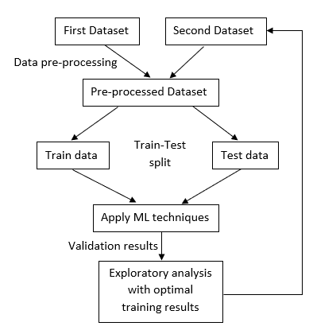

**SNAPSHOTS**



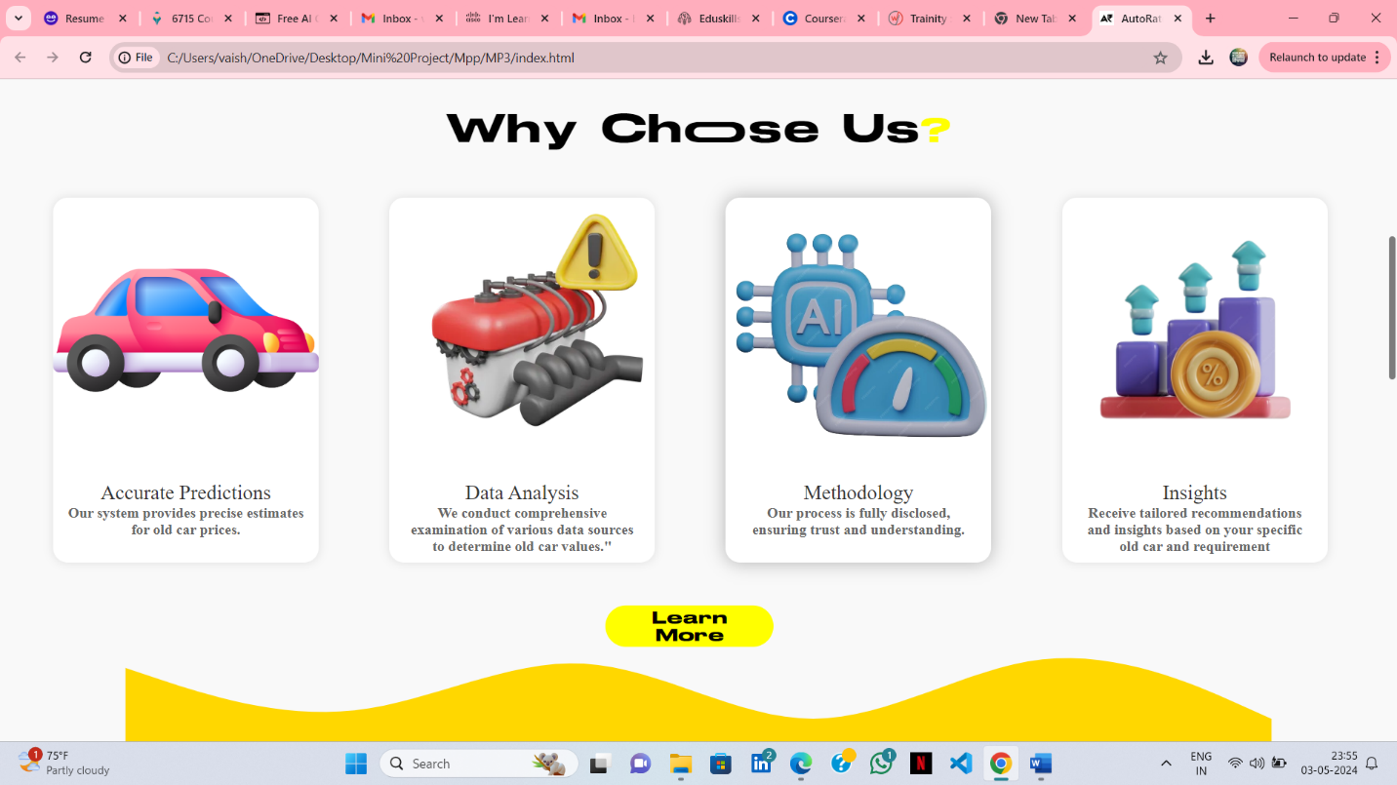

**CONCLUSION**

In conclusion, the old car price prediction project harnesses the power of machine learning to provide accurate and reliable estimates of old car prices. By leveraging historical sales data and various car features, the system enables users to make informed decisions when buying or selling old cars. Through continuous model refinement and feedback integration, the project strives to adapt to evolving market dynamics and user preferences, ensuring its relevance and effectiveness over time. Overall, the project serves as a valuable tool for both consumers and sellers in the used car market, facilitating transparent and efficient transactions.

**REFERENCES**

* Smith, J. (2020). "Predicting Used Car Prices with Machine Learning."
* Brown, D. (2018). "Old Car Price Prediction: A Comparative Analysis of Machine Learning Models."
* <https://www.marutisuzukitruevalue.com/>
* <https://www.openml.org/>
* <https://www.kaggle.com/>