create database employee;

use employee;

create table emp(eno int primary key,ename varchar(20),designation varchar(20),salary float,date_of_joining varchar(20));

desc emp;

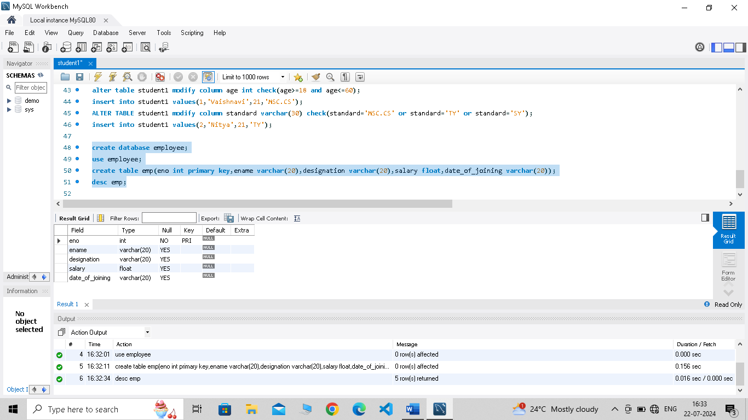

insert into emp(eno,ename,designation,salary,date_of_joining)values(1,'Mr.Advait','Assistant',54000,'23/02/2003');

insert into emp(eno,ename,designation,salary,date_of_joining)values(2,'Mr.Raghav','Manager',420000,'01/03/2002');

insert into emp(eno,ename,designation,salary,date_of_joining)values(3,'Mr.Siddhesh','Developer',74000,'01/02/2004');

insert into emp(eno,ename,designation,salary,date_of_joining)values(4,'Mr.Aditya','Tester',78000,'12/07/2007');

select * from emp;

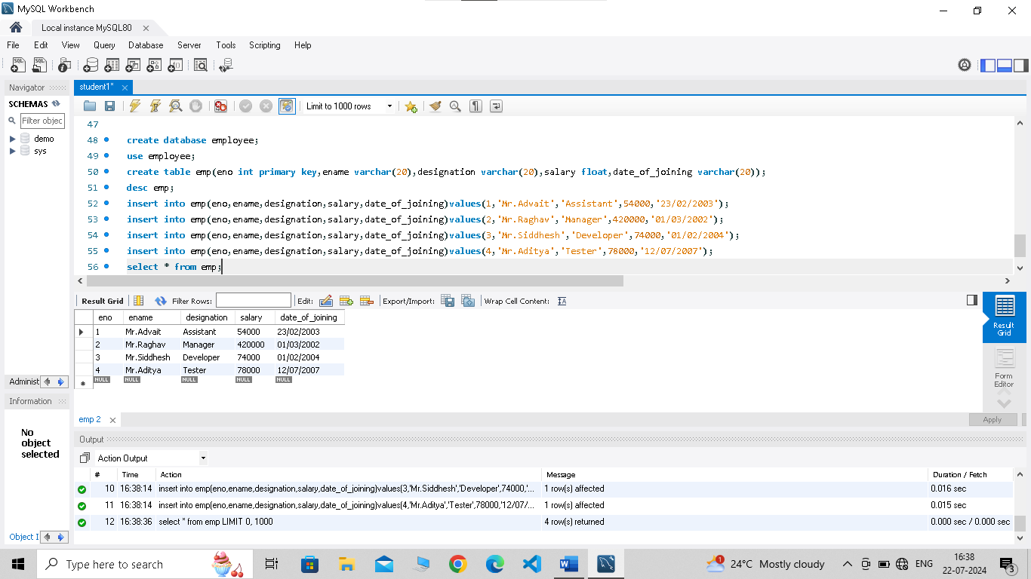

alter table emp add column email varchar(20);

update emp set email='mradvait@gmail.com' where eno=1;

select * from emp;

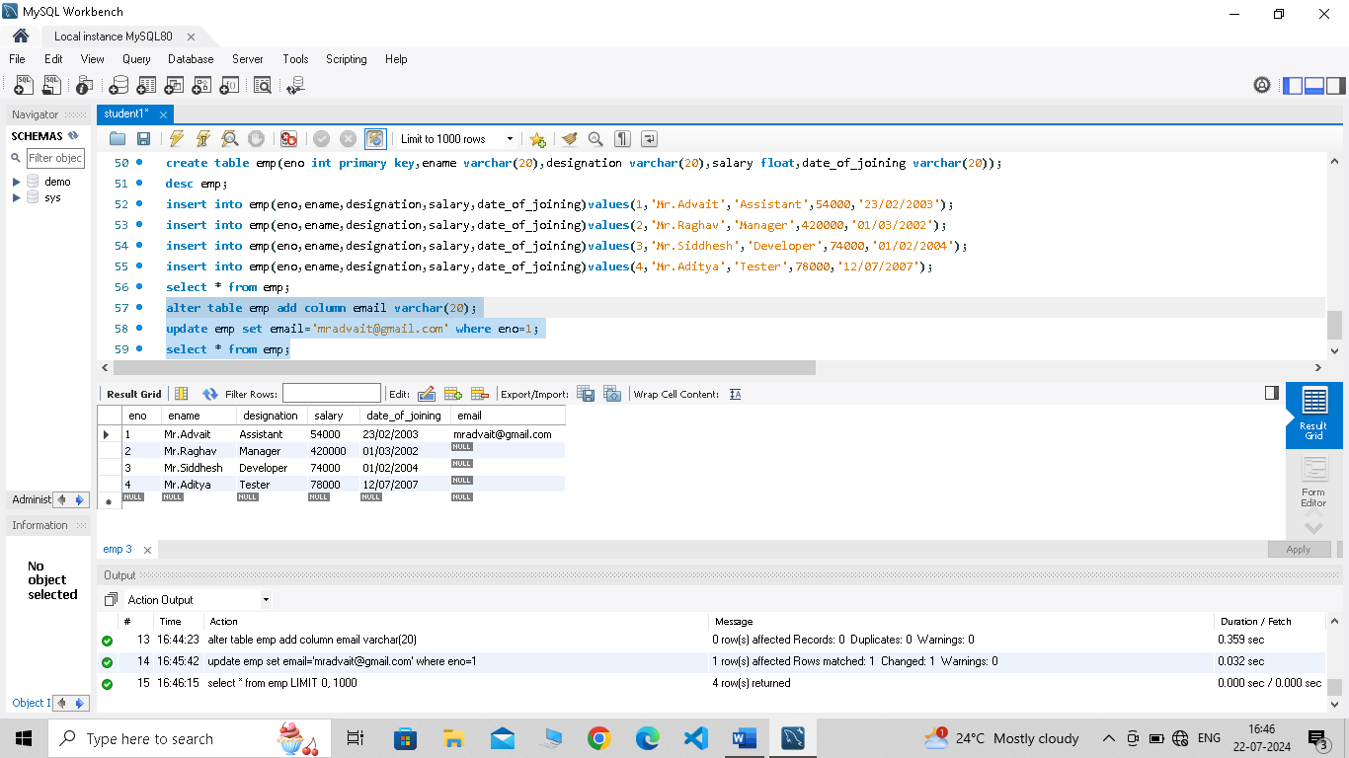

update emp set salary=salary+(salary*0.05);

