**1)Student**

create database student;

use student;

create table students(roll int,name varchar(20),per float,address varchar(50));

insert into students(roll,name,per,address)values(1,'Ram',78,'Pune');

insert into students(roll,name,per,address)values(2,'Nik',70,'mumbai');

insert into students(roll,name,per,address)values(3,'raj',67,'Nagar');

insert into students(roll,name,per,address)values(4,'prem',45,'Dharashiv');

insert into students(roll,name,per,address)values(5,'shyam',65,'Sambhajinagar');

select * from students;

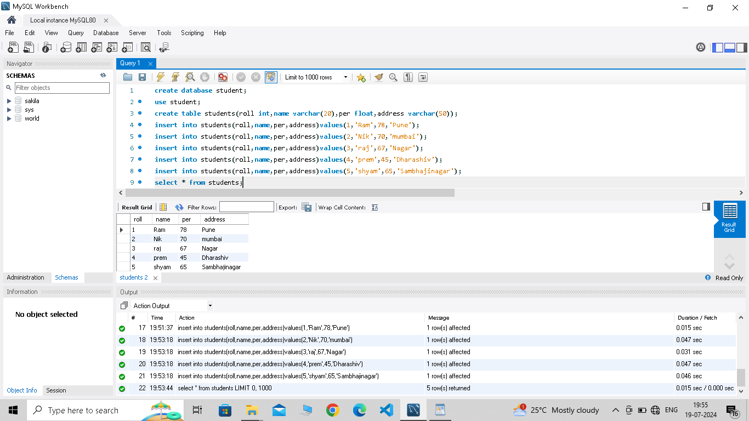

**2)Employee**

create table employee(eid int,ename varchar(20),salary float,designation varchar(50));

insert into employee(eid,ename,salary,designation)values(001,'Ram',780000,'HR');

insert into employee(eid,ename,salary,designation)values(0014,'Vaishnavi',780000,'SR');

insert into employee(eid,ename,salary,designation)values(003,'Nishu',800000,'ceo');

insert into employee(eid,ename,salary,designation)values(008,'Radha',450000,'Assistant');

insert into employee(eid,ename,salary,designation)values(009,'Sunita',120000,'Manager');

insert into employee(eid,ename,salary,designation)values(002,'Aditya',670000,'Developer');

select * from employee;

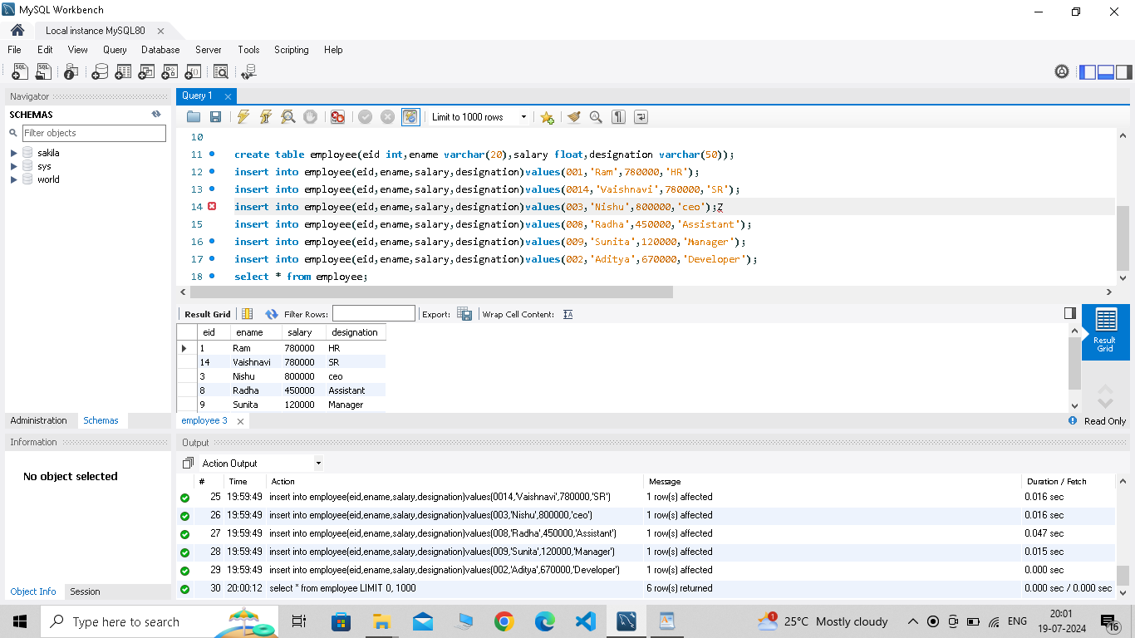

3)Doctor

create table doctor(did int,dname varchar(50),email varchar(20),salary varchar(80));

insert into doctor(did,dname,email,salary)values(101,'Dr.Mishra','Mishra@gmail.com',450000);

insert into doctor(did,dname,email,salary)values(102,'Dr.Mehta','Mehta@gmail.com',900000);

insert into doctor(did,dname,email,salary)values(105,'Dr.Shah','Shah@gmail.com',670000);

insert into doctor(did,dname,email,salary)values(108,'Dr.Farnandiz','Farnandiz@gmail.com',550000);

insert into doctor(did,dname,email,salary)values(109,'Dr.Satpute','Stpyt@gmail.com',890000);

select * from doctor;

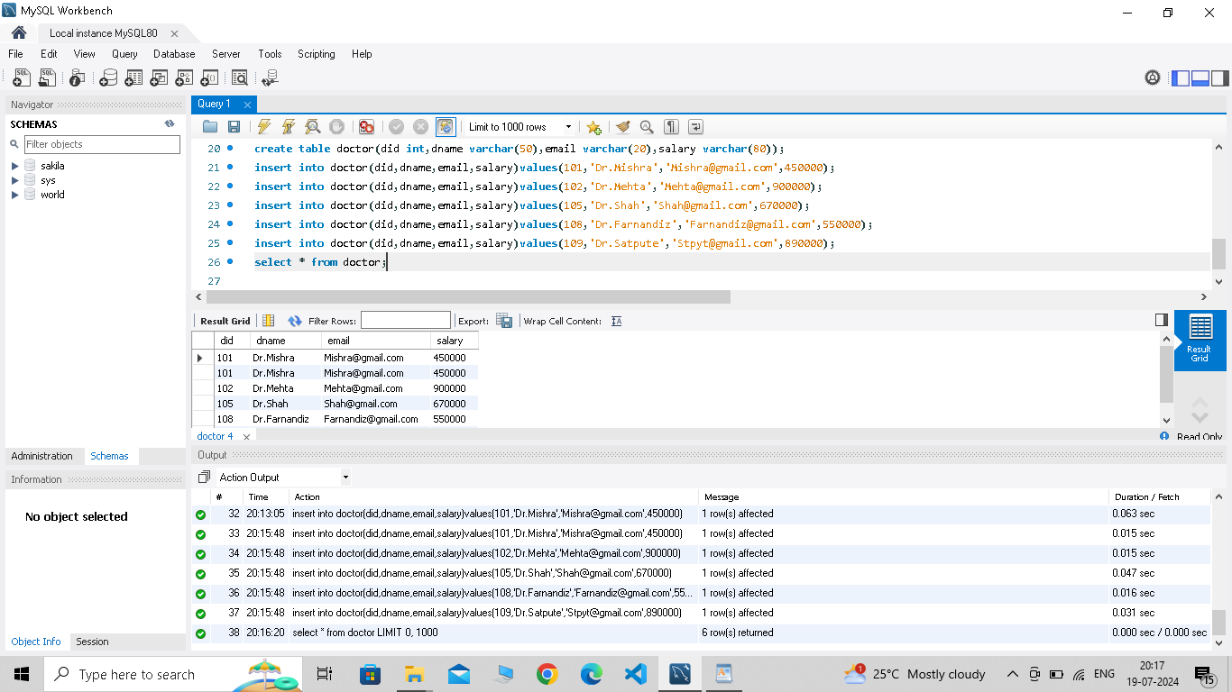

4)Book

create table book(bid int,bname varchar(50),author varchar(20),publication varchar(50),price int);

insert into book(bid,bname,author,publication,price)values(111,'DBMS','PP MAM','Nirali','10000');

insert into book(bid,bname,author,publication,price)values(222,'RDBMS','PP MAM','Nirali','20000');

insert into book(bid,bname,author,publication,price)values(333,'TCS','PP MAM','Nirali','1300');

insert into book(bid,bname,author,publication,price)values(444,'CC','PP MAM','Nirali','1200');

insert into book(bid,bname,author,publication,price)values(111,'DSA','NS MAM','Nirali','2300');

select * from book;

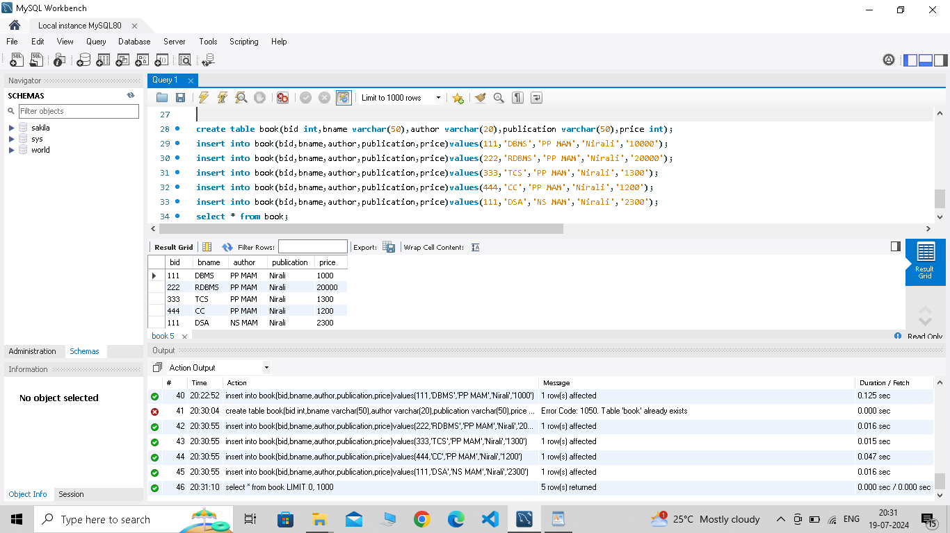

5)Patient

create table patient(pid int,pname varchar(50),address varchar(20),disease varchar(50),test varchar(20));

insert into patient(pid,pname,address,disease,test)values(0101,'max hunter','Pune','TB','NEGATIVE');

insert into patient(pid,pname,address,disease,test)values(0201,'sam curran','punjab','corona','NEGATIVE');

insert into patient(pid,pname,address,disease,test)values(0301,'john cena','Pune','Zika','NEGATIVE');

insert into patient(pid,pname,address,disease,test)values(001,'TYson','goa','TB','POSITIVE');

insert into patient(pid,pname,address,disease,test)values(450,'Ady','mumbai','Cancer','NEGATIVE');

select * from patient;

