**PL*SQL**

**Exercise 1**

1. Write a program that computes the perimeter and the area of a rectangle. Define your own values for the length and width. (Assuming that *L* and *W* are the length and width of the rectangle, Perimeter = *2*(L+W)* and Area = *L*W*. Display the output on the screen using dbms_output.put_line.

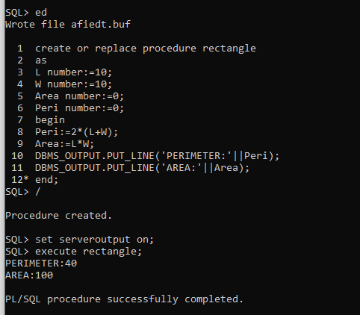

1. Write a program that declares an integer variable called *num*, assigns a value to it, and computes and inserts into the tempp table the value of the variable itself, its square, and its cube.

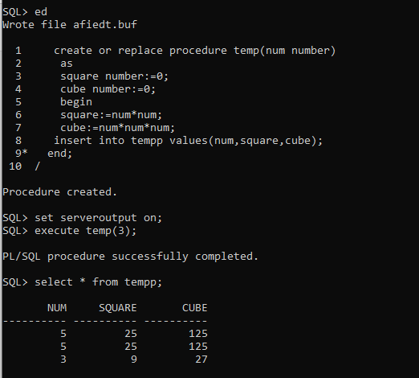

1. Convert a temperature in Fahrenheit (F) to its equivalent in Celsius (C) and vice versa. The required formulae are:- *C*= (*F*-32)*5/9

*F*= 9/5\**C* + 32

Display the output on the screen using dbms_output.put_line. Data has to be input by the user.

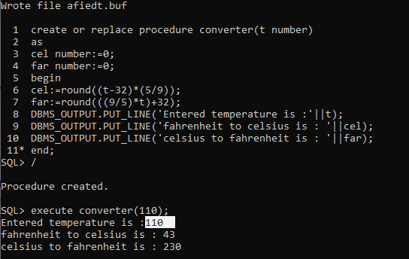

1. Convert a number of inches into yards, feet, and inches. For example, 124 inches equals 3 yards, 1 foot, and 4 inches. Display the output on the screen using dbms_output.put_line. Data has to be input by the user.

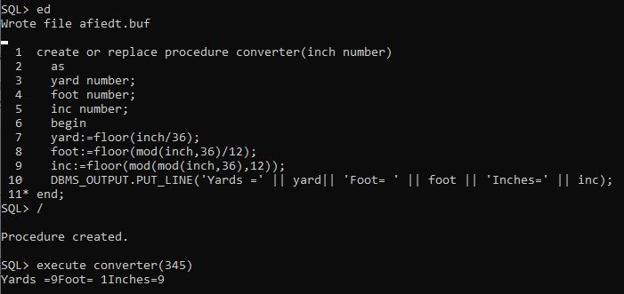

1. Write a program that enables a user to input an integer. The program should then state whether the integer is evenly divisible by 5. (Use decode instead of IF statement where required). Display the output on the screen using dbms_output.put_line. Data has to be input by the user.

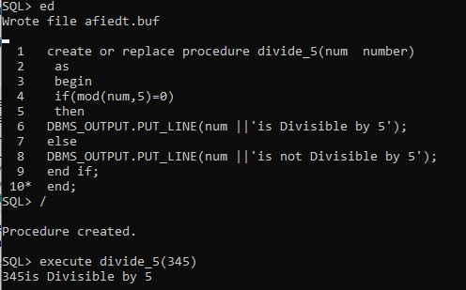

1. Your block should read in two real numbers and tell whether the product of the two numbers is equal to or greater than 100. Display the output on the screen using dbms_output.put_line. (Use decode instead of IF statement where required). Data has to be input by the user.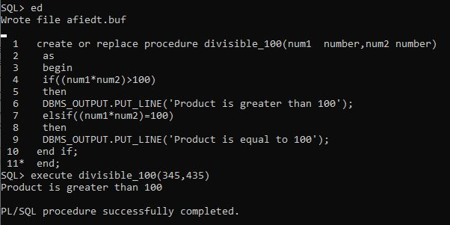

***Sameer Dehadrai* Page: 1**