1. Find all books whose author is Faisal Abid and display name of book authors and

Categories

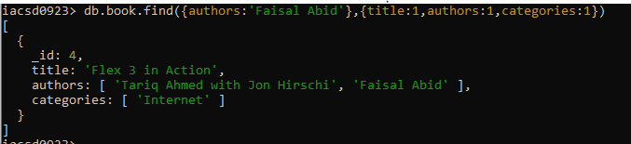

2. List all the books with category Internet at first position in category array

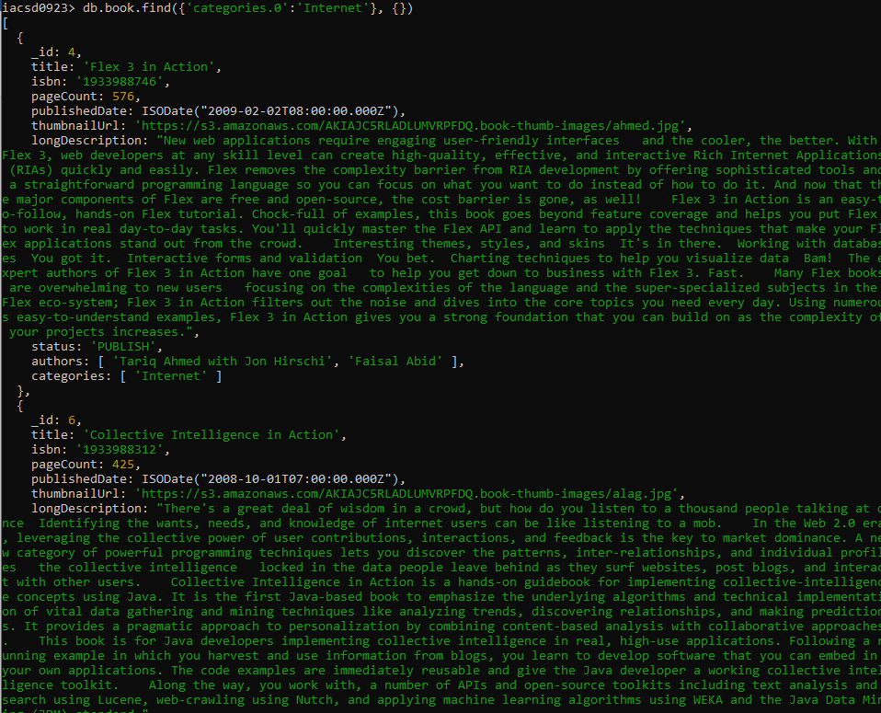

3. Change the status of books “undergoing change” for books having more than 500

pages and published in 2009

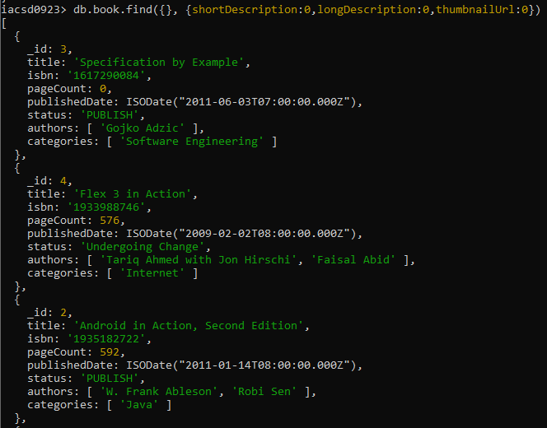

4. Find all the books containing word highlighting and depth in long description of the

Book

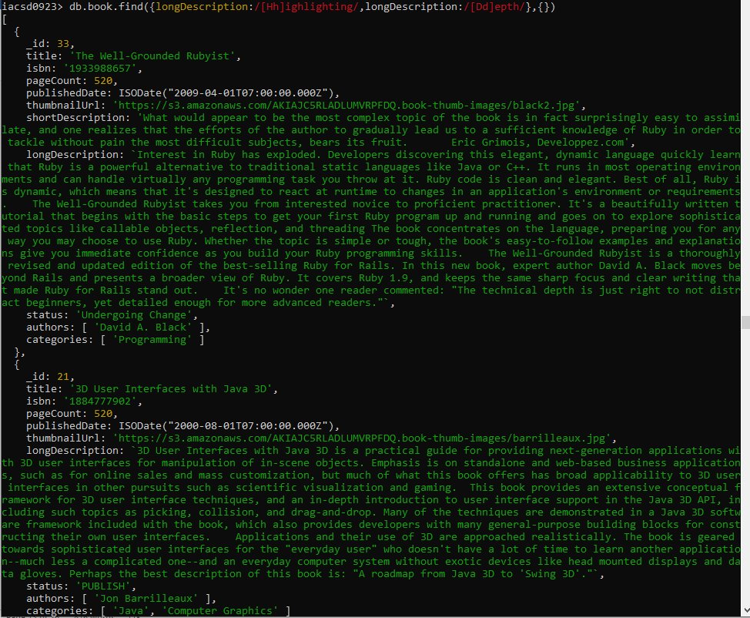

5. Display all books published in 2009

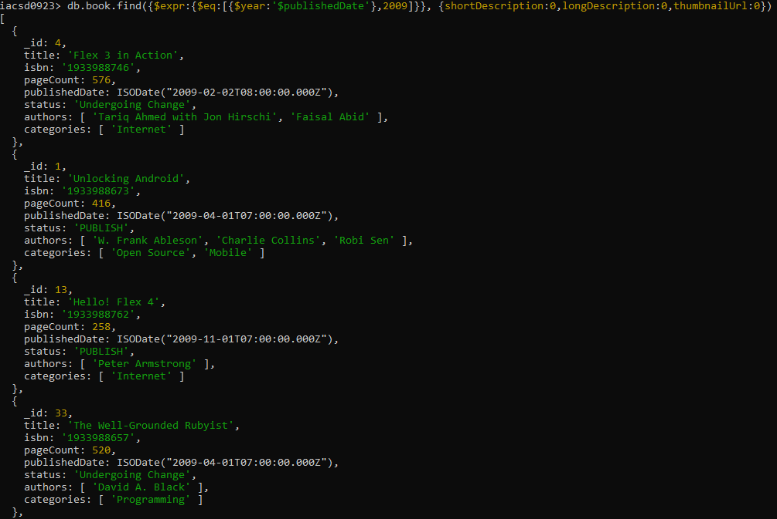

6. Find all books with pageCount is either 500 or 556 or 670

