Deep Theory
• JVM architecture: ClassLoader subsystem (Bootstrap, Extension, Application)
• Memory Areas: Heap generations, Stack frames, PC register, Method area
• Runtime constant pool and symbol resolution
• How JIT compiler performs optimizations
• Escape analysis & scalar replacement
• Object creation lifecycle inside JVM
• OOP fundamentals (deep forms of abstraction, composition, delegation)
• Immutability & thread-safety
• Exception propagation and stack trace mechanics
• Clean code rules for enterprise apps

Hands-on Tasks
• Create base Java project structure
• Implement Patient, Doctor domain classes with strong encapsulation
• Custom exception hierarchy for the project
• Write object creation + memory flow explanation

Q1JVM architecture: ClassLoader subsystem (Bootstrap, Extension, Application)

What is ClassLoader?
The ClassLoader Subsystem in JVM is responsible for:
- Loading .class files into memory
- Converting bytecode into a runtime data structure
- Ensuring classes are loaded only once

2. Types of ClassLoaders

1 Bootstrap ClassLoader
- Purpose: Loads core Java libraries
- Examples: java.lang.*, java.util.*

2 Extension ClassLoader (Platform ClassLoader)
- Purpose: Loads extension libraries

Application ClassLoader (System ClassLoader)
- Purpose: Loads application-specific classes
- Sources:
- Classpath
- Environment variables
- Command-line paths
Q2 Memory Areas: Heap generations, Stack frames, PC register, Method area
- JVM Memory Areas
- The JVM divides memory into different runtime data areas to efficiently manage execution and storage of Java programs.
Main Memory Areas:
- Heap
- Stack
- PC Register
- Method Area

Heap Memory (Shared Area)
Purpose:
- Stores all objects and arrays
- Shared among all threads

Stack
Each thread has its own JVM Stack.

Stack Frame (created per method call)
Each frame contains:
- Local Variables
Method parameters & local variables
- Operand Stack
Used for calculations
- Frame Data
Method info, return address
Key Points:
LIFO (Last In First Out)
Automatically managed
Errors:
StackOverflowError → deep recursion
OutOfMemoryError → stack size exceeded

PC Register (Program Counter)
Purpose:
- Stores address of current instruction being executed
Characteristics:
- Each thread has its own PC register
- Helps JVM track execution flow

Method Area (Metaspace)

Purpose:
Stores class-level data such as:
- Class metadata
- Static variables
- Runtime Constant Pool
- Method bytecode

Q3.Runtime constant pool and symbol resolution

Runtime Constant Pool (RCP)

Definition
The Runtime Constant Pool is a part of the Method Area (Metaspace) that stores constants required during program execution.
It is created per class/interface when the class is loaded into JVM.

What it Stores

Literals (Direct Values)

String literals ("Hello")

Numeric constants (10, 3.14)

Symbolic References

Class names

Method names

Field names

Interface references
Example:- String s = "Hello";
- "Hello" → stored in Runtime Constant Pool
- Reference s → stored in Stack
- Actual object → stored in Heap
Q4. • How JIT compiler performs optimizations

1. What is JIT Compiler?
The JIT (Just-In-Time) Compiler is part of the JVM execution engine that:
- Converts bytecode → native machine code
- Does this at runtime
- Improves performance by avoiding repeated interpretation

2.How JIT Works

Step-by-Step Flow

Java source → compiled into bytecode (.class)

JVM starts execution using interpreter

JVM monitors method execution frequency

Frequently used methods (hotspots) are detected
- JIT compiles these hotspots into native code
- Native code is cached for reuse

3. Hotspot Detection
JVM identifies:
- Frequently executed methods
Q5.Escape analysis & scalar replacement.

Escape Analysis

Escape Analysis is a JVM optimization technique used by the JIT compiler to determine:
Whether an object is accessible outside the method or thread in which it was created.

1.No Escape (Method-Local)
- Object is used only within the method
- Does NOT escape the method

- Example:

void method() {

Point p = new Point(1, 2);

2.Method Escape

Object is returned from the method or passed to another method

Example:

Point method() {

return new Point(1, 2);

}

Thread Escape

Object is shared across threads

Example
class Test {
static Point p;
}

Q6 Object creation lifecycle inside JVM.

1. Overview

In Java, creating an object involves multiple steps handled by the JVM—from class loading to memory allocation, initialization, and reference assignment. This process ensures that objects are properly prepared for execution and memory safety.

2. Steps of Object Creation

Step 1: Class Loading
- JVM checks if the class is already loaded.
- If not, the ClassLoader subsystem loads the .class file into Method Area (Metaspace).

Step 2: Linking
- Performed after loading; consists of:
  - Verification: Ensures bytecode correctness and security.
  - Preparation: Allocates memory for static variables and assigns default values.
  - Resolution: Converts symbolic references to actual memory references.

Step 3: Class Initialization
- Executes static initializers and static blocks.

Step 4: Heap Memory Allocation
- JVM allocates memory for the new object in the Heap (typically in Eden space).
- Size is determined based on the object’s fields and metadata.

Step 5: Object Header Setup
Each object has a header containing:
- Mark Word: Stores hashcode, GC info, lock info.
- Class Pointer: Reference to class metadata in the Method Area.

Step 6: Default Field Initialization
- JVM initializes instance variables with default values:
  - int → 0
  - boolean → false
  - Object references → null

Step 7: Constructor Execution
- JVM calls the constructor to initialize fields with actual values.
- Any initialization logic written by the developer is executed here.

Step 8: Reference Assignment
- The reference variable (e.g., Student s) is assigned the memory address of the object.
- The reference is stored in the Stack, while the object resides in the Heap.
Q7• OOP fundamentals (deep forms of abstraction, composition, delegation)
Object-Oriented Programming (OOP) is based on encapsulation, abstraction, inheritance, and polymorphism. At a deeper level, advanced principles like deep abstraction, composition, and delegation enhance design flexibility and maintainability.
1.Abstraction (Deep Forms)
Abstraction focuses on what an object does, not how it does it. It hides implementation details.
• Interface-Based Abstraction
interface Vehicle {
void start();
void stop();
}
• Abstract Class-Based Abstraction
abstract class Shape {

abstract void draw();
void displayInfo()
{
System.out.println("Shape info");
}
}

• Layered Abstraction
- Abstracting at multiple levels
- Example: Service → Repository → Database

2.Composition

Definition
Composition is a “has-a” relationship:
- One class contains an instance of another class
- Preferred over inheritance for flexibility

Example

class Engine { }

class Car {
private Engine engine; // Car has an Engine
Car()
{
engine = new Engine();
}
}
3. Delegation
Delegation is when an object passes a task to another object instead of performing it itself.

Example
class Printer {

void print(String msg)
{
System.out.println(msg);

}
}

class Manager {
private Printer printer = new Printer();

void printDocument(String msg)
{
printer.print(msg);
}
}
Q8.Immutability & thread-safety.
Immutability and thread-safety are fundamental for building reliable, concurrent, and maintainable Java applications.
- Immutability: Object state cannot change after creation
- Thread-Safety: Safe concurrent access by multiple threads without corruption

Immutability
An immutable object cannot be modified once created.

How to Create an Immutable Class
- Declare the class final → prevents subclassing
- Make all fields private and final
- Initialize all fields in the constructor
- Avoid setters
- Return copies for mutable fields
Example:
final class Person {
private final String name;
private final int age;

Person(String name, int age) {
this.name = name;
this.age = age;
}

public String getName() { return name; }
public int getAge() { return age; }
}
Thread-safety
Thread-safe code executes correctly when multiple threads access shared resources concurrently.
class Counter {
private int count = 0;
public synchronized void increment()
{
count++;
}
public synchronized int getCount() {
return count;
}
}

Q9.Exception propagation and stack trace mechanics.
Java uses exception handling to manage runtime errors. When an exception occurs, it propagates up the call stack until it is caught by an appropriate handler or terminates the program.

Exception Propagation

Mechanism
- Exception occurs
  - JVM creates an exception object with details about the error.
- Search for handler
  - JVM searches the current method for a matching catch block.
- Propagate up
  - If no handler in the current method, JVM moves to the caller method.
  - Continues up the call stack until a handler is found.
- Unhandled exception
  - If no handler exists in the call chain, JVM prints the stack trace and terminates the program.

Stack Trace Mechanics

What is a Stack Trace?
A stack trace is a snapshot of the call stack at the moment the exception occurs. It shows the sequence of method calls leading to the exception.
Example:-

public class StackTraceExample {
public static void main(String[] args) {
methodA();
}

static void methodA() {
methodB();
}

static void methodB() {
int result = 10 / 0; // ArithmeticException occurs here
}
Q10. Clean code rules for enterprise apps.
1.Meaningful Names
Clean code is essential in enterprise applications to ensure maintainability, readability, scalability, and team collaboration. Below is a detailed guide:
Example
// Bad
int d;
// Good
int daysSinceLastLogin;

2.Single Responsibility Principle (SRP)
- Each class or method should have only one reason to change.
- Avoid mixing unrelated functionalities.
// Bad
class EmployeeManager {
void calculateSalary() { ... }
void saveToDatabase() { ... } // Violates SRP
}

// Good
class SalaryCalculator { }
class EmployeeRepository { }
3. Small, Focused Methods
Methods should do one thing.
Keep methods short, readable, and testable.

4. Consistent Formatting
Maintain consistent indentation, braces, and spacing.
Follow standard style guides like Google Java Style.

5. Avoid Magic Numbers & Strings
Use constants or enums for meaningful names instead of raw values.
// Bad
if (status == 1) { }

// Good
final int ACTIVE_STATUS = 1;
if (status == ACTIVE_STATUS) { }

Proper Error Handling

- Use checked exceptions for recoverable errors.
- Use runtime exceptions for programming errors.
- Avoid empty catch blocks; always log or handle exceptions.

try {
}
catch(IOException e) {
logger.error("File not found", e);
}

7. Minimize Side Effects
- Prefer pure functions without modifying external state.
- Easier to test, debug, and reason about.

8. Abstraction and Encapsulation
- Hide internal implementation details.
- Expose only necessary methods or interfaces.
public interface PaymentService {
void pay(double amount);
}

9.Favor Composition over Inheritance

Use “has-a” relationships instead of deep inheritance hierarchies.

Reduces tight coupling and increases flexibility.

10. Write Readable Tests Unit tests should be:

Small

Independent

Descriptive

Use frameworks like JUnit or TestNG.

11. Document Intent, Not Implementation

Comments should explain why code exists, not what it does.

Focus on business rules or complex logic.

12. Avoid Code Duplication (DRY Principle)

Reuse code through methods, services, or libraries.

Duplicated code increases maintenance and risk of bugs.

13. Use Design Patterns Appropriately

Examples:

Singleton → single instance

Factory → object creation abstraction

Hands-on Tasks
• Create base Java project structure.
• Implement Patient, Doctor domain classes with strong encapsulation.
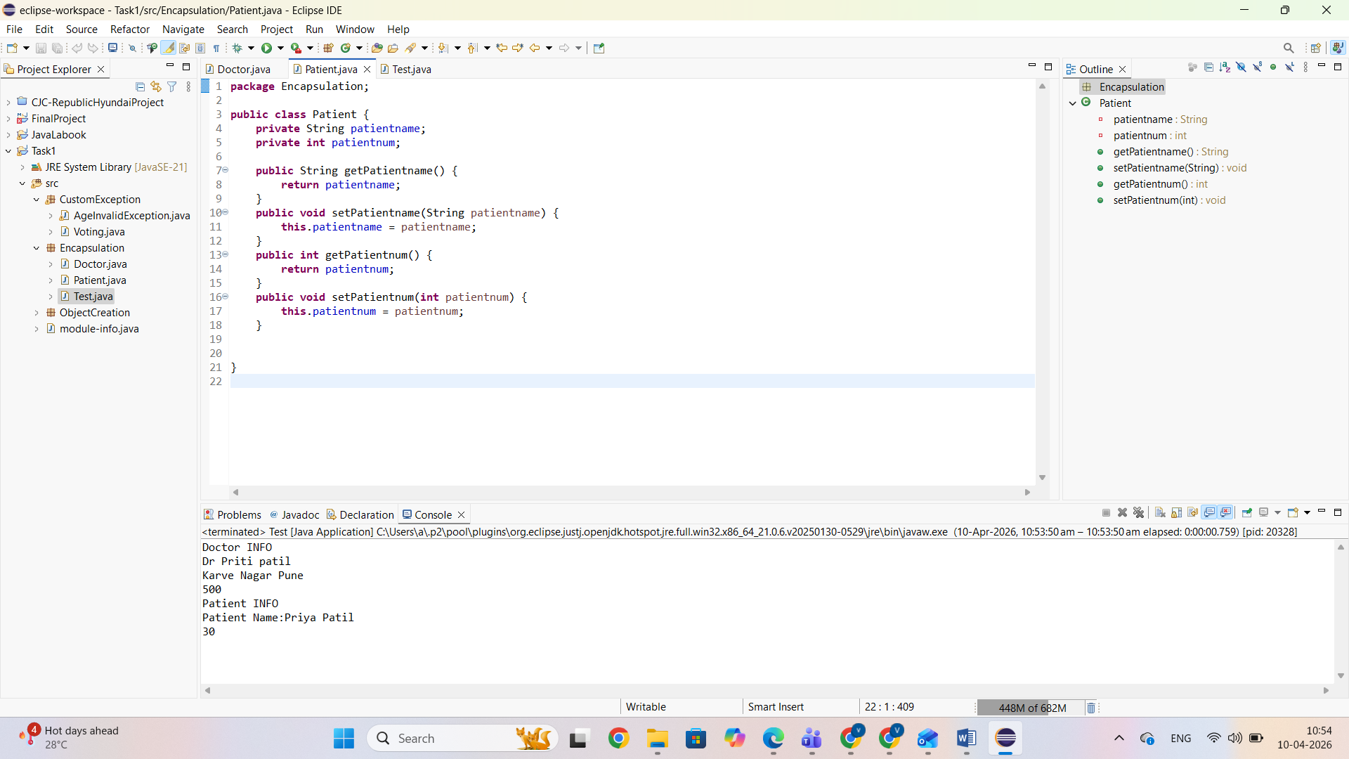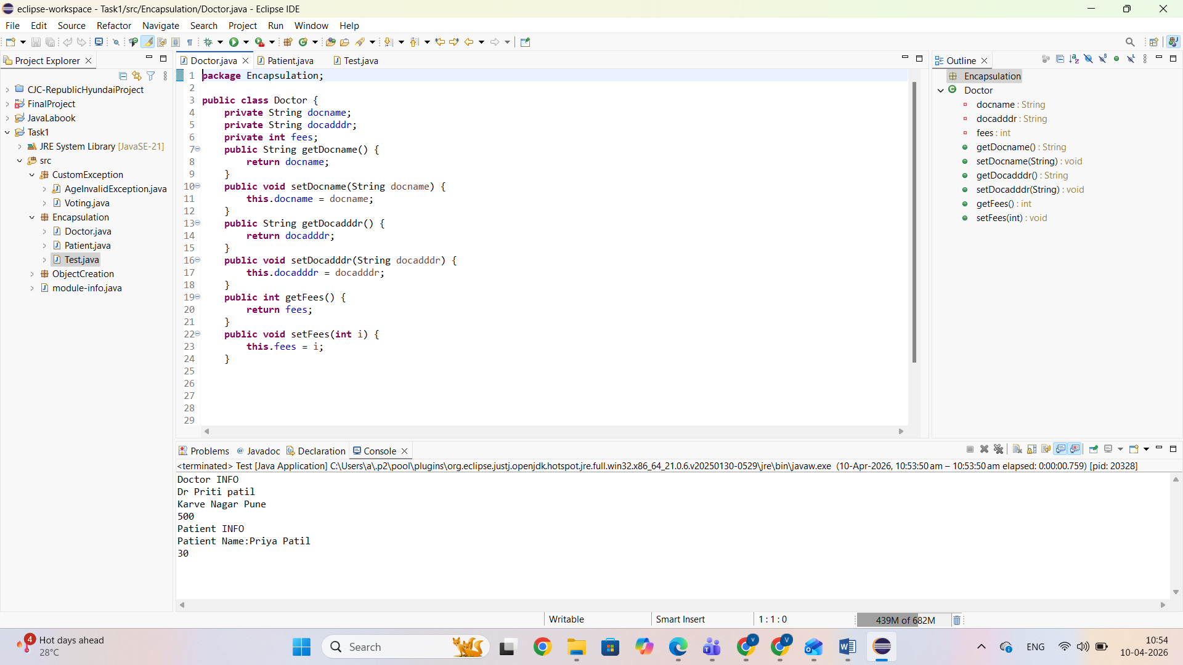

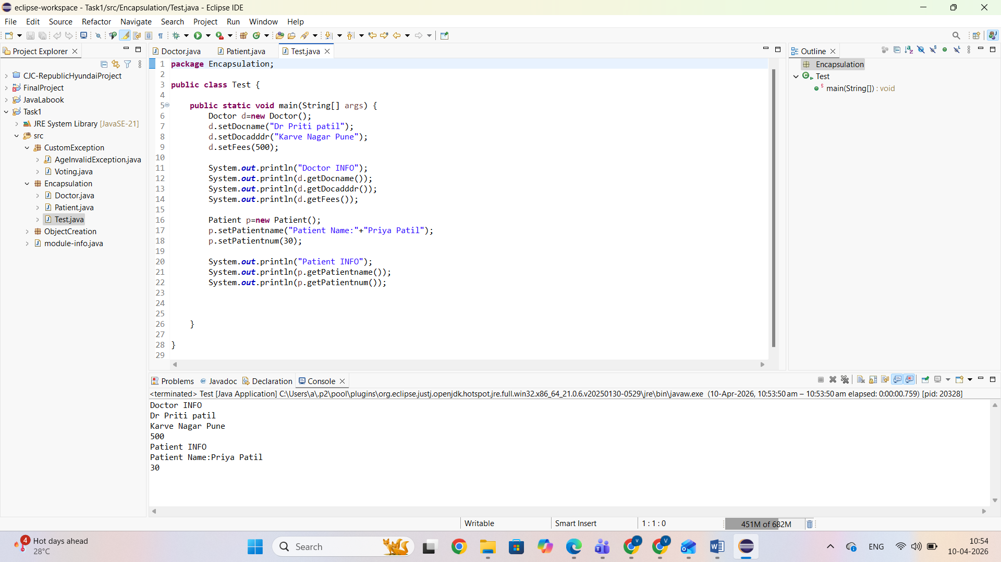

• Custom exception hierarchy for the project
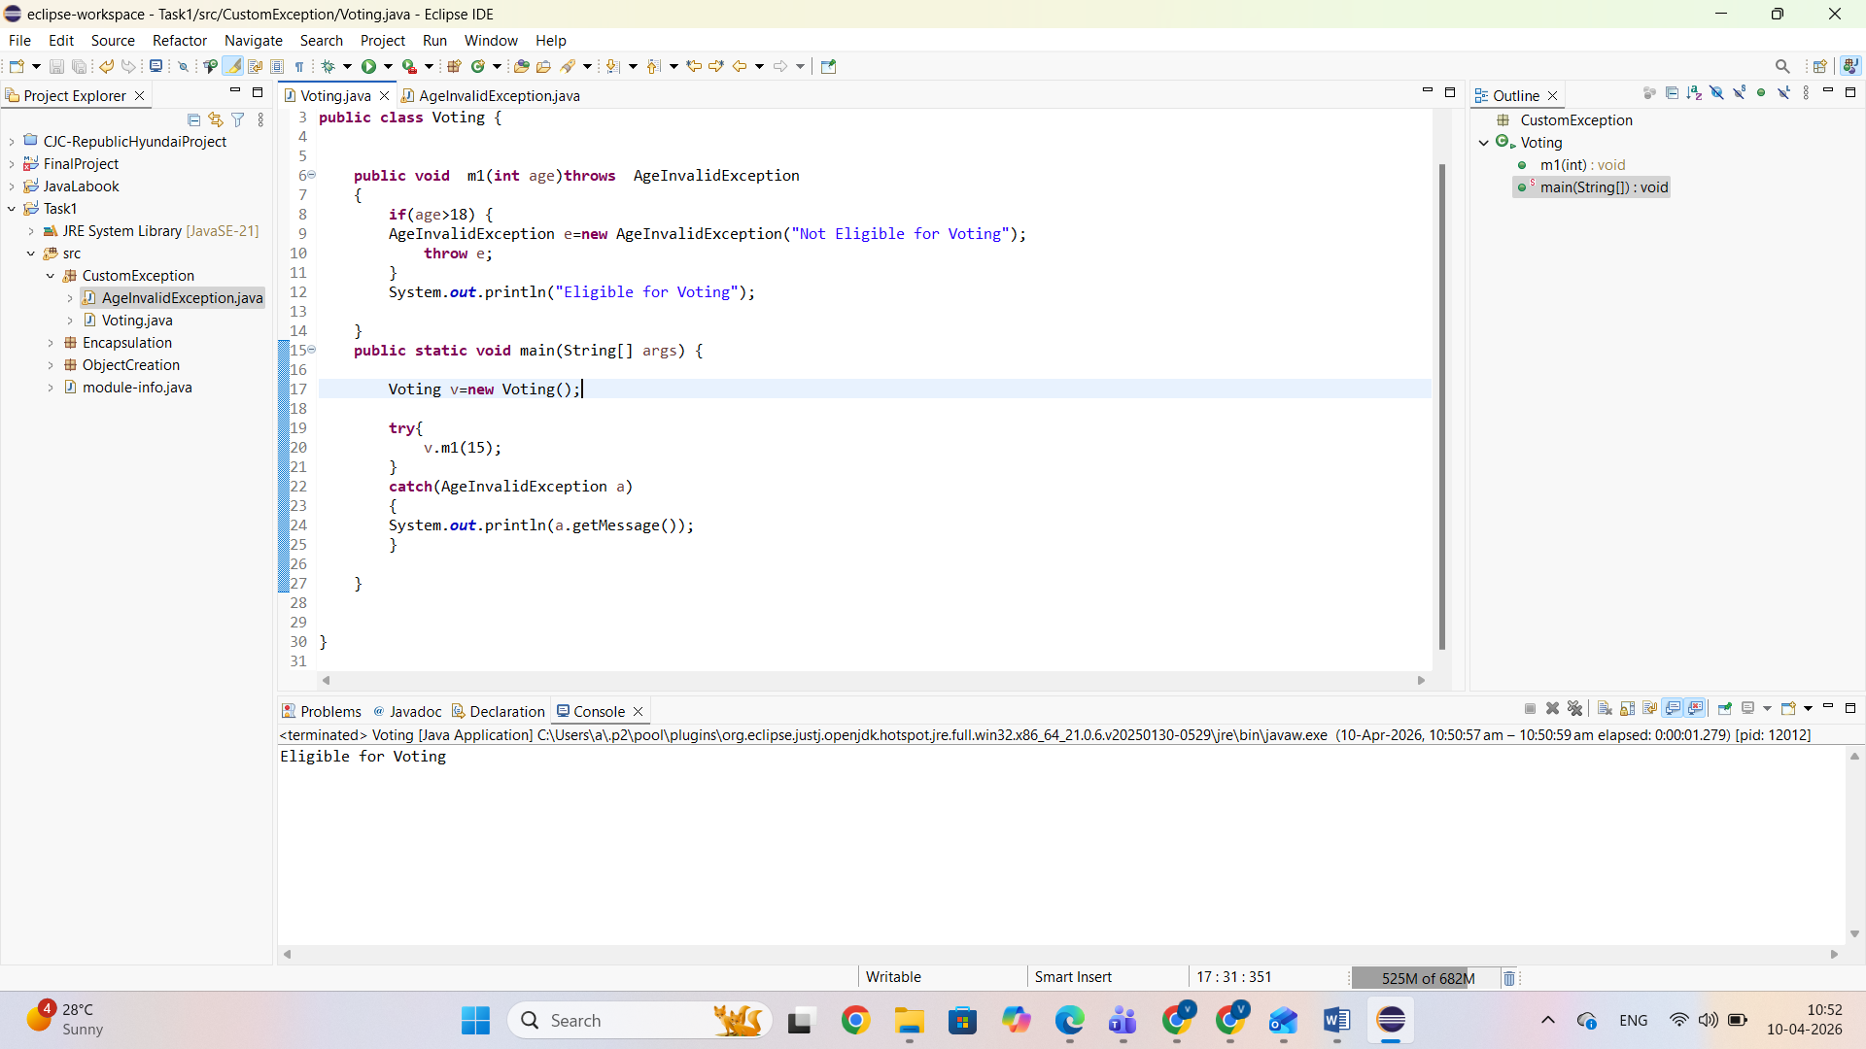
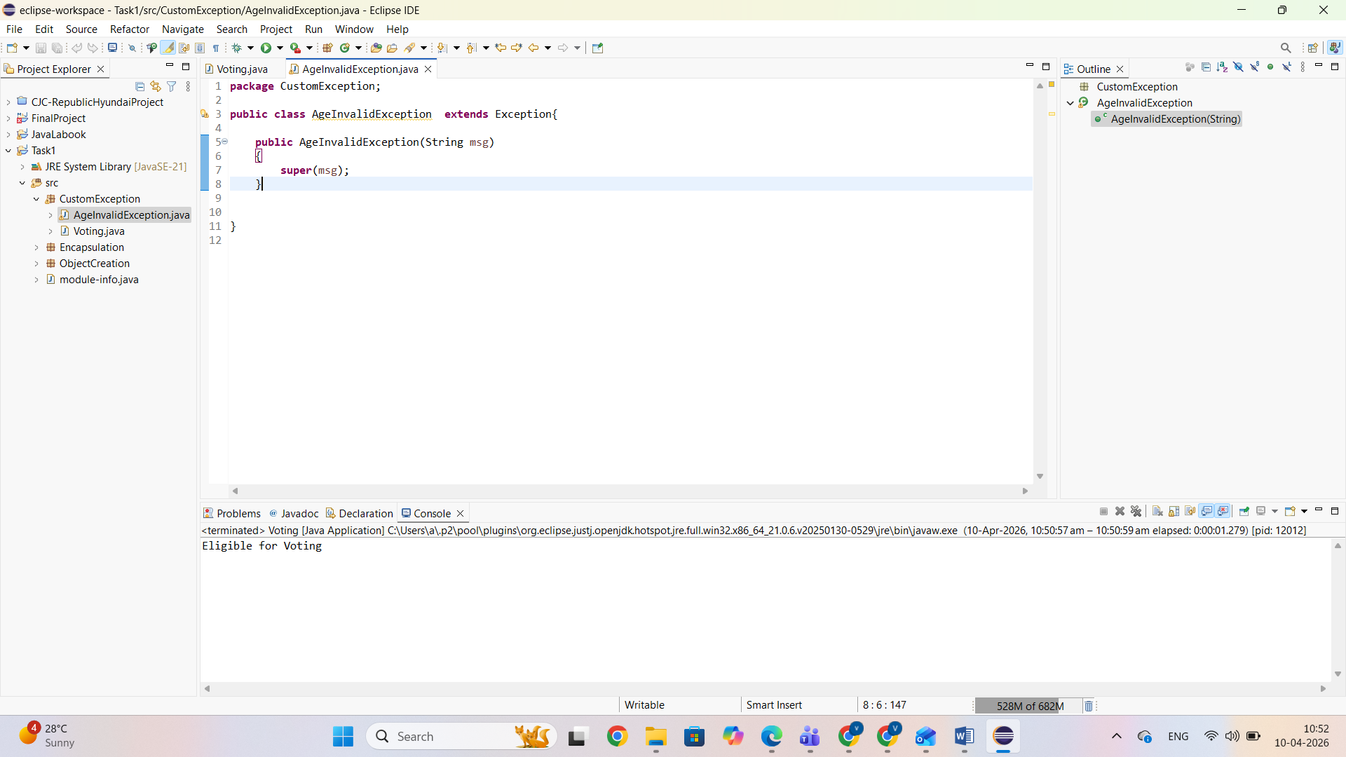
• Write object creation + memory flow explanation



