Java Training Manual – Day 10 Full Deep Theory
(Advanced Exception Handling)

- What Are Exceptions?

- Exceptions are unexpected events that occur during the execution of a program.
- They interrupt the normal flow of instructions and can cause the program to stop if not handled.
- In Java, exceptions are handled using an object-oriented approach, where every exception is an object derived from a class.

Explanation of Each Point

1️. Unexpected Events
Exceptions occur when something goes wrong at runtime, such as:
- Dividing a number by zero
- Accessing an invalid array index
- Trying to open a file that does not exist
Types of Exceptions in Java
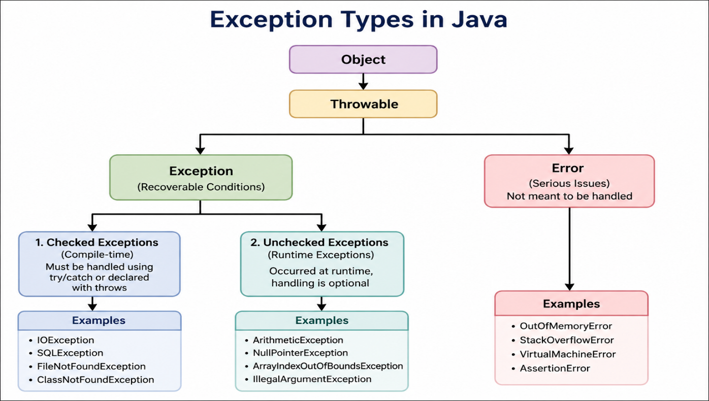

1️.Checked Exceptions
- Checked at compile-time
- Must be handled using try-catch OR declared using throws
- Occur due to external conditions

Examples:
- IOException
- SQLException
- FileNotFoundException
Example:
import java.io.*;
class Test {
public static void main(String[] args) {
try {
FileReader file = new FileReader("test.txt");
} catch (FileNotFoundException e) {
System.out.println("File not found!");
}
}
}

2️.Unchecked Exceptions
- Occur at runtime
- Not mandatory to handle
- Subclasses of RuntimeException

Examples:
- ArithmeticException
- NullPointerException
- ArrayIndexOutOfBoundsException
Example:
class Test {
public static void main(String[] args) {
int a = 10 / 0; // ArithmeticException
}
}

3️. Errors
- Serious problems in the system
- Cannot be handled normally
- Occur due to JVM issues

Examples:
- OutOfMemoryError
- StackOverflowError
Example:
class Test {
public static void main(String[] args) {
main(args); // causes StackOverflowError
}
}

try, catch, finally – Internal Flow

🔷 Flow Diagram

Start
|
try block
|
-----------------
| |
No Exception Exception Occurs
| |
skip catch match catch block
| |
----------- |
| |
finally block
|
End

1. try Block
- Contains risky code (code that may cause an exception)
- If no exception occurs → executes normally
- If exception occurs → control immediately moves to catch
Example:
try {
int result = 10 / 0; // risky code
}

2️.catch Block
- Handles the specific exception
- Multiple catch blocks are allowed
- Executed only if matching exception occurs
- Checked top to bottom
Example:
try {
int arr[] = new int[5];
arr[10] = 50;
} catch (ArrayIndexOutOfBoundsException e) {
System.out.println("Array index issue");
} catch (Exception e) {
System.out.println("General exception");
}

Important:
- Always write specific exceptions first, then general (Exception)

3️. finally Block
- Always executes (whether exception occurs or not)
- Used for cleanup code
  - Closing files
  - Closing database connections
Example:
try {
int a = 10 / 2;
} catch (Exception e) {
System.out.println("Error occurred");
} finally {
System.out.println("This will always execute");
}

throw vs throws in Java

1️ .throw Keyword

Concept
- Used to manually throw an exception
- You create and throw the exception object yourself

Syntax
throw new ExceptionType("message");

Example
class Test {
public static void main(String[] args) {
int age = 15;
if (age < 18) {
throw new ArithmeticException("Not eligible to vote");
}
System.out.println("Eligible to vote");
}
}

2️. throws Keyword

Concept
- Used in method declaration
- Declares that a method may throw exceptions
- Responsibility goes to the caller method

Syntax
returnType methodName()
throws ExceptionType {
// code
}

Example
import java.io.*;
class Test {
static void readFile() throws IOException {
FileReader file = new FileReader("test.txt");
}
public static void main(String[] args) {
try {
readFile();
} catch (IOException e) {
System.out.println("Exception handled");
}
}
}

Concept
- Custom exceptions are user-defined exceptions
- Created by extending:
- class MyException extends Exception {
public MyException(String message) {
super(message);
}
}

3️.Example Of Custom Exception:

- class InvalidAgeException extends Exception {
public InvalidAgeException(String message) {
super(message);
}
}

class Test {
static void checkAge(int age) throws InvalidAgeException {
if (age < 18) {
throw new InvalidAgeException("Age must be 18 or above");
} else {
System.out.println("Valid age");
}
}
public static void main(String[] args) {
try {
checkAge(16);
} catch (InvalidAgeException e) {
System.out.println("Exception: " + e.getMessage());
}
}
}

  - Exception → for checked exceptions
  - RuntimeException → for unchecked exceptions

- Used for application-specific / domain-specific errors

What is the finally block?
The finally block is used in exception handling and always executes after try and catch blocks, regardless of whether an exception occurs or not.
Key Behavior
- Always Executes
  - The finally block runs even if an exception is thrown or not.
  - It also runs if there is a return statement in try or catch.
- Exception: System.exit()
  - If the program calls System.exit(), the JVM shuts down immediately.
  - In this case, the finally block will NOT execute.
- Used for Resource Cleanup (Before Java 7)
  - Commonly used to close:
    - Files
    - Database connections
    - Streams
  - Ensures resources are released even if errors occur.
- After Java 7 (try-with-resources)
  - Java introduced try-with-resources, which automatically closes resources.
  - This reduces the need for finally in many cases.

Example
public class FinallyExample {
public static void main(String[] args) {
try {
int result = 10 / 0; // Exception occurs
} catch (ArithmeticException e) {
System.out.println("Exception caught");
} finally {
System.out.println("Finally block always runs");
}
}
}

Exception caught
Finally block always runs

Try-With-Resources Flow Diagram

┌────────────────────────────┐
│ try (Resource Declared) │
│ e.g., File, DB, Stream │
└─────────────┬──────────────┘
│
▼
┌───────────────┐
│ try block │
│ executes │
└──────┬────────┘
│
┌───────────▼───────────┐
│ Exception Occurred? │
└──────┬────────┬───────┘
│Yes │No
│ │
┌───────▼───┐ │
│ catch │ │
└──────┬────┘ │
│ │
└────┬────┘
▼
┌────────────────────────┐
│ Resource Auto Closed │ ✅
│ (No need of finally) │
└──────────┬─────────────┘
▼
┌───────────────┐
│ Next Code │
└───────────────┘

Key Points (Simple Understanding)
- Introduced in Java 7
- Works with resources implementing AutoCloseable
- Automatically closes resources after execution
- No need to write finally for closing
- Reduces boilerplate code and avoids mistakes

Where It Is Used
- File handling (FileReader, BufferedReader)
- Database connections (Connection, Statement)
- Input/Output streams
import java.io.FileReader;
import java.io.IOException;

public class TWRExample {
public static void main(String[] args) {
try (FileReader fr = new FileReader("test.txt")) {
System.out.println("File opened successfully");
} catch (IOException e) {
System.out.println("Error occurred");

}
}
}

