Day4

1. What is OOP (Object-Oriented Programming)?
- OOP is a programming style based on real-world objects and how they interact.
- In Java, we use OOP to organize code using classes and object .
Benefits of OOP:
- Modularity → Code is divided into small parts
- Reusability → Code can be reused
- Scalability → Easy to expand
- Maintainability → Easy to fix and update

2. Class & Object (Deep Explanation)
• Class:
A class is a blueprint or template.
It defines:
- Properties (variables/fields)
- Behaviors (methods/functions)
• Object:
An object is a real instance of a class.
- It is created using the keyword new
- It is stored in heap memory.

class Car {
String color;
void drive() {
System.out.println("Car is driving");
}
}
public class Main {
public static void main(String[] args) {
Car c1 = new Car(); // object
c1.color = "Red";
c1.drive();
}
}
Constructors
- Constructors are special methods used to initialize objects.
- They are automatically called when an object is created using new.

Rules of Constructor
- Constructor name must be same as class name
- It has no return type (not even void)
- It is called automatically .

Types of Constructors

1. Default Constructor
- No parameters
- Sets default values
class Student {
Student() {
System.out.println("Default Constructor called");
}
}

2. Parameterized Constructor
- Takes parameters to initialize values,
class Student {
String name;
Student(String n) {
name = n;
}}

Constructor Chaining

this()
- Used to call another constructor in the same class
class Student {
Student() {
this("Vaishnavi");
System.out.println("Default");
}
Student(String name) {
System.out.println(name);
}
}

super()
Used to call constructor of parent class
class Parent {
Parent() {
System.out.println("Parent Constructor");
}
}
class Child extends Parent {
Child() {
super();
System.out.println("Child Constructor");
}
}
Four Pillars of OOP (Deep Understanding)
- Encapsulation – hiding internal data using private fields + getters/setters.
Encapsulation means hiding the internal data of a class and allowing access to it only through controlled methods.

Key Idea
- Make variables private (data hiding) .
- Provide public getter & setter methods (controlled access) .
class Student {
private String name; // hidden data
// Getter
public String getName() {
return name;
}
// Setter
public void setName(String name) {
this.name = name;
}
}

Student s = new Student();
s.setName("Vaishnavi"); // set value
System.out.println(s.getName()); // get value
Output-Vaishnavi

- Abstraction – exposing essential features, hiding implementation details.
Abstraction means showing only important (essential) features and hiding internal implementation details.
Achieved using:
  - Abstract classes
  - Interfaces
Abstract classes
- Abstract class it means partial class.
- If class anyone method is abstract then class must have abstract.
- Abstact classs have both type of method implemented(concreate method) and unimplemented
- Method(abstract method).
Rules of Abstract Class
- Child class must be implemented all Abstarct Method.
- If Child class is unable to implemented all method of abstract cl;ass then make that
Child class as a abstract.
abstract class Animal {
// Abstract method
abstract void sound();

// Normal method
void eat() {
System.out.println("Animal eats food");
}}
class Dog extends Animal {
void sound() {
System.out.println("Dog barks");
}
}
Interfaces
- It is set of Rules and guidelines.
- Purpose of interface is to provide rules for all implemented class.
- Interface design by using interface keyword.
- By default interface variable public static final.
- After JDK 1.7v we can write implemented abstract and default method interface.
interface Animal {
void sound(); // abstract method
}
class Dog implements Animal {
public void sound() {
System.out.println("Dog barks");
}}
public class Main {
public static void main(String[] args) {
Animal a = new Dog();
a.sound(); // Dog barks
}

- Inheritance – creating new classes from existing ones.
Interface means subclass aquire property from superclass.

Types of Inheritance in Java

1️.Single Inheritance
One parent → One child
class A {
void show() {
System.out.println("Class A");
}
}
class B extends A {
void display() {
System.out.println("Class B");
}
}

2.Multilevel Inheritance

Chain of inheritance
class A {
void show() {
System.out.println("Class A");
}}
class B extends A {
void display() {
System.out.println("Class B");
}}
class C extends B {
void print() {
System.out.println("Class C");
}
}

3.Hierarchical Inheritance
One parent → Multiple children
class A {
void show() {
System.out.println("Class A");
}
}
class B extends A {
void display() {
System.out.println("Class B");
}
}
class C extends A {
void print() {
System.out.println("Class C");
}
}
✔ B and C both inherit A

4.Multiple Inheritance (Not supported with classes )
One child → Multiple parents
interface A {
void show();
}
interface B {
void display();
}
class C implements A, B {
public void show() {
System.out.println("From A");
}
public void display() {
System.out.println("From B");
}
}

Hybrid inheritance is a combination of two or more types of inheritance
(e.g., hierarchical + multiple inheritance).
- Not supported with classes directly
- Achieved using interfaces
// Parent interface
interface Animal {
void eat();
}
// Child interface 1
interface Dog extends Animal {
void bark();
}
// Child interface 2
interface Cat extends Animal {
void meow();
}
// Class implementing multiple interfaces
class Pet implements Dog, Cat {
public void eat() {
System.out.println("Pet eats food");
}
public void bark() {
System.out.println("Dog barks");
}
public void meow() {
System.out.println("Cat meows");
}
}
Note
Multiple and Hybrid Inheritance does not support java class. We can achieve using Interface.
- Polymorphism – performing the same action in different forms
Polymorphism means “many forms” — one action can behave in different ways.
Types of Polymorphism in Java

1️.Compile-Time Polymorphism (Method Overloading)
Same method name, different parameters
class MathUtils {
int add(int a, int b) {
return a + b;
}
int add(int a, int b, int c) {
return a + b + c;
}
}
2️.Runtime Polymorphism (Method Overriding)
Same method, different implementation in child class
class Animal {
void sound() {
System.out.println("Animal makes sound");
}
}
class Dog extends Animal {
void sound() {
System.out.println("Dog barks");
}
}
public class Main {
public static void main(String[] args) {
Animal a = new Dog(); // parent reference
a.sound(); // Dog barks (runtime decision)
}
}
IS-A and HAS-A Relationships

HAS-A represents ownership / containment
One class contains another class
class Engine {
void start() {
System.out.println("Engine starts");
}
}
class Car {
Engine e = new Engine(); // HAS-A relationship

void drive() {
e.start();
System.out.println("Car drives");
}}

1️.Object stored in Heap Memory
- When you create an object using new, it is stored in Heap memory.
- Heap is used for dynamic memory allocation .
- The “Object” box represents any object created using new.
- Arrow shows that object is stored in Heap Memory.
Student s = new Student();
new Student() → Object created in Heap
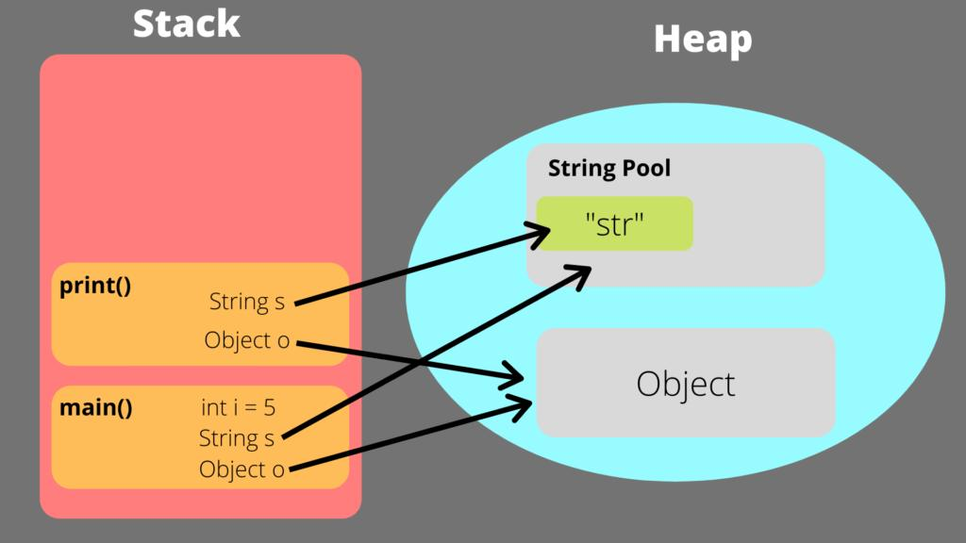

Multiple References to Same Object
Student s1 = new Student();
Student s2 = s1;

Both s1 and s2 point to same object.

Garbage Collection
Student s = new Student();
s = null;

- Object has no reference
- Becomes eligible for garbage collection
Java automatically deletes unused objects using Garbage Collector.
