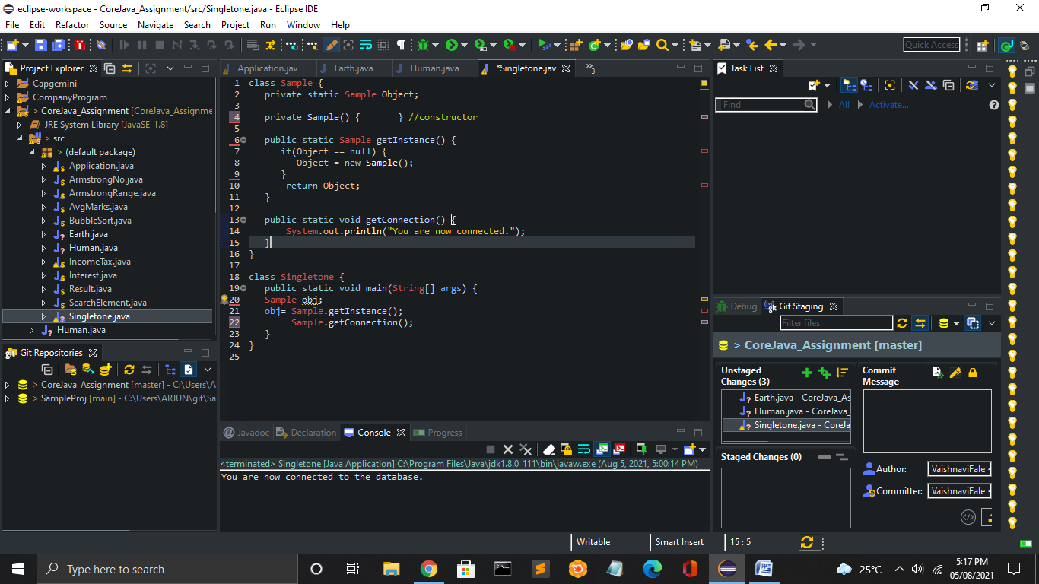



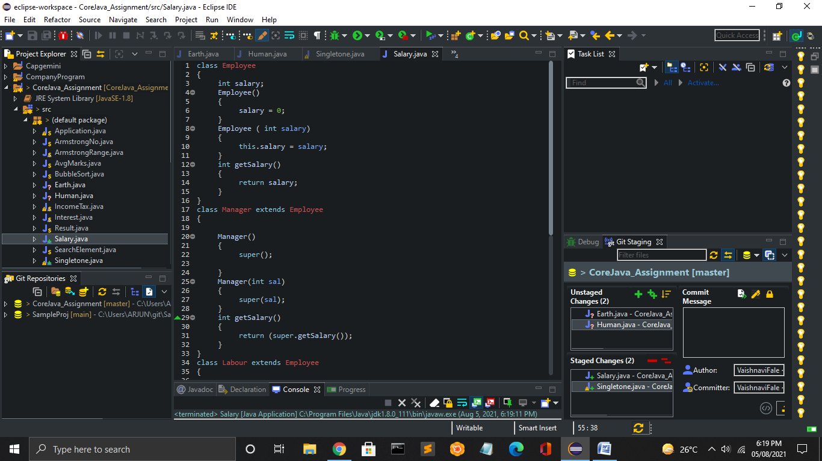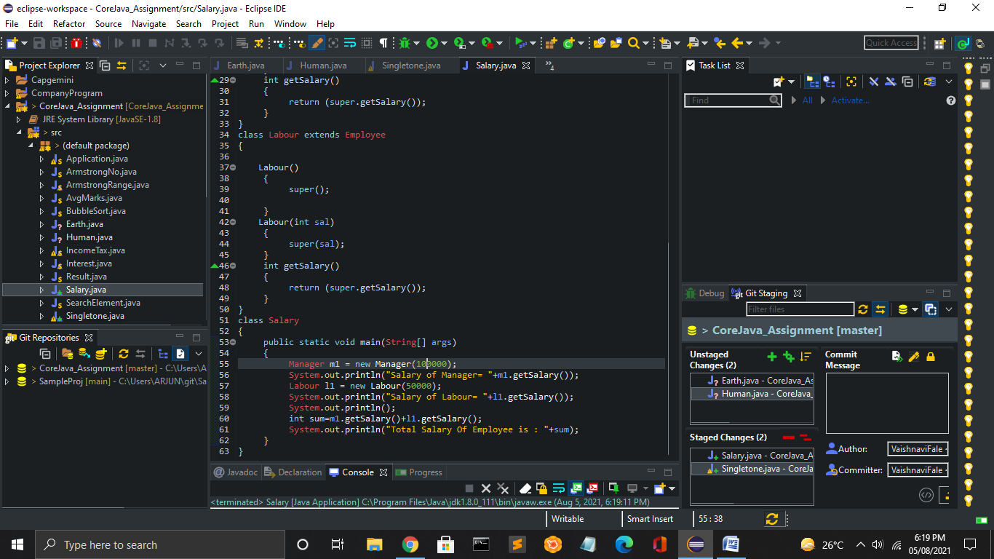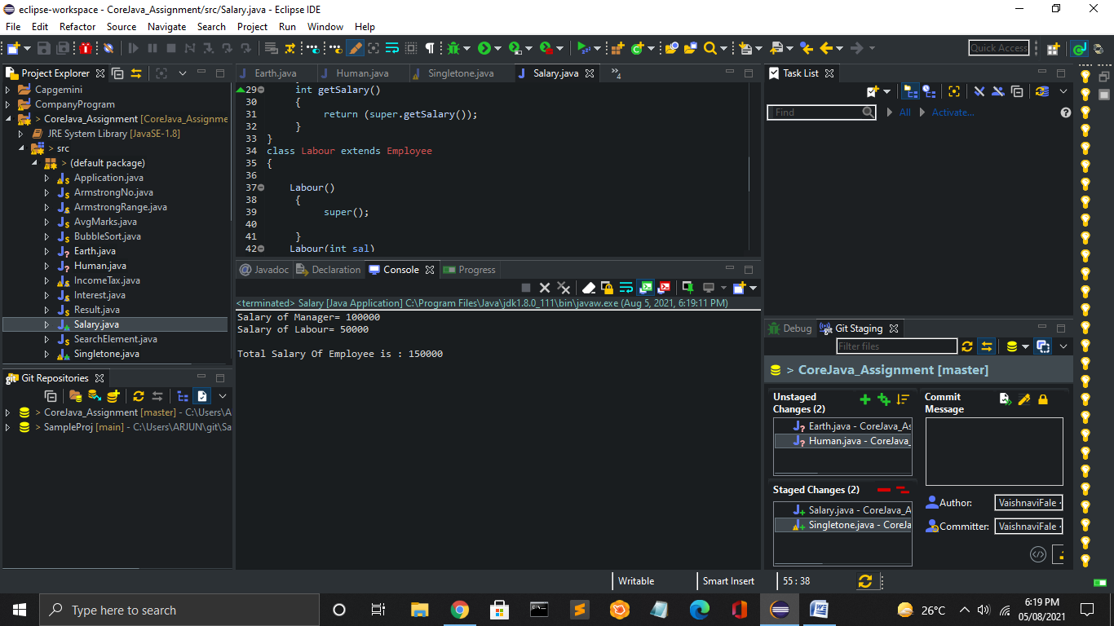



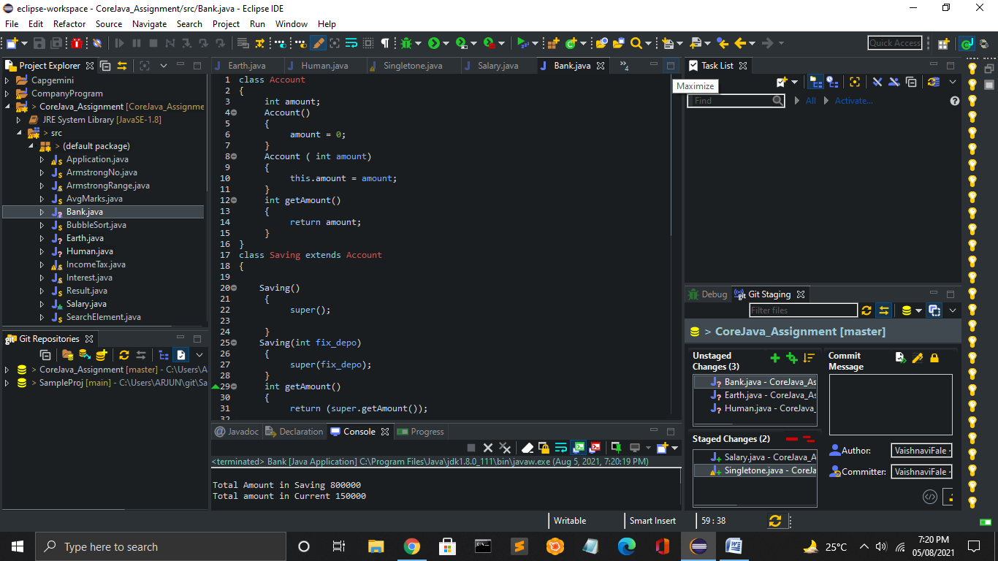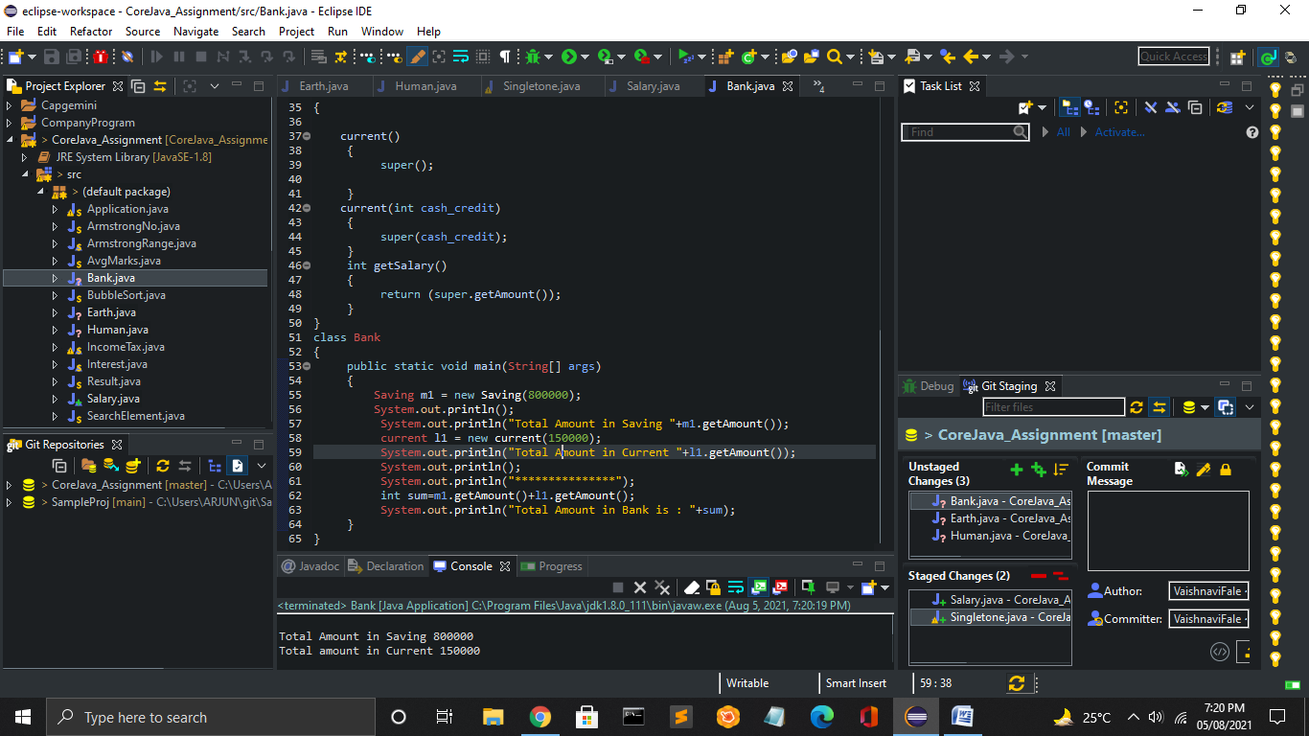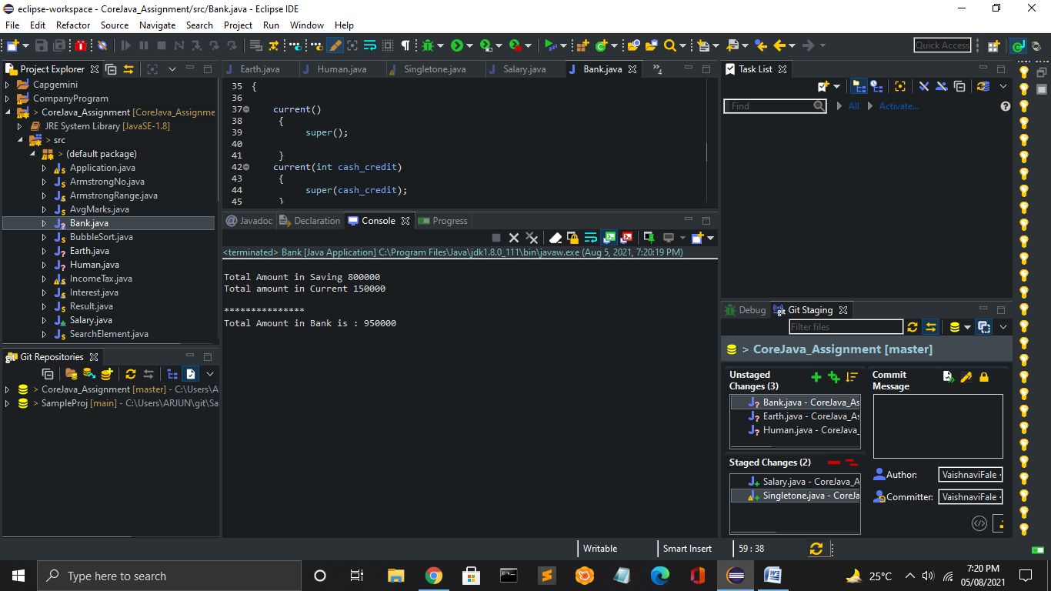



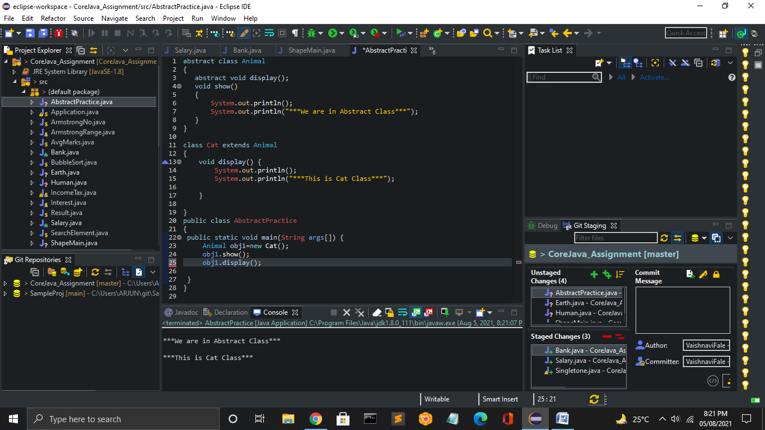



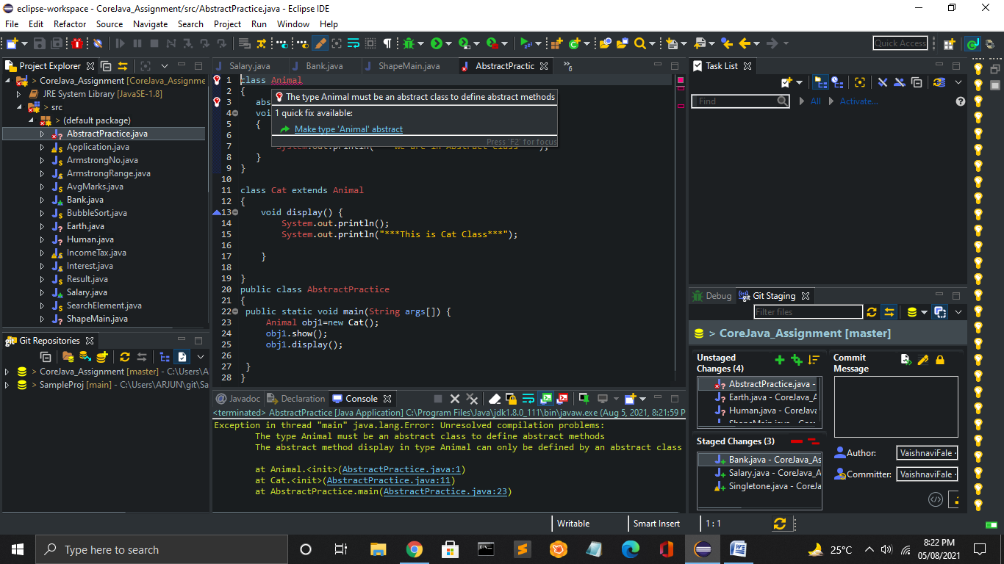

* 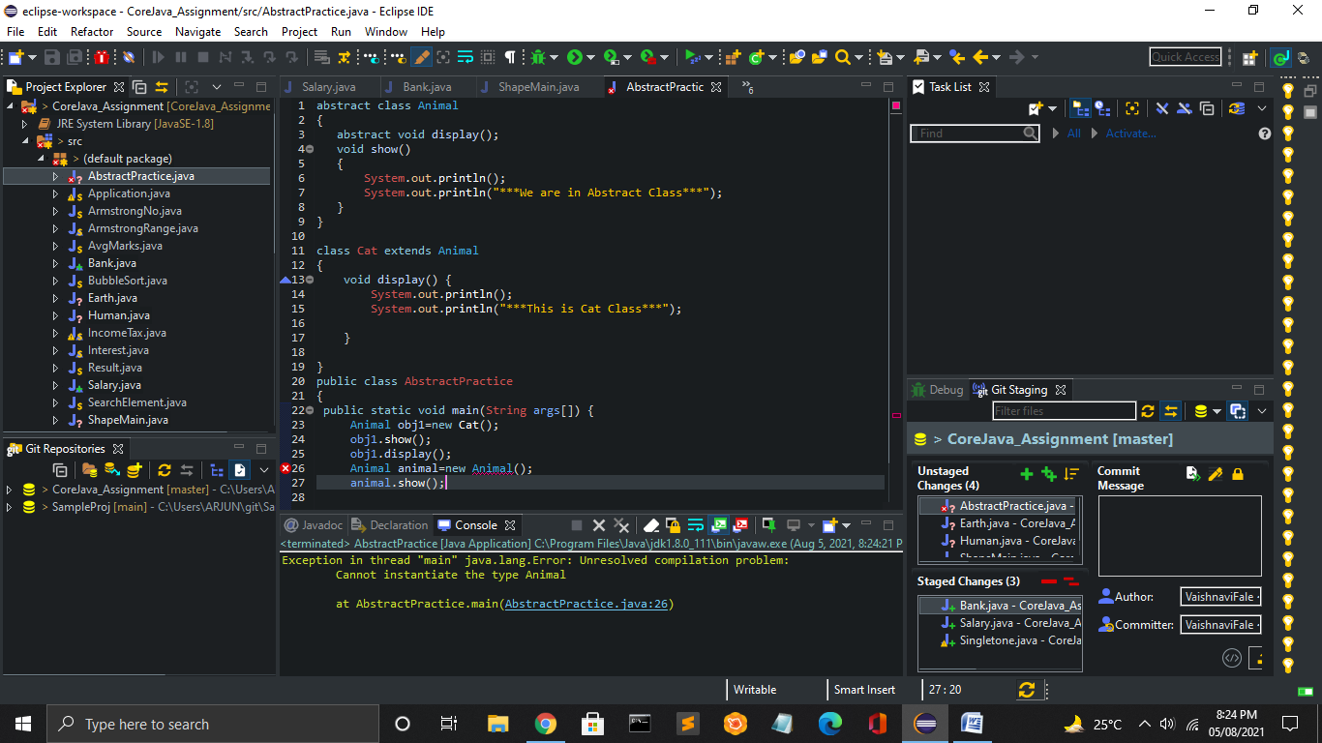
* 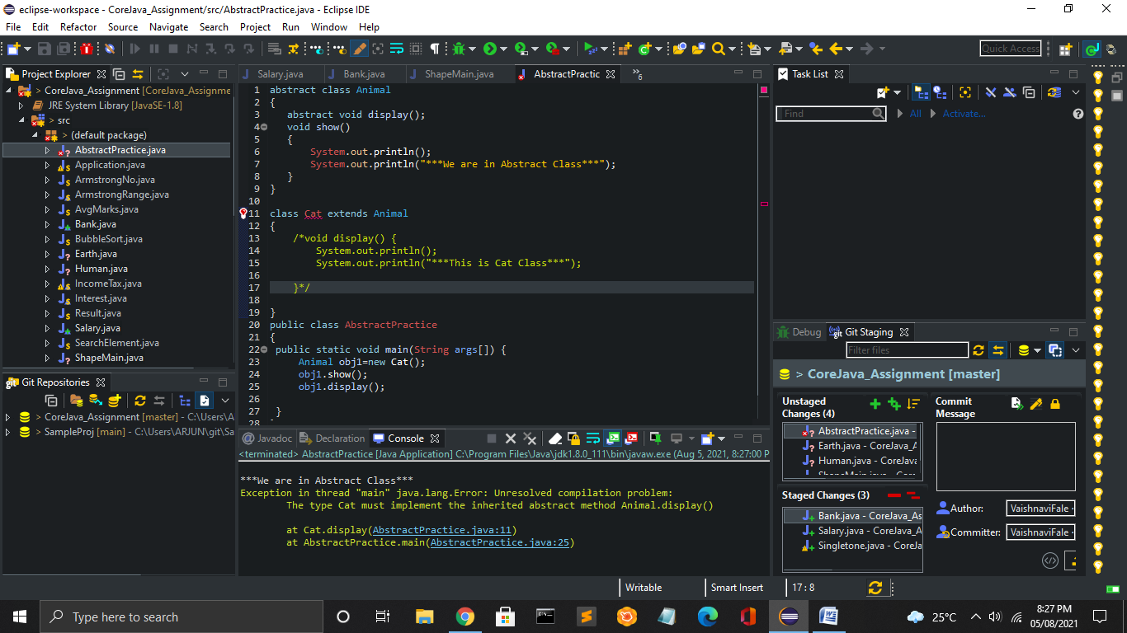
* 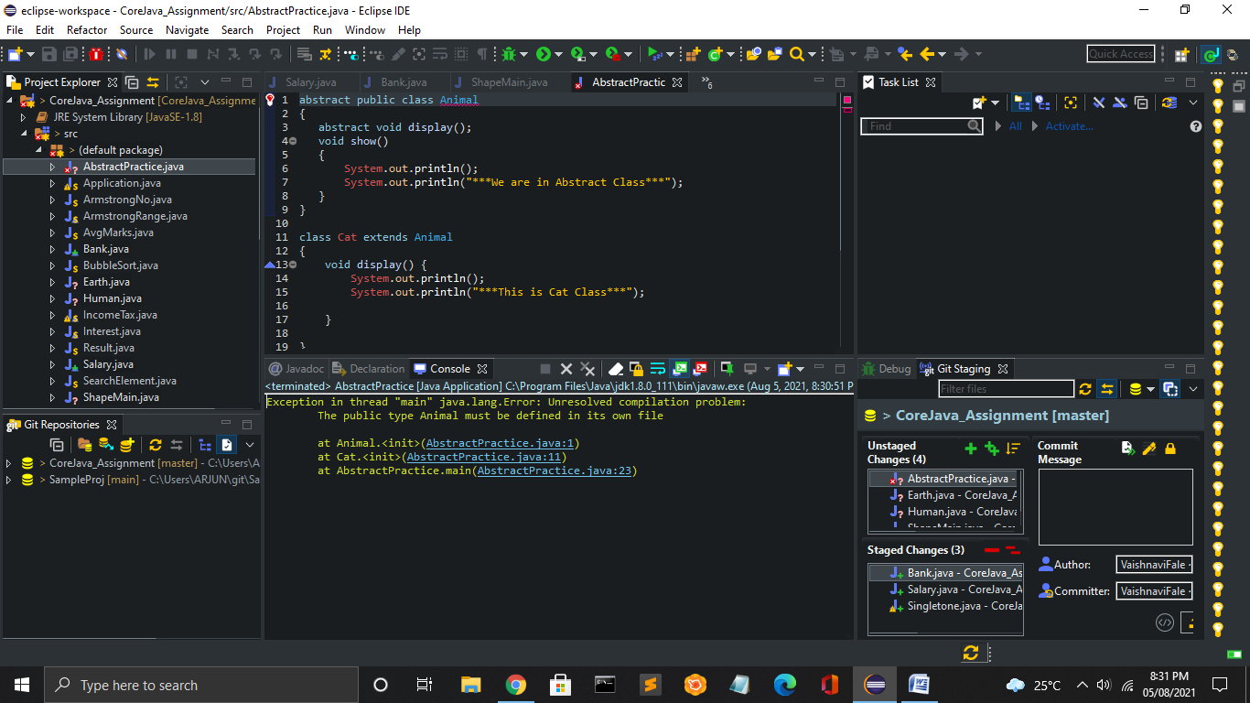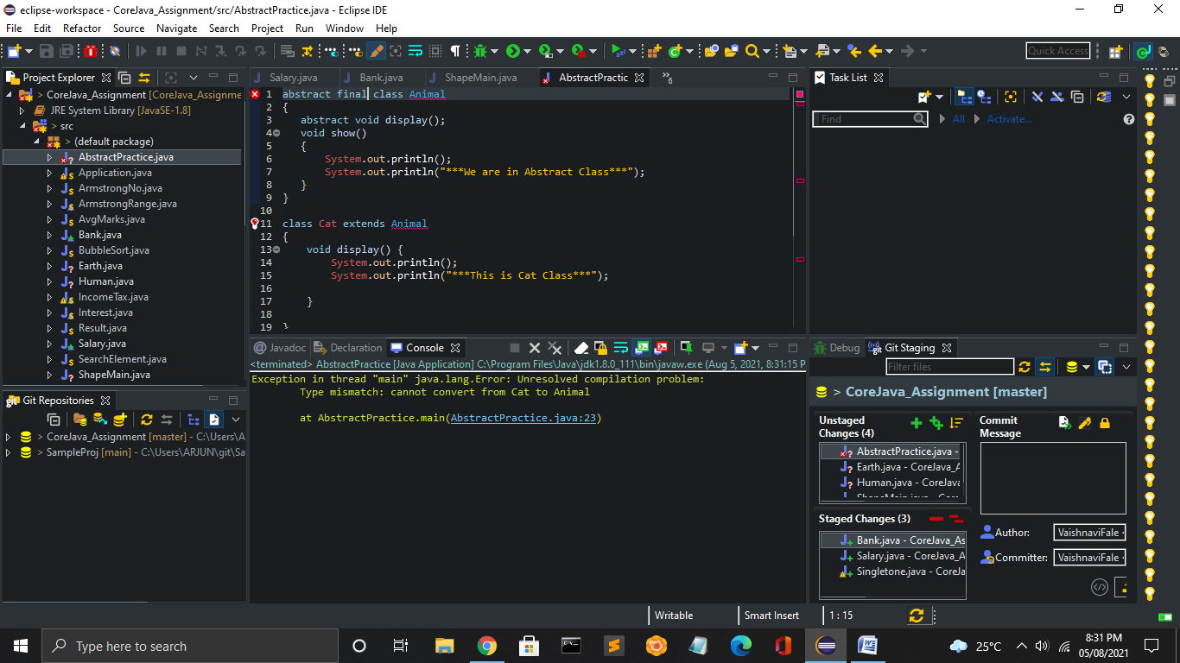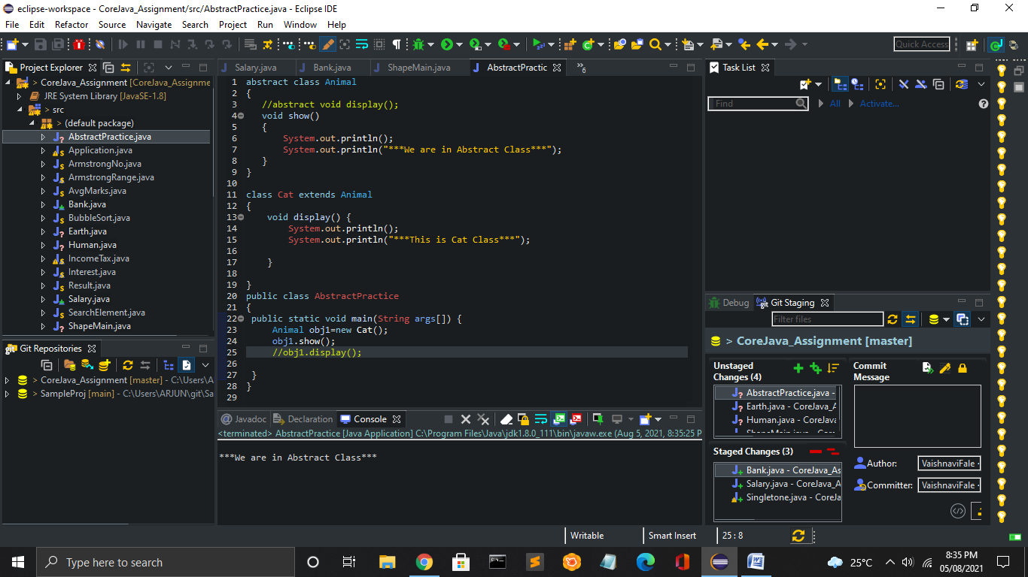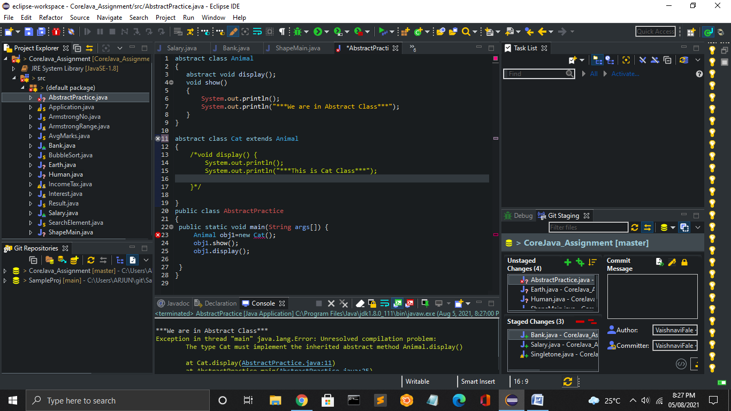



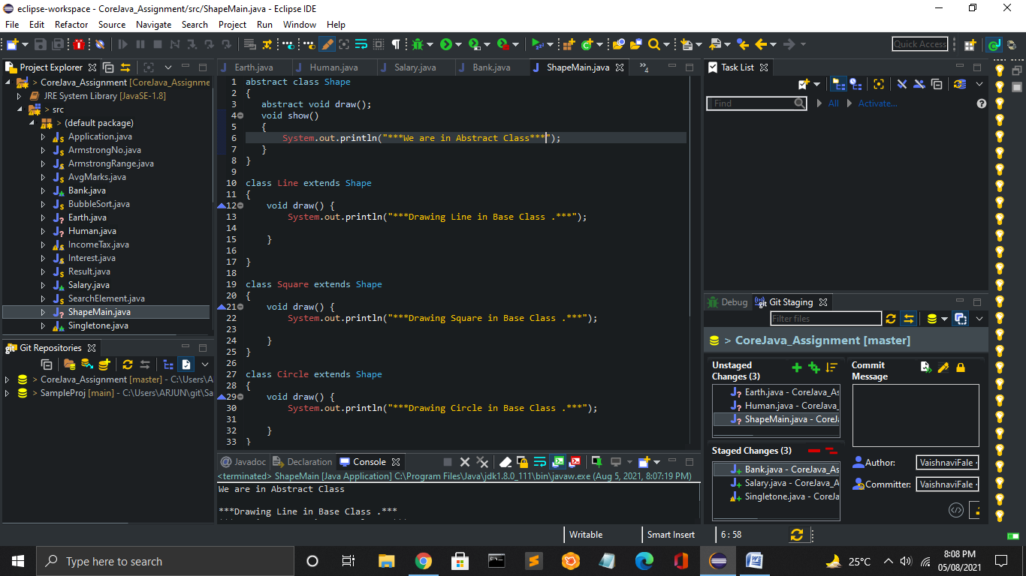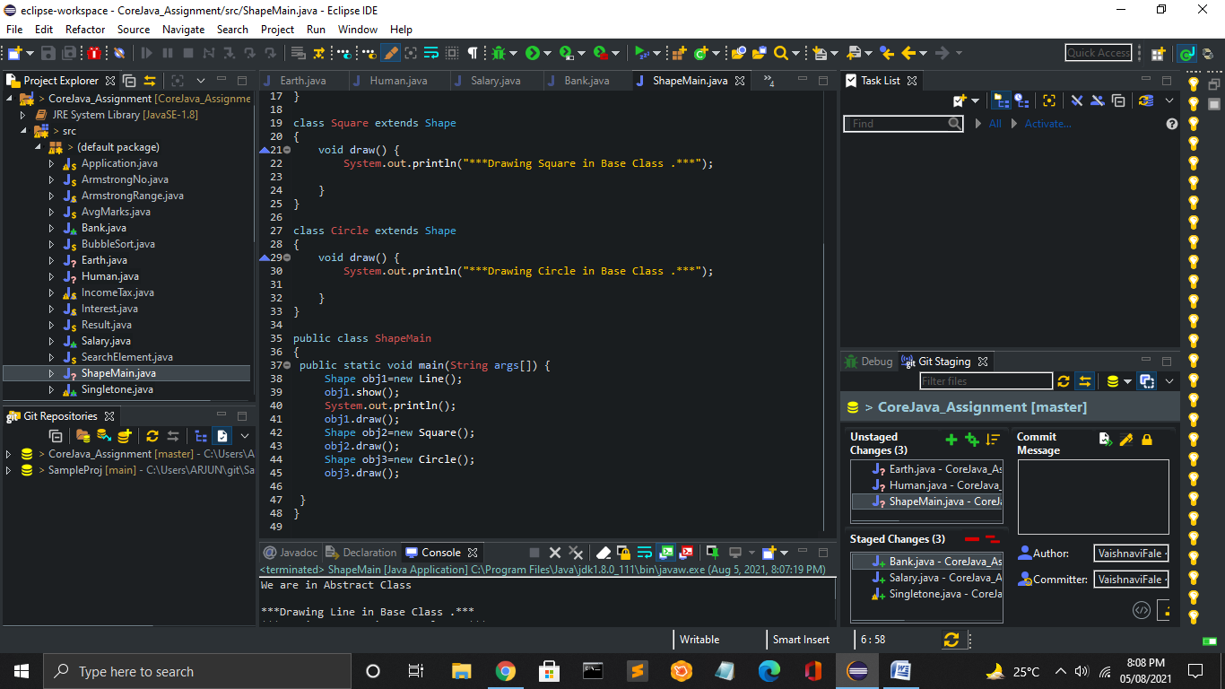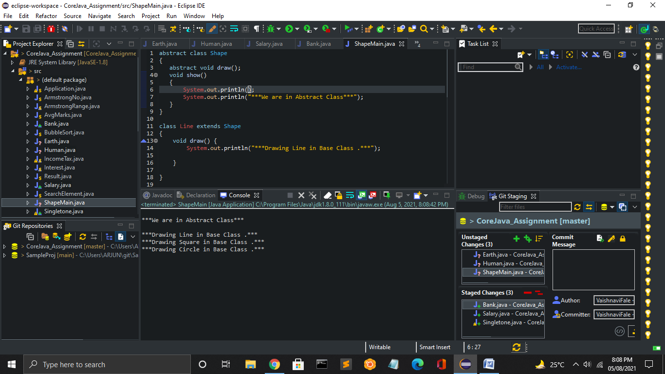



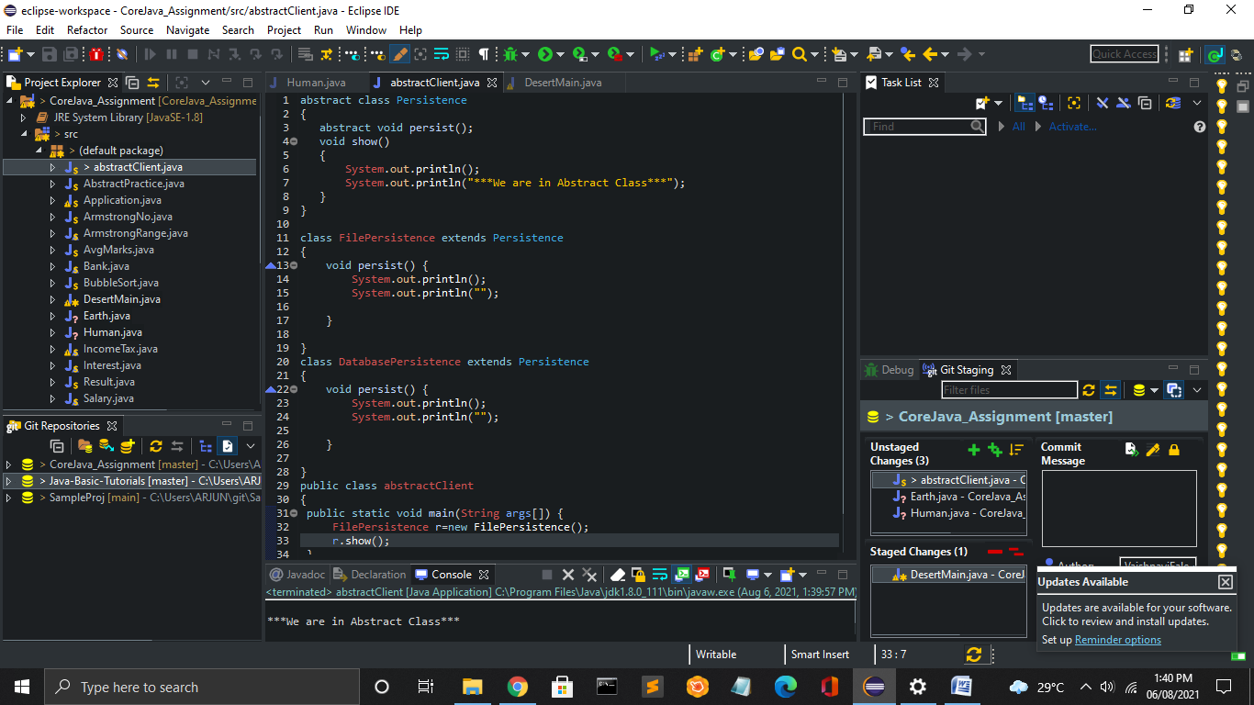



import java.util.Scanner;

abstract class DessertItem {

public String name;

public DessertItem()

{

name = "";

}

public DessertItem(String name1)

{

name = name1;

}

public String getName()

{

return name;

}

public void setName(String name1)

{

name = name1;

}

public abstract double getCost();

}

//Candy Class Start

class Candy extends DessertItem {

private double weight;

private double pricePerPound;

public Candy()

{

super();

weight = 0;

pricePerPound = 0;

}

public Candy(String name, double w, double prc)

{

super(name);

weight = w;

pricePerPound = prc;

}

public double getWeight() {

return weight;

}

public void setWeight(double weight) {

this.weight = weight;

}

public double getPricePerPound() {

return pricePerPound;

}

public void setPricePerPound(double pricePerPound) {

this.pricePerPound = pricePerPound;

}

@Override

public double getCost() {

double total = weight \* pricePerPound;

total = Math.round(total \* 100);

return total;

}

public String toString()

{

String s = String.format( "%-50s $%.2f\n\t %.2f lbs @ $.2f",getName(), getCost()/100, weight, pricePerPound);

System.out.println("You need to pay."+getCost()/100);

return s;

}

}

//Class Cookies

class Cookie extends DessertItem {

private int quantity;

private double pricePerDozen;

public Cookie()

{

super();

quantity = 0;

pricePerDozen = 0;

}

public Cookie(String name, int qty, double prc)

{

super(name);

quantity = qty;

pricePerDozen = prc;

}

public int getQuantity() {

return quantity;

}

public double getPricePerDozen() {

return pricePerDozen;

}

public void setPricePerDozen(double pricePerDozen) {

this.pricePerDozen = pricePerDozen;

}

public void setQuantity(int quantity) {

this.quantity = quantity;

}

@Override

public double getCost() {

double total = pricePerDozen / 12 \* quantity;

total = Math.round(total \* 100);

return total;

}

public String toString()

{

String s = String.format("%-50s $%.2f\n\t %d cookies @ $%.2f per Dozen", getName(), getCost()/100, quantity, pricePerDozen);

System.out.println("You need to pay."+getCost()/100);

return s;

}

}

//class Icecream

class IceCream extends DessertItem{

private int numberOfScoops;

private double pricePerScoop;

private double toppingPrice;

public IceCream() {

super();

numberOfScoops = 0;

pricePerScoop = 0;

toppingPrice = 0;

}

public IceCream(String name, int scoops, double prcPerScoop, double toppings)

{

super(name);

numberOfScoops = scoops;

pricePerScoop = prcPerScoop;

toppingPrice = toppings;

}

public int getNumberOfScoops() {

return numberOfScoops;

}

public void setNumberOfScoops(int numberOfScoops) {

this.numberOfScoops = numberOfScoops;

}

public double getPricePerScoop() {

return pricePerScoop;

}

public void setPricePerScoop(double pricePerScoop) {

this.pricePerScoop = pricePerScoop;

}

public double getToppingPrice() {

return toppingPrice;

}

public void setToppingPrice(double toppingPrice) {

this.toppingPrice = toppingPrice;

}

@Override

public double getCost() {

double total = (numberOfScoops \* pricePerScoop + toppingPrice);

return Math.round(100 \* total );

}

public String toString()

{

String s = String.format("%-50s $%.2f\n\t %d scoops @ $%.2f/scoop + $%.2f", getName(), getCost()/100, numberOfScoops, pricePerScoop, toppingPrice);

System.out.println("You need to pay."+getCost()/100);

return s;

}

}

//Main Class

public class DesertMain {

public static void main(String[] args) {

System.out.println("Select the following role :");

System.out.println("1. Customer ");

System.out.println("2. Shopkeeper ");

System.out.println("Select 1 or 2 ");

System.out.println();

Scanner scan=new Scanner(System.in);

int no=scan.nextInt();

switch (no) {

case 1:

System.out.println("Welcome!");

System.out.println("Tell us What do you like to buy,");

System.out.println("\*\*\*Enter the Desert Code\*\*\*");

System.out.println("1. Candy 2. Cookies 3. Icecream");

int choice=scan.nextInt();

if(choice==1)

{

System.out.println("Enter the Number of Pieces you want.");

int cno=scan.nextInt();

Candy item1 = new Candy("Candy", cno, 10);

System.out.println(item1);

}

else if(choice==2)

{

System.out.println("Enter the Number of Pieces you want.");

int cono=scan.nextInt();

Cookie item2 = new Cookie("Cookies", cono, 40);

System.out.println(item2);

}

else if(choice==3)

{

System.out.println("Enter the Number of Pieces you want.");

int ino=scan.nextInt();

IceCream item3 = new IceCream("IceCream", ino, 1, 50);

System.out.println(item3);

}

break;

case 2:

System.out.println("Welcome !");

String str;

System.out.println("What you like to add :");

str=scan.nextLine();

//System.out.println(str+" is successfully added. ");

break;

default:

System.out.println("Enter proper Choise");

break;

}

}

}

