**Topics: Normal distribution, Functions of Random Variables**

1. The time required for servicing transmissions is normally distributed with *μ* = 45 minutes and *σ* = 8 minutes. The service manager plans to have work begin on the transmission of a customer’s car 10 minutes after the car is dropped off and the customer is told that the car will be ready within 1 hour from drop-off. What is the probability that the service manager cannot meet his commitment?

**Answer:** Normal distribution with *μ* = 45 and *σ* = 8.0

The service manager begins the work after 10 minutes after the car is dropped off and planned to complete work within 1 hour

Hence h has 50 minutes to complete his work.

Let X be the amount of time it takes to complete the repair on a customer's car. To finish in 1 hour 🡪 X <= 50.

We have to calculate probability that the service manager cannot meet his commitment

That is X > 50.

As time required for servicing transmissions is normally distributed, we can calculate P(X>50) through Z-score.

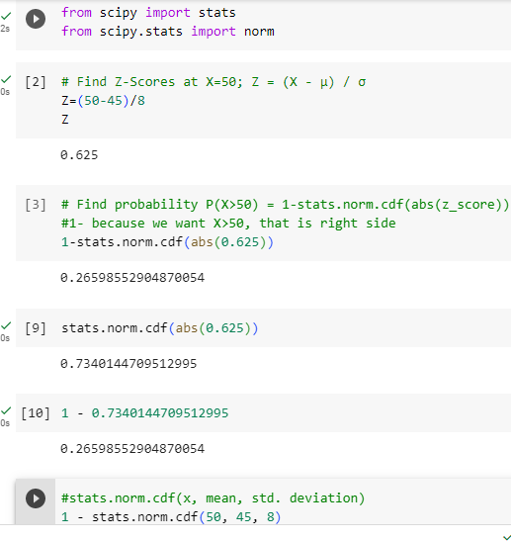



Hence B. is correct.

1. 0.3875
2. 0.2676
3. 0.5
4. 0.6987
5. The current age (in years) of 400 clerical employees at an insurance claims processing center is normally distributed with mean *μ* = 38 and Standard deviation *σ* =6. For each statement below, please specify True/False. If false, briefly explain why.

**Answer:** Mean *μ* = 38 and Standard deviation *σ* =6

1. More employees at the processing center are older than 44 than between 38 and 44. 🡪 **False**

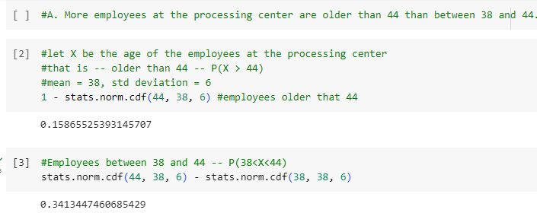

1. A training program for employees under the age of 30 at the center would be expected to attract about 36 employees. 🡪 **True**

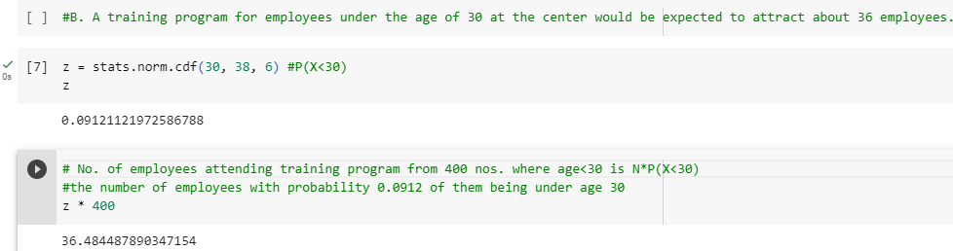

1. If *X1* ~ *N*(μ, σ2) and *X*2 ~ *N*(μ, σ2) are *iid* normal random variables, then what is the difference between 2 *X*1 and *X*1 + *X*2? Discuss both their distributions and parameters.

**Answer:** iid means independent identically distribution

Two variables are identically-distributed if they have the same frequency distribution (the same skew/kurtosis/variance etc.)

The i.i.d. assumption is also used in central limit theorem, which states that the probability distribution of the sum (or average) of i.i.d. variables with finite variance approaches a normal distribution.

According to the central limit theorem, any large sum of independent, identically distributed(iid) random variables is approximately normal.

The normal distribution is defined by two parameters, the mean and variance, written as X ~ N(μ, σ2).

If the two random variables are normal, then their difference will also be normal.

From the properties of normal random variables, if X1 ~ N(μ, σ2) and X2 ~ N(μ, σ2) are two independent identically distributed random variables, then

* The sum of normal random variables is given by

X1 + X2 ~ N(μ1 + μ2, σ12 + σ22).

* And the difference of normal random variables is given by

X1 – X2 ~ N(μ1 - μ2, σ12 + σ22).

* When Z = aX, the product of X is given by

Z ∼N(aμ1, a2σ12)

* When Z = aX1 + bX2

Linear combination of X1 and X2 , then Z ∼N(aμ1 + bμ2, a2σ12 + b2σ22 )

The property of multiplication, we get

2X1~N(2μ1, 22σ12) 🡪 N(2μ, 4σ2)

And the following property of addition,

X1 + X2 ~ N(μ1 + μ2, σ12 + σ22) 🡪 N(2μ, 2σ2)

And the difference between the two is given by 🡪 2X1 – (X1 + X2) ~ N(2μ - 2μ, 4σ2+2σ2)

The mean is same but the variance of 2X1is 2 times more than the variance of X1 + X2.

The difference between the two says that the two given variables are identically and independently distributed.

1. Let X ~ N(100, 202). Find two values, *a* and *b*, symmetric about the mean, such that the probability of the random variable taking a value between them is 0.99.
2. 90.5, 105.9
3. 80.2, 119.8
4. 22, 78
5. 48.5, 151.5
6. 90.1, 109.9

**Answer:** Since we need to find out the values of a and b, which are symmetric about the mean, such that the probability of random variable taking a value between them is 0.99, we have to work out in reverse order.

The Probability of getting value between a and b should be 0.99.

So the Probability outside the a and b area is 1-0.99 = 0.01.

The Probability towards left from a = -0.005 (ie. 0.01/2).

The Probability towards right from b = +0.005 (ie. 0.01/2).

So since we have the probabilities of a and b, we need to calculate X, the random variable at a and b which has got these probabilities.

By finding the Standard Normal Variable Z (Z Value), we can calculate the X values.

Z=(X- μ) / σ

For Probability 0.005 the Z Value is -2.57 (from Z Table).

Z * σ + μ = X

Z(-0.005)*20+100 = -(-2.57)*20+100 = 151.4

Z(+0.005)*20+100 = (-2.57)*20+100 = 48.6

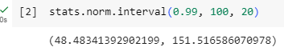

So, option D is correct.

1. Consider a company that has two different divisions. The annual profits from the two divisions are independent and have distributions Profit1 ~ N(5, 32) and Profit2 ~ N(7, 42) respectively. Both the profits are in $ Million. Answer the following questions about the total profit of the company in Rupees. Assume that $1 = Rs. 45
2. Specify a Rupee range (centered on the mean) such that it contains 95% probability for the annual profit of the company.
3. Specify the 5th percentile of profit (in Rupees) for the company
4. Which of the two divisions has a larger probability of making a loss in a given year?

**Answer:** A.Mean profit of company in RS = (5 + 7) * 45 = Rs. 540

Variance of the Company Distributions = 32 + 42 = 9 + 16 = 25

Standard deviation = (25)1/2 = 5 * 45 = 225

Confidence level given is 95% or 0.95

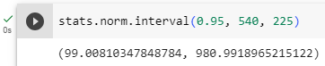

1. To compute 5th Percentile, we use the formula X=μ + Zσ

From z table, 5 percentile = -1.645

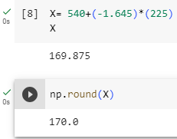

Hence 5th percentile of profit is 170 million

1. Loss is when profit < 0

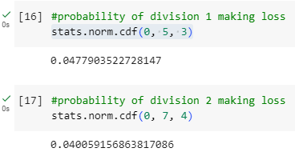

The 1st division of company, thus have larger probability of making a loss in a given year.