**Concepts of Operating System**

**Assignment 2**

Part A

**What will the following commands do?**

**• echo "Hello, World!"** :-- will Print Hello, World! That is whatever written in “ ”.

**• name="Productive":--**string Productive has been addigned to variable name.

**• touch file.txt:--**will create empty .txt file

**• ls -a:-**will list all files and directories including hidden files.

**• rm file.txt:--** will delete the file from directories

**• cp file1.txt file2.txt:--** copy file1.txt into file2.txt.

**• mv file.txt /path/to/directory/:--** file.txt will be moved to directory

**• chmod 755 script.sh:--** will give permission r,w,x – owner r,x – group and other user.

**• grep "pattern" file.txt:--** will search for patthern string in file.txt.

**• kill PID:-** will kill active process by using process id.

**• mkdir mydir && cd mydir && touch file.txt && echo "Hello, World!" > file.txt && cat file.txt:-**will create mydir directory then will to to it, in it file.txt text file will be created in which Hello,World will be printed and then content of it will be displayed using cat.

**• ls -l | grep ".txt":-** is -l will list all the files then ouput will be given to grep where it will filter .txt files.

**• cat file1.txt file2.txt | sort | uniq:-**will concate file1 and file2 then it will be given to sorting and then by using unique duplicates will be removed.

**• ls -l | grep "^d":-** will list all the files then only the lines starting with character d will be shown.

**• grep -r "pattern" /path/to/directory/:-** will search for the pattern within given directory

**• cat file1.txt file2.txt | sort | uniq –d:-**will merge file1 and file2 then sorting and then filtering unique lines by displaying duplicate.

**• chmod 644 file.txt:-** file permission w-owner read-group and other user

**• cp -r source_directory destination_directory:-**copy file from source to destination.

**• find /path/to/search -name "*.txt":-**will search for file using name pattern , .txt files will be searched.

**• chmod u+x file.txt:-**execution permission for Owner.

**• echo $PATH:-**searches each directory listed in variable, in order, to find the corresponding executable file.

Part B

**Identify True or False:**

**1. ls is used to list files and directories in a directory:-** True

**2. mv is used to move files and directories:-** True

**3. cd is used to copy files and directories:-**False

**4. pwd stands for "print working directory" and displays the current directory:-**True

**5. grep is used to search for patterns in files:-**True

**6. chmod 755 file.txt gives read, write, and execute permissions to the owner, and read and execute to group and others.:-**True

**7. mkdir -p directory1/directory2 creates nested directories, creating directory2 inside directory1**

**if directory1 does not exist:-**True

**8. rm -rf file.txt deletes a file forcefully without confirmation:-**True

**Identify the Incorrect Commands:**

**1. chmodx is used to change file permissions. :-** chmod

**2. cpy is used to copy files and directories. :-** cp

**3. mkfile is used to create a new file. :-** Touch

**4. catx is used to concatenate files. :-** cat

**5. rn is used to rename files. :-** mv

Part C

Question 1: Write a shell script that prints "Hello, World!" to the terminal.

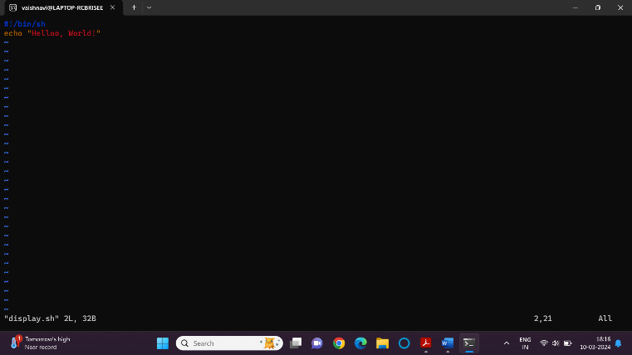

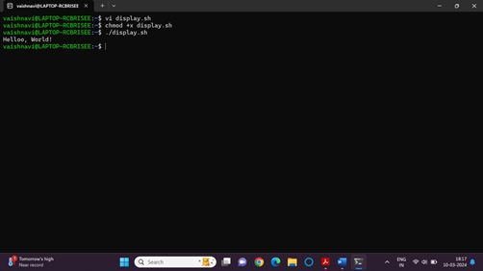

Question 2: Declare a variable named "name" and assign the value "CDAC Mumbai" to it. Print the value of the variable.

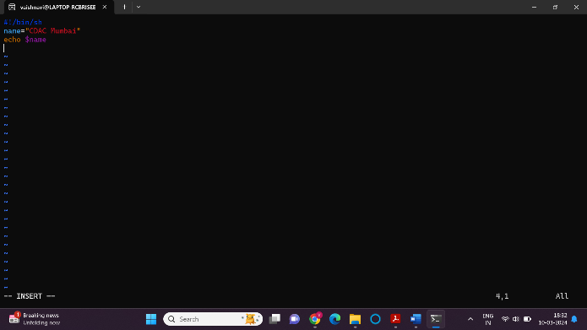

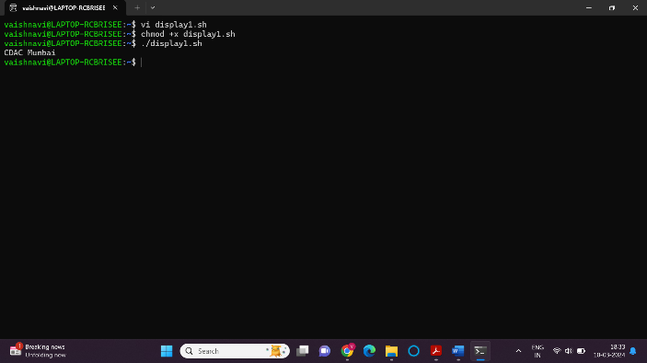

Question 3: Write a shell script that takes a number as input from the user and prints it.

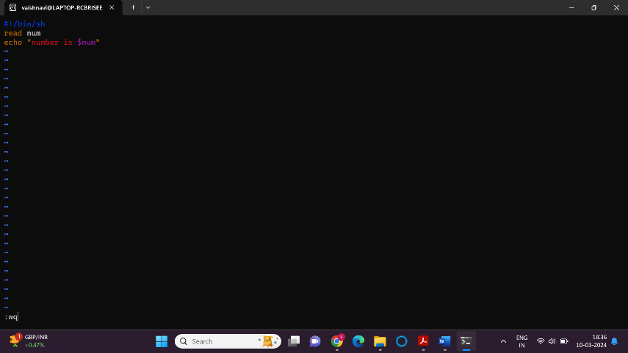

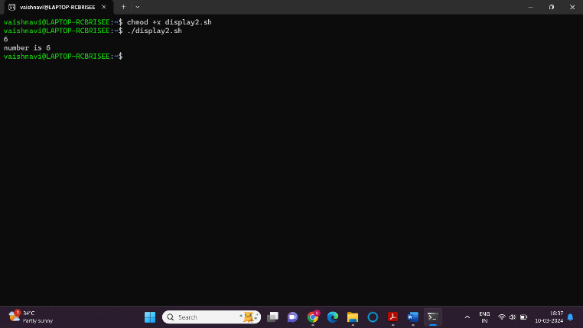

Question 4: Write a shell script that performs addition of two numbers (e.g., 5 and 3) and prints the

result.

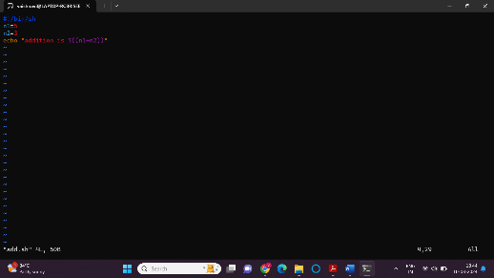

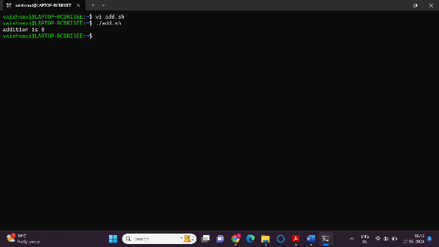

Question 5: Write a shell script that takes a number as input and prints "Even" if it is even, otherwise

prints "Odd".

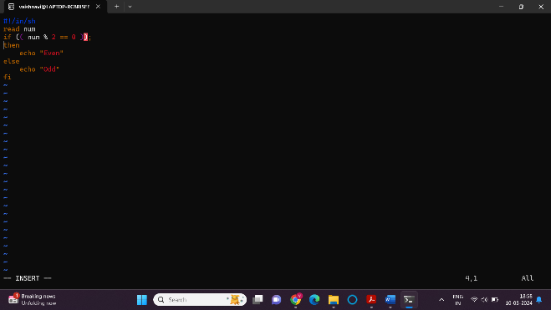

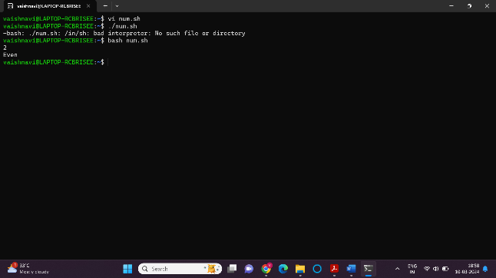

Question 6: Write a shell script that uses a for loop to print numbers from 1 to 5.

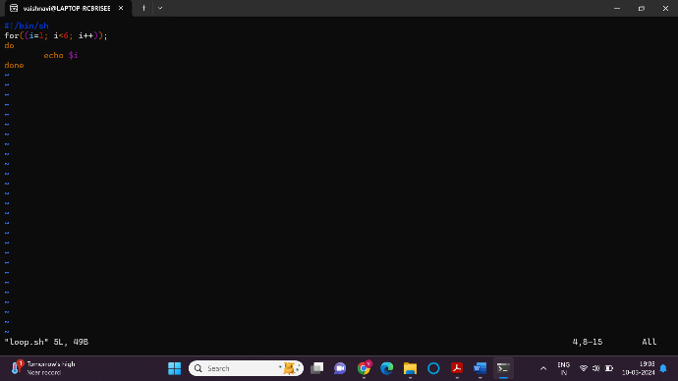

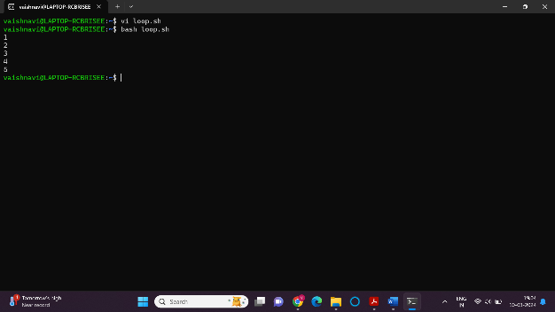

Question 7: Write a shell script that uses a while loop to print numbers from 1 to 5.

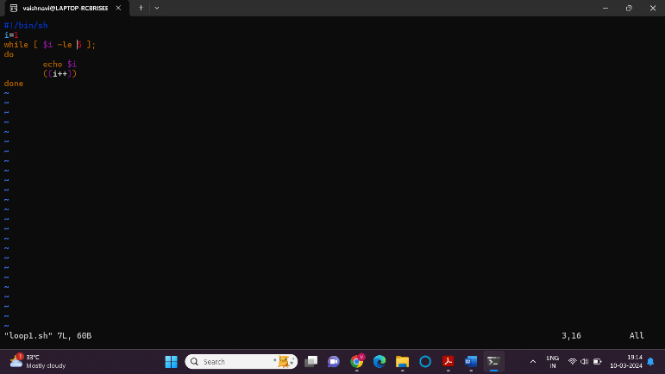

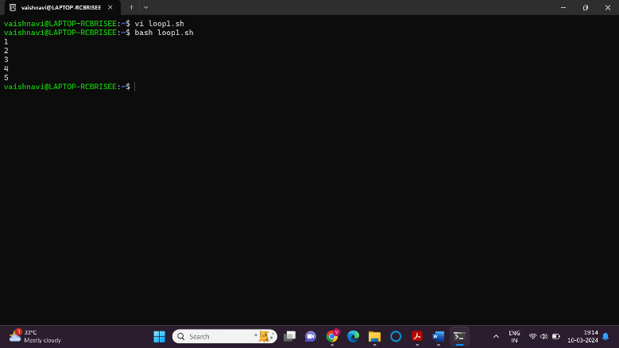

Question 8: Write a shell script that checks if a file named "file.txt" exists in the current directory. If it

does, print "File exists", otherwise, print "File does not exist".

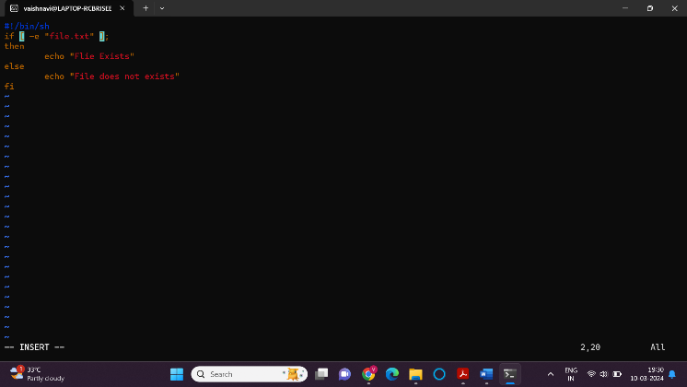

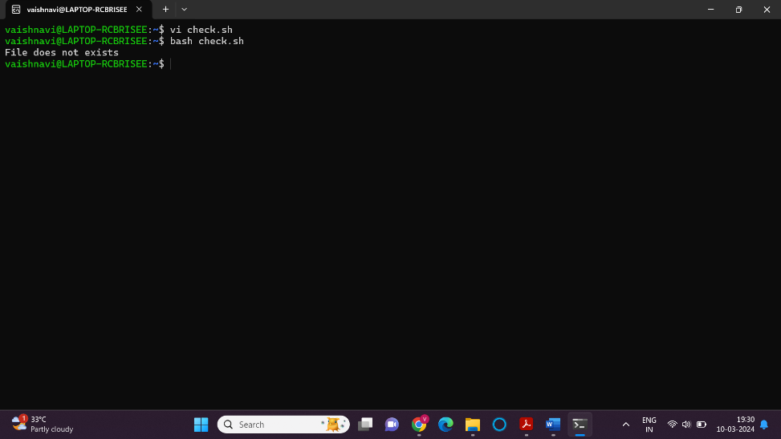

Question 9: Write a shell script that uses the if statement to check if a number is greater than 10 and

prints a message accordingly.

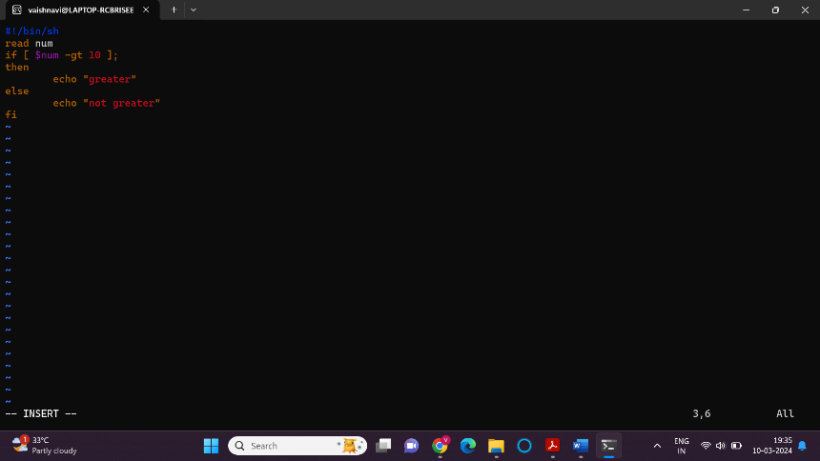

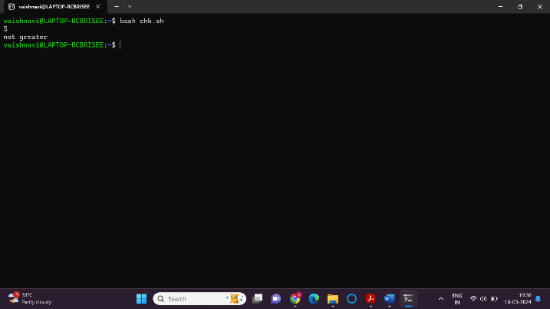

Question 10: Write a shell script that uses nested for loops to print a multiplication table for numbers from 1 to 5. The output should be formatted nicely, with each row representing a number and each column representing the multiplication result for that number.

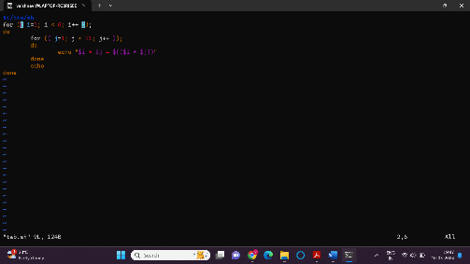

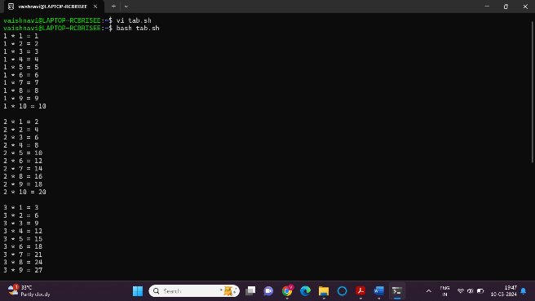

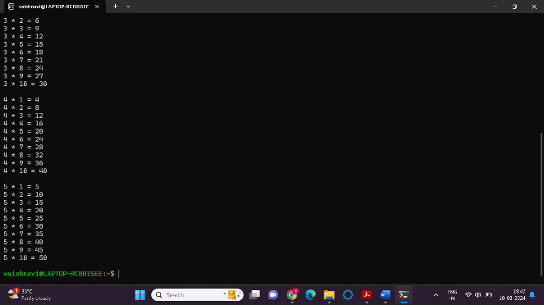

Question 11: Write a shell script that uses a while loop to read numbers from the user until the user enters

a negative number. For each positive number entered, print its square. Use the break statement to exit the

loop when a negative number is entered.

