**WEEK-2 PL/SQL**

**Exercise 3: Stored Procedures**.

**Prerequisite Tables**

-- Accounts Table

CREATE TABLE Accounts (

AccountID NUMBER PRIMARY KEY,

CustomerID NUMBER,

AccountType VARCHAR2(20), -- e.g., 'Savings'

Balance NUMBER

);

-- Employees Table

CREATE TABLE Employees (

EmployeeID NUMBER PRIMARY KEY,

Name VARCHAR2(50),

Department VARCHAR2(50),

Salary NUMBER

);  
 **Scenario 1: Process Monthly Interest for Savings Accounts**

CREATE OR REPLACE PROCEDURE ProcessMonthlyInterest IS

BEGIN

FOR rec IN (

SELECT AccountID, Balance FROM Accounts WHERE AccountType = 'Savings'

) LOOP

UPDATE Accounts

SET Balance = rec.Balance + (rec.Balance * 0.01)

WHERE AccountID = rec.AccountID;

DBMS_OUTPUT.PUT_LINE('Updated AccountID ' || rec.AccountID ||

': New Balance = ' || TO_CHAR(rec.Balance + (rec.Balance * 0.01)));

END LOOP;

END;

/

OUTPUT

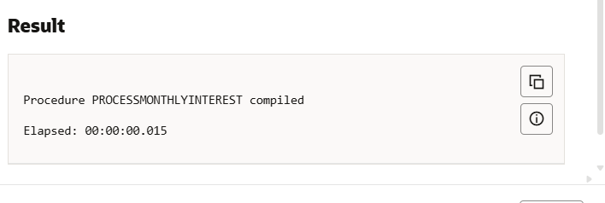

**Scenario 2: Bonus for Employees Based on Department**

CREATE OR REPLACE PROCEDURE UpdateEmployeeBonus (

p_department IN VARCHAR2,

p_bonus_pct IN NUMBER

) IS

BEGIN

FOR rec IN (

SELECT EmployeeID, Salary FROM Employees WHERE Department = p_department

) LOOP

UPDATE Employees

SET Salary = rec.Salary + (rec.Salary * p_bonus_pct / 100)

WHERE EmployeeID = rec.EmployeeID;

DBMS_OUTPUT.PUT_LINE('Bonus applied to EmployeeID ' || rec.EmployeeID ||

': New Salary = ' || TO_CHAR(rec.Salary + (rec.Salary * p_bonus_pct / 100)));

END LOOP;

END;

/

**OUTPUT**

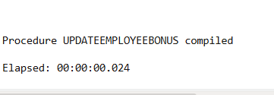

**Scenario 3: Transfer Funds Between Accounts**

CREATE OR REPLACE PROCEDURE TransferFunds (

p_from_account IN NUMBER,

p_to_account IN NUMBER,

p_amount IN NUMBER

) IS

v_from_balance NUMBER;

BEGIN

-- Get balance of source account

SELECT Balance INTO v_from_balance FROM Accounts WHERE AccountID = p_from_account;

IF v_from_balance < p_amount THEN

DBMS_OUTPUT.PUT_LINE('Insufficient funds in source account.');

ELSE

-- Deduct from source

UPDATE Accounts

SET Balance = Balance - p_amount

WHERE AccountID = p_from_account;

-- Add to destination

UPDATE Accounts

SET Balance = Balance + p_amount

WHERE AccountID = p_to_account;

DBMS_OUTPUT.PUT_LINE('Transferred ' || p_amount ||

' from AccountID ' || p_from_account ||

' to AccountID ' || p_to_account);

END IF;

END;

/

OUTPUT

