**WEEK-2 PL/SQL**

**Exercise 1: Control Structures**

Scenario 1: Discount Loan Interest for Customers Over 60

SET SERVEROUTPUT ON;

BEGIN

  FOR rec IN (

    SELECT l.LoanID, l.InterestRate

    FROM Loans l

    JOIN Customers c ON l.CustomerID = c.CustomerID

    WHERE c.Age > 60

  ) LOOP

    UPDATE Loans

    SET InterestRate = rec.InterestRate - 0.01

    WHERE LoanID = rec.LoanID;

    DBMS_OUTPUT.PUT_LINE('Updated LoanID ' || rec.LoanID ||

                         ' to new rate: ' || TO_CHAR(rec.InterestRate - 0.01));

  END LOOP;

END;

/

OUTPUT

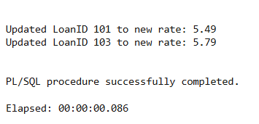

**Scenario 2: Promote Customers to VIP if Balance > 10,000**

**Code**

BEGIN

FOR rec IN (

SELECT CustomerID, Balance FROM Customers WHERE Balance > 10000

) LOOP

UPDATE Customers

SET IsVIP = 'TRUE'

WHERE CustomerID = rec.CustomerID;

DBMS_OUTPUT.PUT_LINE('Promoted CustomerID ' || rec.CustomerID ||

' to VIP (Balance: ' || rec.Balance || ')');

END LOOP;

END;

/  
  
OUTPUT

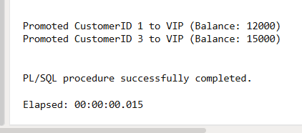

**Scenario 3: Remind Customers with Loans Due in Next 30 Days**

**CODE**  
BEGIN

FOR rec IN (

SELECT c.Name, l.LoanID, l.DueDate

FROM Loans l

JOIN Customers c ON l.CustomerID = c.CustomerID

WHERE l.DueDate BETWEEN SYSDATE AND SYSDATE + 30

) LOOP

DBMS_OUTPUT.PUT_LINE('Reminder: ' || rec.Name ||

', your loan (ID: ' || rec.LoanID ||

') is due on ' || TO_CHAR(rec.DueDate, 'DD-MON-YYYY'));

END LOOP;

END;

/  
  
  
**OUTPUT**  
