JUnit Testing Exercises

Exercise 1: Setting Up Junit

Step 1: Create Java Project

* Open IntelliJ IDEA
* Go to **File → New → Project**
* Select **Maven Archetype**
* Use archetype: maven-archetype-quickstart
* Set GroupId: org.example, ArtifactId: JUnitDemo

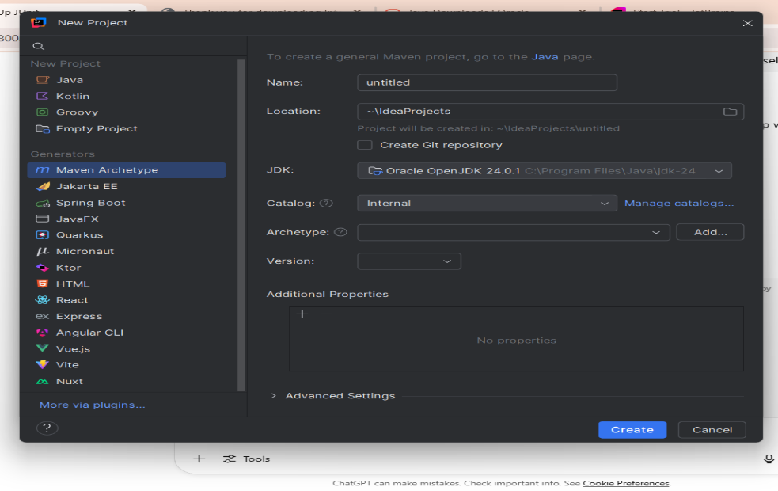

Step 2: Add JUnit Dependency

Added the following dependency in pom.xml inside <dependencies>:

<dependency>

<groupId>junit</groupId>

<artifactId>junit</artifactId>

<version>4.13.2</version>

<scope>test</scope>

</dependency>

3.Saved and clicked **Reload Maven Project**

✅ Step 3: Create a Test Class

Created a class at:  
src/test/java/org/example/CalculatorTest.java

package org.example;

import org.junit.Test;

import static org.junit.Assert.*;

public class CalculatorTest {

@Test

public void testAddition() {

int result = 2 + 3;

assertEquals(5, result);

}

}

**🔹 Result:**

* Project compiled successfully
* JUnit test ran and passed ✅

