Exploratory Data Analysis (EDA) Report

Dataset Name: Train.csv

Author: Vaishnavi H

Date: 29/09/25

---

# 1. Introduction & Objective

The objective of this analysis is to explore the dataset, understand its structure, and identify patterns, trends, and anomalies that could inform further analysis or predictive modeling. The EDA focuses on:  
- Understanding the dataset and its features  
- Summarizing key statistics  
- Visualizing data distributions and relationships  
- Highlighting key insights

---

# 2. Analysis Steps

1. Data Loading: Imported the dataset and reviewed basic information.  
2. Data Cleaning: Handled missing values, duplicates, and inconsistent entries.  
3. Statistical Summary: Generated descriptive statistics for numeric and categorical features.  
4. Univariate Analysis: Examined distributions of individual features using histograms and bar charts.  
5. Bivariate Analysis: Studied relationships between variables using scatter plots, boxplots, and correlation matrices.  
6. Feature Insights: Identified key variables impacting target/outcome features.

---

# 3. Visualizations

## 3.1 Univariate Analysis

- Example: Distribution of a numeric column  
[Histogram / Boxplot here]

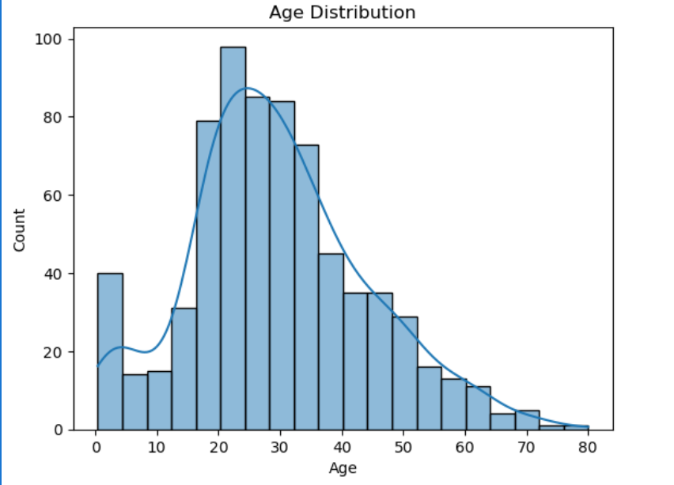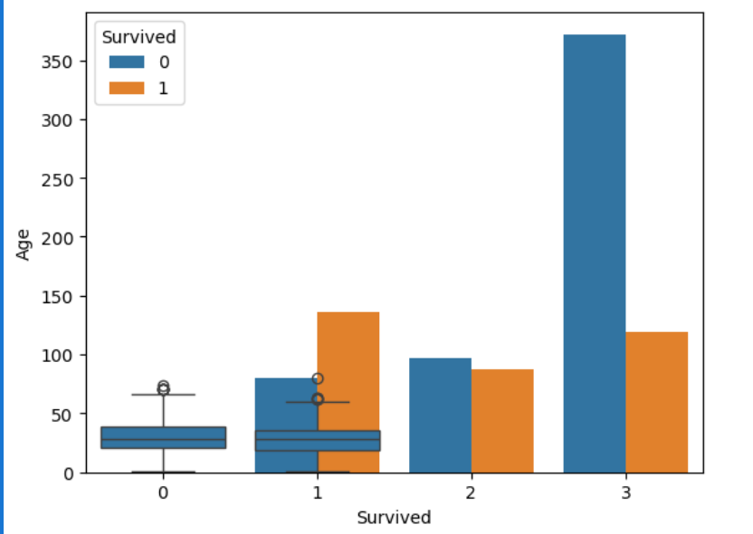

- Example: Count of categorical values  
[Bar chart here]

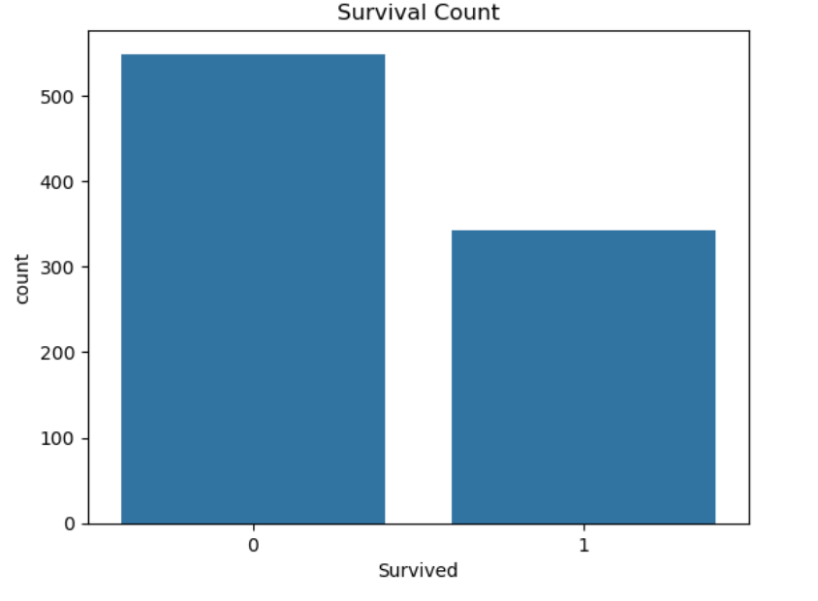

## 3.2 Bivariate Analysis

- Example: Correlation between features  
[Heatmap here]

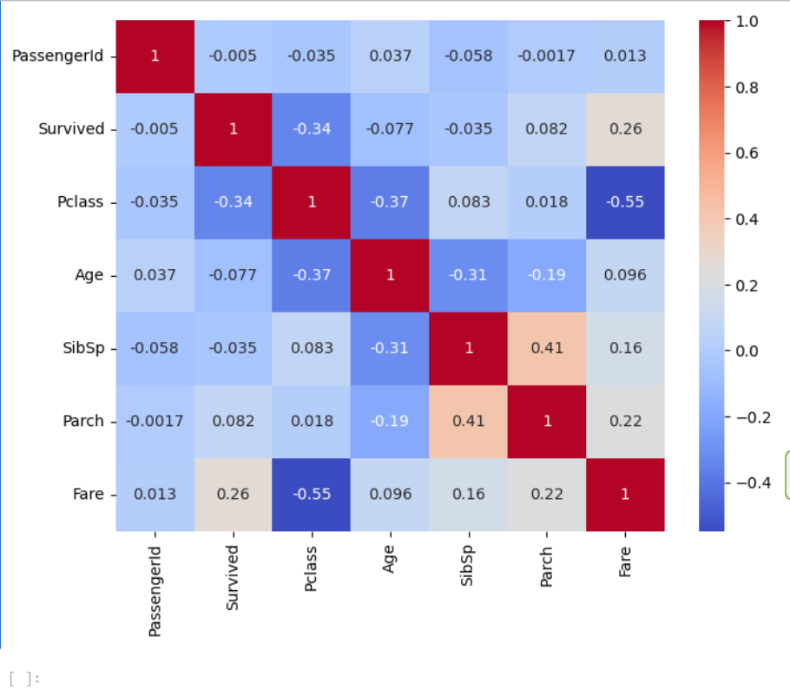

- Example: Relationship between features and target  
[Scatterplot here]

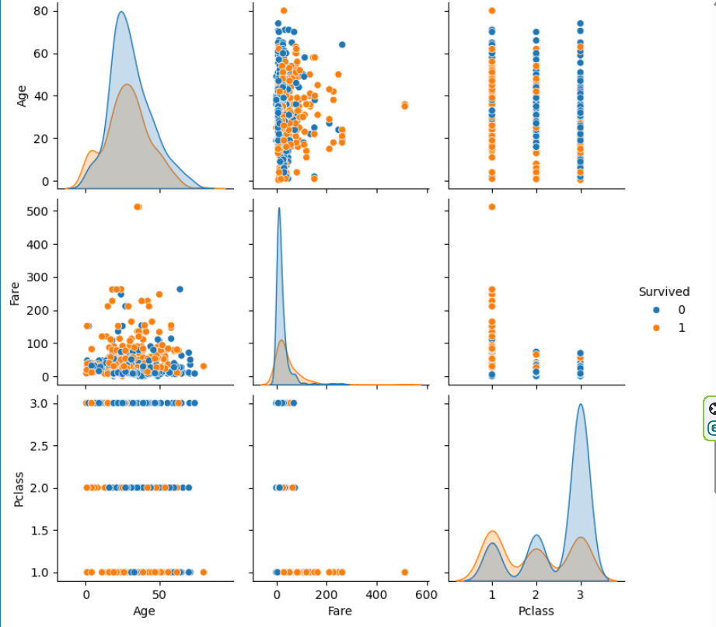  
---  
  
Conclusion:  
The dataset provides [brief conclusion on patterns, trends, or potential areas for modeling]. Further analysis can focus on [predictive modeling, clustering, feature selection, etc.].

---