Product Line Profitability and Margin Performance Analysis for a Multi-Division Candy Distributor: A Data-Driven Case Study
Vaishnavi Nahush Helwatkar
Department of Information Technology
Data Analytics Intern
Unified Mentor Pvt. Ltd.
vaishnavihelwatkar19@gmail.com
Abstract - Distributors that sell a diverse portfolio of products often struggle to identify which items genuinely drive profitability, as sales volume alone can be a misleading indicator of financial health. This study presents a structured, end-to-end profitability analysis of a multi-division candy distributor using an order-level transactional dataset of 10,194 records spanning two years. Five key performance indicators were engineered: Gross Margin, Profit per Unit, Revenue Contribution, Profit Contribution, and Margin Volatility, followed by product-level, division-level, profit-concentration, and cost-structure diagnostics. Five of the 15 products were found to account for over 95% of total gross profit, a concentration substantially exceeding the classical 80/20 rule, while a specific division and product were identified as carrying disproportionate margin risk despite meaningful sales volume. The findings were operationalized through a publicly deployed, interactive Streamlit dashboard supporting real-time filtering by division, region, margin threshold, product, and date range, with dynamic margin-risk alerts and data export.
Index Terms: Cost structure diagnostics, gross margin, Pareto analysis, profitability analysis, and interactive dashboard.
I. Introduction
Distribution businesses that carry a wide product portfolio face a recurring analytical challenge: high-selling products are not automatically the most profitable ones. A product can move large volumes while returning a thin margin, consume disproportionate cost relative to its price point, or mask an underlying pricing inefficiency behind an otherwise healthy top-line figure. Without dedicated profitability analysis, decisions on pricing, promotions, and product-line rationalization tend to remain reactive and based on intuition rather than evidence.
This is particularly relevant for candy and confectionery distributors, where product portfolios frequently span multiple categories with very different cost structures and margin profiles. A distributor may be structurally dependent on a small number of “hero” products for the majority of its profit, while a long tail of smaller products contributes disproportionately little, a pattern consistent with the Pareto principle but one that is rarely quantified formally in day-to-day operations.
This paper presents a case study applying a structured, five-stage profitability analysis pipeline, data cleaning and validation, KPI engineering, product-level analysis, division-level analysis, and profit-concentration analysis, supplemented by cost-structure diagnostics, to an order-level transactional dataset from a multi-division candy distributor. The analysis is further operationalized through a publicly deployed interactive dashboard, allowing non-technical stakeholders to explore the same findings on demand from any browser.
II. Literature Review
Profitability and margin analysis in distribution and retail contexts draws on several well-established analytical frameworks rather than a single dominant technique. Gross margin analysis, gross profit expressed as a percentage of sales, remains the most widely used single indicator of product-level financial health, since it normalizes profit contribution across products of very different price points and volumes [6].
The Pareto principle, or 80/20 rule, was originally observed by Pareto [4], and is a long-standing heuristic in inventory and category management, later formalized by Juran into ABC analysis [5]: ranking items by cumulative contribution to revenue or profit to separate a small set of high-impact items from a long tail of low-impact ones. This framework underpins the profit-concentration analysis performed in this study.
Cost-structure diagnostics, which compare a product's cost base against its realized sales price, are used in cost-volume-profit analysis to identify items whose pricing or cost position deviates from an organization's typical margin band, flagging candidates for repricing or supplier renegotiation.
This study's implementation draws on established tooling and design practice: data manipulation and cleaning follow conventions described in McKinney [7], the value of enterprise-wide analytics for competitive decision-making is discussed by Davenport and Harris [8], and the dashboard's visual design follows dashboard usability principles established by Few [9]. This study integrates these established frameworks and applies them to a real transactional dataset delivered through a publicly deployed, filterable dashboard rather than a static report alone.
III. Methodology
The analysis followed a five-stage pipeline, illustrated in Figure 1, taking the raw transactional export through validation, KPI engineering, and analytical modelling to a deployed interactive dashboard.
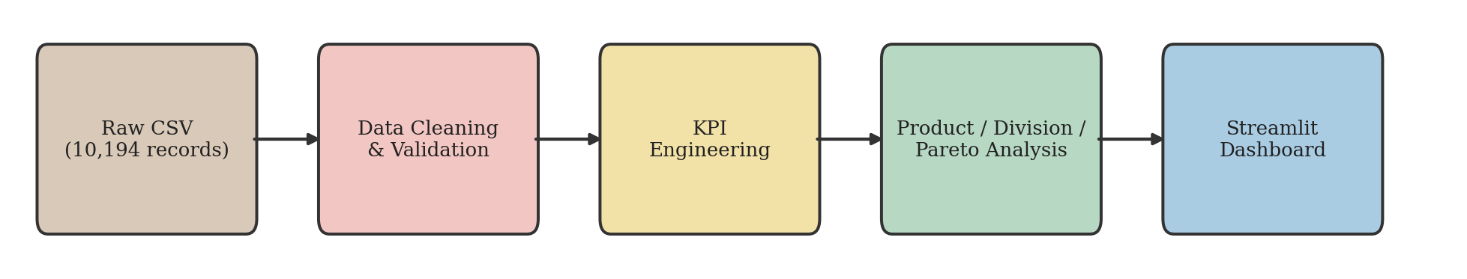
Figure 1. Five-stage analysis pipeline from raw transactional data to the deployed dashboard.
A. Dataset and analysis
The dataset consists of 10,194 order-level records collected over a two-year period (2024–2025), with 18 fields including Order Date, Ship Date, Division, Region, Product Name, Sales, Units, Cost, and Gross Profit. Analysis was conducted in Python using pandas, matplotlib, seaborn, and plotly within a Jupyter environment.
B. Data pre-processing and validation
A structural validation pass was performed prior to any business-logic calculations. No null values, duplicate rows, or duplicate Row IDs were found. No records showed Cost exceeding Sales, and no zero or negative Sales, Units, or Cost values were present.
Table 1. Data completeness and validity checks
Check | Result
Null values | 0
Duplicate rows | 0
Cost greater than Sales | 0
Order Date and Ship Date were converted from text to datetime format. The Sales distribution was right-skewed (mean $13.91 vs. median $10.80); manual inspection of the largest transactions confirmed these to be legitimate orders rather than data errors. The Division field showed a severe class imbalance, with 96.6% of records belonging to a single division, which is treated as a limitation for minority-division conclusions throughout this study.
C. KPI engineering
Five KPIs were engineered: Gross Margin (Gross Profit / Sales), Profit per Unit (Gross Profit / Units), Revenue Contribution (product Sales / total Sales), Profit Contribution (product profit / total profit), and Margin Volatility (standard deviation of average monthly Gross Margin). Contribution metrics were validated by confirming that per-record values summed to 1.0 across the dataset.
D. Profitability and concentration analysis
Products and divisions were ranked by total Gross Profit and average Gross Margin. A Pareto analysis was performed by sorting products in descending order of Gross Profit and computing cumulative percentage of total profit contributed by each successive product.
E. Dashboard deployment
Findings were operationalized through a Streamlit web application and publicly deployed via the Streamlit Community Cloud, making the dashboard accessible from any browser without local installation. The dashboard provides five sidebar filters — division, region, minimum gross margin threshold, product name search, and order date range — all of which jointly narrow a single shared dataset that feeds every view in the application. Figure 2 illustrates the resulting data flow, from the KPI-enriched dataset through the application backend to the filters and tabs a stakeholder interacts with directly.
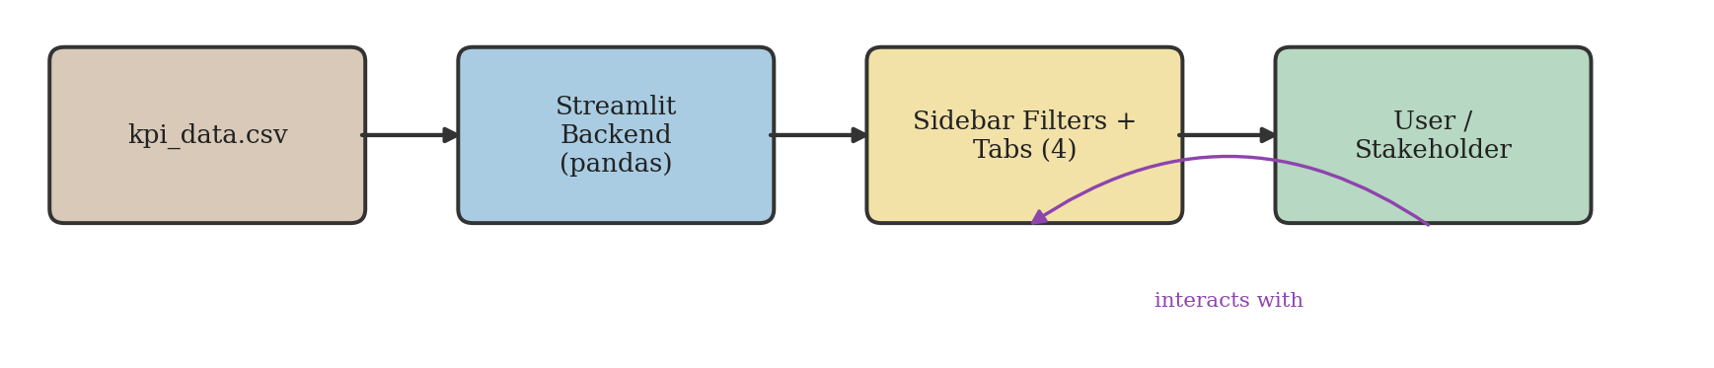
Figure 2. Dashboard architecture, showing data flow from the KPI-enriched dataset through the Streamlit backend to the interactive filters, tabs, and end user.
Beyond the shared filters, two product-level views are provided: a Quick Product Stats lookup, which reports Sales, Gross Profit, Units, and Order count for a single selected product independent of the active filters, and a Focus-on-Product control, which narrows all four analytical tabs to a single selected product. The application also includes a dynamic margin-risk alert, which flags any product currently in view with a Gross Margin below 20%, recalculated live as filters change; a no-results guard that displays a warning rather than failing when a filter combination matches zero records; and a CSV export button allowing stakeholders to download the currently filtered dataset. The four analytical views are: Product Overview, Division Performance, Cost versus Margin Diagnostics, and Pareto Analysis.
IV. Results
A. KPI outcomes
Gross Margin averaged 66.5% across all records (range: 7.7% to 80%). Profit per Unit averaged $2.41. Margin Volatility was measured at 0.0032, approximately 0.32% points of standard deviation across 24 months, indicating highly stable pricing and cost discipline over the study period.
B. Product and division level findings
Table 2. Division-level performance summary
Division | Sales | Profit | Margin
Chocolate | $131,692.90 | $88,824.62 | 67.5%
Sugar | $427.48 | $284.73 | 57.7%
Other | $9,663.25 | $4,333.45 | 37.7%
The Chocolate division was confirmed as the dominant performer in both scale and margin efficiency, driven by five Wonka Bar product variants. The Other division returned the lowest average margin at 37.7%, driven by Kazookles, Lickable Wallpaper, Wonka Gum, and Fizzy Lifting Drinks. Kazookles exhibited a gross margin of 7.7%, the lowest across the full 15-product catalogue, despite carrying meaningful sales volume of $1,205.75. This product is automatically surfaced by the dashboard's margin-risk alert whenever it remains within the active filter selection.
C. Profit concentration analysis
Five of 15 products, all Wonka Bar variants, were found to account for 95.1% of total gross profit, exceeding the classical 80/20 benchmark. Figure 3 presents the resulting Pareto chart, showing individual product profit contribution alongside the cumulative percentage curve.
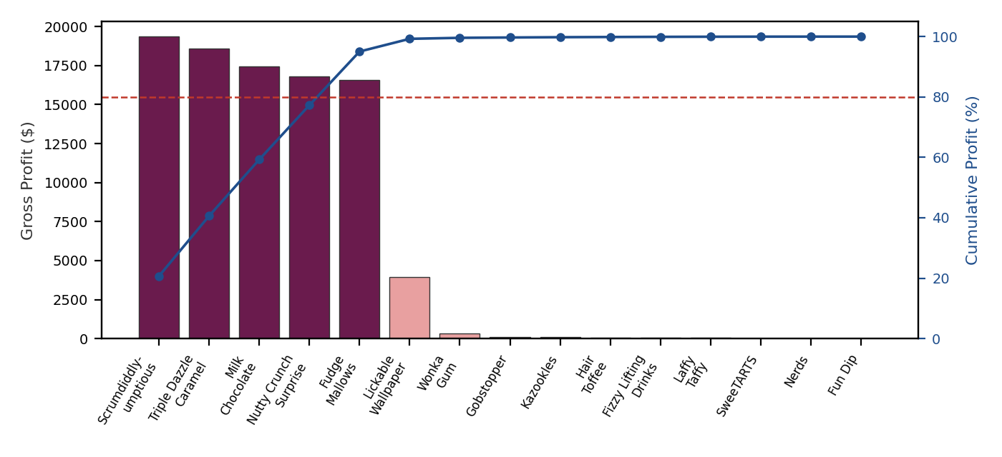
Figure 3. Profit concentration across the 15-product catalogue. Bars show individual product gross profit; the line shows cumulative percentage of total profit, crossing 95 % at the fifth product.
D. Cost structure diagnostics
A Cost-versus-Sales scatter analysis showed the five Wonka Bar products forming a consistent linear trend of approximately 3.3 to 3.5 times Sales-to-Cost ratio. Lickable Wallpaper fell visibly below this trend line, consistent with its comparatively weaker 50% margin.
E. Dashboard usability and deployment outcome
The deployed dashboard allows a stakeholder to reproduce every finding above interactively: filtering to the Other division surfaces its weaker average margin directly in the Division Performance tab; searching or selecting Kazookles triggers the live margin-risk alert in the Product Overview tab; and the Pareto Analysis tab reproduces Figure 3 dynamically for any filtered subset of the data. This confirms that the findings generalize beyond the static analysis and remain consistent under interactive exploration.
V. Conclusion
This study demonstrates that a structured combination of KPI engineering, product and division-level ranking, Pareto concentration analysis, and cost-structure diagnostics can surface actionable profitability insights from routine transactional data without requiring predictive modelling. Profit concentration in this dataset substantially exceeds the classical 80/20 benchmark, indicating a significant single-category dependency risk, while margin, not sales volume, proved the more reliable indicator of product health. Deploying the dashboard publicly, rather than keeping it as a local analysis artifact, allows stakeholders to independently verify and explore these findings without any technical setup. Severe class imbalance in the Division field limits statistical confidence in minority-division findings and should be treated as a limitation in any operational decision based on this analysis.
References
[1] Data source: internal order-level transactional dataset, candy distribution operations, 2024–2025 (10,194 records).
[2] Python Software Foundation, "pandas documentation," 2024. [Online]. Available: https://pandas.pydata.org
[3] Streamlit Inc., "Streamlit documentation," 2024. [Online]. Available: https://docs.streamlit.io
[4] V. Pareto, Cours d'Économie Politique. Lausanne: F. Rouge, 1896.
[5] J. M. Juran, Juran's Quality Control Handbook, 4th ed. New York: McGraw-Hill, 1988.
[6] M. Hall and J. Knapp, "Gross margins and efficiency measurement in retail trade," Oxford Economic Papers, vol. 7, no. 3, pp. 312–326, Oct. 1955.
[7] W. McKinney, Python for Data Analysis: Data Wrangling with pandas, NumPy, and Jupyter, 3rd ed. Sebastopol, CA: O'Reilly Media, 2022.
[8] T. H. Davenport and J. G. Harris, Competing on Analytics: The New Science of Winning. Boston, MA: Harvard Business School Press, 2007.
[9] S. Few, Information Dashboard Design: The Effective Visual Communication of Data. Sebastopol, CA: O'Reilly Media, 2006.
[10] Live dashboard. [Online]. Available: https://dataanalytics1234.streamlit.app
[11] Project repository. [Online]. Available: https://github.com/VaishnaviH119/nassau-candy-analysis
About the Authors
Vaishnavi N. Helwatkar is a student researcher who designed and executed this end-to-end profitability analysis, including data cleaning, KPI engineering, statistical analysis, and development and public deployment of the accompanying interactive dashboard.

