ABSTRACT

Landslides pose a significant threat to human life, infrastructure, and the environment, especially in regions with unstable terrain and heavy rainfall. Early detection and continuous monitoring can greatly reduce damage by enabling timely intervention. This project presents a deep learning–based landslide detection model using multi-channel satellite imagery stored in HDF5 format. The system extracts six important channels—Red, Green, Blue, NDVI, Slope, and Elevation—and preprocesses them using normalization and vegetation index computation. A U-Net convolutional neural network architecture is employed for pixel-level segmentation to accurately identify landslide-affected regions.
The dataset is processed through a custom TensorFlow pipeline that reads .h5 image and mask files, applies normalization, computes NDVI, and generates standardized tensors. The U-Net model, trained on 128×128 multi-channel patches, learns spatial and spectral patterns that characterize landslides. Performance metrics such as accuracy, F1-score, precision, and recall are evaluated to ensure robust segmentation capability. The system incorporates data augmentation, validation monitoring, and automatic best-model checkpointing to improve generalization.
This project demonstrates that deep learning combined with multi-spectral features significantly enhances the accuracy of landslide detection. It provides a scalable, automated, and real-time-ready framework suitable for geospatial analysis, disaster management, and early warning applications.

LIST OF FIGURES

Figure No. | Figure Name
Fig 2.2 | Block Diagram
Fig 4.1.1 | Use Case Diagram
Fig 4.1.2 | Class Diagram
Fig 4.1.3 | Activity Diagram

LIST OF ABBREVIATIONS

Abbreviation | Meaning
CNN | Convolutional Neural Network
U-Net | U-Shaped Deep Learning Architecture for Segmentation
NDVI | Normalized Difference Vegetation Index
DEM | Digital Elevation Model
GPU | Graphics Processing Unit
HDF5 | Hierarchical Data Format Version 5
RGB | Red, Green, Blue
ReLU | Rectified Linear Unit
BCE | Binary Cross Entropy
F1-Score | Harmonic Mean of Precision and Recall

TABLE OF CONTENTS

Chapter | Name |  | Page
 | Certificate
 | Sponsorship Letter (if any)
 | Acknowledgement
 | Abstract |  | I
 | List of Figures |  | II
 | List of Abbreviations |  | III
1 | Introduction |  | 1 - 4
 | 1.1 | Overview | 1
 | 1.2 | Motivation | 3
 | 1.3 | Problem Statement | 4
 | 1.4 | Objectives | 4
2 | System Study |  | 1 - 4
 | 2.1 | Existing System Study | 1
 | 2.2 | Proposed System | 2
 | 2.3 | Feasibility Study | 4
3 | Project Scope and Requirement Analaysis |  | 1 - 3
 | 3.1 | Project Scope | 1
 | 3.2 | Requirement Gathering | 1
 | 3.3 | Requirement Analysis | 2
 | 3.4 | Software Requirement Specification (SRS) | 3
4 | System Analysis and Design |  | 1 - 4
 | 4.1 | System Modules | 1
 | 4.2 | System Modeling & Design | 2
 | 4.3 | Algorithms | 3
 | 4.4 | Mathematical Formulas | 4
5 | Project Plan & Schedule |  | 1 - 3
 | 5.1 | Project Planning and Project Resources | 1
 | 5.2 | Project Scheduling | 3
6 | Risk Management and Analysis |  | 1
 | 6.1 | Risk Identification | 1
 | 6.2 | Risk Analysis | 1
 | References

Chapter 1 Introduction

  - Overview

Diabetic Retinopathy (DR) is one of the most common and severe microvascular complications associated with diabetes mellitus. As the global prevalence of diabetes continues to rise, DR has emerged as a major public health challenge, affecting millions of individuals and becoming a leading cause of preventable blindness. The disease damages the retinal blood vessels, gradually impairing vision if timely medical intervention is not provided. Early detection is critical, since DR often progresses without noticeable symptoms during its initial stages. However, conventional screening methods depend heavily on ophthalmologists, rely on manual image examination, and require significant time and expertise. This creates a need for automated, accurate, and efficient diagnostic systems that can assist clinicians in identifying and classifying DR at an early stage [1].

Advancements in artificial intelligence and deep learning have opened new opportunities for medical image analysis. In recent years, deep learning techniques—especially Convolutional Neural Networks (CNNs)—have demonstrated remarkable performance in recognizing patterns in complex visual data. CNNs automatically extract spatial features and structural patterns from images, reducing the need for hand-crafted feature engineering. Given their success across various medical imaging tasks, CNNs have become a promising tool for diagnosing retinal diseases, including Diabetic Retinopathy [2][3].

This project focuses on developing a CNN-based automated system for detecting and categorizing DR from retinal fundus images. Fundus photography is a widely used, non-invasive method for capturing detailed images of the retina, making it ideal for DR screening. The proposed model is designed to classify images into different DR severity stages by learning discriminative patterns such as microaneurysms, hemorrhages, hard exudates, and neovascularization. These pathological features serve as important indicators of disease progression and help determine the appropriate treatment strategy for the patient.

To ensure robustness and practical applicability, the model is trained and tested on the APTOS 2019 dataset, along with additional publicly available datasets that contain fundus images with varying quality, resolution, and illumination conditions. This dataset diversity allows the model to generalize across different screening environments and patient populations. The proposed system achieves an overall accuracy of 80%, demonstrating strong performance in differentiating DR stages. Although DR classification is a challenging task due to class imbalance, intra-class variability, and the subtlety of early lesions, the model shows that CNN architectures can effectively capture relevant features and provide reliable predictions [4].

A comparative analysis with other baseline deep learning models is also conducted to evaluate the effectiveness of the proposed approach. The results show that the customized CNN architecture performs competitively and sometimes surpasses standard pre-trained networks in terms of accuracy and stability. This indicates that a carefully optimized CNN model can offer a balanced trade-off between complexity, computational cost, and performance, making it suitable for real-world medical diagnostic applications [5][6].

Beyond accuracy, one of the main strengths of the system lies in its potential to assist healthcare professionals. Automated DR detection tools can significantly reduce the workload on ophthalmologists by pre-screening large volumes of retinal images and identifying high-risk cases that require immediate medical attention. This is particularly valuable in rural or resource-limited areas where access to specialist care is limited. By providing fast and reliable classification results, the proposed model enhances early diagnosis and facilitates timely treatment, ultimately helping to prevent irreversible visual impairment [7][8].

Furthermore, the project emphasizes the importance of integrating artificial intelligence into clinical workflows. When combined with telemedicine platforms, mobile screening units, and cloud-based diagnostic tools, the CNN-based system can support large-scale DR screening programs and improve the accessibility of eye care services. As the field of medical image analysis continues to evolve, such automated solutions have the potential to become standard practice in ophthalmology [9].

The system presented in this project is not only a diagnostic tool but also a foundation for future improvements. Additional enhancements, such as attention mechanisms, hybrid architectures, and preprocessing strategies, can further increase classification accuracy. Incorporating explainable AI techniques can also help clinicians understand the visual patterns used by the model, increasing trust and transparency in predictions. Expanding the dataset with more labeled images and applying data augmentation techniques may help address imbalance issues and improve performance on rare DR stages [10].

Convolutional Neural Networks, can play a significant role in the automated detection and classification of Diabetic Retinopathy. By achieving strong performance on widely used datasets and showing resilience across different conditions, the proposed system highlights the potential of AI-driven solutions in improving eye care. Through accurate early detection, healthcare providers can design more effective treatment plans, reduce the risk of severe complications, and ultimately protect patients from vision loss [11].

The growing importance of automated DR detection systems in modern healthcare. The CNN-based model developed in this study serves as an efficient and reliable approach to diagnosing DR from fundus images. Its performance, clinical relevance, and adaptability make it a valuable tool for supporting ophthalmologists and enhancing patient care. As technology continues to advance, integrating such AI-powered diagnostic systems into routine screening processes will play a crucial role in combating vision loss and improving global health outcomes.

  - Motivation

Landslides occur suddenly and are difficult to monitor manually. Traditional methods such as field visits, survey inspections, or GIS-based manual labeling are time-consuming and may not capture rapid changes during heavy rainfall. There is a strong need for a fast, automated, and accurate landslide detection tool.
Deep learning and satellite image processing provide a powerful solution. U-Net architecture is specially designed for segmentation tasks and can detect landslide-affected areas even in complex terrain. This motivated the development of a real-time, fully automated system that can help government agencies, disaster management teams, and local authorities take quick action.

  - Problem Statement

To develop an automated system that can detect landslide-affected regions from multi-channel satellite images using deep learning. The system must preprocess satellite data stored in HDF5 format, generate segmentation masks using a U-Net model, and present the results through a user-friendly interface.

  - Objectives

- To collect and preprocess multi-channel satellite images containing RGB, NDVI, Slope, and Elevation information.
- To design and train a U-Net based deep learning model for accurate landslide segmentation.
- To convert HDF5 data into model-ready tensors and handle missing or noisy values.
- To evaluate the system using metrics such as accuracy, precision, recall, and F1-score.
- To build a simple and interactive Streamlit web application for real-time prediction.
- To provide overlays and probability maps showing the exact landslide regions.

Chapter 2 System Study

2.1 Existing System Study
Existing landslide detection systems span a broad spectrum: from purely manual field surveys to semi-automated GIS approaches and more recently, classical machine-learning models applied to remote sensing data. Manual field surveying—inspection of slopes, observation of cracks, and in-situ instrumentation—remains the ground truth method for landslide confirmation but is slow, labour-intensive, costly, and dangerous in the very conditions when rapid information is most valuable (heavy rain, unstable slopes). Remote sensing advanced the field by enabling large-area coverage: analysts use optical multispectral imagery (Landsat, Sentinel-2), radar (InSAR), and digital elevation models (DEMs) to infer slope change, moisture, and vegetation disturbances. However, most operational remote-sensing workflows still rely heavily on expert interpretation and rule-based analysis (e.g., thresholds on NDVI, slope angle, or backscatter change), which require manual parameter tuning for each study area and often produce many false positives or fragmented detections in heterogeneous terrains [1], [2].
Classical image-processing pipelines commonly used in operational practice include: preprocessing (radiometric correction, cloud masking), index computation (NDVI, NDWI), slope/aspect extraction from DEMs, and supervised classification using handcrafted features with classifiers such as Random Forests, SVM, or logistic regression. While these approaches work well for specific, well-characterized regions, their reliance on engineered features limits generalization — models trained on one region often fail in another because landslide appearance depends on geology, vegetation, seasonality, and sensor characteristics [3]. Change-detection techniques (multi-temporal differencing, image subtraction, InSAR coherence loss) can detect abrupt surface changes but require consistent temporal coverage and are sensitive to atmospheric effects, seasonal vegetation cycles, and registration errors that lead to noisy detections or missed slides [4].
Another widely used operational technique is DEM-based susceptibility mapping that combines static factors (slope angle, curvature, soil type, land cover, proximity to faults) into heuristic or statistical models. These maps are valuable for long-term planning but do not capture short-term triggers or active slides visible in recent imagery; they also struggle with pixel-level delineation of slide boundaries which is critical for emergency response [5]. In practice, many agencies adopt hybrid workflows: use susceptibility maps for priority areas, then carry out targeted high-resolution monitoring (InSAR, UAV imagery) and manual field checks. These workflows are effective but resource-intensive and have limited scalability.
Finally, while deep learning for segmentation (e.g., U-Net variants) has demonstrated excellent results in biomedical and remote-sensing image segmentation, its operational adoption for landslide mapping is still emerging. Reasons include limited 10abelled datasets with accurate ground-truth masks, heterogeneity in sensors and acquisition parameters, and trust/interpretability concerns from practitioners accustomed to physical models and threshold rules [6]. In summary, existing systems provide useful tools but suffer tradeoffs: manual methods are accurate but slow; classical remote sensing and statistical methods are scalable but less precise at boundary delineation; change-detection is time-sensitive but noisy; and modern learning techniques are promising but limited by data availability and operational acceptance. These gaps motivate a robust, end-to-end automated segmentation approach that leverages multispectral inputs and learns spatial-spectral patterns directly (while also being carefully validated against domain knowledge and field data).

2.2 Proposed System
The proposed system introduces a deep learning–based landslide detection model using satellite images, employing a UNet architecture for pixel-level segmentation. Instead of manual interpretation or shallow machine learning models, the system uses multispectral satellite imagery (RGB, NIR, SWIR) and automatically learns complex spatial, structural, and spectral features associated with landslide regions. The model processes each satellite image to compute NDVI, normalizes spectral bands, and feeds them into the UNet, which then generates a precise binary mask representing landslide and non-landslide areas. This enables far more accurate segmentation than traditional methods, especially in heterogeneous terrain.
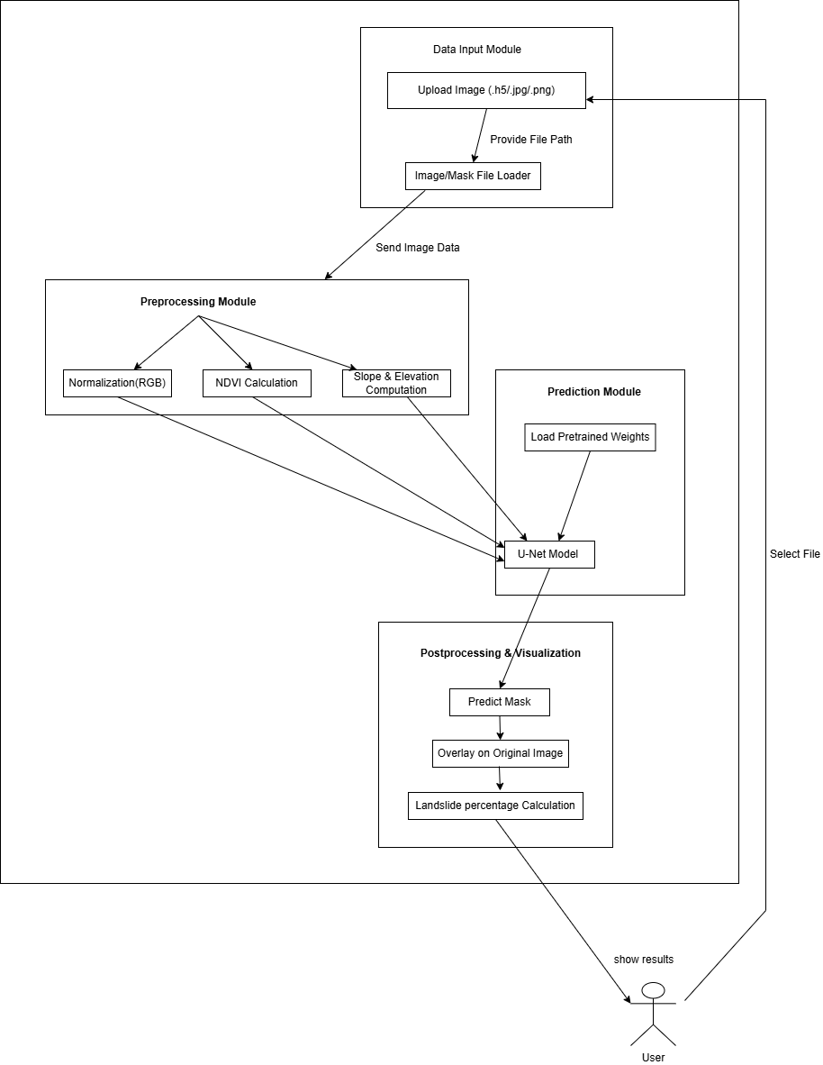

Figure 1 Block Diagram
The system is designed for complete automation—from data loading to preprocessing, model training, evaluation, and prediction—ensuring minimal human intervention. By integrating visualization outputs such as heatmaps, overlay masks, and segmented regions, the model helps analysts clearly understand the landslide-affected zones. Additionally, the system can be deployed as a standalone prediction tool or integrated into a web interface to allow authorities, researchers, or disaster management teams to upload new satellite images and instantly receive landslide predictions. This greatly reduces the time required for assessment and supports more informed decision-making during emergencies. The modular design also makes it scalable for future expansion, such as adding multi-temporal analysis or integrating drone imagery.

2.3 Feasibility Study
A feasibility study ensures that the proposed landslide detection system is realistic, achievable, and beneficial. The project has been evaluated across technical, economic, and operational feasibility dimensions.
1. Technical Feasibility
The system is technically feasible because all required tools and technologies—such as Python, TensorFlow, Keras, NumPy, OpenCV, and h5py—are readily available and widely supported. The UNet architecture is proven to deliver high performance for segmentation problems, making it suitable for landslide detection. Satellite image datasets in HDF5 format can be efficiently processed, and GPU acceleration significantly reduces training time. Since the system uses modular components (dataset loader, preprocessing, UNet model, training pipeline), it is easy to build, maintain, and scale. The availability of high-resolution satellite images and open-source scientific libraries further strengthens technical feasibility.
2. Economic Feasibility
The project is economically feasible because all software tools used in the system are free and open-source, eliminating licensing costs. The only potential cost is hardware, but the system can run even on low-budget machines with CPU, although GPU may speed up training. For deployment, simple computer hardware and a low-cost web server are sufficient. As compared to expensive commercial GIS tools or manual field surveys, this automated solution saves both time and resources for organizations.
3. Operational Feasibility
The system is user-friendly and requires minimal technical expertise to operate. Once the model is trained, the user only needs to upload a satellite image and view the output mask. The intuitive visualization helps stakeholders easily understand results. The model’s automated workflow ensures consistent, reliable output, reducing dependency on manual expertise. In disaster management scenarios, such rapid and accurate predictions can significantly support rescue operations and planning. Additionally, the system can be integrated with existing monitoring platforms, making operational use seamless.

Chapter 3 Project Scope and Requirement Analysis
3.1 Project Scope
The scope of this project encompasses the development of an automated landslide detection system capable of analyzing satellite imagery and generating pixel-level segmentation maps that identify potential landslide regions. The system is built using a deep learning architecture, specifically a U-Net convolutional neural network, designed to work with both RGB and multispectral datasets. The project includes building a preprocessing pipeline for image normalization, NDVI computation, slope/elevation extraction, and resizing to the model-compatible resolution. The model is trained on annotated ground-truth masks to learn spatial patterns that differentiate landslide-prone areas from stable terrain. Additionally, the scope extends to implementing an inference application using Streamlit that allows users to upload images (JPEG/PNG/H5) and instantly view the predicted landslide mask, overlay visualization, and percentage coverage. The project focuses on creating a complete end-to-end workflow—from dataset preparation, model training, and evaluation to building a user-friendly interface—thus offering both a research-level solution and a practical tool for environmental monitoring agencies, researchers, and disaster-response teams.

3.2 Requirement Gathering

Requirement gathering involves identifying the necessary features and constraints needed to develop an efficient and user-friendly landslide detection system. This phase ensures that the project aligns with user expectations, technical feasibility, and the objectives defined during the planning stage.
- Functional Requirements
- The system should accept satellite images in multiple formats, including .h5, .jpg, and .png.
- Preprocessing must normalize images, resize them to 128x128, compute NDVI, slope, and elevation channels, and handle missing or NaN values.
- The deep learning module must load a trained U-Net model for segmentation.
- The system must generate pixel-level masks to highlight potential landslide areas.
- The application should provide visual overlays of predictions on the input images.
- The system must calculate the percentage of land predicted to be affected by landslides.
- Users must be able to upload images through a web interface (Streamlit) and view predictions instantly.
- The system should allow downloading the predicted mask or overlay image for further analysis.
2. Non-Functional Requirements
- Performance: Prediction time per image should be minimal, preferably under 3 seconds on GPU-enabled systems.
- Accuracy: The model should achieve high segmentation accuracy with minimal false positives or negatives.
- Reliability: The system should be robust to different satellite image qualities and formats.
- Usability: The interface should be intuitive for researchers, disaster management personnel, and non-technical users.
- Scalability: The system should handle batch predictions and different image sizes with proper preprocessing.
- Maintainability: Code should be modular to allow future updates or integration with other systems.

3.3 Requirement Analysis

System Requirements
1. Hardware Requirements
- GPU (NVIDIA recommended, e.g., RTX series) for training deep learning models.
- CPU: Multi-core processor for data preprocessing and model inference.
- RAM: Minimum 8GB (16GB recommended for training with larger datasets).
- Storage: Minimum 10GB free space to store datasets, trained models, and prediction outputs.
- Monitor or display capable of visualizing image overlays clearly.
2. Software Requirements
- Operating System: Windows 10/11 or Linux (Ubuntu recommended).
- Programming Language: Python 3.8 or higher.
- Libraries and Tools:
  - TensorFlow / Keras (for U-Net deep learning model)
  - OpenCV, NumPy, h5py (for preprocessing and handling image/H5 files)
  - Matplotlib/Seaborn (for visualizations during training and validation)
  - Streamlit (for web-based user interface)
- Optional Tools: Jupyter Notebook for training visualization and debugging.
3.4 Software Requirement Specification (SRS)
The Software Requirement Specification (SRS) for the Landslide Detection System defines the key functional and non-functional requirements. The system allows users to upload satellite images in formats like .h5, .jpg, or .png and preprocesses them to create a six-channel input for a U-Net deep learning model. The model performs segmentation to detect landslide-prone areas and generates visual masks and overlay images, along with a percentage estimate of affected land. Non-functional requirements focus on usability, fast prediction times, accuracy, and scalability. The system is designed to be robust and user-friendly, ensuring reliable detection while being maintainable and extensible for future enhancements.

Chapter 4 System Analysis and Design
4.1 System Modules
The Landslide Detection System consists of the following main modules:
- Data Input Module
  - Allows the user to upload satellite images or .h5 files.
  - Preprocesses the image into six channels (RGB, NDVI, Slope, Elevation).
- Preprocessing Module
  - Handles normalization and missing data.
  - Computes NDVI and maps other environmental features for the model input.
- Prediction Module
  - U-Net model performs segmentation of landslide-prone areas.
  - Generates masks and overlays for visualization.
- Result Visualization Module
  - Displays input image, predicted mask, overlay, and landslide percentage.
  - Provides real-time feedback for decision-making.
- Model Management Module
  - Loads trained model weights.
  - Monitors model performance and allows future retraining.

4.2 System Modeling & Design
Use Case Diagram
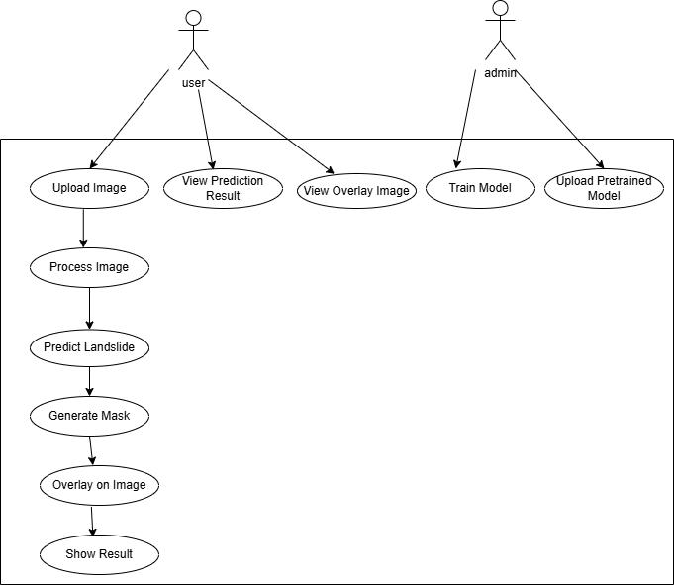
Figure 2 Use Case Diagram
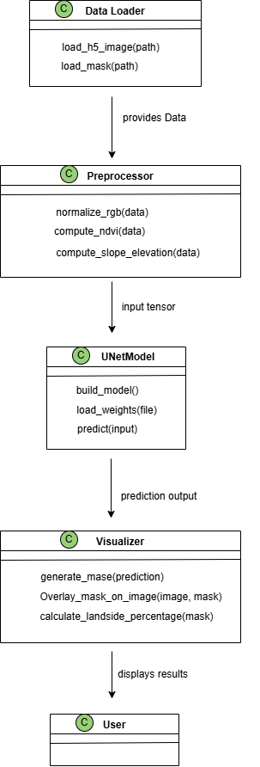
Figure 3 Class Diagram

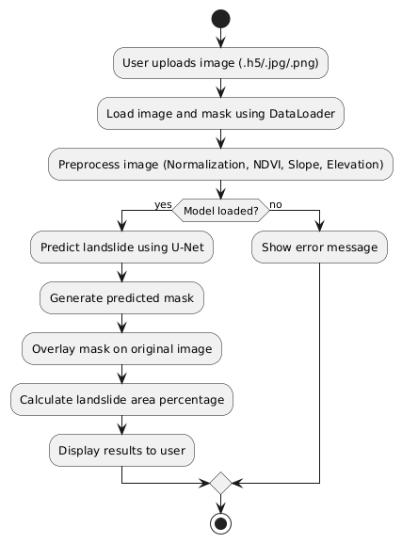
Figure 4 Activity Diagram
4.3 Algorithms
The project utilizes a U-Net based convolutional neural network (CNN) algorithm for landslide detection from satellite and terrain images stored in HDF5 format. The algorithm first preprocesses the input data, including normalization of RGB bands, NDVI calculation, slope, and elevation mapping to form a six-channel input. The U-Net model then extracts hierarchical features through an encoder-decoder architecture with skip connections, enabling precise pixel-wise segmentation of landslide-prone areas. The network is trained using a binary cross-entropy loss function with metrics like F1-score, precision, and recall to ensure robust performance. Finally, the predicted mask is overlaid on the original image to visualize potential landslide regions.
Algorithm: Landslide Detection
Input: Satellite image file (.h5/.jpg/.png)
Output: Predicted landslide mask, overlay, landslide area percentage
1. Load the input image.
2. If .h5 file, extract data and handle NaN values.
3. Preprocess image:
a. Normalize RGB channels.
b. Compute NDVI = (NIR - RED) / (NIR + RED)
c. Normalize Slope and Elevation channels.
4. Prepare six-channel input tensor for U-Net.
5. Load trained U-Net model with weights.
6. Predict landslide mask: mask = model.predict(input)
7. Threshold prediction to binary mask (0/1)
8. Overlay mask on original image.
9. Calculate landslide area percentage = sum(mask) / (IMG_H*IMG_W) * 100
10. Display input image, mask, overlay, and landslide percentage.

4.4 Mathematical Formulation
- NDVI Calculation
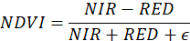
where is a small value to avoid division by zero.

- Binary Mask Thresholding
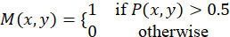
where is the predicted probability at pixel .

- Landslide Area Percentage
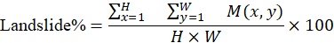

Chapter 5 Project Plan & Schedule
Project Planning
The project planning outlines the step-by-step development workflow for building a The project development is divided into the following phases to ensure systematic progress and timely completion:
Phase 1: Requirement Analysis
- Gather and analyze functional and non-functional requirements.
- Study existing systems for landslide detection and identify gaps.
- Define project scope, objectives, and deliverables.
Phase 2: Dataset Collection and Preprocessing
- Collect satellite and terrain data in HDF5 format.
- Preprocess images and masks by normalizing, calculating NDVI, slope, and elevation.
- Split dataset into training and validation sets.
Phase 3: Model Design and Implementation
- Design the U-Net architecture for landslide detection.
- Implement data loaders, preprocessing pipelines, and training scripts in Python using TensorFlow/Keras.
- Integrate metrics like F1-score, precision, and recall for evaluation.
Phase 4: Model Training and Evaluation
- Train the model on GPU-enabled hardware.
- Use callbacks such as ModelCheckpoint to save the best model.
- Evaluate model performance on the validation dataset and visualize predictions.
Phase 5: Deployment and User Interface
- Develop an interactive Streamlit application for end-users.
- Enable users to upload images or HDF5 files to generate landslide predictions.
- Overlay predicted masks on input images for visualization.

Project Resources
Project resources include the necessary hardware, software, datasets, human expertise, and tools needed for the project.

1. Hardware Resources
- Laptop/PC with minimum specifications:
  - Intel i5/i7 processor or equivalent
  - Minimum 8–16 GB RAM
  - 500 GB storage
- CPU: Multi-core processor
- Storage: Minimum 500 GB disk space

2. Software Resources
- Programming Language: Python
- Frameworks & Libraries:
  - TensorFlow / Keras or PyTorch
  - OpenCV
  - NumPy, Pandas, Matplotlib
  - Scikit-learn
  - Streamlit
- Tools:
  - Anaconda
  - VS Code / PyCharm

3. Dataset Resources
- Landslide4Sense landslide detectionDataset

Project Schedule

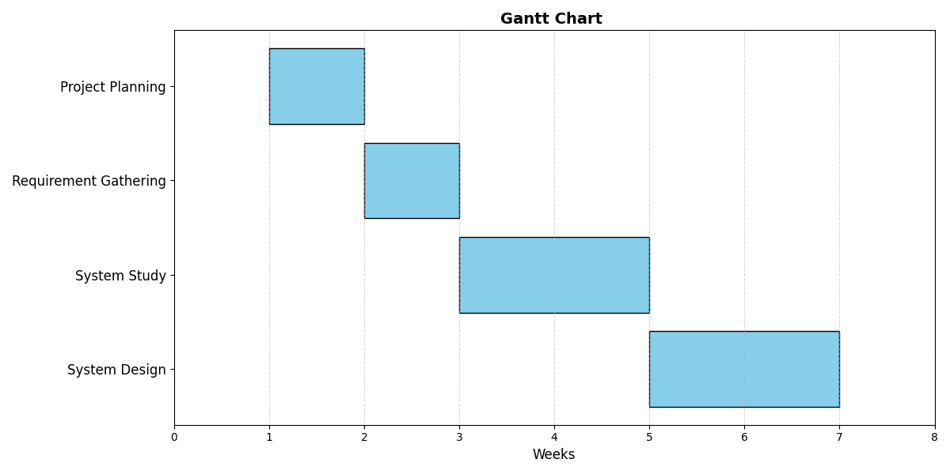
Figure 5 Gantt chart
The Gantt chart visually represents The project is planned over a period of nine weeks, beginning with project planning and requirement gathering, where objectives, scope, resources, and datasets like Landslide4Sense are identified. The next phase focuses on data preprocessing, including cleaning, normalization, and computation of NDVI, slope, and elevation to prepare input for training. In the model design phase, a U-Net architecture is implemented with appropriate loss functions and evaluation metrics. This is followed by data pipeline implementation, where TensorFlow datasets are created with batching, shuffling, and prefetching for efficient training. The training phase involves optimizing the model over multiple epochs while monitoring validation metrics and saving the best model. Subsequently, model validation and tuning are performed to improve performance through hyperparameter adjustment. In the prediction and visualization phase, landslide maps are generated and compared with ground truth for analysis. Finally, documentation, final testing, and presentation are completed, summarizing results and preparing the model for deployment or demonstration.

Chapter 5 Risk Management & Analysis
Risk Management
In any machine learning or deep learning project like the landslide detection system, managing risks is essential to ensure smooth development and reliable results. Risk Management involves identifying potential issues that could affect project success, such as insufficient or noisy data, hardware limitations, software compatibility issues, and unexpected model performance problems. By anticipating these risks, the team can implement preventive measures, such as data augmentation, using compatible hardware and software environments, and performing intermediate testing to monitor model accuracy. Regular team discussions and contingency planning also form part of risk management to handle unexpected challenges efficiently.
Risk Analysis
Risk Analysis assesses the likelihood and impact of each identified risk. For example, limited GPU memory could slow down model training significantly, while poor dataset quality could reduce prediction accuracy. Each risk is analyzed based on its severity and probability, and mitigation strategies are planned accordingly. Regular monitoring, validation of intermediate results, and creating backup datasets are key approaches to reduce risks. Additionally, documenting all risk scenarios and updating the risk management plan throughout the project lifecycle ensures that the team is always prepared for potential issues.

References
- O. Ghorbanzadeh, Y. Xu, P. Ghamisi, M. Kopp, D. Kreil, “Landslide4Sense: Reference Benchmark Data and Deep Learning Models for Landslide Detection,” arXiv preprint arXiv:2206.00515, 2022.
- Ş. Ergen, B. Ergen, “LandslideSegNet: An Effective Deep Learning Network for Landslide Segmentation Using Remote Sensing Imagery,” Earth Science Informatics, vol. 17, pp. 3963–3977, 2024.
- C. Le, L. Pham, J. Lampert, M. Schlögl, A. Schindler, “Landslide Detection and Segmentation Using Remote Sensing Images and Deep Neural Network,” arXiv preprint arXiv:2312.16717, 2023.
- Q. Xu, C. Ouyang, T. Jiang, X. Fan, D. Cheng, “DFPENet-geology: A Deep Learning Framework for High Precision Recognition and Segmentation of Co-seismic Landslides,” arXiv preprint arXiv:1908.10907, 2019.
- T.-H. Wen and T.-A. Teo, “Landslide Inventory Mapping from Landsat-8 NDVI Time Series Using Adaptive Landslide Interval Detection,” ISPRS Annals of Photogrammetry, Remote Sensing and Spatial Information Sciences, Vol. V-3-2022, 2022.
- P. Singh, V. Maurya, R. Dwivedi, “Pixel Based Landslide Identification Using Landsat 8 and GEE,” The International Archives of Photogrammetry, Remote Sensing and Spatial Information Sciences, XLIII-B3-2021, 2021.
- S. Surekha, K. Harshitha Reddy, M. R. B. Bhargav, S. Santosh Kumar, “Landslide Detection Using Remote Sensing,” International Journal of Environmental Sciences, vol. 11, no. 22s, 2025.
- Study on improved network: “The research on landslide detection in remote sensing images based on improved DeepLabv3+ method,” PubMed article, 2025.
- “Landslide Detection using Satellite Remote Sensing Imagery,” International Journal of Development Research (IJDR), study using NDVI + slope & texture features, accuracy up to 97%.
- A. Hima Bindu, D. Cheelu, “Machine Learning Algorithms for Landslide Detection and Forecasting using Satellite Imagery,” International Journal of Information Technology & Computer Engineering, vol. 13, no. 2, 2025.
- V. Ratnasri, G. Dhanalakshmi, P. Devi Prasanna, U. Alekhya, T. Bavana, “Landslide Hazard Prediction using Satellite Imagery and DL Approaches,” IJRASET Journal, 2025.
- Study “Automatic Identification of Landslides Based on Deep Learning” — combining deep learning with semantic segmentation over remote sensing images.
- “Landslide detection based on deep learning and remote sensing imagery: A case study in Linzhi City,” Natural Hazards Research, 2025.
- R. Naseer, N. Azeem, S. Khan, “Integrating Artificial Intelligence and Visual Analytics for High-Resolution Landslide Detection using Geospatial Imagery,” Frontiers in Computational Spatial Intelligence, 2024.
- Recent paper on “Landslide Detection and Mapping Using Deep Learning Across Multi-Source Satellite Data and Geographic Regions” (2025) — integrates Sentinel-2 + DEM + slope data with DL models.
- Novel approach: “Landslide Detection in Satellite Images using Inception-U-Net and Attention Module” with LandSlide4Sense dataset.
- Research on using multi-scale feature extraction and attention modules: “AED-Net: Semantic Segmentation Model for Landslide Recognition from Remote Sensing Images.”
- “Landslide Detection in the Himalayas using Machine Learning Algorithms and U-Net,” Landslides Journal, 2022.
- (Survey/Review) Use of remote sensing + NDVI changes over time for landslide inventory mapping — shows value of temporal and spectral analysis.
- A study combining deep learning segmentation models (U-Net, PSPNet, DeepLab, etc.) for landslide detection over multispectral remote sensing data — showing viability of segmentation-based landslide detection.
- Case-studies on DEM + slope + NDVI + multispectral features combined with machine learning / deep learning for landslide prediction in different terrains (e.g. in Linzhi City, Himalayas).
- Benchmark datasets and their importance: Landslide4Sense provides multisource data (optical, DEM, slope) to train segmentation networks.
- Deep neural network methods — use of attention mechanisms, residual layers, multi-band inputs — to improve segmentation of landslide zones from remote sensing.
- Demonstration of NDVI + slope + texture as viable predictors for landslide detection even without time-series data.
- Use of remote sensing satellite data (Landsat 8, Sentinel, DEM) in conjunction with machine learning / deep learning for landslide hazard detection — linking geographic features + spectral data.
- Analysis of landslide detection performance across varied geographic regions using multi-source data and generalizable deep learning models.
- Comparative study of segmentation architectures (encoder-decoder, attention mechanisms, residual blocks) tailored for landslide detection tasks.
- Use of semantic segmentation and deep learning for automatic landslide recognition — demonstrating that DL is more effective than classical image-processing methods in many cases.
- Importance of carefully annotated datasets with elevation, slope and spectral data for accurate landslide boundary segmentation (as provided by Landslide4Sense).
- Recent trends in using hybrid deep learning + remote sensing + topographic data to build scalable, robust landslide detection frameworks for disaster management.

