Microsoft Azure Training
2026
Vaishnavi Kamthe

Assignment 2b

Question
1. Create a Windows virtual machine instance which is available from free tier.
2. Select image as 'Windows Server 2025 Datacenter – x64 Gen2'.
3. Select B1S General Purpose Virtual Machine.
4. Enable RDP.
5. Create a managed disk of the smallest size available.
6. Attach the managed disk to the instance and make it available to use.
7. Connect to VM using RDP.

A Windows virtual machine was created using Azure Portal under the free tier subscription with appropriate configuration settings.
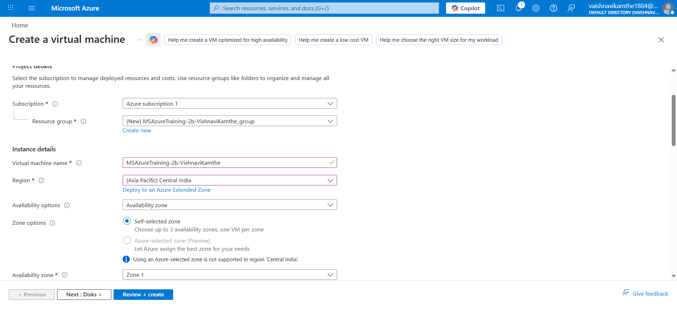
The image selected was Windows Server 2025 Datacenter – x64 Gen2, suitable for enterprise-level applications and testing
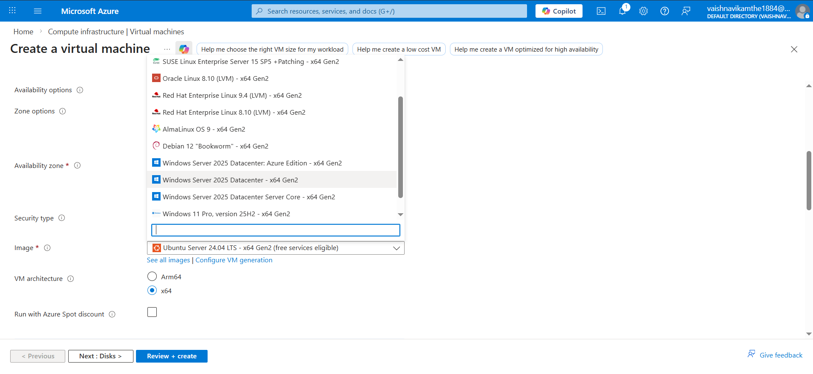
The B1s size was not available due to regional limitations; therefore, the closest available B-series virtual machine was selected to meet the requirements.
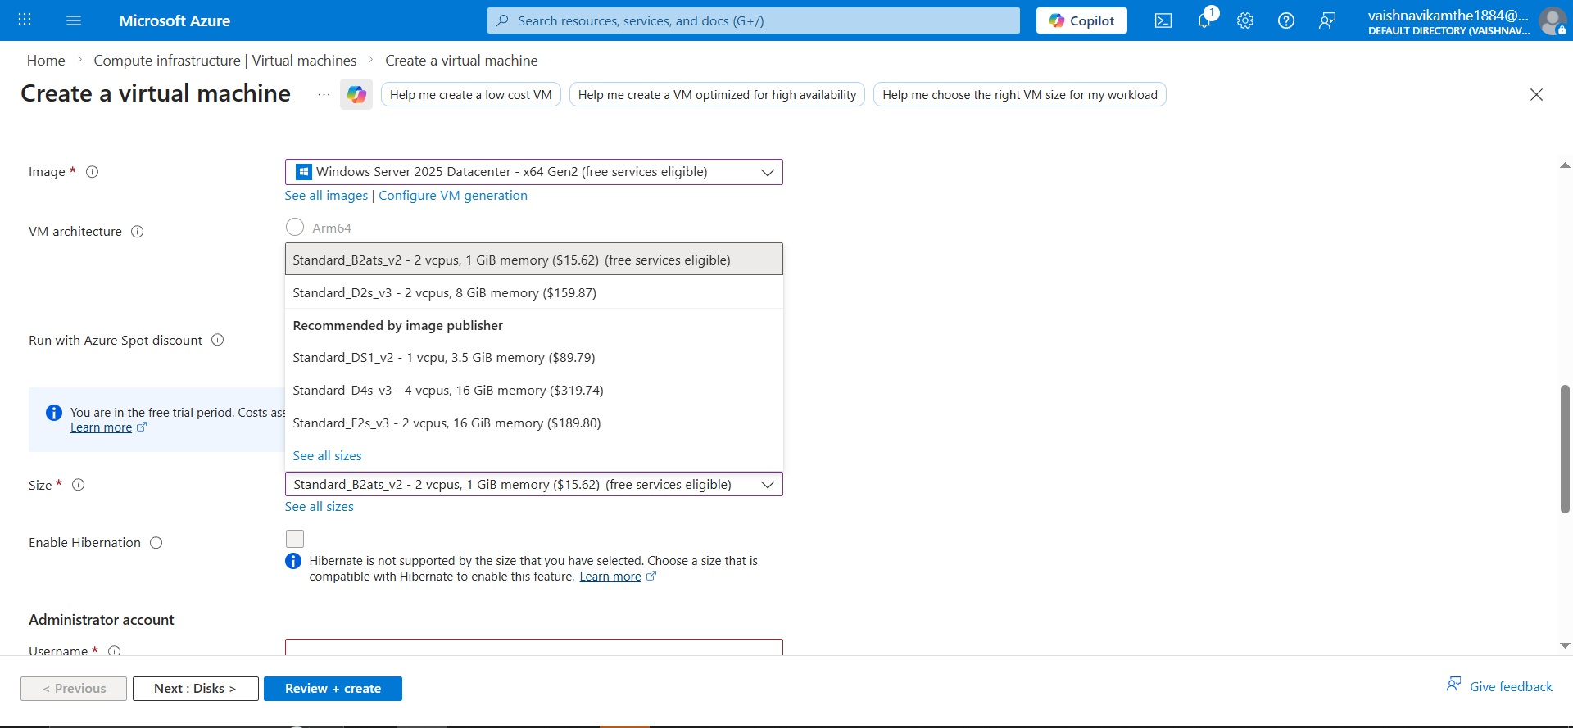
Remote Desktop Protocol (RDP) was enabled to allow secure remote access to the virtual machine.
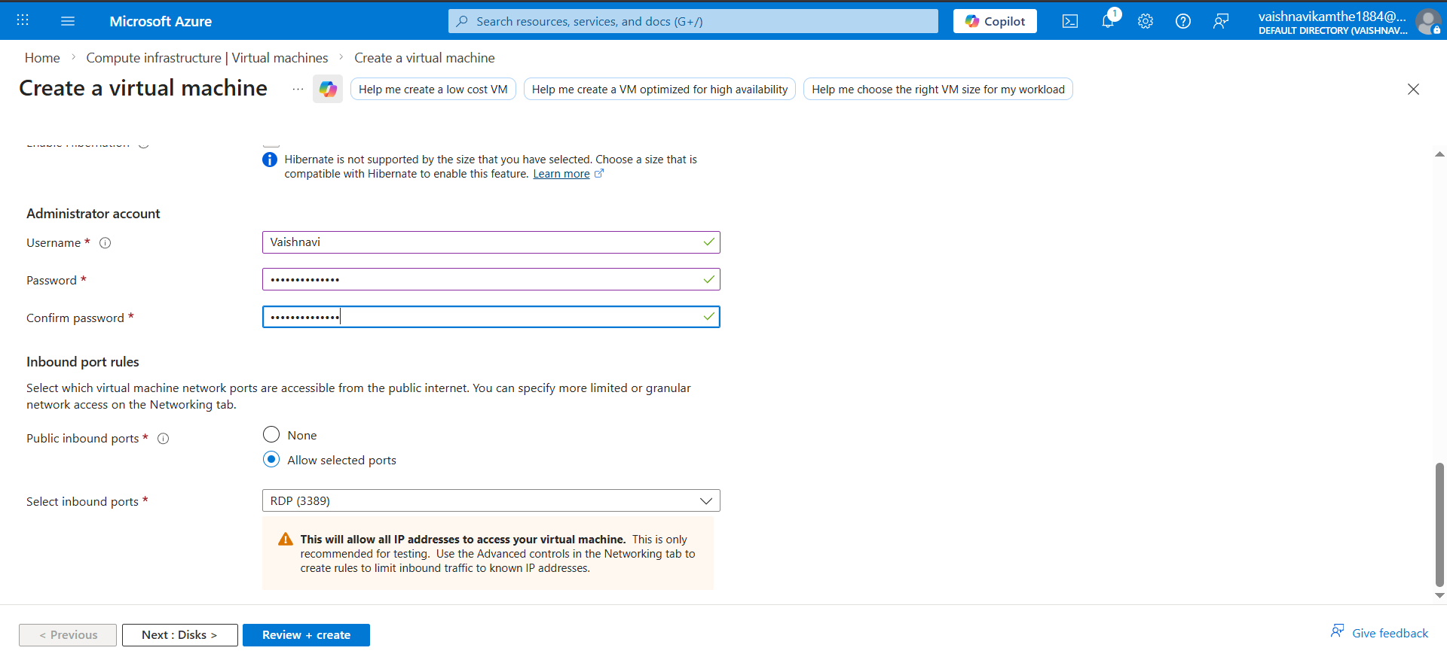
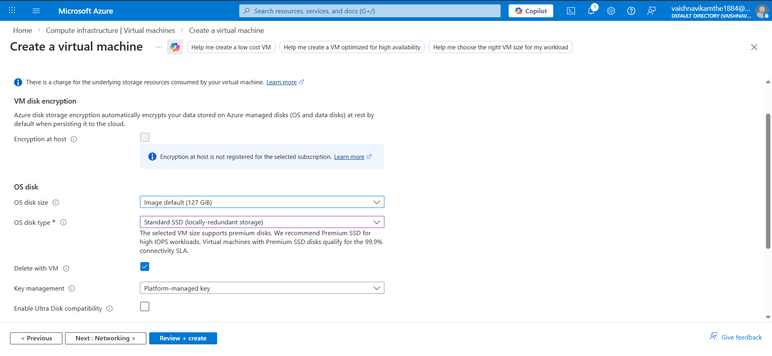
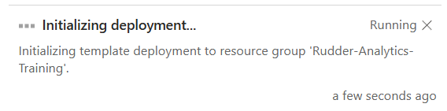
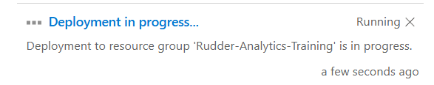
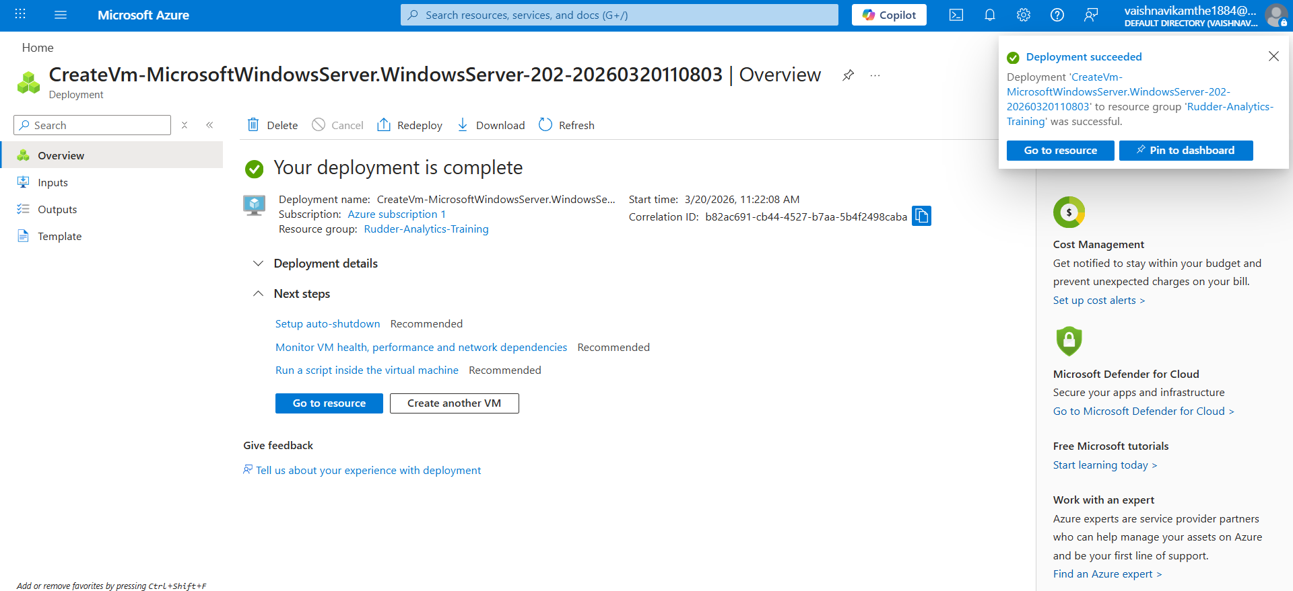
A managed disk of the smallest available size was created to optimize cost and resource usage.The managed disk was successfully attached to the virtual machine and initialized for use.
