Microsoft Azure Training
2026
Vaishnavi Kamthe

Assignment 3b

Question
1. Create a storage account.
A storage account was created in Azure with standard performance and locally redundant storage for cost efficiency.
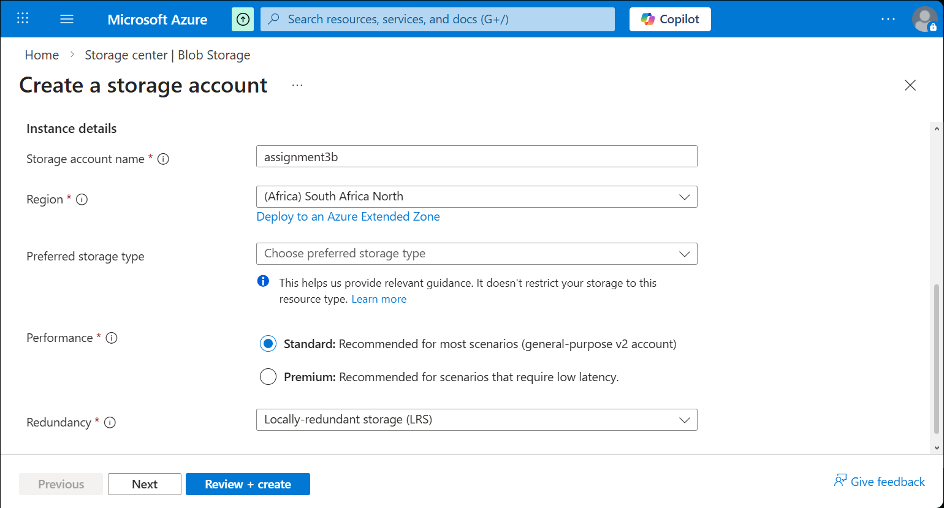
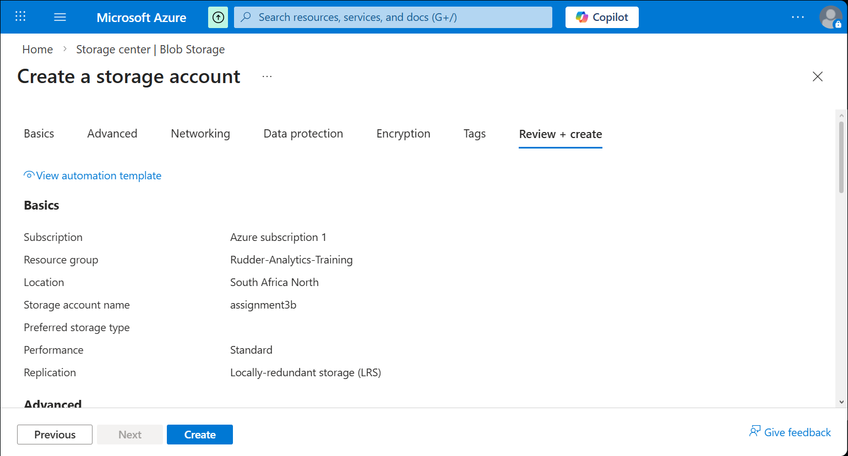
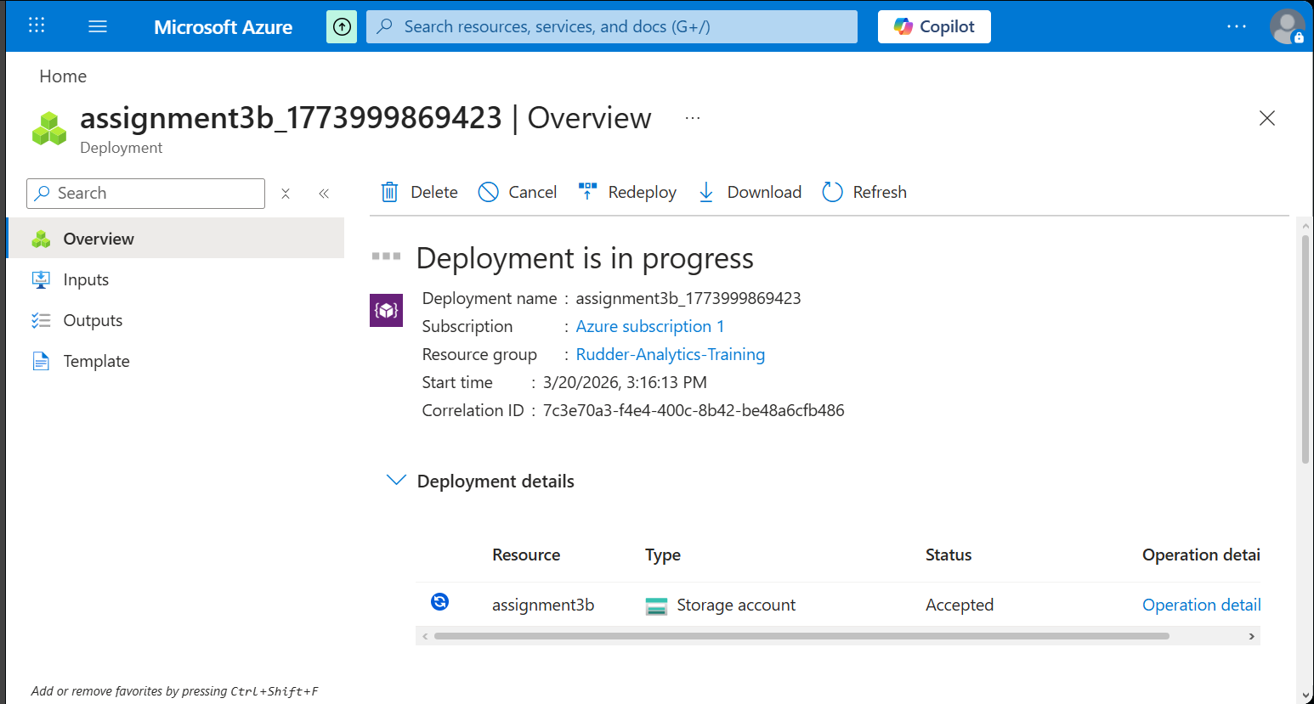
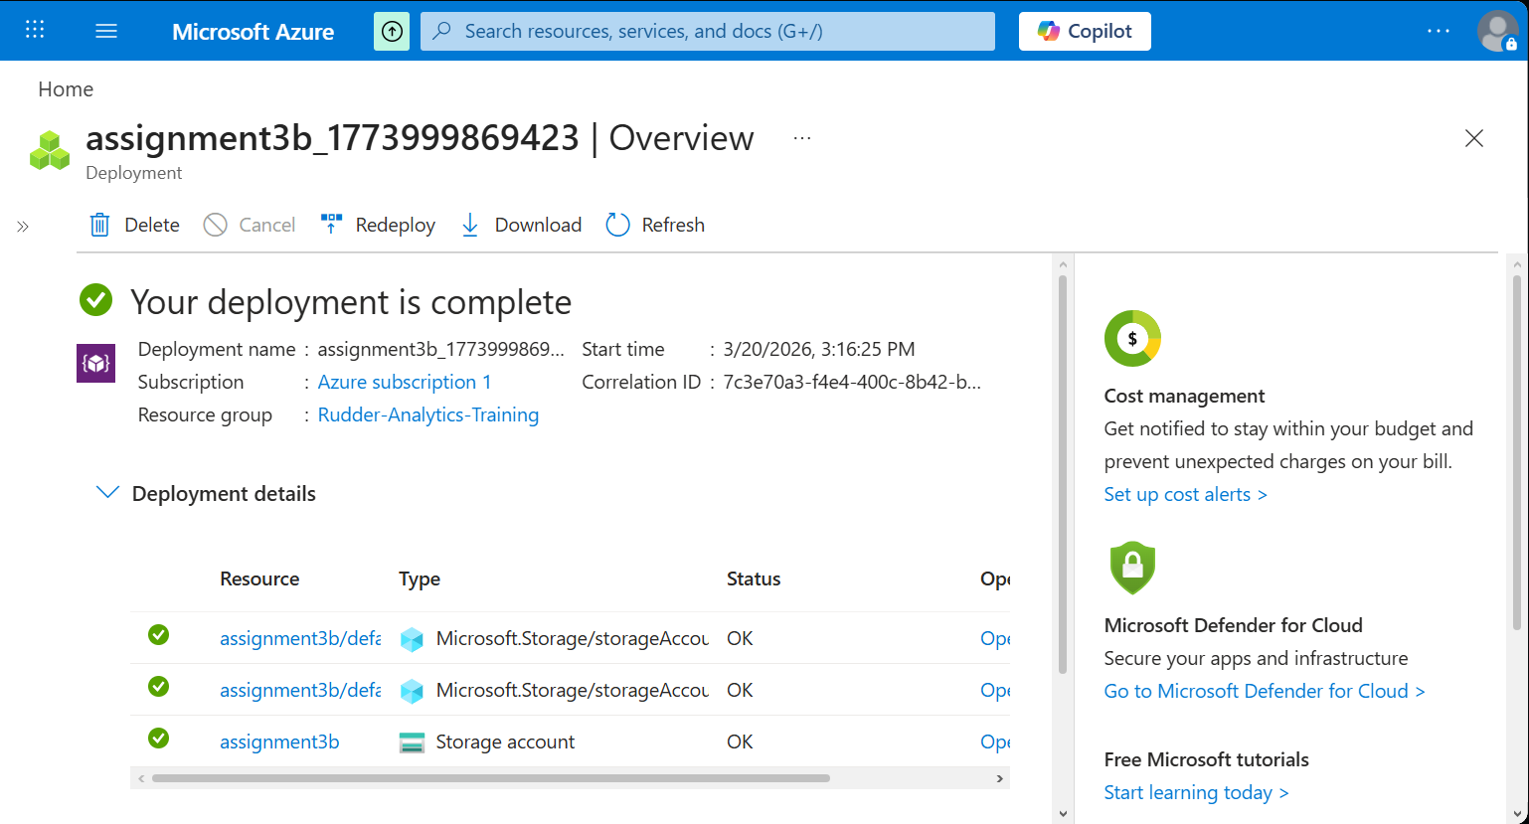
2. Explore various portal features.
Overview:
Displays basic details such as storage account name, region, and service endpoints.
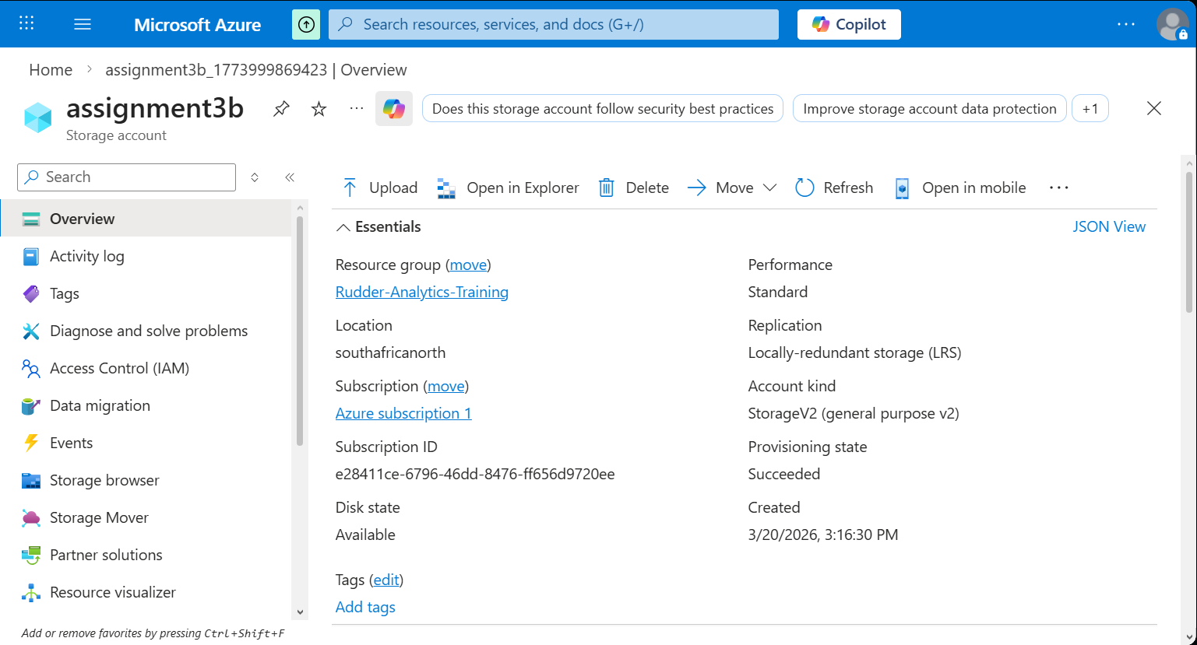
Containers:
Used to store blob data; each container acts as a logical grouping of files.
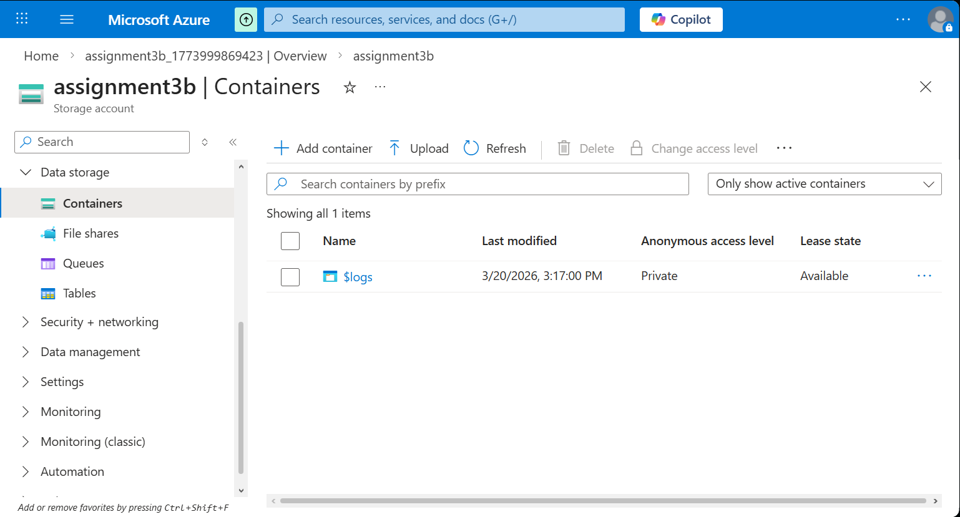
Access Keys:
Provides secure authentication keys to access the storage account.
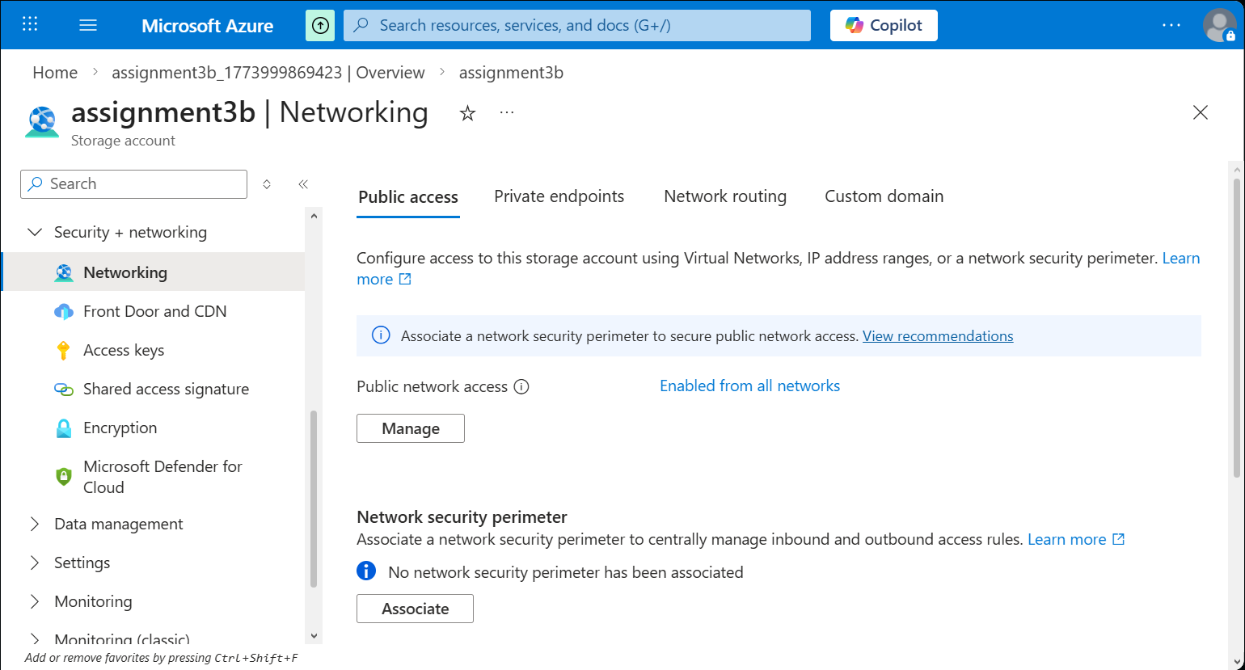
Storage Browser:
Allows uploading, viewing, and managing files directly within the portal.
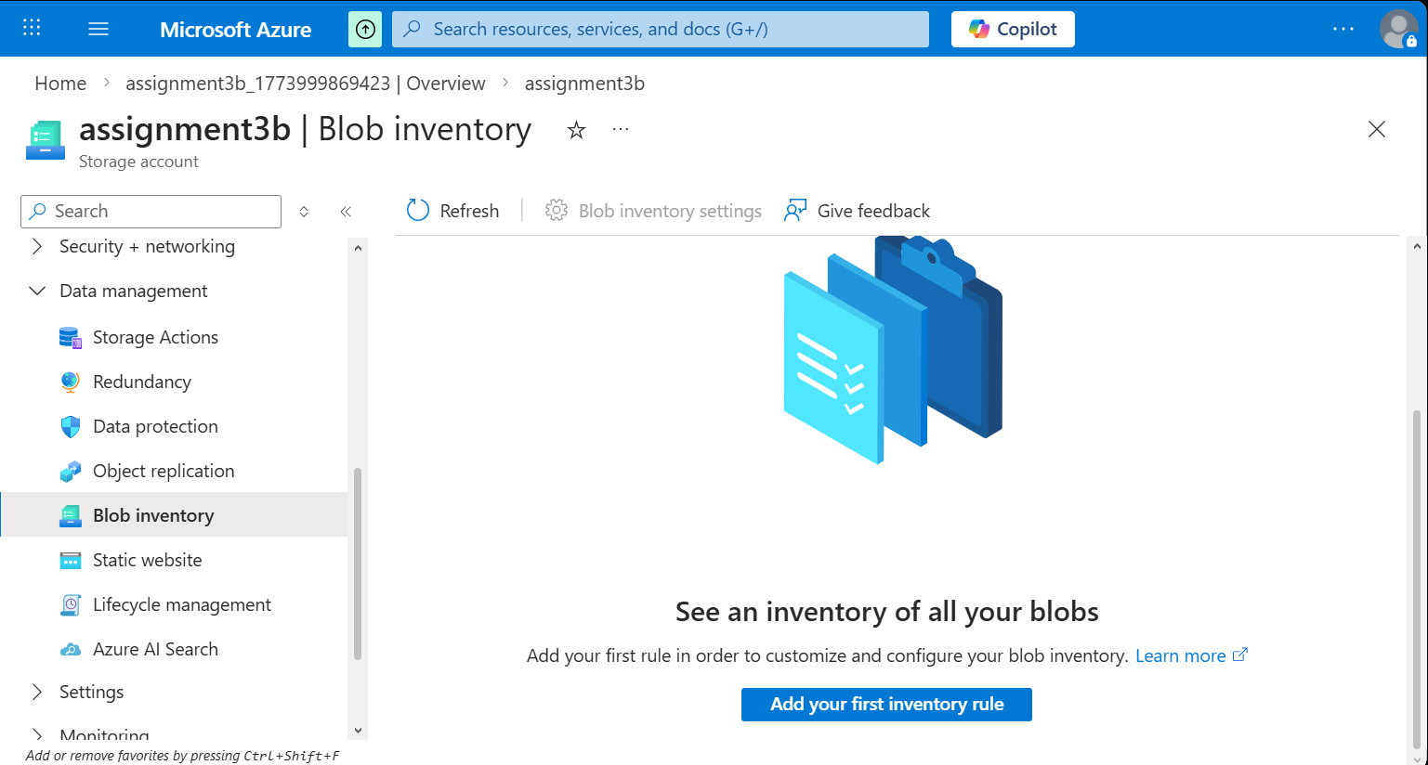
Monitoring:
Helps track usage, performance, and activity of the storage account.
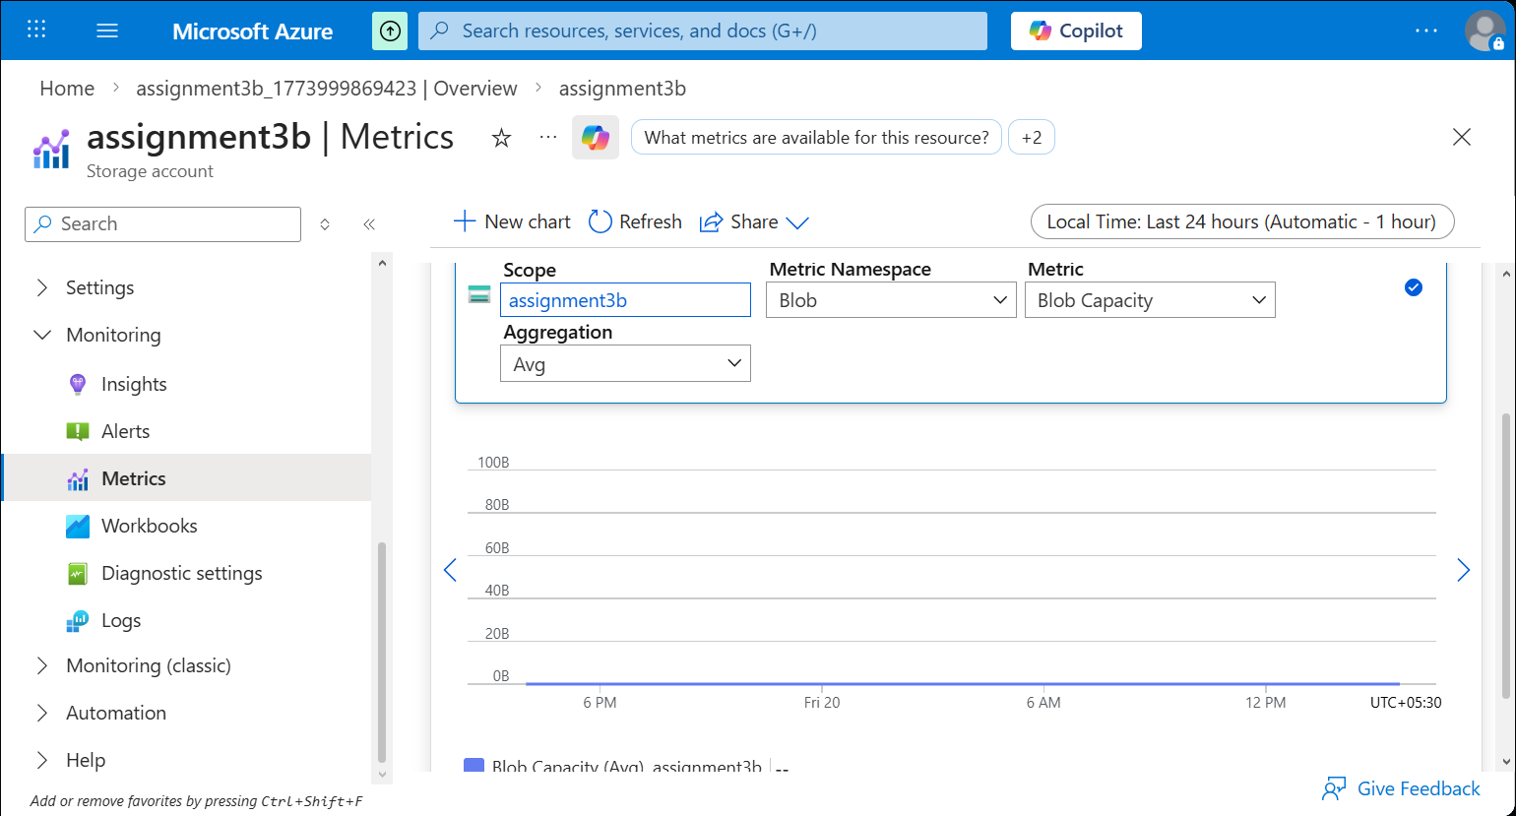
3. Create a blob container and upload following files to it using storage explorer.
Employees
Salaries

A blob container was created, and files named Employees and Salaries were uploaded successfully using the Azure portal.
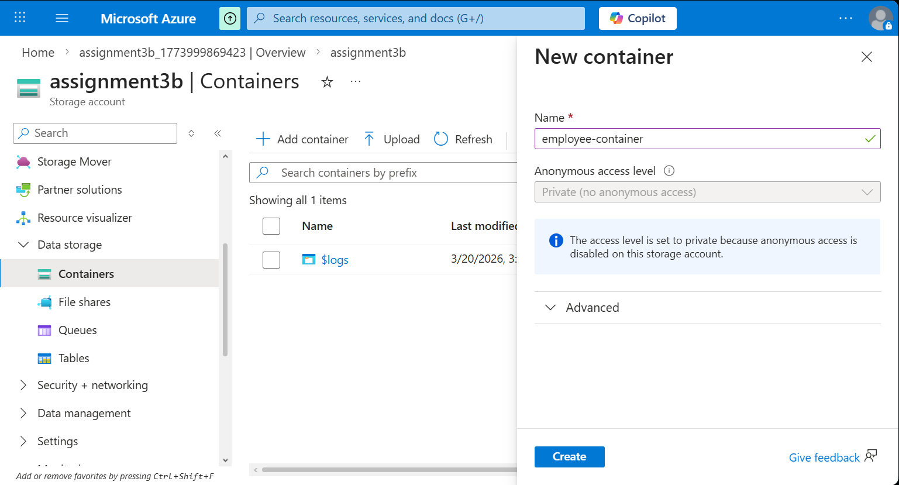
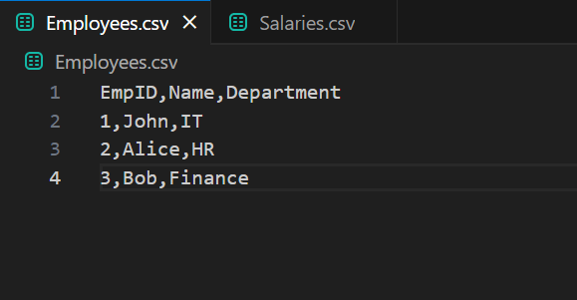
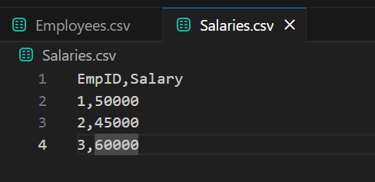
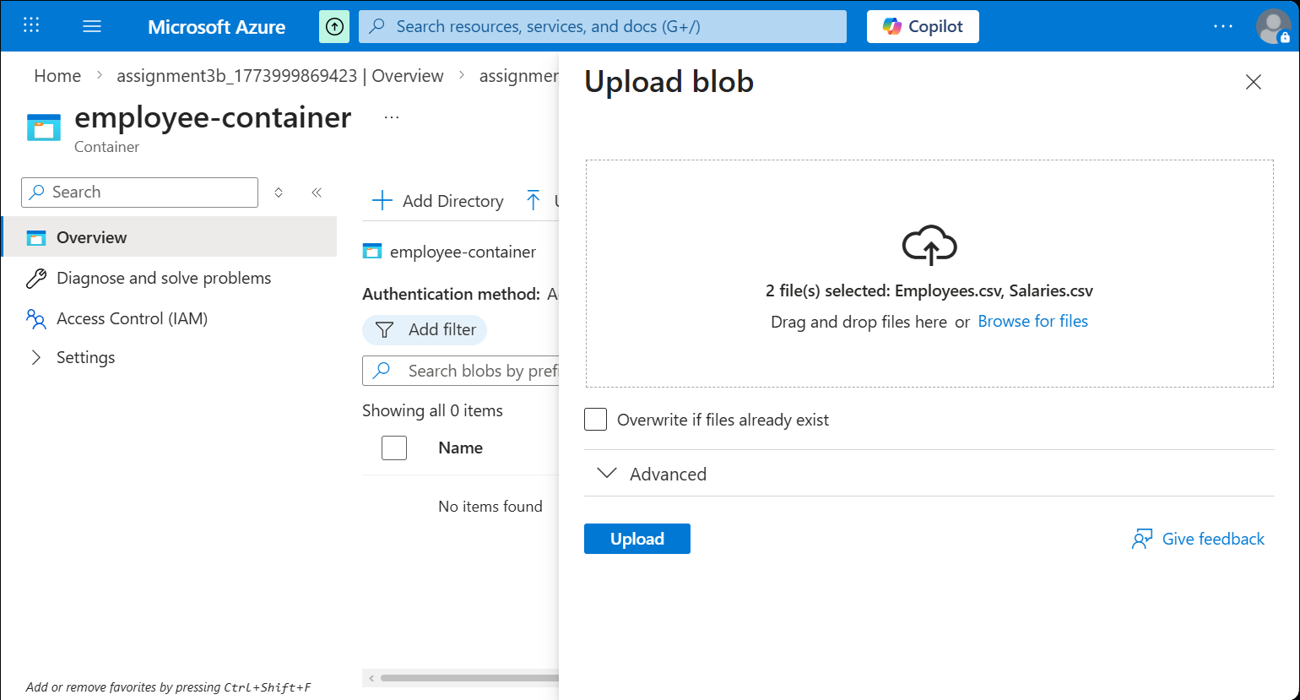
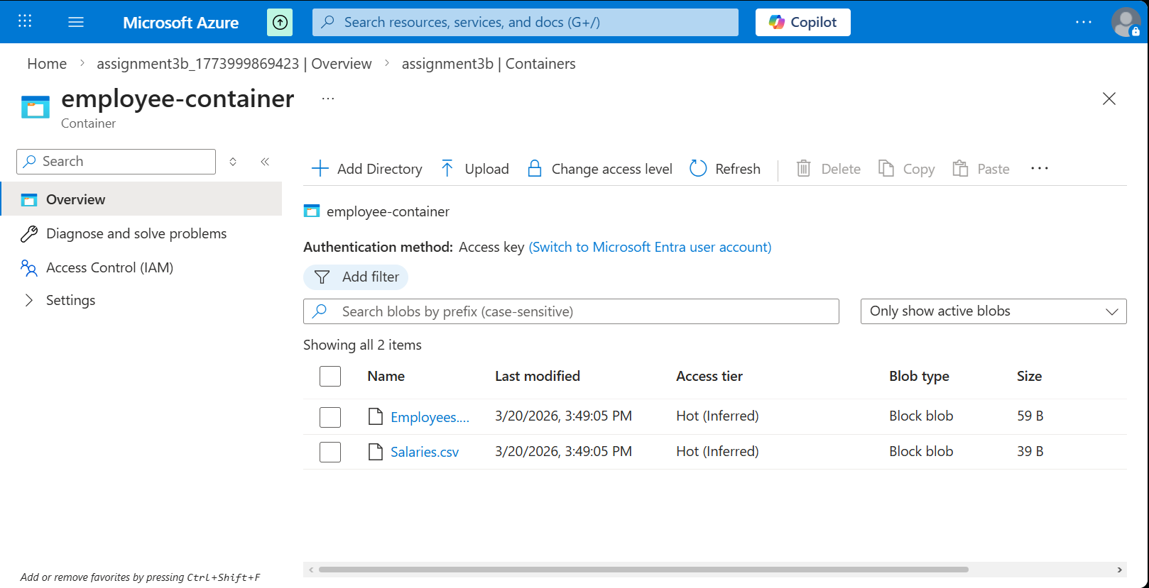
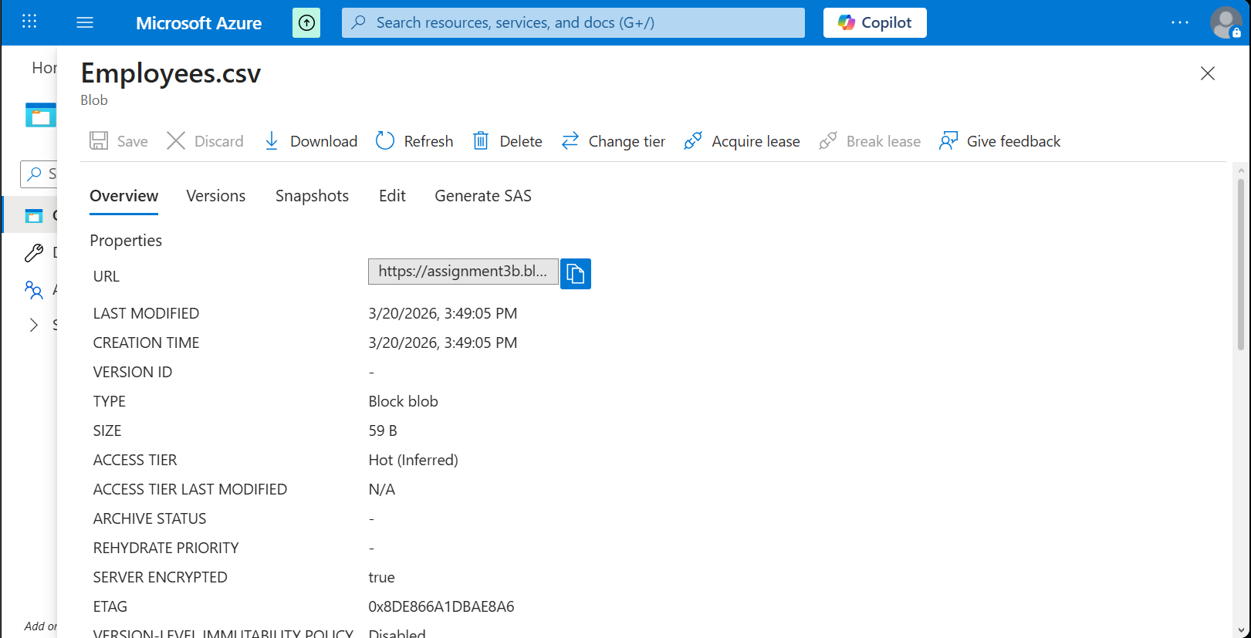

4. Download the desktop version of Azure storage explorer and upload another file to the blob container.
https://azure.microsoft.com/en-in/features/storage-explorer/
Azure Storage Explorer desktop application was installed and used to upload an additional file named Department_Manager to the blob container.
