Name: Vaishnavi Kamthe
Roll no.: 44

Assignment No: 1
#include <iostream>
#include <vector>
#include <queue>
#include <omp.h>
using namespace std;

class Graph {
int V;
vector<vector<int>> adj;
public:
Graph(int V) {
this->V = V;
adj.resize(V);
}
void addEdge(int u, int v) {
adj[u].push_back(v);
adj[v].push_back(u); // undirected graph
}
// Parallel BFS
void parallelBFS(int start) {
vector<bool> visited(V, false);
queue<int> q;
visited[start] = true;
q.push(start);
cout << "\nParallel BFS Traversal: ";
while (!q.empty()) {
int size = q.size();
#pragma omp parallel for
for (int i = 0; i < size; i++) {
int node = -1;
#pragma omp critical
{
if (!q.empty()) {
node = q.front();
q.pop();
cout << node << " ";
}
}
if (node != -1) {
for (int neighbor : adj[node]) {
if (!visited[neighbor]) {
#pragma omp critical
{
if (!visited[neighbor]) {
visited[neighbor] = true;
q.push(neighbor);
}
}
}
}
}
}
}
cout << endl;
}
// Parallel DFS Utility
void parallelDFSUtil(int node, vector<bool> &visited) {
bool alreadyVisited;
#pragma omp critical
{
alreadyVisited = visited[node];
if (!visited[node]) {
visited[node] = true;
cout << node << " ";
}
}
if (alreadyVisited) return;
#pragma omp parallel for
for (int i = 0; i < adj[node].size(); i++) {
int neighbor = adj[node][i];
if (!visited[neighbor]) {
#pragma omp task
parallelDFSUtil(neighbor, visited);
}
}
}
// Parallel DFS
void parallelDFS(int start) {
vector<bool> visited(V, false);
cout << "\nParallel DFS Traversal: ";
#pragma omp parallel
{
#pragma omp single
{
parallelDFSUtil(start, visited);
}
}
cout << endl;
}
};
int main() {
int V, E;
cout << "Enter number of vertices: ";
cin >> V;
Graph g(V);
cout << "Enter number of edges: ";
cin >> E;
cout << "Enter edges (u v):\n";
for (int i = 0; i < E; i++) {
int u, v;
cin >> u >> v;
g.addEdge(u, v);
}
int start;
cout << "Enter starting vertex: ";
cin >> start;
g.parallelBFS(start);
g.parallelDFS(start);
return 0;
}
// 0
// / \
// 1 2
// / \ \
// 3 4 5
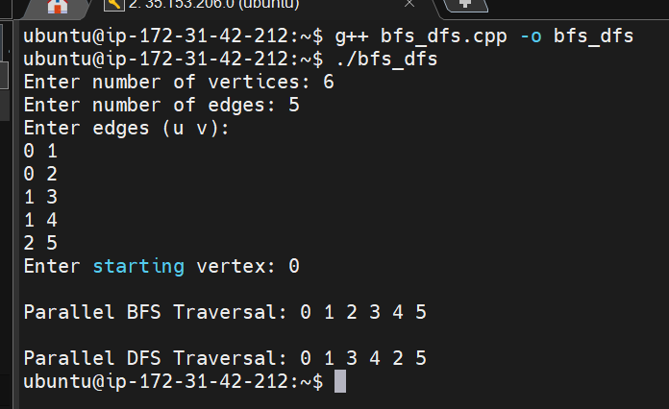

Name: Vaishnavi Kamthe
Roll no.: 44

Assignment No: 2
#include <iostream>
#include <vector>
#include <cstdlib>
#include <ctime>
#include <omp.h>
using namespace std;

// Sequential Bubble Sort

void bubbleSortSeq(vector<int>& arr) {
int n = arr.size();
for (int i = 0; i < n - 1; i++) {
for (int j = 0; j < n - i - 1; j++) {
if (arr[j] > arr[j + 1]) {
swap(arr[j], arr[j + 1]);
}
}
}
}

// Parallel Bubble Sort

void bubbleSortParallel(vector<int>& arr) {
int n = arr.size();

for (int i = 0; i < n; i++) {
// Even phase
#pragma omp parallel for
for (int j = 0; j < n - 1; j += 2) {
if (arr[j] > arr[j + 1]) {
swap(arr[j], arr[j + 1]);
}
}

// Odd phase
#pragma omp parallel for
for (int j = 1; j < n - 1; j += 2) {
if (arr[j] > arr[j + 1]) {
swap(arr[j], arr[j + 1]);
}
}
}
}

// Merge Function

void merge(vector<int>& arr, int l, int m, int r) {
vector<int> left(arr.begin() + l, arr.begin() + m + 1);
vector<int> right(arr.begin() + m + 1, arr.begin() + r + 1);

int i = 0, j = 0, k = l;

while (i < left.size() && j < right.size()) {
if (left[i] <= right[j]) arr[k++] = left[i++];
else arr[k++] = right[j++];
}

while (i < left.size()) arr[k++] = left[i++];
while (j < right.size()) arr[k++] = right[j++];
}

// Sequential Merge Sort

void mergeSortSeq(vector<int>& arr, int l, int r) {
if (l < r) {
int m = (l + r) / 2;
mergeSortSeq(arr, l, m);
mergeSortSeq(arr, m + 1, r);
merge(arr, l, m, r);
}
}

// Parallel Merge Sort

void mergeSortParallel(vector<int>& arr, int l, int r, int depth) {
if (l < r) {
int m = (l + r) / 2;

if (depth <= 0) {
mergeSortSeq(arr, l, m);
mergeSortSeq(arr, m + 1, r);
} else {
#pragma omp parallel sections
{
#pragma omp section
mergeSortParallel(arr, l, m, depth - 1);

#pragma omp section
mergeSortParallel(arr, m + 1, r, depth - 1);
}
}

merge(arr, l, m, r);
}
}

// Utility Functions

void generateRandom(vector<int>& arr) {
for (int& x : arr) {
x = rand() % 100000;
}
}

// Main

int main() {
vector<int> arr(SIZE), temp;

srand(time(0));
generateRandom(arr);

double start, end;

// Bubble Sort Sequential
temp = arr;
start = omp_get_wtime();
bubbleSortSeq(temp);
end = omp_get_wtime();
cout << "Sequential Bubble Sort Time: " << (end - start) << " sec\n";

// Bubble Sort Parallel
temp = arr;
start = omp_get_wtime();
bubbleSortParallel(temp);
end = omp_get_wtime();
cout << "Parallel Bubble Sort Time: " << (end - start) << " sec\n";

// Merge Sort Sequential
temp = arr;
start = omp_get_wtime();
mergeSortSeq(temp, 0, SIZE - 1);
end = omp_get_wtime();
cout << "Sequential Merge Sort Time: " << (end - start) << " sec\n";

// Merge Sort Parallel
temp = arr;
start = omp_get_wtime();
mergeSortParallel(temp, 0, SIZE - 1, 4);
end = omp_get_wtime();
cout << "Parallel Merge Sort Time: " << (end - start) << " sec\n";

return 0;
}
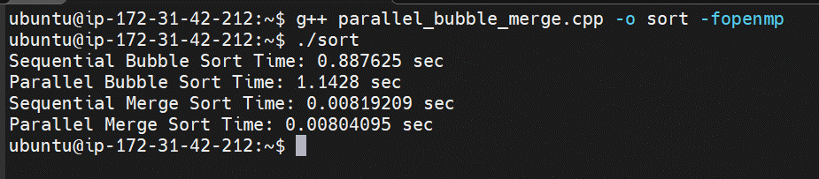

Name: Vaishnavi Kamthe
Roll no.: 44

Assignment No: 3
#include<iostream>
#include<omp.h>

using namespace std;
int minval(int arr[], int n){
int minval = arr[0];
#pragma omp parallel for reduction(min : minval)
for(int i = 0; i < n; i++){
if(arr[i] < minval) minval = arr[i];
}
return minval;
}

int maxval(int arr[], int n){
int maxval = arr[0];
#pragma omp parallel for reduction(max : maxval)
for(int i = 0; i < n; i++){
if(arr[i] > maxval) maxval = arr[i];
}
return maxval;
}

int sum(int arr[], int n){
int sum = 0;
#pragma omp parallel for reduction(+ : sum)
for(int i = 0; i < n; i++){
sum += arr[i];
}
return sum;
}

int average(int arr[], int n){
return (double)sum(arr, n) / n;
}

int main(){
int n = 5;
int arr[] = {1,2,3,4,5};
cout << "The minimum value is: " << minval(arr, n) << '\n';
cout << "The maximum value is: " << maxval(arr, n) << '\n';
cout << "The summation is: " << sum(arr, n) << '\n';
cout << "The average is: " << average(arr, n) << '\n';
return 0;
}
