Cover Sheet for Coursework

Surname (in CAPITALS): LATE
First name (in CAPITALS): VAISHNAVI
Email ID: vl99@student.le.ac.uk

I acknowledge that this is an assessed piece of coursework. I have completed the Academic Integrity training course ADX178 on Blackboard and understand the University’s policy on plagiarism:
https://le.ac.uk/policies/regulations/senate-regulations/senate-regulation-11/academic

I hereby declare that all work submitted is my own and has been created solely by me, except where clearly stated otherwise within the text

Date: 12-01-2026 Signature: VAISHNAVI LATE

Please give a summary of your submission in the table below:

Category: (Web Application )
Your choice of language and framework: JavaScript, Node.js/React.js, MongoDB

Section | Sub-tasks | A: achieved  P: partially implemented  N: not attempt
Task 1  Voter | register | A: achieved
Task 1  Voter | login | A: achieved
Task 1  Voter | voter page | A: achieved
Task 1  Election Commission | login | A: achieved
Task 1  Election Commission | create and manage referendum | A: achieved
Task 1  Election Commission | visualise results | A: achieved
Task 2  REST API | 2.1 | A: achieved
Task 2  REST API | 2.2 | A: achieved
Bonus | - Responsiveness  - My Profile (Update Password).  - Added Forgot Password.  - Help/Support for voters.  - Notifications on Election Commission dashboard for Voter Support Queries.  - Voter engagement (Notify pending voters) from election commission dashboard.  - Notification on Voter Dashboard to caste the vote.  - Landing Page with Live Ongoing Referendums. | A: achieved

Note: The coursework will be assessed based on factors such as complexity, functionality quality, and the overall effort demonstrated.

Please attach at least TWO screenshots below:

Voter dashboard
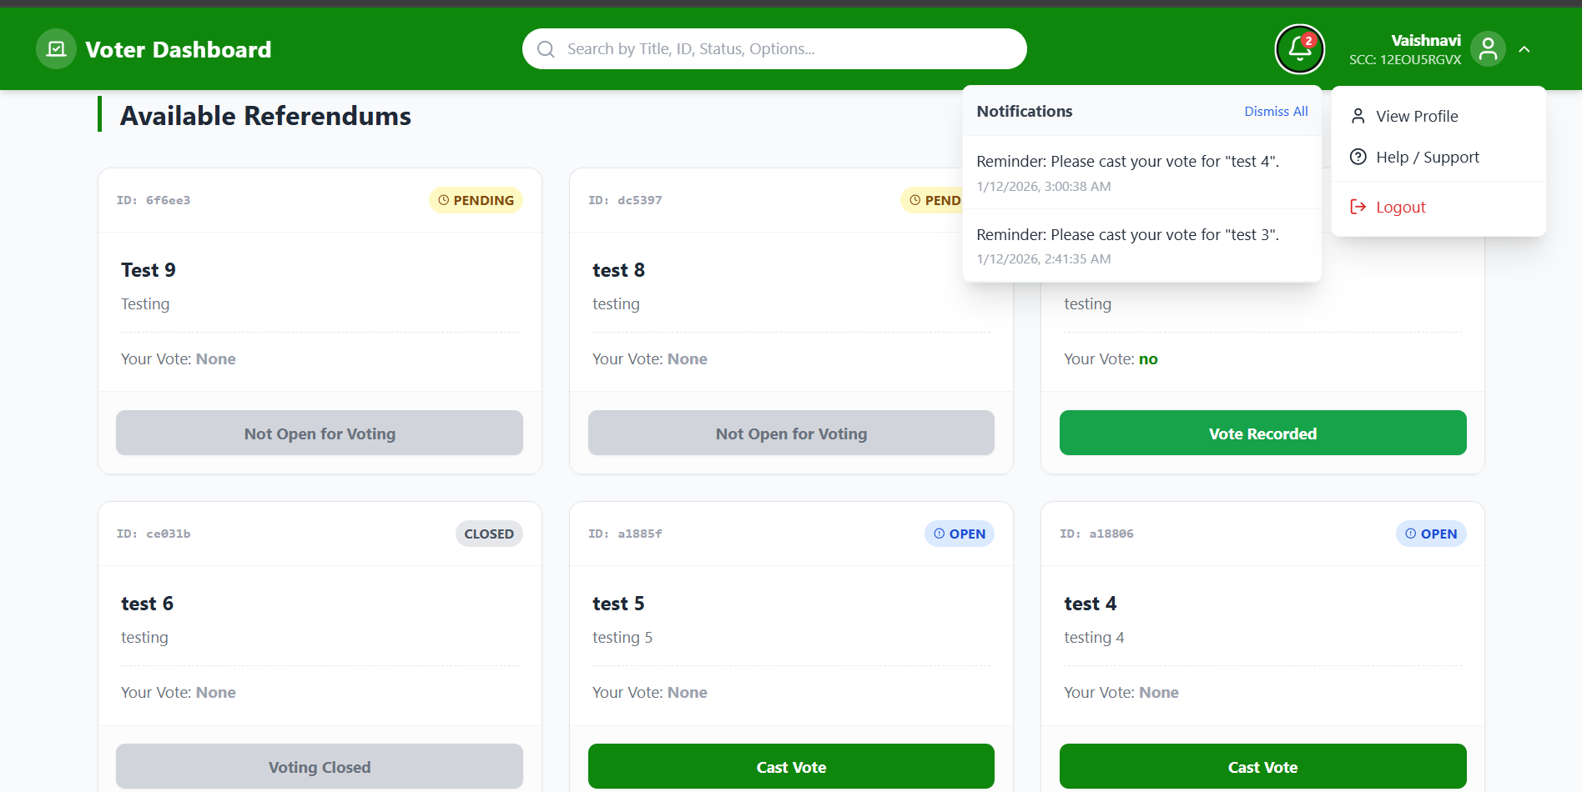

Election Commission dashboard

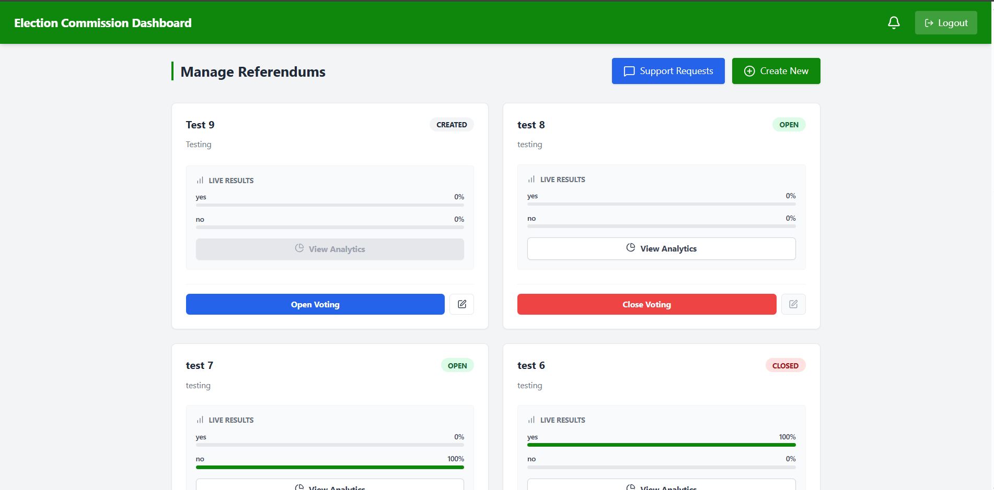

Voter Support Queries
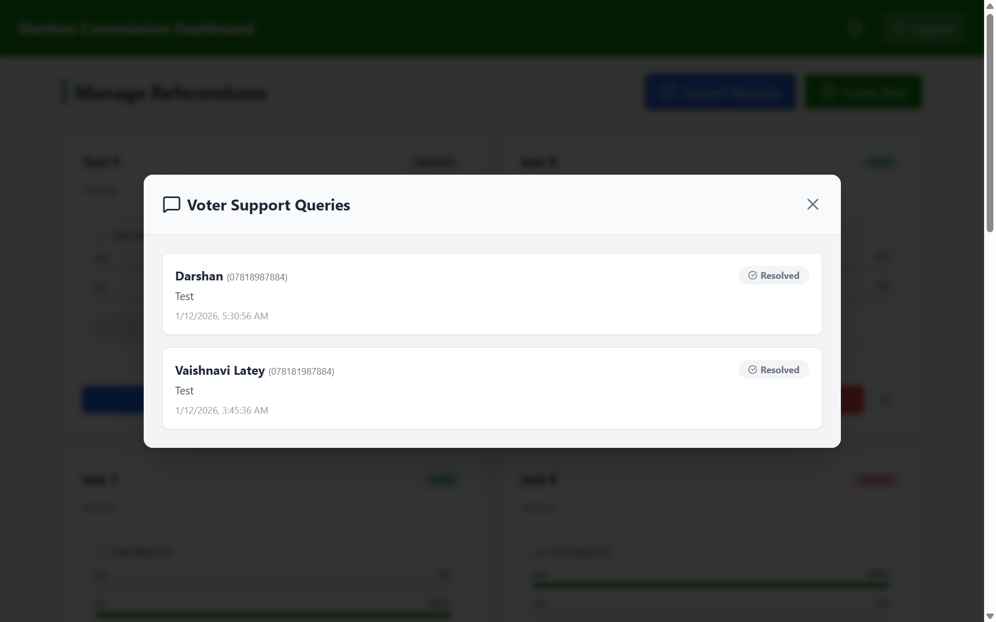

Analytics
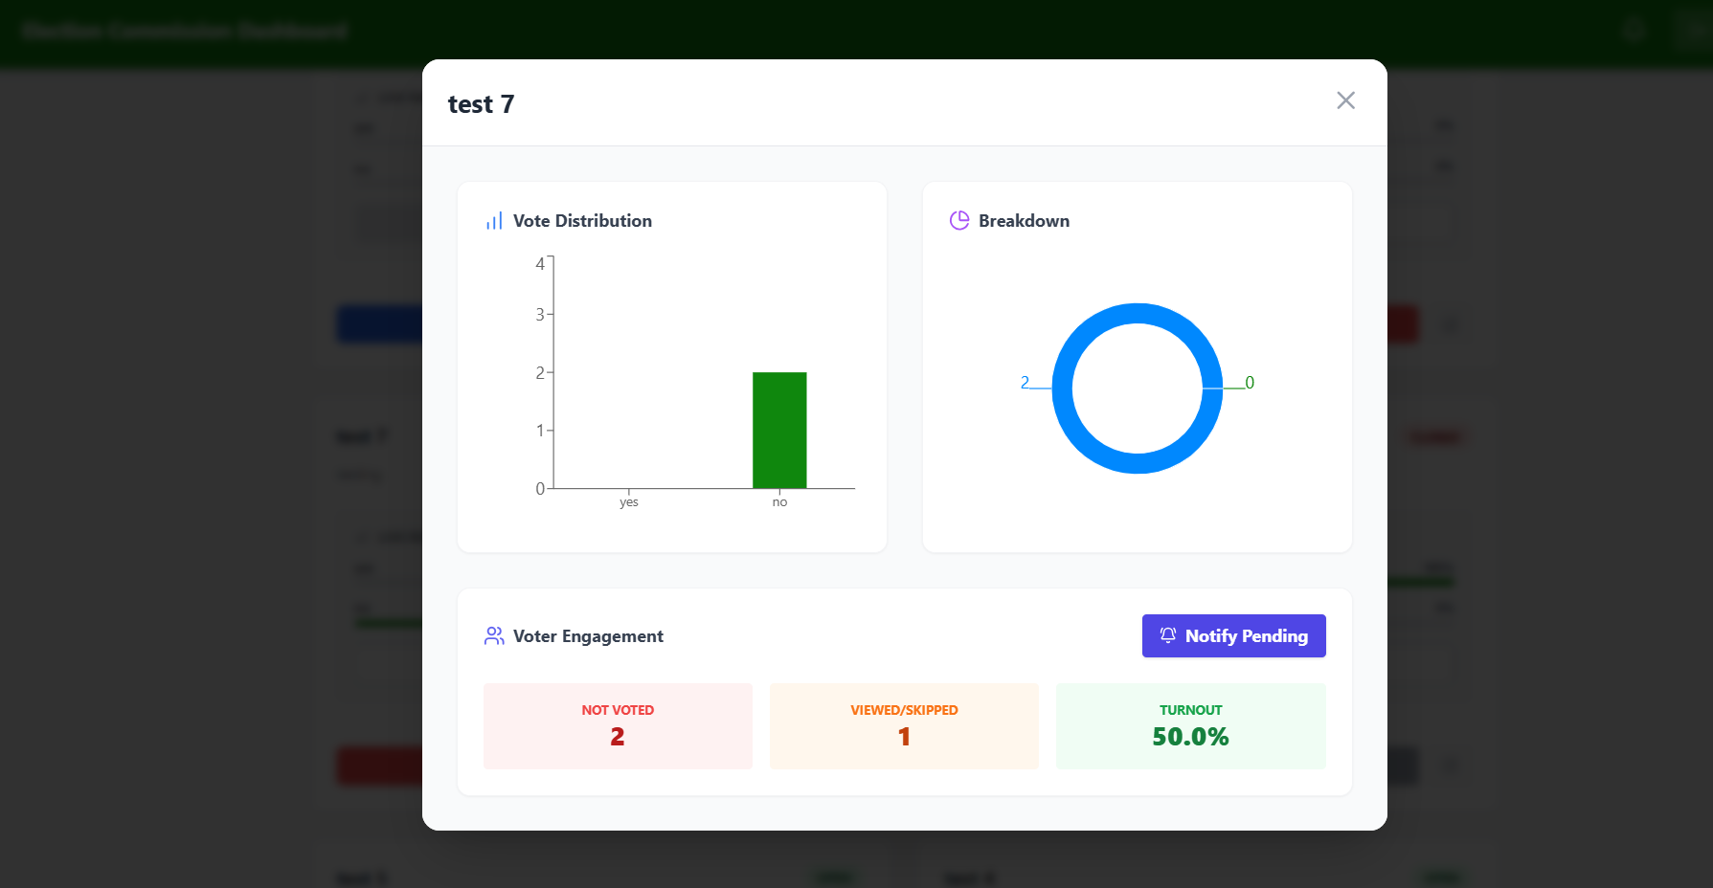

Landing Page
