Game Design Document

Fill up the Following document

1. Write the title of your project.

Animal Hospital

1. What is the goal of the game?

Curing as many animals as you can.

1. Write a brief story of your game?

You must collect items by using arrow keys and use those items to

cure animals.

1. Which are the playing characters of this game?

* Playing characters are the ones which respond to the user based on the input from the user
* Cars, monkeys, dinos, wizards etc, are the playing characters in the game.

|  |  |  |
| --- | --- | --- |
| Number | Character Name | What can this character do? |
| 1 | I’m a doctor | Collect items and cure animals with one more doctor. |
| 2 | Masters | They bring their pets to hospital and tell doctors what has happened |
| 3 | Animals | They are cured by doctors |
| 4 | Doctor 2 | Helps the main doctor to cure animals and can use the items collected by the main doctor |
| 5 |  |  |
| 6 |  |  |
| 7 |  |  |
| 8 |  |  |

1. Which are the Non Playing Characters of this game?

* Non Playing characters are the ones which don't have an action or a behaviour when the user interacts with the game.
* Hurdles, stones, bananas, coins, etc are non playing characters in the game.

|  |  |  |
| --- | --- | --- |
| Number | Character Name | What can this character do? |
| 1 | Masters | They bring their pets to hospital and tell doctors what has happened |
| 2 | Animals | They are cured by doctors |
| 3 | Doctor 2 | Helps the main doctor to cure animals and can use the items collected by the main doctor |
| 4 |  |  |
| 5 |  |  |
| 6 |  |  |
| 7 |  |  |
| 8 |  |  |

Draw your imagination of this game. What does this game look like?

* Draw the game either on your computer or on paper,
* Add images of scenes of the game to show each of the playing and non-playing characters at least once.

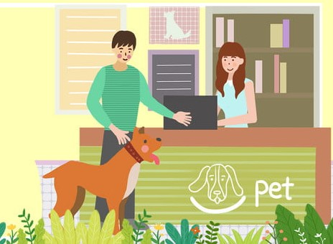

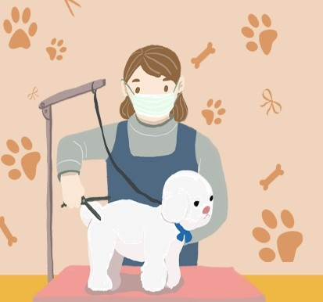



How do you plan to make your game engaging?

I want to make my game engaging by good graphics ,tasks which get

harder after finishing one tasks, sound animation and harder levels of

collecting items.