***ANUDIP FOUNDATION***

A Project Report on

**“ONLINE MOBILE MANAGEMENT SYSTEM”**

By

Batch: ANP-D0453

Student ID: AF0477098

Name: Vaishnavi Pandurang Nandal

**Under the Guidance of**

Mrs. Rajshri Chandrabhan Thete

**Introduction:**

The Online Mobile Management System is a Java-based application designed to manage mobile phone records efficiently. This system allows users to perform CRUD (Create, Read, Update, Delete) operations on mobile data, such as adding new mobile details, retrieving stored mobile records, updating existing mobile information, and deleting records when necessary. The application leverages Hibernate ORM (Object-Relational Mapping) for database interaction and SQL for data storage and retrieval, ensuring seamless and structured data management.

**Objective:**

The main objective of this project is to develop a robust and scalable system that provides an efficient way to store, manage, and retrieve mobile-related information. This system reduces manual data handling and enhances data integrity, accuracy, and accessibility.

**Entities:**

1. Address

2. Admin

3. Cart

4. Customer

5. Order

6. Mobile

7. User

8. Payment

**Attributes of Entities:**

1. **Address**

address_id (int, Primary Key)

city (varchar(255))

country (varchar(255))

pincode (varchar(255))

state (varchar(255))

street_no (varchar(255))

1. **Admin**

admin_id (int, Primary Key)

email (varchar(255))

name (varchar(255))

mobile_number (varchar(255))

password (varchar(255))

1. **Cart**

cart_id (int, Primary Key)

customer_id (int, Foreign Key)

1. **Customer**

customer_id (int, Primary Key)

email (varchar(255))

name (varchar(255))

mobile_number (varchar(255))

password (varchar(255))

address_id (int, Foreign Key)

1. **Order**

order_id (int, Primary Key)

location (varchar(255))

order_date (date)

total (double)

address_id (int, Foreign Key)

customer_id (int, Foreign Key)

1. **Mobile**

mobile_id (int, Primary Key)

cart_id (int)

category_name (varchar(255))

colour (varchar(255))

dimension (varchar(255))

price (double)

mobile_name (varchar(255))

quantity (int)

specification (varchar(255))

1. **User**

id (varchar(255), Primary Key)

password (varchar(255))

role (varchar(255))

1. **Payment**

payment_id(int, Primary Key)

payment_date(date)

payment_method (varchar(255))

amount(decimal)

**Entity Relationship Diagram – Online Mobile Management System:**

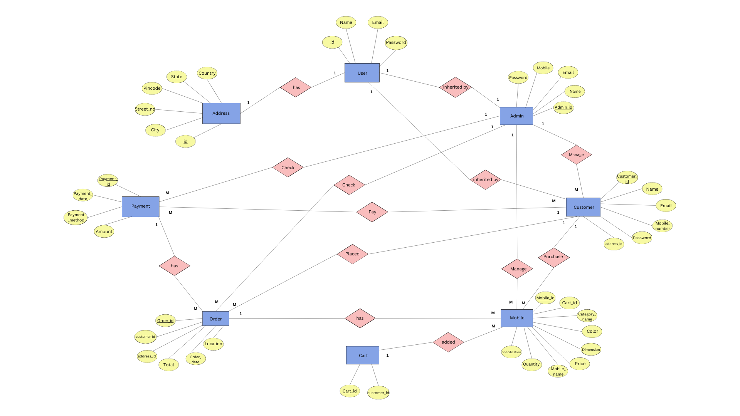

Fig: ER diagram

**Conclusion:**

The Online Mobile Management System is a robust solution for managing mobile phone records efficiently. Developed using Java, Hibernate, and SQL, it ensures scalability, maintainability, and user-friendliness. The system automates data handling, inventory tracking, and record management, reducing manual efforts and minimizing errors. It enables seamless data retrieval, updating, and reporting, improving operational efficiency. With secure database management and structured data storage, it enhances reliability and accessibility. The use of Hibernate ORM simplifies database interactions, ensuring smooth performance. This system is ideal for retailers, service centers, and mobile distributors. Its automated workflows and real-time data updates make mobile inventory management effortless.

**Top of Form**

**Bottom of Form**

**Database Creation Query:**

**mysql> create table Address (**

**-> address_id int(255) not null primary key,**

**-> city varchar(255)not null,**

**-> country varchar(255) not null,**

**-> pincode varchar(255) not null,**

**-> state varchar(255) not null,**

**-> street_no varchar(255) not null**

**-> );**

**Query OK, 0 rows affected (0.06 sec)**

**mysql> create table Admin (**

**-> admin_id int(255) not null primary key,**

**-> email varchar(255) not null,**

**-> name varchar(255) not null,**

**-> mobile_number varchar(255) not null,**

**-> password varchar(255)**

**-> );**

**Query OK, 0 rows affected (0.06 sec)**

**mysql> create table User (**

**-> id varchar(255) primary key,**

**-> password varchar(255),**

**-> role varchar(255) not null**

**-> );**

**Query OK, 0 rows affected (0.06 sec)**

**mysql> create table Payment (**

**-> payment_id int(255) not null,**

**-> payment_date date,**

**-> payment_method varchar(255),**

**-> amount decimal**

**-> );**

**Query OK, 0 rows affected (0.06 sec)**

**mysql> create table Mobile (**

**-> mobile_id int(255) primary key,**

**-> cart_id int(255),**

**-> category_name varchar(255) not null,**

**-> colour varchar(255),**

**-> dimension varchar(255),**

**-> price double,**

**-> product_name varchar(255),**

**-> quantity int,**

**-> specification varchar(255)**

**-> );**

**Query OK, 0 rows affected (0.06 sec)**

**mysql> CREATE TABLE customer (**

**-> customer_id INT AUTO_INCREMENT PRIMARY KEY,**

**-> email VARCHAR(255) UNIQUE NOT NULL,**

**-> first_name VARCHAR(255) NOT NULL,**

**-> mobile_number VARCHAR(20) UNIQUE NOT NULL,**

**-> password VARCHAR(255) NOT NULL,**

**-> address_id INT,**

**-> FOREIGN KEY (address_id) REFERENCES address(address_id) ON DELETE SET NULL**

**-> );**

**Query OK, 0 rows affected (0.06 sec)**

**mysql> CREATE TABLE cart (**

**-> cart_id INT AUTO_INCREMENT PRIMARY KEY,**

**-> customer_id INT,**

**-> FOREIGN KEY (customer_id) REFERENCES customer(customer_id)**

**-> );**

**Query OK, 0 rows affected (0.16 sec)**

**mysql> CREATE TABLE orders (**

**-> order_id INT AUTO_INCREMENT PRIMARY KEY,**

**-> location VARCHAR(255) NOT NULL,**

**-> order_date DATE NOT NULL,**

**-> order_status VARCHAR(50) DEFAULT 'Pending',**

**-> total DECIMAL(10,2) NOT NULL,**

**-> address_id INT,**

**-> customer_id INT,**

**-> FOREIGN KEY (address_id) REFERENCES address(address_id) ON DELETE SET NULL,**

**-> FOREIGN KEY (customer_id) REFERENCES customer(customer_id) ON DELETE CASCADE,**

**-> INDEX (address_id),**

**-> INDEX (customer_id)**

**-> );**

**Query OK, 0 rows affected (0.26 sec)**