**PHASE 3: IMPLEMENTATION OF PROJECT**

**TITLE: TRAFFIC FLOW OPTIMIZATION USING AI AND IOT**

**OBJECTIVE**

The goal of phase 3 is to implement the core components of a smart traffic optimization system using AI and IoT. This includes the development of a traffic prediction model, deployment of a traffic-sensing network, implementation of control algorithms for dynamic signal adjustments, and integration of data privacy and security measures.

**1.AI MODEL DEVELOPMENT**

**Overview**

The core of the system is a machine learning model that analyses historical and real-time traffic data to optimize traffic signal timing and routing recommendations.

**Implementation**

* **Traffic prediction Model:** Use supervised learning to analyse traffic patterns using historical data and real-time feeds.
* **Data Source:** Datasets include city traffic logs, GPS data from vehicles, and feeds from road sensors and cameras.
* **Model functionality:** Predict congestion,Travel times, and suggest dynamic adjustments to traffic lights.

**Outcome**

By the end of phase 3, the AI model should be able to predict traffic build-ups and suggest optimal signal timings with a focus on reducing delays at key intersections.

**2. SENSOR AND IOT INTEGRATION**

**Overview**

To enable real-time optimization, sensors and IoT devices will collect traffic data, such as vehicle counts, speeds, and environmental conditions.

**Implementation**

* **Network Integration:** Connect sensors to a central server using edge devices and IoT gateways.
* **API Usage:** Data transmitted via MQTT or RESTful APIs for analysis and processing.

**Outcome**

The system will have real-time access to live traffic conditions, enabling dynamic adjustments to traffic flow via smart signaling.

### **3. ADAPTIVE TRAFFIC SIGNAL CONTROL**

**Overview**

Based on the AI predictions, traffic signals will adapt their timings dynamically to

improve flow and reduce congestion.

**Implementation**

* **Control Algorithms:** Implement reinforcement learning or heuristic-**based** algorithms for adjusting light cycles.
* **Intersection Management:** Prioritize high-density routes and emergency vehicle detection
* **Feedback Loop:** Integrate with live data from sensors to adjust signals every few minutes.

**Outcome**

Smart traffic signals will adapt in near real-time to traffic volumes, significantly improving flow efficiency.

### **4. DATA SECURITY AND PRIVACY**

#### **Overview**

Traffic and vehicle data may contain sensitive location information; hence secure data handling is essential.

#### **Implementation**

* **Encryption:** All transmitted data will be encrypted using TLS.
* **Secure Storage:** Use secure cloud-based infrastructure with restricted access.
* **Compliance:** Ensure compliance with local data protection laws and anonymize vehicle data.

#### **Outcome**

#### All data collected and processed during this will be phase stored and transmitted securely.

#### **5. TESTING AND FEEDBACK COLLECTION**

#### **Overview**

#### Testing will be conducted in a simulated environment or controlled field deployment to evaluate system performance.

#### **Implementation**

* **Simulations:** Use tools like SUMO or VISSIM to simulate traffic conditions.
* **Test Sites:** Deploy in a small real-world intersection or city sector.
* **User Feedback:** Gather input from traffic managers and drivers on perceived improvements.

#### **Outcome**

### Feedback will be used to fine-tune the AI model, improve signal control logic, and prepare the system for broader deployment.

### **Challenges and Solutions**

1. **Real-Time Data Reliability**
   * **Challenge**: Sensor failures or connectivity issues.
   * **Solution:** Redundant sensors and fallback prediction models.
2. **Scalability**
   * **Challenge**: Expanding the system to a city-wide level.
   * **Solution:** Modular architecture and cloud-based scalability.
3. **System Integration**
   * **Challenge:** Integration with legacy traffic systems.
   * **Solution:** Use middleware and open-standard APIs for compatibility.

**OUTCOMES OF PHASE 3:**

1. **BASIC AI MODEL**: AI model capable of predicting and optimizing traffic flow.
2. **FUNCTIONAL CHATBOT INTERFACE**: Real-time sensor network integrated for live data collection.
3. **OPTIONAL IoT INTEGRATION**: If IoT devices are available Dynamic traffic signal control in a test environment.
4. **DATA SECURITY:** Data handling procedures compliant with security standards which gives protection for mechanism in place.
5. **INITIAL TESTING AND FEEDBACK:** Initial performance testing and stakeholder feedback collected.

**NEXT STEPS FOR PHASE 4:**

In phase 4, the team will focus on:

1. **Wider Deployment:** Expand to more intersections and integrate public transport data.
2. **User Interface Development:** Develop a dashboard for traffic controllers and a mobile app for drivers.

**\*\*\*\*\*\*\*\*\*\*\*\*\*\*\*\*\*\*\*\*\*\*\*\*\*\*\*\*\*\*\*\*\*\*\*\*\*\*\*\*\*\*\*\*\***

**CODE FOR TRAFFIC FLOW AND OPTIMIZATION:**

**PICTURE1:**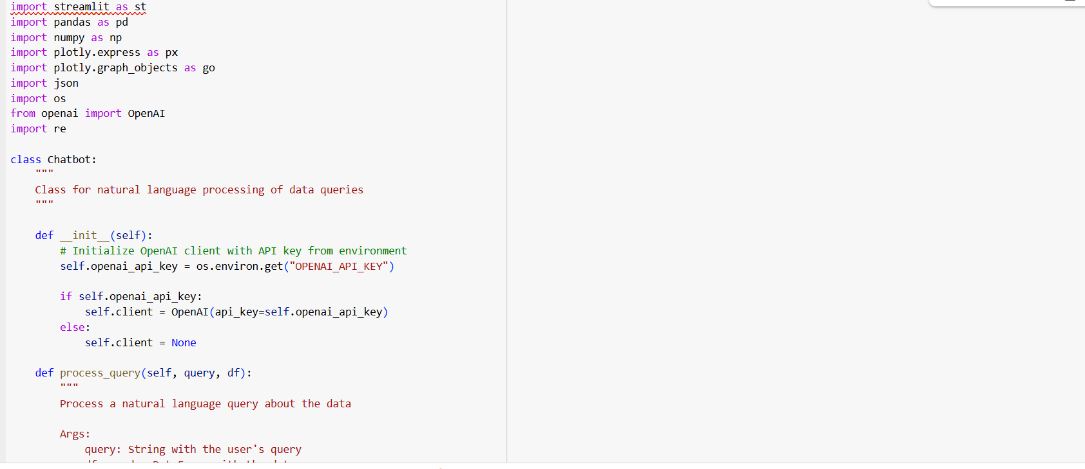

**PICTURE 2:**

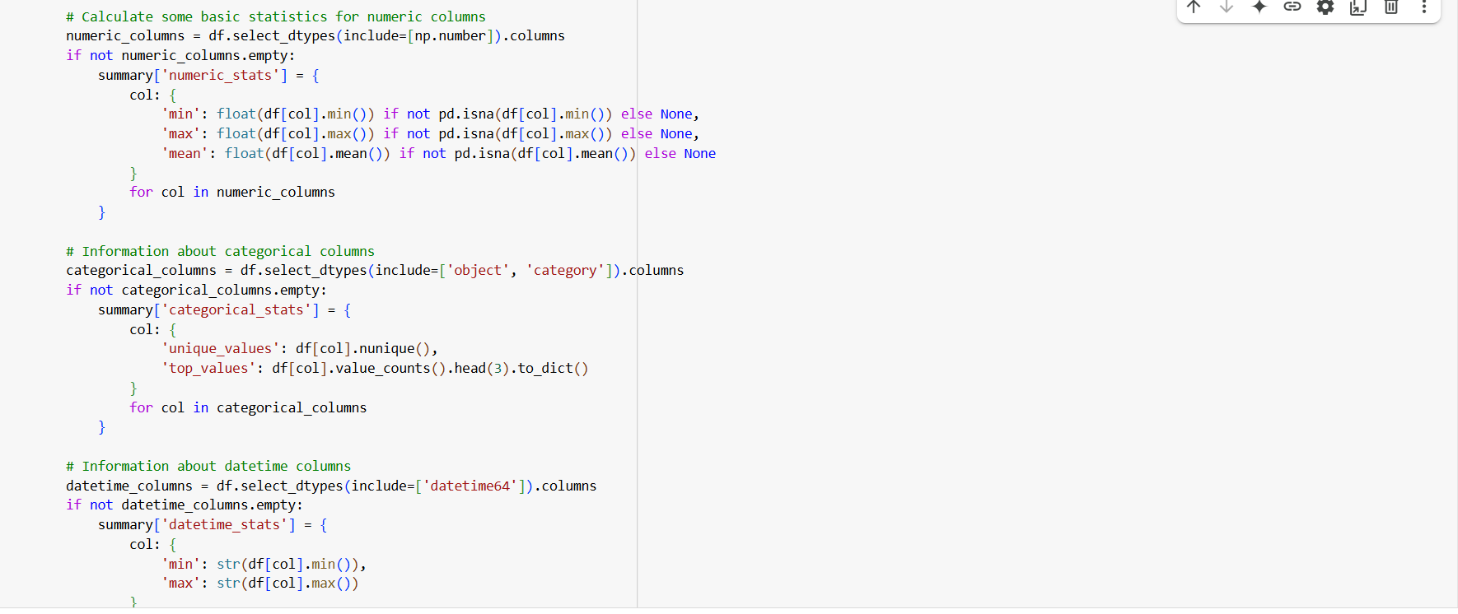

**PICTURE 3:**

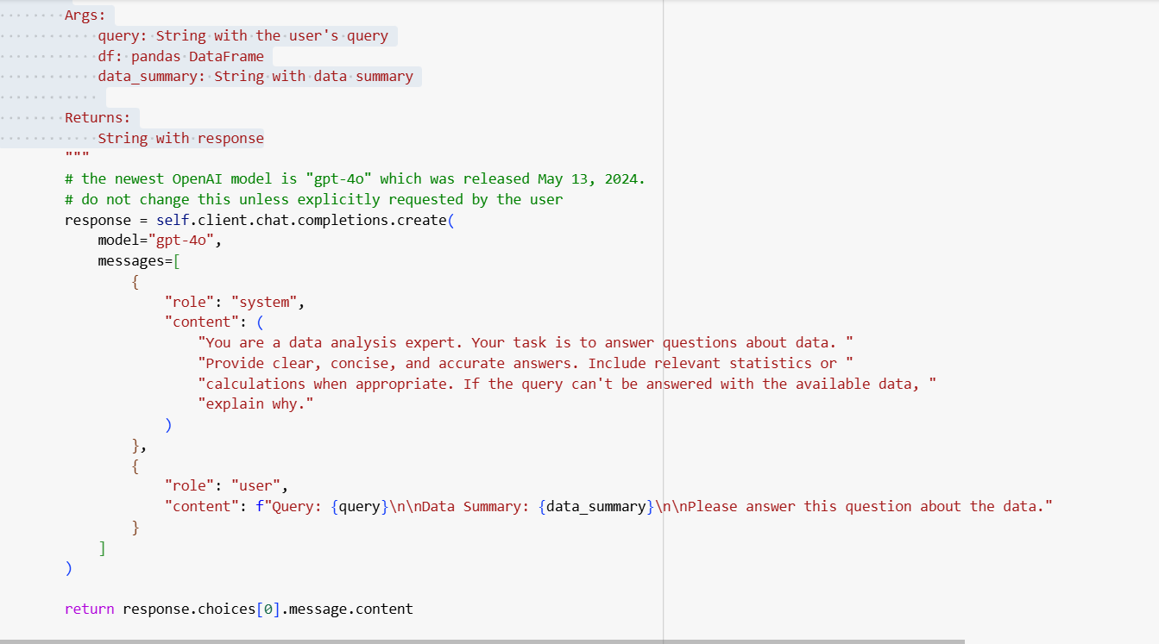

**OUTPUT:**

