**Problem Statement:**

Every image has same details at specific location (i.e ‘Device Name’, ‘REF’, ‘LOT’, ‘Qty’ and symbols.) Task is to extract these details from the images and add them in the excel file in a specific format

**Methodology :**

1. Python library OCR was first used to obtain the text from the images .
2. It returns a dictionary , where ‘Device Name’, ‘REF’, ‘LOT’, ‘Qty’ can be obtained from the dictionary by traversing through the dictionary
3. Storing the quantities in a dataframe
4. Next step is to crop the symbols from the images , using numpy array slicing .
5. Comparing the cropped images with the images in the symbols folder and assigning the value to it
6. Combining all the quantities into a single dataframe

**Results**

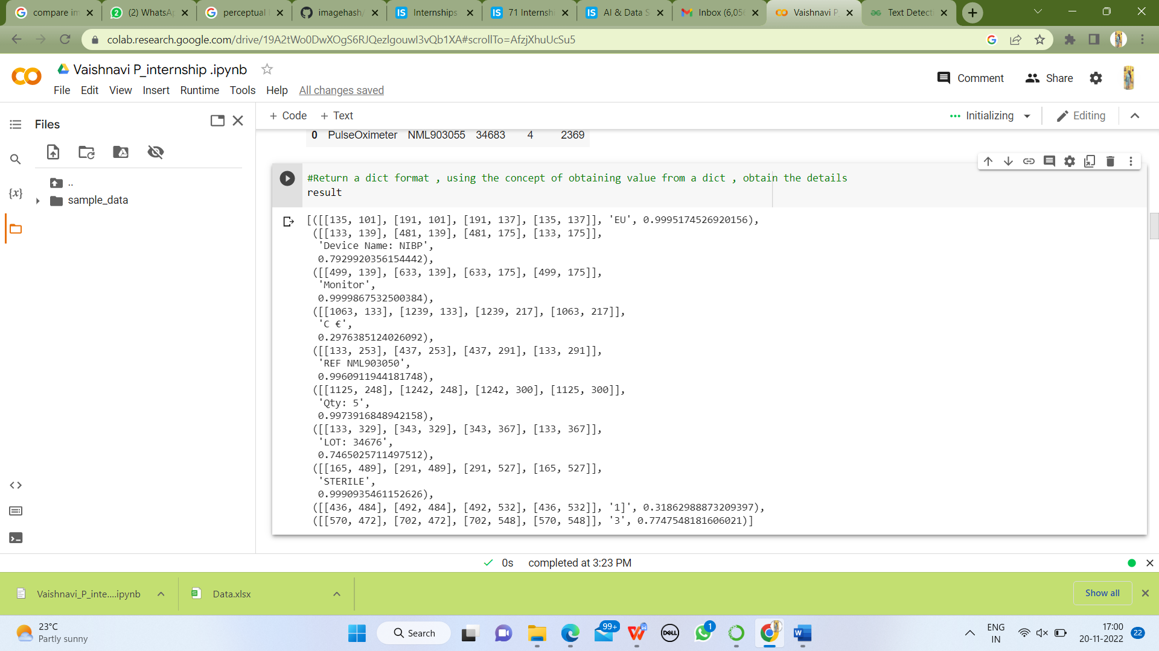

Fig1: Obtaining the dictionary of the quantities

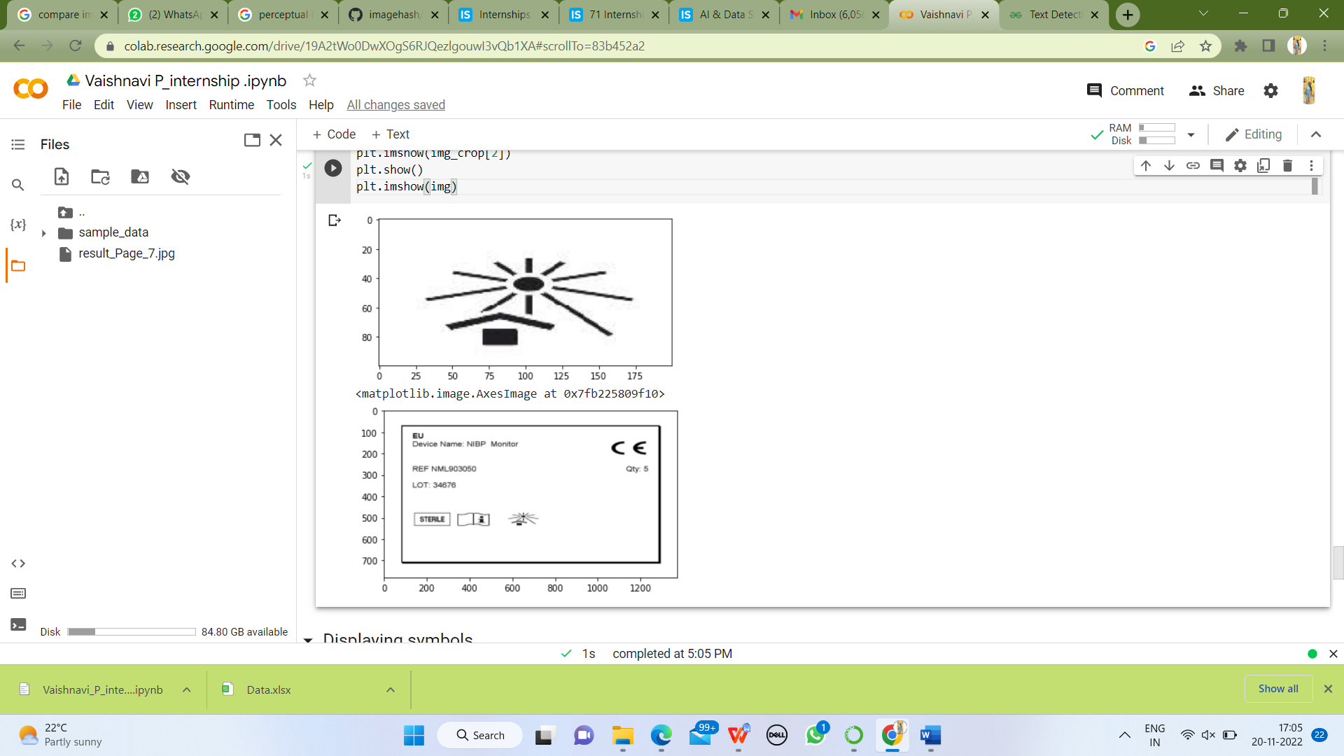

Fig2: Cropping the symbols from images

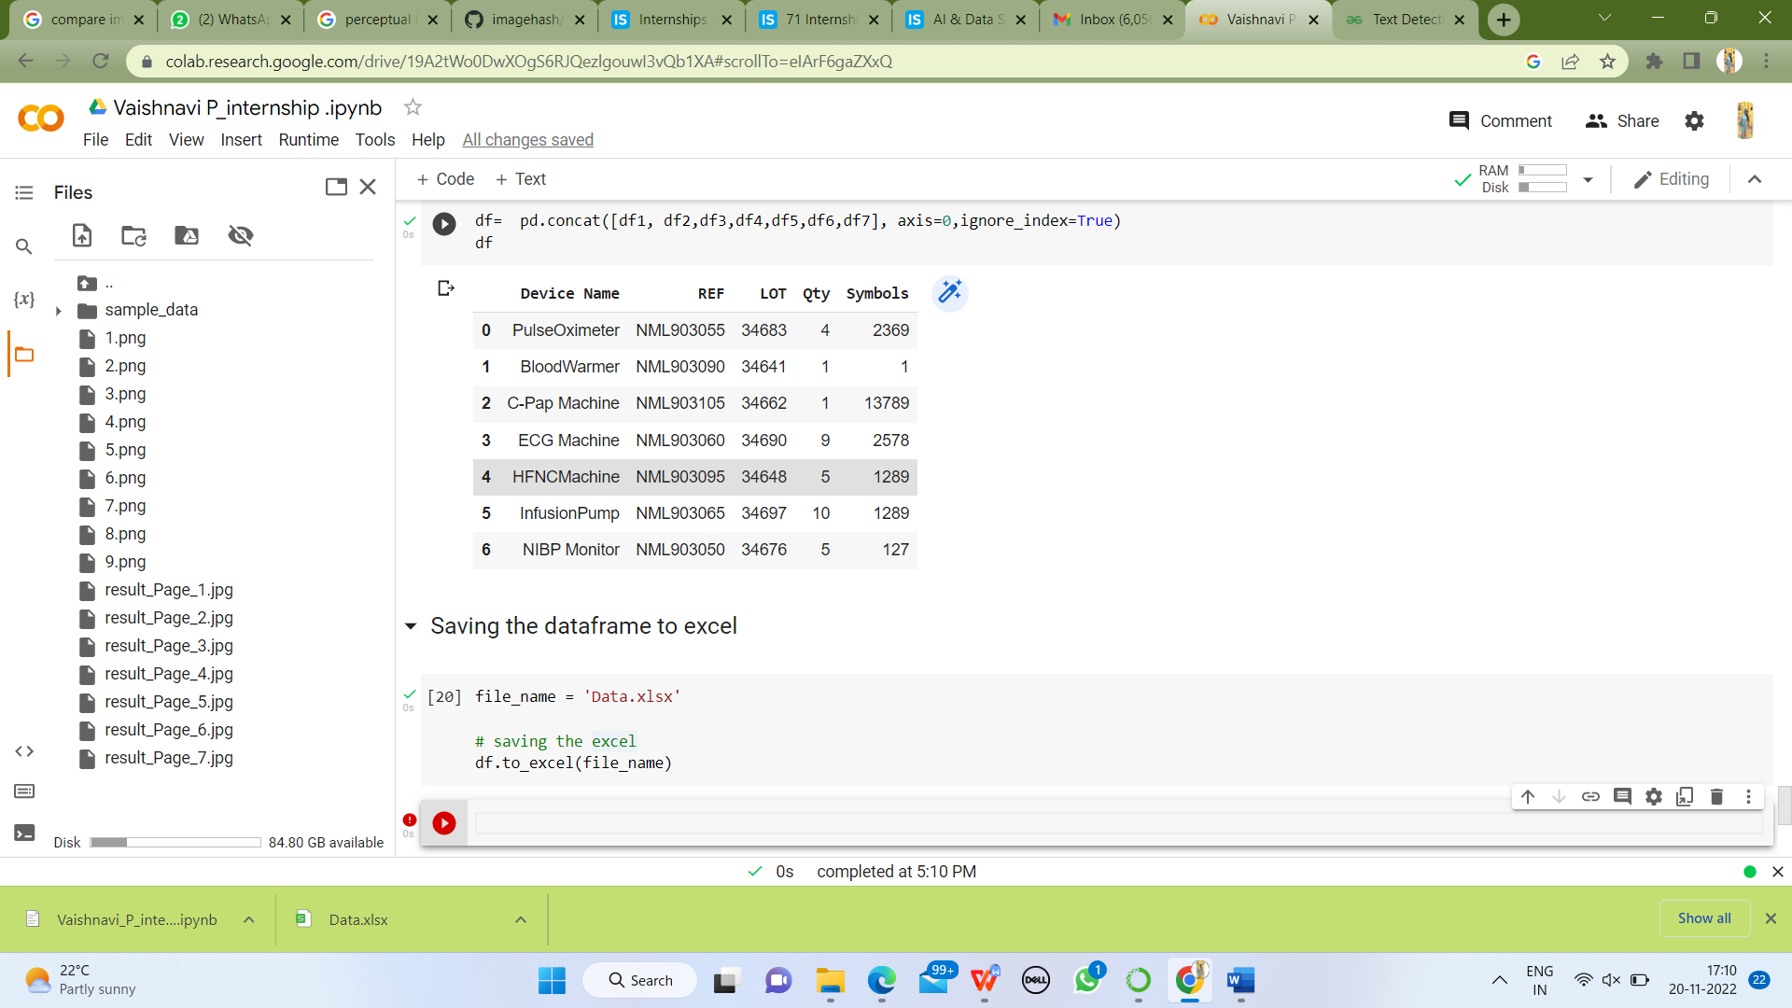

Fig3: Obtaining the dataframe and saving it to excel format