**Airbnb Dynamic Pricing Recommendation Engine**

**Pricing optimization based on location, seasonality, and listing quality**

Prepared by: *Vaishnavi Srivastava*  
Date: *21/06/2025*

## Introduction:

This project focuses on analyzing Airbnb listing data to build a dynamic pricing engine. It aims to provide optimal price recommendations for hosts based on key factors like city, season, and listing attributes.

## Abstract:

We used historical Airbnb data to uncover pricing patterns and build machine learning models (Linear Regression, Random Forest) for price prediction. The project combines data analysis, machine learning, and data visualization through a Power BI dashboard, helping hosts make data-driven pricing decisions.

## Tools Used:

| **Tool** |  |  |  |  |  |  |  |  |  |  |  | **Purpose** |
| --- | --- | --- | --- | --- | --- | --- | --- | --- | --- | --- | --- | --- |
| Python |  |  |  |  |  |  |  |  |  |  |  | Data cleaning, regression modeling |
| Excel |  |  |  |  |  |  |  |  |  |  |  | Data review and pre-processing |
| Power BI |  |  |  |  |  |  |  |  |  |  |  | Interactive dashboard creation |
| Random Forest, Linear Regression |  |  |  |  |  |  |  |  |  |  |  | Price prediction models |

## Steps involved in building the project:

* **Data Collection & Cleaning**
* Dataset: 74112 rows × 24 columns
* Cleaned columns: city, room_type, review_scores_rating, number_of_reviews, accommodates, bathrooms, bedrooms, beds, review_season, host_response_rate, host_has_profile_pic, host_identity_verified, log_price
* Missing values handled using median/mode; booleans encoded; irrelevant columns dropped
* **Exploratory Data Analysis (EDA)**
* Analyzed city-wise, room type-wise, and season-wise pricing patterns
* Visualized price distribution and correlations
* **Modeling**
* Applied Linear Regression and Random Forest Regressor
* Evaluation:

| **Model** |  |  |  |  |  |  |  |  |  | **R² Score** |  |  |  |  |  |  |  |  |  |  |  |  |  | **RMSE** |
| --- | --- | --- | --- | --- | --- | --- | --- | --- | --- | --- | --- | --- | --- | --- | --- | --- | --- | --- | --- | --- | --- | --- | --- | --- |
| Linear Regression |  |  |  |  |  |  |  |  |  | *0.564* |  |  |  |  |  |  |  |  |  |  |  |  |  | *0.473* |
| Random Forest |  |  |  |  |  |  |  |  |  | 0.563 |  |  |  |  |  |  |  |  |  |  |  |  |  | *0.474* |

* **Dashboard Development**
* Created interactive Power BI dashboard with city, room type, season filters
* Included visualizations: price trends, room type proportions, feature importance.

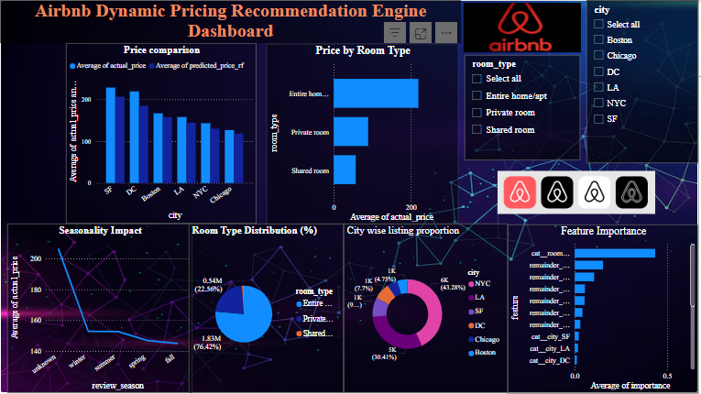

## Conclusions:

Both models achieved similar results, but Random Forest provides better flexibility to capture non-linear pricing patterns.  
Key insights:

* Listings in cities like San Francisco and DC have higher prices
* Entire home/apartment room types attract higher rates
* Prices peak during winter and holidays
* Review scores, beds, host response rate impact price

The dashboard helps hosts explore dynamic pricing trends and make informed decisions.