 

INSTITUTE FOR ADVANCED COMPUTING AND SOFTWARE DEVELOPMENT AKURDI, PUNE

Documentation On

**“ONLINE BEAUTY PARLOUR AND MANAGEMENT SYSTEM”**

PG-DAC SEPT 2020

*Submitted By:*

**Group No: 10 Anshul Bahadure 2015 Vaishnavi Tambe 2204**

**Prashant Karhale Mr. Chetan Pardeshi**

**Centre Coordinator Project Guide**

# Table of Contents

1. Introduction 1

Document Purpose 2

Problem Statement 2

Product Scope 2

Aim & Objectives 2

1. Overall Description 3

Product Perspective 3

Benefits of Online Beauty Parlor and Management System 3

User and Characteristics 3

Operating Environment 3

Design and Implementation Constraints 3

1. Requirements Specification 4

External Interface Requirements 4

3.3 Non-Functional Requirements 12

1. System Diagram 11

Activity Diagram 11

Data Flow Diagram 13

Class Diagram 15

Use Case Diagram 16

ER Diagram 16

1. Table Structure 17

Flat owners 17

Notices 17

Complaints 17

Visitors 18

Bill 18

Workers 18

1. Conclusion 19

Future Scope 19

1. References 20

**List of Figures**

Figure 1 Admin Activity Diagram 11

Figure 2 Flat Owner Activity Diagram 12

Figure 3 Watchman Activity Diagram 12

Figure 4 Level 0 Data Flow Diagram 13

Figure 5 Level 1 Data Flow Diagram 13

Figure 6 Level 2 Data Flow Diagram for Admin 14

Figure 7 Level 2 Data Flow Diagram for Flat Owner 14

Figure 8 Level 2 Data Flow Diagram for Watchman 15

Figure 9 Class Diagram 15

Figure 10 Use Case Diagram 16

Figure 11 ER Diagram 16

# Introduction

Online beauty parlor and management system is a web-based salon management application with appointment booking functionality. Being a salon client today is inconvenient. You have to remember that you need to make an appointment, and then hope you remembered during business hours, and finally scramble to find the phone number and take time out of your busy day to make the call. This is the experience of countless salon-goers every day, even as we move well into the twenty first century. This System connects clients, salon, and stylists in an online community allowing users to browse services and book or cancel appointments. Users can also choose their timing of salon and for particular stylists. Salons can specify the stylists that work at their salons, as well as the services they offer.

## Document Purpose

The advancement in Information Technology and internet penetration has greatly enhanced various business processes and communication between salon owners and their clients who are taking the services. This Online Beauty Parlor and Management System is developed to provide the following services:

Enhance Business Processes:

To be able to use internet technology to project to the global world instead of limiting their services to their local domain alone, thus increase their return on investment (ROI). Our vision is to become a world-class software development and technology provider and to provide clients with innovated technical and business solutions by utilizing industry standards and technology.

Online Beauty Parlor and Management System:

A tool through which the admin allows to register a user and provides many types functionalities to them. The admin also receives some set of functionalities which help in managing the various salon activities.

Appointment Booking:

This system’s key functionality is that it helps in Appointment Booking of the salon conveniently.

## Problem Statement

Existing system for a salon is based on our traditional way keeping records and details on paper and registers. Access of these details and papers are not granted to common member in absence of the authority. It is hard to manage all the salon system with pen and paper. It gets really hard to maintain the records of appointment booking and clients and then keep track of past records also waiting in a salon is too hectic these days . Hence this system is proposed to overcome the flaws of the existing system and giving power to the admin of the salon so that he/she will be able to manage the salon easily.

## Product Scope

This project traverses a lot of areas ranging from business concept to computing field, and required to perform several researches to be able to achieve the project objectives. The area covers include:

* Beauty Parlor industry: This includes study on how the daily Salon work actually is being done, process involved and opportunity that exist for improvement.
* Web Programming Technology is used for the development of the application.
* General clients as well as the salon’s staff will be able to use the system effectively.
* Web-platform means that the system will be available for access 24/7 except when there is a temporary server issue which is expected to be minimal.

## Aims & Objectives

Specific goals are: -

* To produce a web-based system that allows the admin to add clients and provide functionalities to its role.
* To ease salon by providing different functionalities to it.
* To ease clients to help them in their appointment booking to add and track their appointment efficiently.

# Overall Description

## System Perspective:

2.1.1 Existing system function:

Existing system for a salon is based on our traditional way keeping records and details on paper and registers. Many salons today are still using paper and pencil systems to schedule appointments and manage customers. These systems are grossly inefficient at sharing and syncing information, and are prone to costly human error. We studied Online Beauty Parlor and Management System. This software system helps to book appointment easily. Online Beauty Parlor and Management System promises to end the dependence on paper-pencil systems, and put salons in control with an easy to use interface. This Smart salon System will be more than just an online scheduler; it will be a salon management tool that will allow salons to manage stylists and services, promote sales to customers, and track customer satisfaction.

* **III. PROPOSED SYSTEM**

Product functionality:

Online Beauty Parlor and Management System provides the features for admin and customers. It includes several functionalities describes as below:

*Salon Management:*

It provides facility to add, update, delete and view the Clients who are taking a particular service in the salon. We can view their details and also update it if that particular service and appointment is allotted to any new client.

*Services Management:*

Administrator can update the daily Services available on the basis of the daily available service stylists and type of services which client’s demands.

*Appointment Booking:*

The admin can book an appointment which can be viewed by the salon owner in their ‘Services’ functionality when they login in, into the system.

*Appointment Canceling:*

The admin can cancel an appointment which can be viewed by the salon owner in their ‘Services’ functionality when they login in, into the system.

The application contains several pages: Home, Services, Login - a page for authentication, Appointment - a page for booking an appointment and Account. On Home page you can find information about salon and a team of the salon. On Services page you can find a list of services for men and women. Booking an appointment is available only for authenticated clients. Account page stores all appointments of users and personal information about users. Every user not only can book or cancel appointments after login (Account page), but also can change the personal information.

## Benefits of Online Beauty Parlor and Management System

* This Online Beauty Parlor and management solution is fully functional and flexible.
* It is very easy to use.
* This Online Beauty Parlor and management system helps in back office administration by streamlining and standardizing the procedures.
* It saves a lot of time and money.
* Eco-friendly: The monitoring of the Online Beauty Parlor and management and the overall business becomes easy and includes the least of paper work.
* The application acts as an office that is open 24/7.
* It increases the efficiency of the salon management at offering quality services to the Clint’s.
* It provides custom features development and support with the application.

## Users and Characteristics:

Admin:

* Admin can login to the system.
* View the list of all salon Clients in the salon.
* Add, delete, update clients.
* View Appointments of all the clients.
* Circulate services among all the clients.
* Add services in the salon.
* Shows the names of Stylists working in the salon.

Clients:

* + Clients can login to the system.
  + View his/her details.
  + View services.
  + Book Appointments.
  + View services types, and costs who visited to the salon.
  + Update their personal credentials (Phone No. ,Email-ID and name which are necessary for booking an appointment)
  + View available slots for their appointments.

## Operating Environment:

Server Side:

**Processor:** Intel® Xeon® processor 3500 series

**HDD:** Minimum 500GB Disk Space

**RAM:** Minimum 2GB **OS:** Windows 10, Linux 6 **Database:** firebase

Client Side (minimum requirement):

**Processor:** Intel Dual Core

**HDD:** Minimum 80GB Disk Space

**RAM:** Minimum 1GB

**OS:** Windows 7, Linux

## Design and Implementation Constraints:

* The application will use Axios, Node js, React, Firebase Database, Redux, Antd library, JavaScript, jest and CSS as main web technologies.
* HTTP and FTP protocols are used as communication protocols. FTP is used to upload the web application in live domain and the client can access it via HTTP protocol.
* Several types of validations make this web application a secured one and SQL Injections can also be prevented.
* Responsive Web design approach used in this system that suggests that design and development should respond to the user’s behavior and environment based on screen size, platform and orientation.
* Since Online Beauty Parlor and Management system is a web-based application, internet connection must be established.
* The Online Beauty Parlor and Management System will be used on PCs and will function via internet or intranet in any web browser.

# Specific Requirement

## External Interface Requirements:

User Interfaces:

* + All the users will see the same page when they enter in this website. This page asks the users a mail-id and a password for sign up as well as in sign in .
  + After being authenticated by correct username and password, user will be redirect to their corresponding profile where they can do various activities.
  + The user interface will be simple and consistence, using terminology commonly understood by intended users of the system. The system will have simple interface, consistence with standard interface, to eliminate need for user training of infrequent users.

Hardware Interfaces:

* + No extra hardware interfaces are needed.
  + The system will use the standard hardware and data communication resources.
  + This includes, but not limited to, general network connection at the server/hosting site, network server and network management tools.

Application Interfaces:

**OS:** Windows 10, Linux

**Web Browser:**

The system is a web-based application; clients need a modern web browser such as Mozilla Firebox, Internet Explorer, Opera, and Chrome. The computer must have an Internet connection in order to be able to access the system.

Communications Interfaces:

* + This system uses communication resources which includes but not limited to, HTTP protocol for communication with the web browser and web server and TCP/IP network protocol with HTTP protocol.
  + This application will communicate with the database that holds all the Appointment booking information. Users can contact with server side through HTTP protocol by means of a function that is called HTTP Service. This function allows the application to use the data retrieved by server to fulfil the request fired by the user.

# System Design

# Beauty parlor management system is a web-based salon management application with appointment scheduling functionality. In this system user can review salons and stylist online and can make appointment online. In this system beauty parlor owner can make their account online and give details of the services they offer and also describe the stylist information. User can review the salons and their services using this system and can make appointment with favorite stylist online. User can also cancel appointments online. User can also write and reviews about the salon or stylist. This system helps both the customer and the salon. Customer can easily find best salon in their locality and can check the review of other customer of that salon online

## Class Diagram

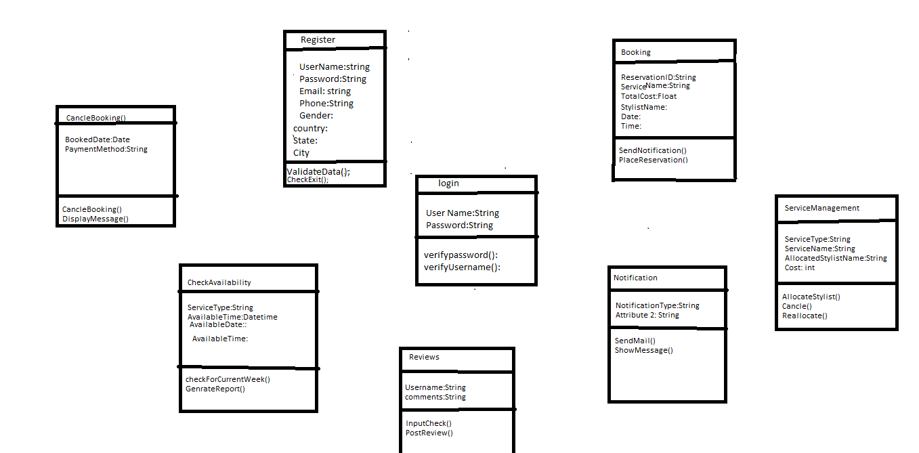

**Figure 9: Class Diagram**

## Use Case Diagram

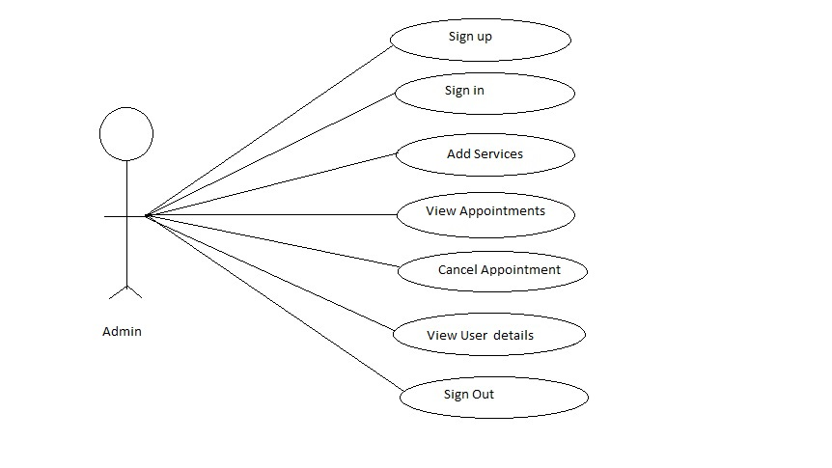

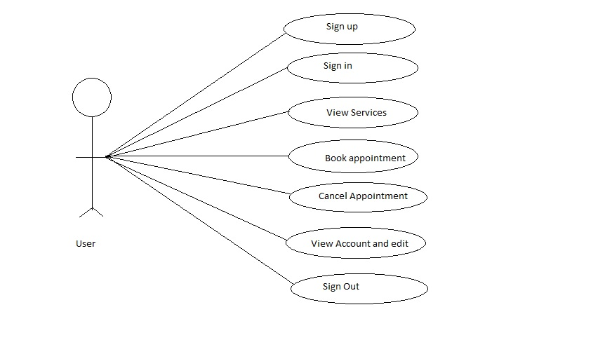

**Figure 11: Use case Diagram**

Sequence Diagram

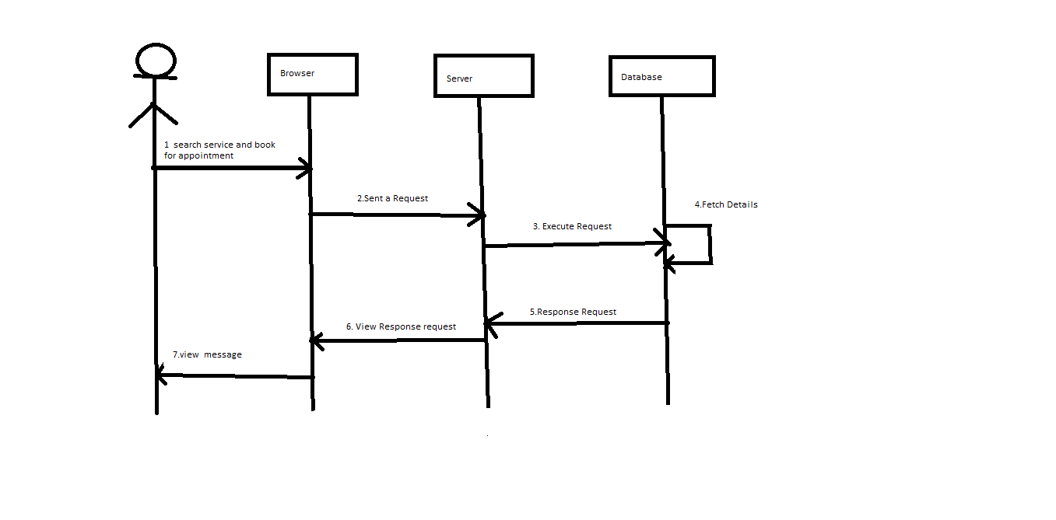

## 

## ER Diagram

**Figure 11: Sequence Diagram**

**Figure 12 : ER Diagram**

# Database Schema:

Appointment Schema:

{

Message:{

type:String,

required:true,

},

Service:{

type:String,

required:true,

},

Time:{

type:time

required:true,

},

Userid:{

type:int

required:true

},

Userdata Schema:

{

Phone:{

type:int,

required:true,

},

UserId:{

type:int,

required:true,

},

UserName:{

type:string

required:true,

},

Services Schema:

{

Men:{

type:int,

required:true,

},

Women:{

type:int,

required:true,

},

ServiceType:{

type:string,

required:true,

},

ServicePrice:{

type:int,

required:true,

},

Authentication Schema:

Email:{

type:string,

required:true,

},

Password:{

type:string,

required:true,

},

**Results:**

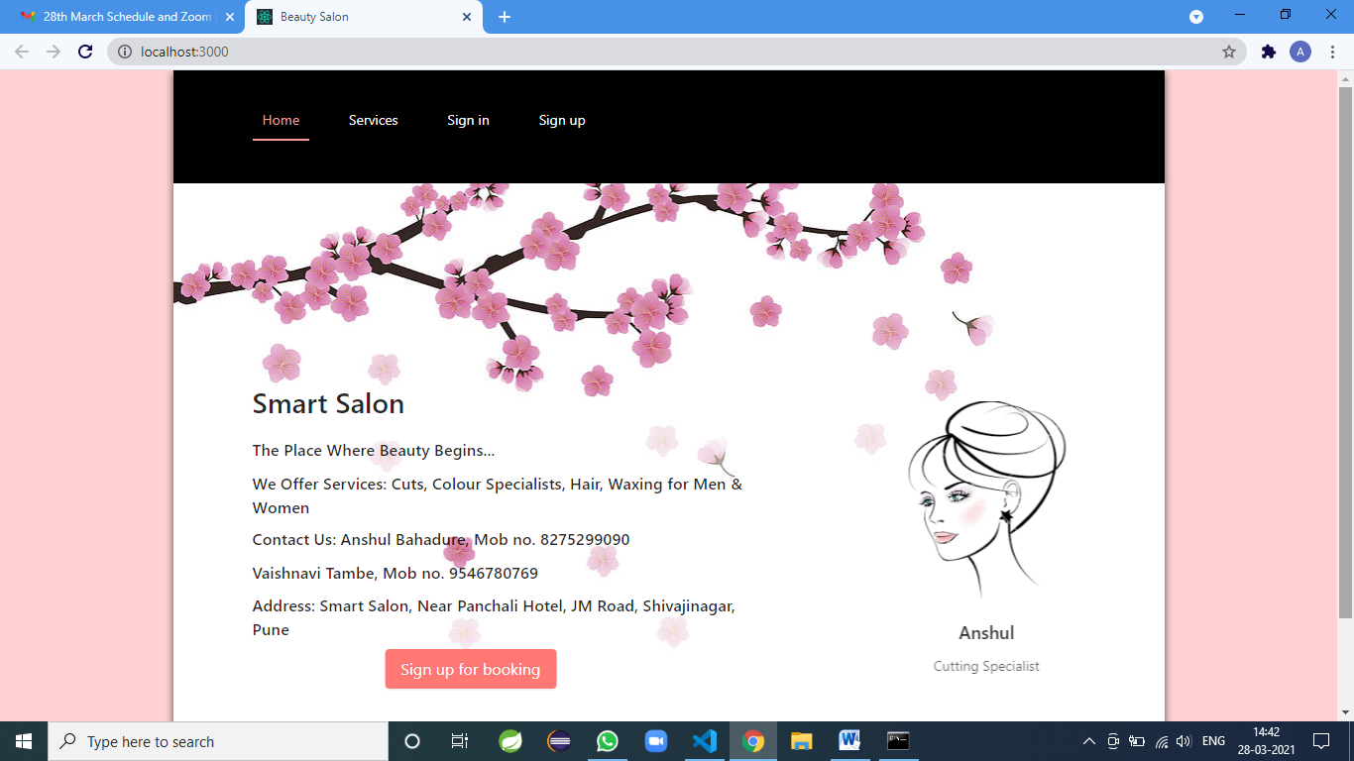

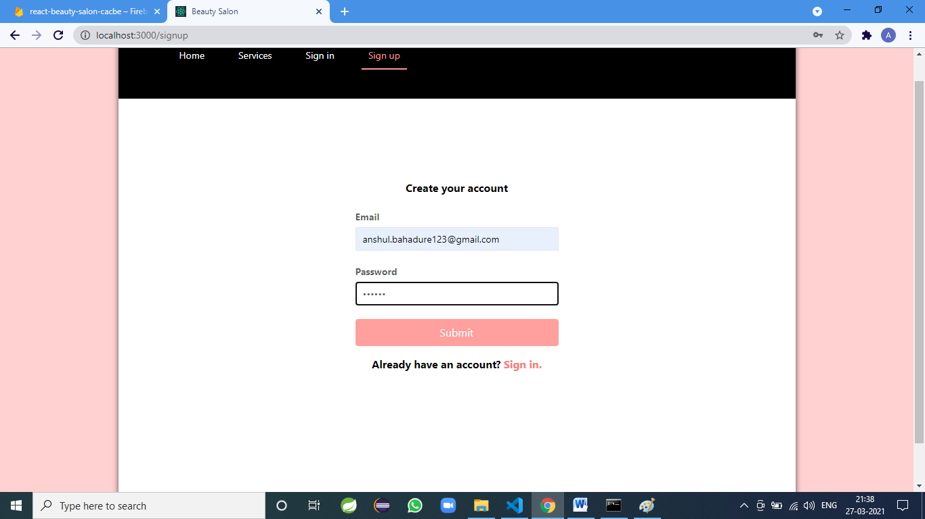

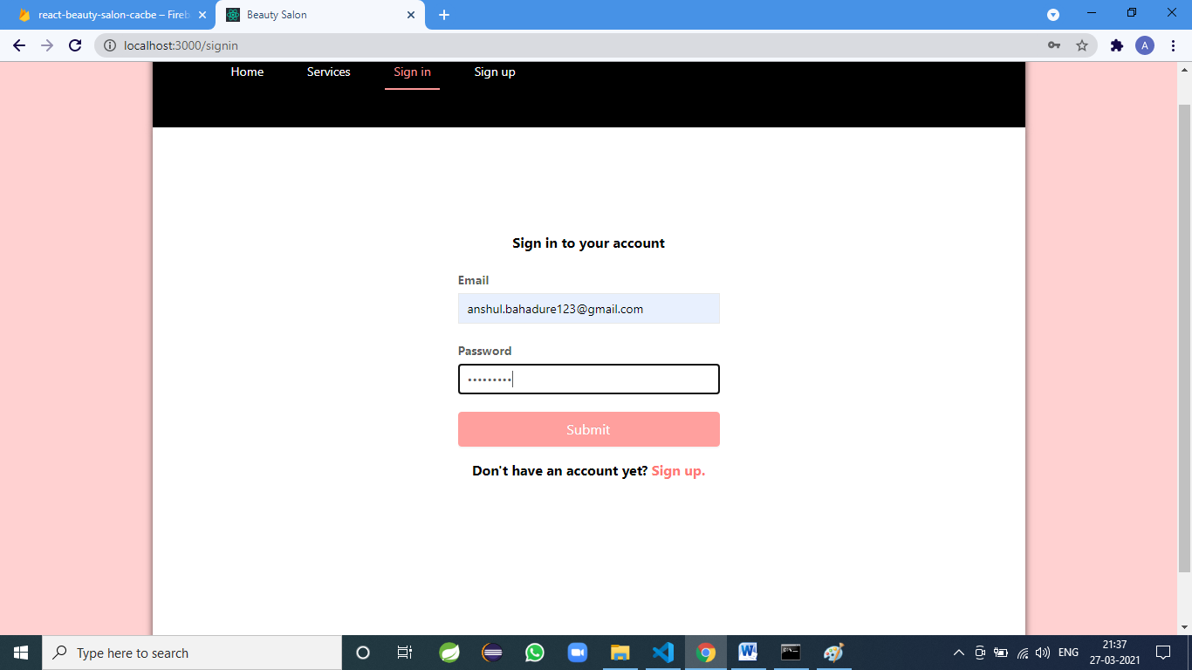

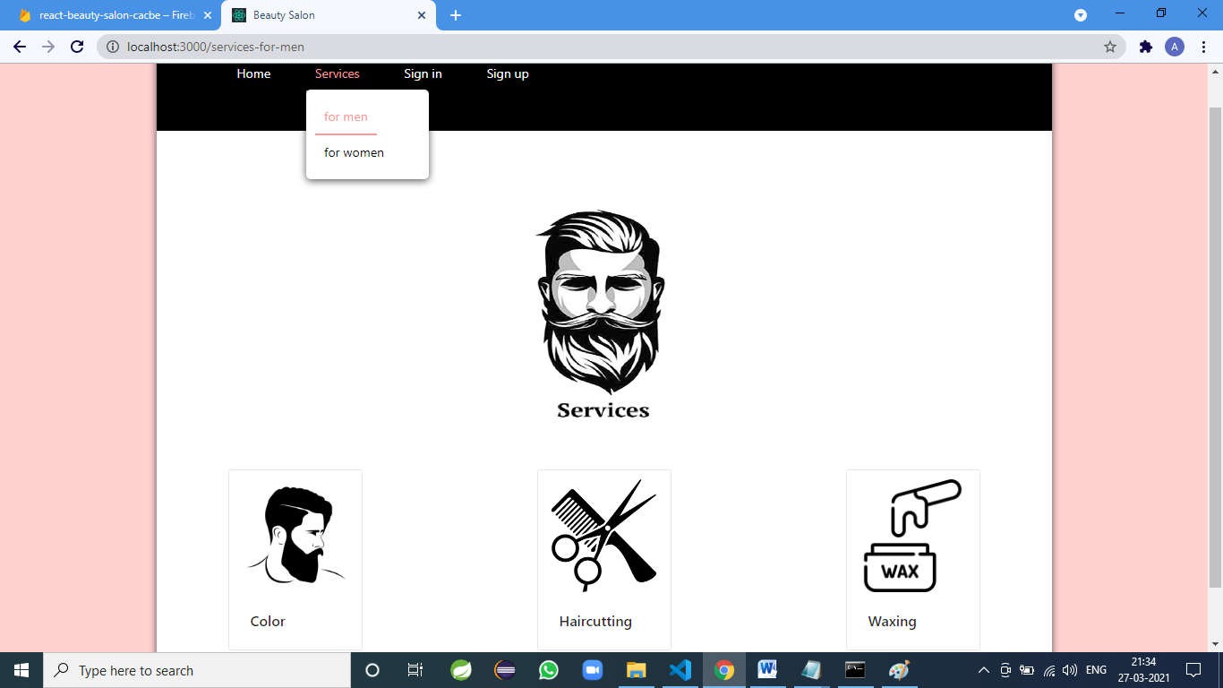

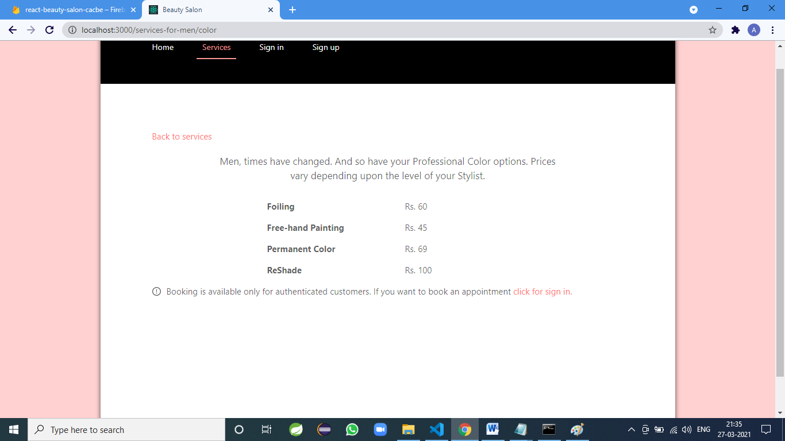

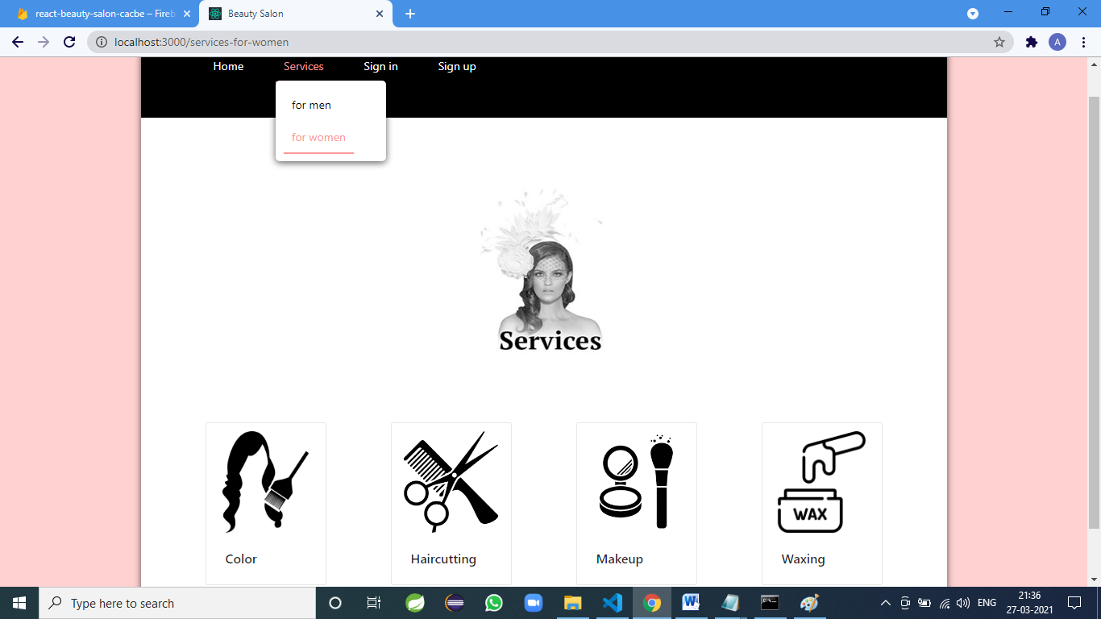

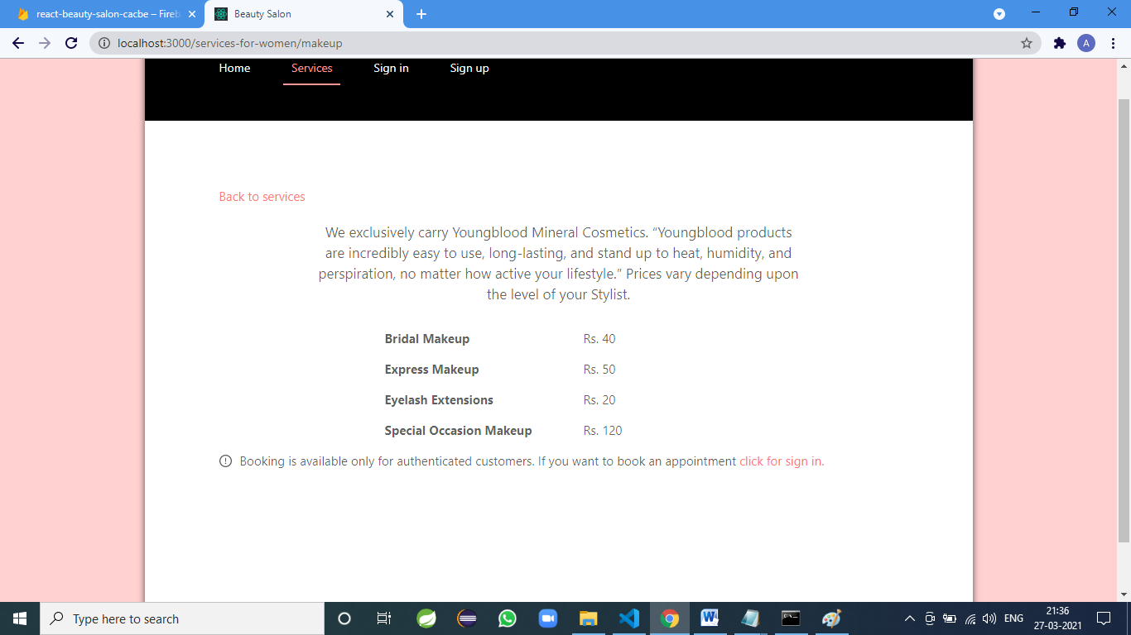

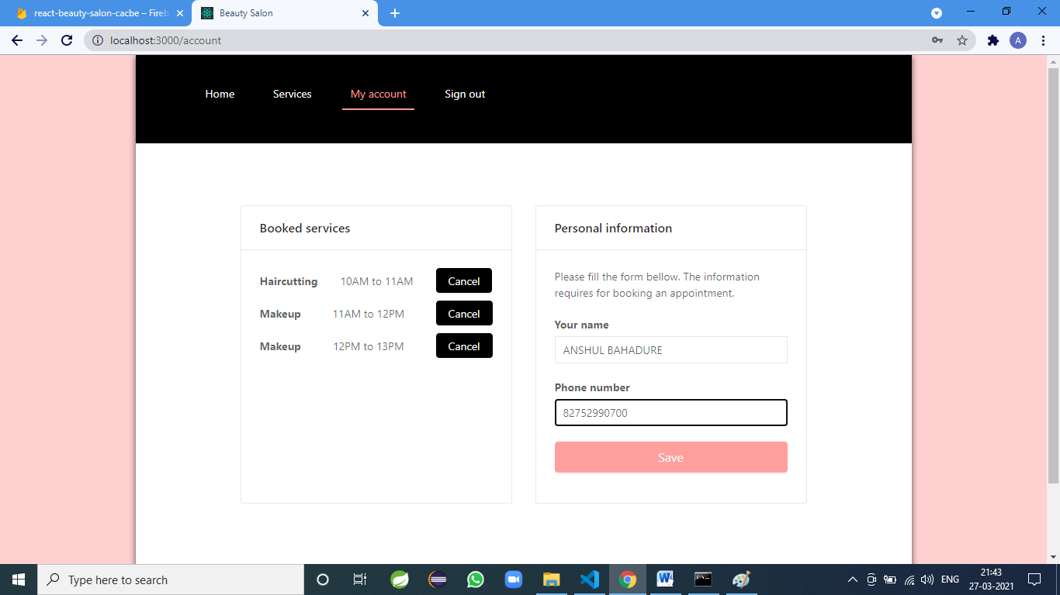

**Conclusion**

Online Beauty Parlor and management system puts forth the actual working of a salon. Administration, management, Appointment booking, Clients management, service management, etc. similar to a Salon are the key features of our project. User can access services and functionalities from the salon anywhere and anytime for their own comfort.

# Future Scope

This project can be enhanced further by adding Searching Option for various Salons, adding booking with Offers, Giving Festival Discount, and online payment facility for the members to reduce the extra work of the admin. The software is flexible enough to be modified and implemented as per future requirements. We have tried our best to present this free and user–friendly website to Salon owners and for clients. Message and Email alerts for various happenings in the society can be added to the system so that users do not miss the updates and happenings of the Particular Salon.

# References

1. Nindito, H. and Alianto, H., 2019, August. Prototype Development For Online Reservation System in Barbershop and Salon Industry. In *2019 International Conference on Information Management and Technology (ICIMTech)* (Vol. 1, pp. 58-61). IEEE.
2. JAYAWARDENA, GJVPSO. "SALON MANAGEMENT SYSTEM FOR “SALON NIROSHA”." PhD diss., 2017.
3. Chai, Annie, and Chuah Chai Wen. "SHEARS INC. Salon Management System." *JOIV: International Journal on Informatics Visualization* 1, no. 4-2 (2017): 246-249.
4. Ang, B.K.M., 2013. *Beauty Salon Management System* (Doctoral dissertation, Tunku Abdul Rahman University College)..
5. Putra, Kadek Dharma Krisna, I. Nyoman Piarsa, and I. Made Sukarsa. "Geographic Information System for Booking Beauty Salon and Barber Shop with an Android-Based ECRM Approach." *Scientific Journal of Informatics* 7, no. 1 (2020): 52-65.