BUSINESS REQUIREMENT DOCUMENT (BRD)
Project Name: E-Commerce Order Processing API Integration
Version: 1.0
Prepared by: Vaishnavi
Date: 10/12/25

TABLE OF CONTENTS
- Introduction
  - Purpose of the Document
  - Intended Audience
- Project Overview
- Business Problem
- Project Objectives
- Scope
  - In Scope
  - Out of Scope
- Stakeholders
- High-level Business Requirements
- Business Rules
- Assumptions & Dependencies
- Risks
- Glossary
- Appendix
- AS-IS Diagram
- TO-BE Diagram
- Architecture Diagram
- Sample API Responses

- Introduction
  - Purpose of the Document
The purpose of this Business Requirements Document (BRD) is to outline the business needs, objectives, scope, and high-level requirements for the E-Commerce Order Processing API Integration project. This document provides a clear understanding of the current challenges in the order processing workflow and defines the proposed automated solution using API integrations. It will serve as a reference for stakeholders, business analysts, developers, testers, and project managers involved in the project.

  - Intended Audience
This document is intended for:
- Business Analysts
- Product Owners
- Development Team
- QA/Testing Team
- Operations Team
- Project Managers
- External vendors involved in API integrations

- Project Overview
The E-Commerce Order Processing API Integration project aims to automate the key steps involved in order placement, stock verification, payment processing, vendor coordination, and customer notifications. The current order management workflow is manual and fragmented, resulting in delays, errors, and inconsistent customer experience.

By integrating multiple systems through REST APIs, including Vendor API, Payment Gateway API, and Notification services, the project provides a streamlined, real-time, and scalable solution. The API-driven approach enables faster processing, improved accuracy, and transparent communication across all stakeholders.

- Business Problem
The existing order processing workflow relies heavily on manual activities across stock checks, payment verification, and vendor coordination. Customers have limited visibility into order status, and internal teams must manually confirm availability, track payments, and follow up with vendors for fulfilment updates.

This manual approach leads to:

- Delayed order confirmation
- High likelihood of human error
- Poor customer experience due to lack of timely notifications
- No real-time insight into inventory status
- Inefficient communication between teams

The absence of automation reduces operational efficiency and negatively impacts customer satisfaction.

- Project Objectives
The key objectives of the E-Commerce Order Processing API Integration project are to:
- Automate order processing through REST API integrations
- Enable real-time stock verification using the Vendor API.
- Integrate with a Payment Gateway to streamline payment validation.
- Trigger automated customer notifications for order events (confirmation, failure, shipment).
- Reduce manual dependency and improve overall processing speed.
- Improve customer experience through timely and accurate updates.
- Establish a scalable and standardized workflow for future enhancements.

- Scope
  - In Scope
The following activities are included within the scope of the E-Commerce Order Processing API Integration project:
- Order Placement through the website
- Integration with Vendor API to check stock availability
- Integration with Payment Gateway API to initiate payment and receive webhook updates.
- System-driven order confirmation, cancellation, and status updates.
- Automated customer notifications for key order events (confirmation, cancellation, shipment).
- Order creation and tracking within the internal system
- Handling of payment success and payment failure scenarios
- Handling of out-of-stock scenarios based on Vendor API response.

  - Out of Scope
The following items are not included in this project:
- Mobile application order placement (Phase 2 enhancement; current scope focuses on website orders only).
- UI/UX redesign or enhancements for the customer-facing website.
- Vendor’s internal inventory management or stock allocation processes.
- Actual payment processing logic (handled completely by the Payment Gateway).
- Advanced reporting, dashboards, or analytics.
- Detailed email/SMS provider integration setup (only notification triggers are included).
- Advanced security protocols such as OAuth, encryption details, or token lifecycle management.
- Multi-vendor or multi-country expansion (future consideration).

- Stakeholders

Stakeholder | Role/ Responsibility
Customer (End User) | Places orders through the website; receives notifications regarding order status.
E-Commerce System/ Internal Backend | Processes orders, communicates with Vendor API, Payment Gateway, and Notification Service; updates order status.
Vendor System | Provides stock availability information through the Vendor API and fulfils the order after confirmation.
Payment Gateway | Handles Payment initiation and returns success/ failure updates through API/ webhook integration.
Notification Service | Sends automated email/SMS/push notifications for order confirmation, cancellation, and shipment updates.
Business Analyst | Gathers requirements, documents AS-IS and TO-BE processes, prepares BRD/FRD, supports testing.
Development Team | Builds API integrations, implements backend logic, handles technical enhancements.
QA / Testing Team | Validates business requirements through test cases and ensures system quality.
Project Manager | Oversees project delivery, timelines, risks, and coordination among teams.
- Business Requirements
BR 1:
The system shall allow customers to browse available products and place an order through the website.
BR 2:
The system shall automatically verify product availability using the Vendor API before processing the order.
BR 3:
The system shall process the customer’s payment request through the Payment Gateway API.
BR 4:
The system shall notify the customer when the ordered product is unavailable based on the Vendor API response.
BR 5:
The system shall cancel the order when the payment is unsuccessful, based on the Payment Gateway API response.
BR 6:
The system shall send the confirmed order details to the Vendor API for fulfilment after receiving a successful payment response from the Payment Gateway.
BR 7:
The system shall notify the customer when the order has been shipped, based on the shipment update received from the Vendor API.
BR 8:
The system shall update the order status to ‘Payment Successful’ or ‘Payment Failed’ based on the response received from the Payment Gateway.

- Business Rules
- The system shall cancel the order when the Payment Gateway API returns an unsuccessful payment response.
- The system shall cancel the order if the Vendor API indicates that the product is out of stock.
- The system shall send the confirmed order details to the Vendor API for fulfilment when the payment is successful.
- Notifications shall be sent to the customer immediately after the corresponding event occurs (order confirmation, cancellation, or shipment update).
- All order-related decisions shall be based solely on the responses received from the Vendor API and Payment Gateway API.
- The system shall update the order status in real time based on API responses, including ‘Order Confirmed’, ‘Order Cancelled’, ‘Payment Successful’, and ‘Payment Failed’.
- The system shall allow order creation only when all mandatory fields are provided, including customer ID, product ID, and quantity.

- Assumptions & Dependencies
  - Assumptions
- The Vendor API will provide accurate and real-time stock availability information.
- The Payment Gateway API will return payment status responses without delay.
- Customers will provide valid and complete information during order placement.
- Internet connectivity will be stable for both system-to-system API communication.
- Notification services (email/SMS) will function reliably and support instant message delivery.
- Product catalogue and pricing information are already maintained in the system and are accurate.
- Only website-based orders are included in this phase; mobile app orders will be considered in future enhancements.

  - Dependencies
- Vendor API – Required to check product availability and receive shipment updates.
- Payment Gateway API – Required to process payments and return status (success or failure).
- Notification Service – Required to send order-related notifications to customers.
- Internal Database – Required to store order details, status updates, and API responses.
- Web Server / Hosting Platform – Required to support customer order placement via website.

- Risks
The following risks may impact the successful delivery or functioning of the API integration project:

- Vendor API Downtime

If the Vendor API becomes unavailable, the system will not be able to verify product availability, resulting in order delays or automatic cancellations.
- Payment Gateway API Failure
API disruptions or delays from the payment gateway may affect payment processing and lead to failed or incomplete transactions.
- Incorrect or Delayed API Responses
Inaccurate stock data or delayed payment confirmations may cause incorrect order decisions and impact customer satisfaction.
- Notification Service Failure
If email/SMS services fail, customers may not receive timely updates regarding order confirmation, cancellation, or shipment.
- Network or Connectivity Issues
Internet interruptions may disrupt API communication and delay order processing.
- High Traffic Load
Sudden spikes in user activity may slow down system performance if not properly handled.
- Data Inconsistency
If system data (product catalogue, pricing, customer details) is outdated or incomplete, the order process may be impacted.
- Security Risks
API communication may be vulnerable if not properly secured; although detailed security implementation is out of scope, it remains a potential risk.

- Glossary
Term | Definition
API (Application Programming Interface) | A communication method that allows two systems to send and receive data. Used in this project to interact with Vendor and Payment Gateway systems.
Vendor API | An external API provided by the vendor to check product availability and receive shipment updates.
Payment Gateway | An external API used to process payments and return payment status (success or failure).
Webhook | A method used by external systems (like the payment gateway) to send real-time updates back to the e-commerce system.
Order Status | Current state of the order
Business Requirement | High-level statements that describe what the system must do from a business perspective.
Business Rule | A guideline or condition that defines how the system must behave under specific circumstances.
System | The internal e-commerce backend application responsible for processing orders and communicating with external APIs.

- Appendix
  - AS-IS Process Flow Diagram
The AS-IS diagram represents the current manual order processing workflow without any API integrations. It shows how the customer places an order, how stock is manually verified, and how payment and fulfilment processes are handled without automation.
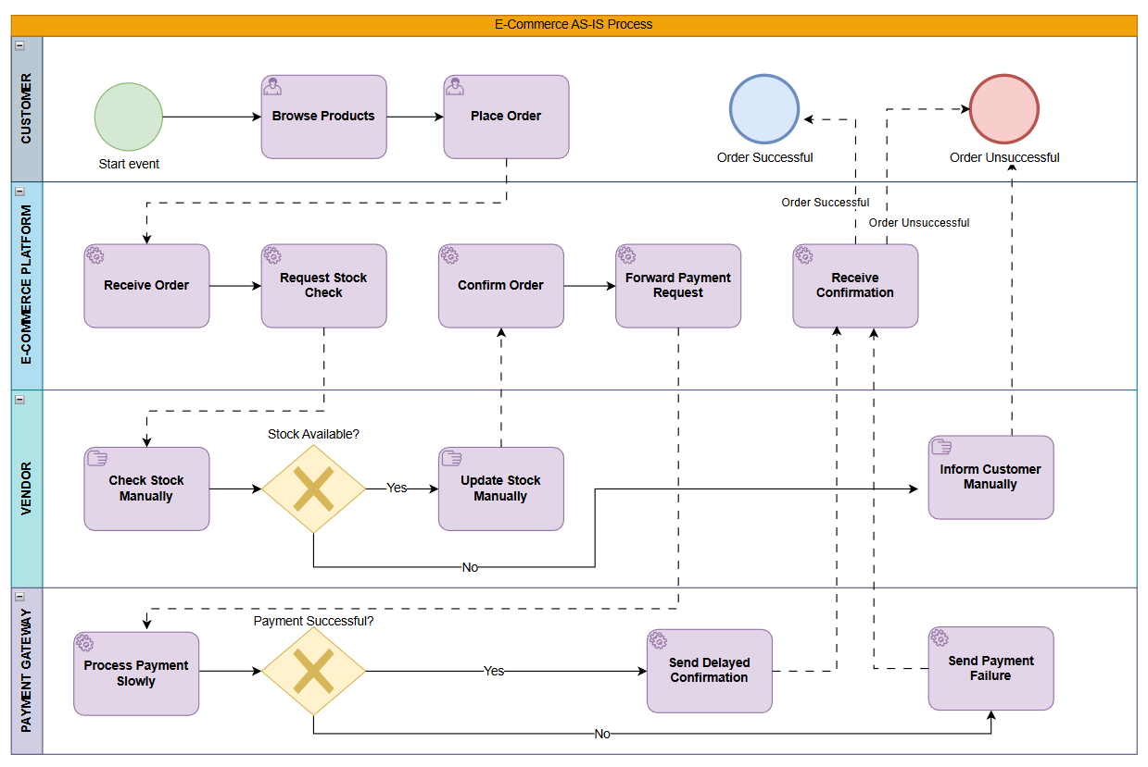

  - TO-BE Process Flow Diagram
The TO-BE diagram illustrates the improved automated workflow enabled by Vendor API, Payment Gateway API, and Notification Service integration. It shows how stock checks, payment processing, order confirmation, and shipment updates flow through automated system interactions.
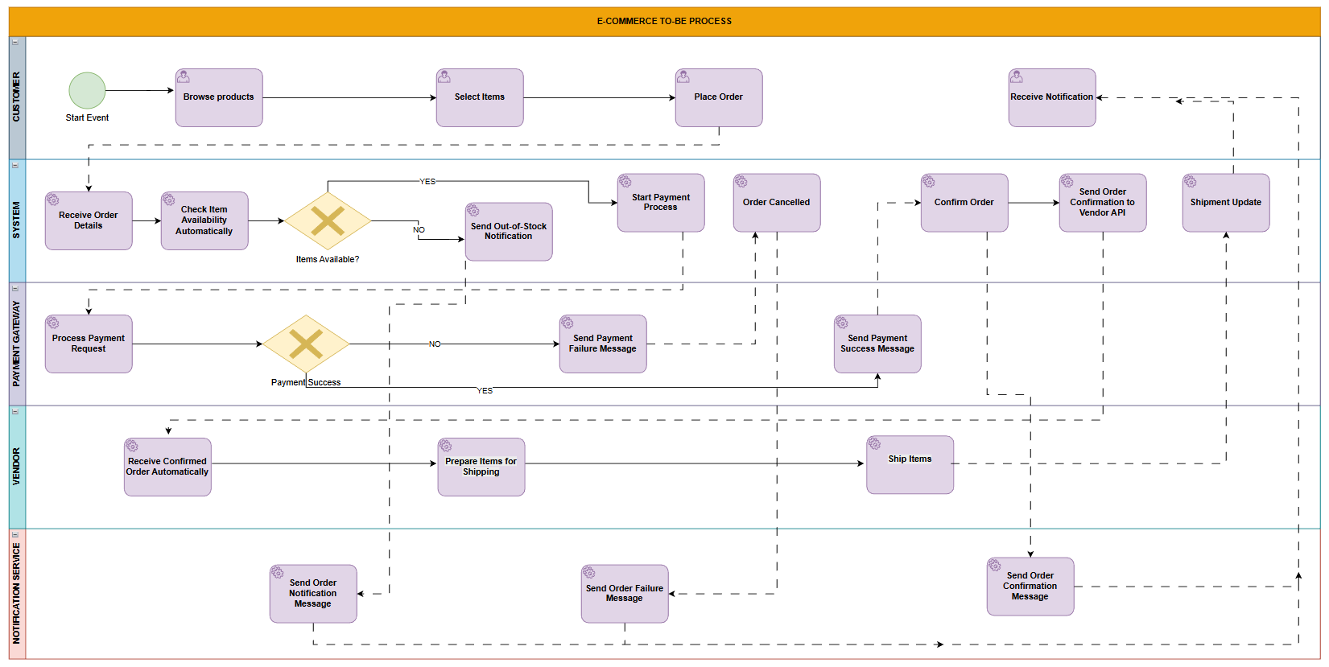

  - System Architecture Diagram
The System Architecture Diagram provides a visual overview of how the e-commerce backend interacts with external systems through APIs. It highlights the role of the Vendor API, Payment Gateway API, Notification Service, and internal database within the order processing workflow.
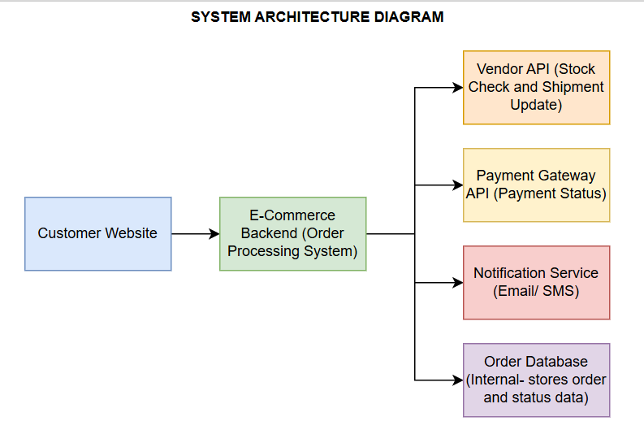

  - Sample API Responses
The following examples illustrate typical API responses used in the integrated order processing system.
    - Vendor API- Stock Check
Used to verify whether a product is available before payment.
- Product Available Response
{
"productId": "P12345",
"available": true,
"quantity": 12
}
- Product Out of Stock Response
{
"productId": "P12345",
"available": false,
"quantity": 0
}

    - Payment Gateway API- Payment Status
Used to confirm whether the customer’s payment was successful or failed.
- Payment Success Response
{
"orderId": "O98765",
"paymentStatus": "SUCCESS",
"transactionId": "T55555"
}
- Payment Failure Response
{
"orderId": "O98765",
"paymentStatus": "FAILED",
"reason": "Insufficient Funds"
}

    - Vendor API-Shipment Update
Used to update the system when the vendor ships the order.
{
"orderId": "O98765",
"shipmentStatus": "SHIPPED",
"trackingId": "TRK12345"
}

